The impact of exchange rate changes on inflation in the V4 countries in the process of economic transition

Libor Žídek[1], Daniel Němec[2]

Abstract. Our contribution focuses on the role of the exchange rate changes in the V4 countries during the transition process towards a market economy. Regarding the variety of exchange rate regimes implemented in the V4 countries at the start of the economic transition, we are especially interested in the degree of exchange rate pass-through to the domestic inflation in these countries. The respective countries followed different exchange rate strategies. The fixed exchange rate regime was applied in Czechoslovakia. Crawling peg was used in Hungary and Poland. And floating and fixed exchange rate with large band were applied in the new century. We have compared the impacts of the different exchange rate regimes on the price stability during the transformation process. The effects were examined using country specific SVAR models and corresponding historical shock decompositions. We found out that the exchange rate indeed played important role in the price stability but the specific impact is highly individual.

Keywords: V4 countries, exchange rate pass-through, structural vector autoregression model, economic transition, inflation.

JEL Classification: C22, F31

AMS Classification: 91B84

# Introduction

The Central European countries decided to follow different exchange rate strategies during the transformation process. Our goal is to detect the impact of the different exchange rate regimes on the inflation development in the V4 countries (the Czech Republic, the Slovak Republic, Hungary and Poland) in the period between the beginning of 1993 and the end of 2007. The first date was selected due to availability of data and the second due to the start of the financial crisis that would affect the overall results. We suppose that the different exchange rate strategies had different impacts on inflation development. Foremost we expect that the fixed exchange rate should have only a limited impact on inflation – indeed, this type of exchange rate should stabilize it. The crawling peg system should be inflationary because small devaluations are supposed to cause growth in imported prices. And we expect that the impact of the floating regime will be ambiguous because there are usually periods of both appreciation and depreciation. The countries applied different regimes in different times. We split the overall analyzed period into subperiods according to the applied exchange rate regime. And we use the country specific Structural Vector Autoregression models (SVAR models) to estimate structural shocks. Using SVAR simulation procedures we are able to decompose the development of inflation into the specific structural shocks contribution. This method allows us to evaluate the impact of the historical exchange rate shocks on inflation. Our approach differs from those one presented by Mirdala [4], [5] due to fact that he has evaluated the exchange rate pass-through to domestic prices using the forecast error variance decomposition. He was thus not able to observe the real historical consequences of the exchange rate changes in the first half of the 1990s. Although the SVAR approach assumes possible interdependencies among all of the modeled endogenous variables, we will focus on one sided causality from nominal exchange rates changes to price level changes.

# Exchange rates in transformation process

In this section we first of all describe the different exchange rate regimes and consequently write about their application in the transformation process. The Central European countries used generally three different exchange rate regimes. The first was the fixed exchange rate regime. There is no general agreement on the definition of the fixed exchange rate because definitions diverge about the existence and the size of the potential fluctuation zone. [3] We will consider the exchange rate as fixed even if there was a fluctuation zone. Keeping a fixed exchange rate was the main goal of the respective central bank in the specific period and it was supposed that a stable exchange rate should stabilize inflation pressures at the same time. The flip side of this exchange rate system was a parallel real appreciation of the currency. The other con is that the fixed exchange rate regimes are in the long run unstable and can lead to currency crisis as in the Czech Republic in 1997. The second exchange rate regime – crawling peg – tried to avoid or soften this real appreciation by small periodic monthly devaluations of the currency. These devaluations were supposed to balance the impact of higher growth in prices in the domestic economy. The positive side is transparency for the market subjects. The flip side of this regime should be inflation that is caused by devaluations. It means that this exchange rate regime tries to soften real appreciation but it causes it as the side effect of devaluations. The third regime that was applied later on in the period is floating. There should not be any general impact of the regime on inflation. The depreciation of the exchange rate should have of course an inflationary impact and contrary wise.

What was the specific development of the exchange rate regimes? We will consider only the main changes in the development. The reformers decided for the fixed exchange rate regime at the beginning of the transformation process in the Czech Republic (Czechoslovakia). A small fluctuation zone (+/- 0.5%) was introduced in May 1993. And the zone was widened in February 1996 to +/- 7.5 %. The fixed exchange rate system collapsed in May 1997 in the currency crisis. The managed floating has been in use since that time which is close to de facto free floating. The trend in this period was towards nominal appreciation. Generally, the real exchange rate was appreciating for the whole period Frait, Komárek [1]. We can see the development of both nominal as well as real exchange rate in the following charts – Figure 1.[4]

Slovakia had the same basis of the exchange rate as the Czech Republic. But the Slovak crown was allowed to move in a small fluctuation zone +/- 1.5 since February 1993 and the currency was devaluated by 10 % in July of that year. In 1996 and 1997, the fluctuation zone was widened in three steps to +/- 7 %. And the currency regime changed to managed floating in October 1998. The country became a member of ERM II in October 2005. The country joined the Eurozone after two revaluations at the beginning of 2009. The overall trends in the nominal and real exchange rates were similar to the development of the Czech crown.

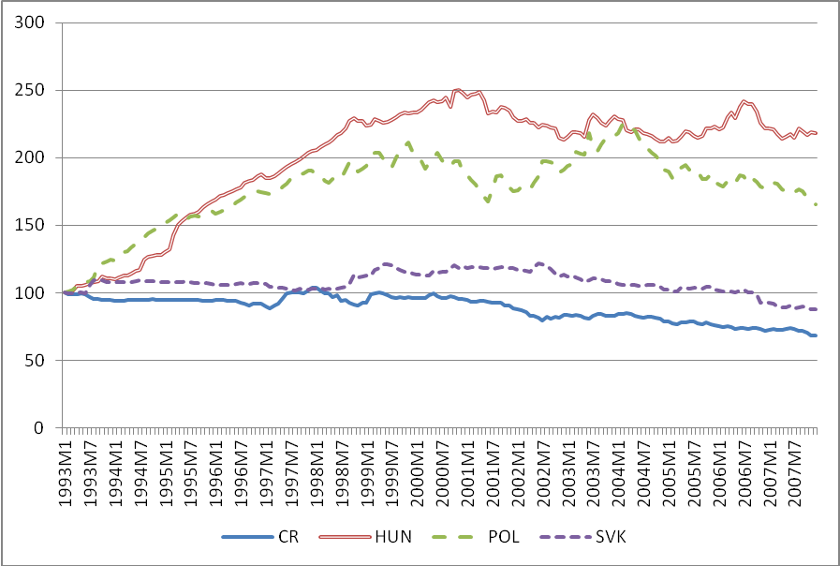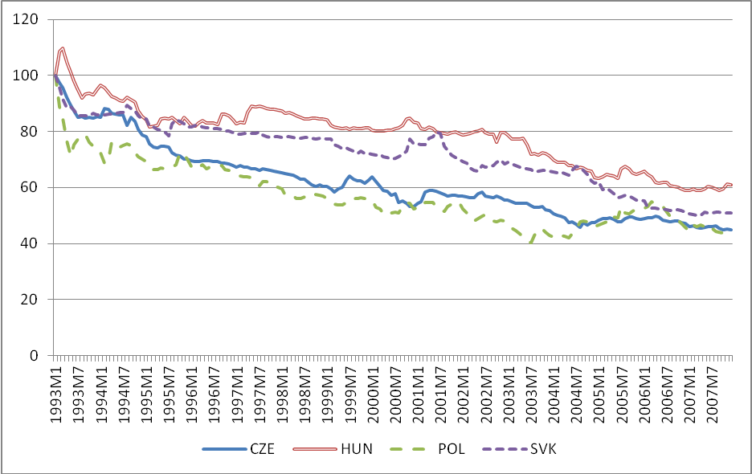

**Figure 1** Development of the nominal and real exchange rates (index, 1993M1 = 100, indirect quote)

Hungary used the fixed exchange rate regime at the beginning of the transformation process. But the exchange rate was irregularly devaluated and the fluctuation zone gradually widened from +/- 0.3 % in July 1992 to +/-2.25 % in December 1994. The overall exchange rate regime was changed to crawling peg in March 1995 after a 9 % devaluation. Regular devaluations in the system gradually decreased till October 2001, when the central bank decided for the fixed exchange rate system with a fluctuation zone +/- 15 %. The system changed to managed floating only in May 2008. We can see in the following chart that the nominal exchange rate significantly depreciated during the 1990s and consequently oscillated. The real exchange rate appreciated in the first years but then it was highly stable during the crawling peg period. Since 2003, the trend was again towards real appreciation.

Poland applied the fixed exchange rate regime at the beginning of the transformation process Žídek [7] . It was changed to the crawling peg regime at the end of 1991. Consequently there were additionally irregular devaluations of Zloty. The monthly devaluations connected with crawling peg were gradually declining. Meanwhile, the fluctuation zone was widened up to +/- 15 % in March 1999. Zloty has been in the regime of free floating since April 2000. The currency significantly nominally depreciated in the 1990s. Consequently, there were periods of appreciation and depreciation. In real terms Zloty appreciated nearly for the whole period regardless of the exchange rate regime.

# Data and methodology

The main purpose of our paper is to estimate the impact of exchange rate changes on domestic inflation. To study the determinants of the domestic price level changes in the economy we use the methodology proposed by Ito and Sato [3] tuned in a way to incorporate the particularities of the V4 transition economies. In order to examine the sources of inflation in the transition period, we will use a framework that includes the possibility of mutual interactions of the key macroeconomic variables. Although the main question is to reveal the direct influence of the exchange rate on domestic inflation, it is also possible that domestic inflation may affect the exchange rate. This type of causality will be thus examined using the vector autoregression (VAR) analysis which is a useful approach allowing interaction between the exchange rate and domestic macroeconomic variables.

Our VAR analysis starts with an estimation of a reduced form model. Obtained residuals are then transformed to the structural shocks using Cholesky decomposition. Effects of structural shocks of various macroeconomic variables on inflation are thus investigated using the structural VAR model (SVAR model). Identified structural shocks are incorporated into simulation exercises that will decompose the actual trajectories of our observed variables into the particular shock components. The resulting historical shock decomposition points out the main factors standing behind the development of inflation in the transition period.

Our VAR model is set up using the vector of five endogenous variables[5]:

|  |  |
| --- | --- |
|  | (1) |

where denotes changes in the natural log of oil prices,  is the output gap, denotes changes in the natural log of money supply,  is the growth rate of nominal effective exchange rate and  is the difference of the natural log of the price index.

The data set used for estimation is from January 1993 to December 2007. The data source is International Financial Statistics (IFS) provided by the International Monetary Fund. The observed variables for all V4 countries are as follows:

* IPM: Index of industrial production, 2005=100;
* CPI: Consumer prices index, all items, 2005=100;
* PPI: Producer prices index, all commodities, 2005=100;
* M1: Monetary Aggregate M1, national currency;
* OIL: Crude oil prices (Brent – Europe), dollars per barrel;
* NEER: Nominal effective exchange rate (index), 2005=100, direct quote (increase means appreciation);

All variables (except NEER) were seasonally adjusted using the X12-ARIMA procedure. After seasonal adjustment, the variables were transformed using logarithmic transformation. Unit root tests proved the existence of unit roots in all variables. Except IPM, the variables were expressed in growth rates terms (i.e. logarithmic differences). Variables IPM were filtered using Hodrick-Prescott filter with the smoothing constant. This procedure resulted in the corresponding  variable. These transformations led to stationary variables. As a monetary policy variable (money supply), the base money (M1) is used. As price index variable, we used CPI in our final model. All the variables were selected in accordance with the arguments presented by Ito and Sato (2008) and are very similar to those used by Mirdala (2009). These variables express economic linkage between inflation and internal and external macroeconomic factors. Oil price inflation represents possible external supply shocks, demand shock effects are included in the output gap, and money supply allows us to capture the effects of monetary policy on domestic inflation.



Identified structural shocks are based on the Cholesky decomposition of the variance-covariance matrix  of the reduced-form VAR residuals. The link between the reduced-form VAR residuals  and the structural shocks  can be written as

|  |  |
| --- | --- |
|  | (2) |

where,  and is the lower-triangular matrix derived given the covariance matrix . The Cholesky decomposition of  implies  with a lower triangular matrix. Since, where structural disturbances  are considered to be orthonormal, the matrix  is equal to. The structural model defined by the equation (2) is identified due to fact that lower-triangular matrix  imposes enough zero restrictions, where  denotes the number of endogenous variables. The lower-triangular matrix  implies that some structural shocks have no long-lasting effect on the endogenous variables. The ordering is thus important and is based on the economic intuition. For example, we assume that changes in oil prices are influenced only by the oil price (supply) shockitself.

# Estimation results

The lag order of the VAR model was selected using the Akaike information criterion (AIC). The constant term was included in our model specification that might be justified by the fact, that there was a significant (i.e. non-zero) growth in the monthly CPI. The reduced form VAR models for all V4 countries have been estimated using the complete data set starting from 1993M2 to 2007M12[6]. Structural shocks were computed from the VAR residuals.

Figure 2 Historical shock decompositions – inflation



Figure 2 shows the historical shocks decomposition of monthly CPI inflation and the development of the NEER (indirect quotation where increase means depreciation). The corresponding structural shocks contributions were computed using the identified and simulated SVAR model. Non-zero shocks were simulated with respect to the lag of reduced-form model (in 1993M4 for the Czech Republic and Slovakia or 1993M5 in case of Hungary and Poland). The subplots in Figure 2 contain a mark of the period of change (vertical line) of the exchange rate regimes. These time intervals are used in Table 2 to determine the relative importance of all shocks to the variance in inflation during the examined period. In particular, the ends of fixed exchange rate period are stated in each country as follow: 1997M5 for the Czech Republic, 2001M5 for Hungary, 2000M5 for Poland and 1998M10 for Slovakia. The remaining periods are considered as the regime of the floating exchange rate. We can notice in the following charts that in several periods exchange rate plays an important role in the explanation of inflation. An interesting period is for example spring of 1997 in the Czech Republic – after the currency crisis. The devaluation was causing inflation. Another interesting period is crawling peg in Hungary after 1995 that had an impact on the growth of the price level as well. On the contrary in Poland and Slovakia there were no periods with such obvious influence of the exchange rate.

Forecast error variance decomposition of inflation for all V4 countries is shown in Table 1. We should notice that the exchange rates were the most important inflation variables for all countries. But there are some obvious differences among the countries in terms of the extent of variability.

|  |  |  |  |  |  |
| --- | --- | --- | --- | --- | --- |
|  |  |  |  |  |  |
| CZE | 0.0089 | 0.0224 | 0.0051 | 0.1467 | 0.8168 |
| HUN | 0.0151 | 0.0213 | 0.0190 | 0.1828 | 0.7618 |
| POL | 0.0085 | 0.0070 | 0.0507 | 0.0623 | 0.8715 |
| SVK | 0.0441 | 0.0061 | 0.0186 | 0.0439 | 0.8874 |

Table 1 Forecast error variance decomposition of inflation

Relative importance of structural shocks may be found in Table 2. The presented numbers are outputs of the regressions where dependent variable is the standardized inflation and the explaining variables are standardized structural shocks. The resulting is decomposed into individual contribution using the formula whereis the regression coefficient at the structural shock (i.e. standardized coefficient in the regression with original variables) and is the correlation coefficient between the dependent variable (standardized inflation) and the  structural shock. All the computations were carried out for the periods of fixed exchange rate, floating exchange rate and the period of both regimes[7]. This approach allows us to distinguish the influence of exchange rate on inflation in periods mentioned previously.

|  |  |  |  |  |  |  |  |  |  |  |  |  |  |  |  |
| --- | --- | --- | --- | --- | --- | --- | --- | --- | --- | --- | --- | --- | --- | --- | --- |
|  |  | **“1990s”** | | | |  | **“2000s”** | | | |  | **“1990s” and “2000s”** | | | |
|  |  | **CZE** | **HUN** | **POL** | **SVK** |  | **CZE** | **HUN** | **POL** | **SVK** |  | **CZE** | **HUN** | **POL** | **SVK** |
|  |  | **Fix** | **Crawl peg** | **Crawl peg** | **Fix** |  | **Float** | **Fix with band** | **Float** | **Float** |  | **Both regimes** | | | |
| **Till/from** |  | **1997** | **2001** | 2000 | **1998** |  | **1997** | **2001** | **2000** | **1998** |  | **1993 - 2007** | | | |
|  |  | -0.21% | 4.14% | 0.58% | -1.08% |  | 1.37% | -0.23% | 5.26% | 6.07% |  | 1.04% | 1.99% | 1.63% | 5.31% |
|  |  | 7.68% | 1.72% | 3.55% | 6.24% |  | 3.33% | 5.47% | 8.33% | 0.03% |  | 2.82% | 1.42% | 1.92% | 0.55% |
|  |  | 0.27% | -4.67% | 16.81% | -1.36% |  | 1.29% | 1.76% | -5.52% | 2.13% |  | 0.67% | 0.78% | 11.76% | 1.88% |
|  |  | 11.46% | 24.38% | -0.46% | 1.31% |  | 18.05% | 15.51% | 11.63% | 3.10% |  | 16.56% | 23.83% | 0.11% | 3.09% |
|  |  | 80.80% | 74.31% | 67.38% | 94.89% |  | 75.95% | 77.50% | 80.31% | 88.67% |  | 78.92% | 71.88% | 78.25% | 89.18% |

Table 2 Explained historical variability of inflation

For the analysis of the results we divided our period as mentioned above. For easier recognition we roughly divided the period to the 1990s and the 2000s in Table 2. We can see the specific year of the switch of the system in the table. We consider periods of irregular devaluations in Poland and Hungary as part of the crawling peg system as well. Our conclusions are only to some extend in attune with our expectations. We generally supposed that the role of the exchange rate should be negative or limited in the periods of the fixed exchange rate regimes. But in the case of the Czech Republic, the model shows a rather strong impact of the exchange rate changes on the explanation of inflation. It can be caused by higher fluctuations when the Crown was moving in the bands. On the contrary, in Slovakia the impact was in accordance with our expectations. Secondly, we supposed that in the period of crawling pegs small devaluations should cause inflation and our conclusion for Hungary is fully in accordance with this expectation. On the contrary, in Poland general impact of the monetary aggregate was the main source of inflation and in our model, the exchange rate has even a negative impact.

Roughly with the turn of the century the exchange rate regimes changed. The impact of the exchange rate was in our view surprisingly important especially in the floating regimes in Poland and the Czech Republic; and in the Hungarian fixed exchange rate regime with a large band. On the contrary, in Slovakia the impact of the exchange rate was relatively small but it was significant. To be more specific, we have computed contribution of the nominal effective exchange rates to the year-on-year inflation in V4 countries. These computations are presented in Table 3. The periods are similar to those from Table 2. The column “Model” **contains est**imated intercept in the **(i.e. inflation) equation of the SVAR model. This estimate corresponds to a part of the inflation which is not explained by the variability of the endogenous variables and may be this considered as the overall trend in price level development. We can see the inflationary impacts of the NEER changes in the 1990s and the mostly deflationary tendencies caused by the NEER changes in the 2000s.**

|  |  |  |  |  |  |  |  |
| --- | --- | --- | --- | --- | --- | --- | --- |
|  | **“1990s”** | | **“2000s”** | | **“1990s and 2000s”** | | **Model** |
|  |  |  |  |  |  |  |  |
| **CZE** | 0.47% | 8.49% | -0.07% | 3.65% | 0.06% | 4.81% | 4.98% |
| **HUN** | 1.29% | 16.10% | -1.10% | 5.46% | 0.16% | 10.97% | 11.20% |
| **POL** | 0.05% | 16.09% | 0.25% | 2.81% | 0.16% | 8.62% | 7.48% |
| **SVK** | 0.15% | 7.44% | -0.26% | 6.42% | -0.12% | 6.77% | 7.18% |

Table 3 Contribution of NEER changes to the average year to year CPI inflation

# Conclusion

In our contribution, we have analyzed the relationship between exchange rates and inflation in the Central European countries. These countries applied different exchange rate strategies during the transformation process. We have found out that changes in exchange rates were a significant cause of inflation in some periods – for example the period of crawling peg in Hungary. On the hand, the impact was smaller than expected in other periods – for example Poland during the application of the same exchange rate system. Our conclusion is that exchange rate can play an important role in the development of inflation but the specific impact is highly individual.

Acknowledgements

This work is supported by funding of specific research at Masaryk University (project MUNI/A/0799/2012).

References

1. Frait, J., and Komárek, L.: Real exchange rate trends in transitional countries. Warwick Economic Research Paper No. 596, 2001.
2. International Monetary Fund (IMF): *De Facto Classification of Exchange Rate Regimes and Monetary Policy Framework*. http://www.imf.org/external/np/mfd/er/2006/eng/0706.htm (22. 2. 2007)
3. Ito, T., and Sato, K.: Exchange Rate Changes and Inflation in Post-Crisis Asian Economies: Vector Autoregression Analysis of the Exchange Rate Pass-Through. Journal of Money, Credit and Banking **40** (2008), 1407–1438.
4. Mirdala, R.: *Menové kurzy v krajinách strednej Europy*. Technická univerzita v Košiciach, Košice, 2011.
5. Mirdala, R.: Exchange rate pass-through to domestic prices in the Central European countries. *Journal of Applied Economic Sciences* **4** (2009), 408–424.
6. Singer, M.: Dohled a makroekonomické politiky – poučíme se z historie?. In: *20 let finančních a bankovních reforem v České Republice* (VŠE ed.). Oeconomica. Prague. 2009.
7. Žídek, L.: Transformation in Poland. *Review of Economic Perspectives* **4** (2011), 236-270.

1. Masaryk University, Faculty of Economics and Administration, Department of Economics, Lipová 41a, 602 00 Brno, l_zidek@centrum.cz.
2. Masaryk University, Faculty of Economics and Administration, Department of Economics, Lipová 41a, 602 00 Brno, nemecd@econ.muni.cz.
3. For instance the term fixed exchange rate is in the Czech literature used even in situation of broad fluctuation zone +/- 7.5 % (for example Singer [6]). On the contrary the definition of the IMF says that fixed exchange rate is only within margins +/- 1 % (see for example [2]).
4. The data source is International Financial Statistics (IFS) provided by the International Monetary Fund. The observed variables for all V4 countries are real and nominal effective exchange rate (index).
5. We have constructed other models which were extended by foreign gap variable (output gap of Germany) and by inclusion of consumer price index and producer prices index. The main results remained relatively stable. We will thus present the results for the basic model with consumer prices index only. Due to lack of historical import prices indices, we were unable to model a link of inflation transmission among various sectors of economy (i.e. importers, producers and consumers).
6. The first observation in 1993M1 was lost due to differencing procedure.
7. We have omitted the months in 1993 due to the influence of initial zero-shocks conditions in historical simulation. Moreover, the negative  are the results of insignificant influence of the shocks on inflation. It means that their explanatory power was simply negative due to the fact that the sum of individualhas to be equal to the overall.