Individualized on-line Education in STEM

Jan Slovák

Masaryk University and PolyMedia Technologies
Department of Mathematics and Statistics, Masaryk University, Kotlářská 2, 611 37 Brno, Czech Republic, slovak@muni.cz, jslovak@polymedia.hk

Abstract: This note focuses on the culture of individual communication within the massified Education process, and the prospective role of new technologies there. Based on the authors experience in the area of STEM Education, new horizons and possibilities are questioned.

Keywords: asynchronous communication, flipped classrooms, MOOC, EduArt.

INTRODUCTION

Over centuries, the development of teaching and learning swapped repeatedly, roughly speaking, between two main phases: “Teaching Facts” and “Engaging the Intellect”. Both can be done in a useful and practical way, or the opposite. But in recent decades the tendency to teaching facts was perhaps stronger than ever before. Moreover, there were many other risk factors appearing: too much specialization, fit for purpose training, unrealistic expectation from new web based technologies, etc. At the same time we are facing heavy decline of interest in the Science, Technology, Engineering, and Mathematics education, the so called “STEM”. Actually, a good illustration and essence of the problems can be seen in the current role and the position of Mathematics within STEM.

This paper displays the authors personal views and experience from the Masaryk University, the ongoing project "A Brisk Guide to Mathematics", and recent usage of the newly developed EduArt technology. On the way, we shall pay attention to the potential of the new technologies including rich media, on-line learning, and further web based communication techniques in general.

1. Why new technologies

1.1 The impact of personal typologies

All experienced teachers are aware of the fact that the perception and thinking schemes of individual students are as diverse as their behaviour and attitudes. The author devoted attention to this phenomenon in [3]. In particular, it is clear that classical face to face lecturing in big classes cannot address all the students in a fully satisfactory way because there is no universal best approach for all of them.

This phenomenon was not well visible in small groups of well-motivated students, living together in the colleges with their teachers. Nowadays, the massified Education is mostly flourishing at the universities, but the current generation of students is ready to live in a quite virtual world in the internet and so we should be able to substitute the lacking direct communication by its virtual forms.

This is the great potential of new technologies, but we must not focus on capturing and archiving classical lectures without changing their form or, even worth, on replacing them by simpleminded drill e-learning environments. Instead, we should build platforms where all the relevant types of (mainly asynchronous) communication can happen. Moreover, the chosen tools and channels should support both the quest for real understanding – let us call this the “engaging the intellect phase”, and the obligatory “teaching facts phase”, and they should support them in a way allowing the students to choose the ordering of these two phases. This is extremely important in view of the personal typology differences among the students, see again [3] for more details.

The architecture of our platforms should also take into account the quickly growing differences between the generations. Recently, studies pointing out some of the most obvious worries were published. For example the results of the survey Meet Generation Z: Forget Everything You Learned About Millennials says that the current (American) teenagers are, unlike their teachers: they are multitasking across 5 screens; keeping attention for less than 8 seconds only; they collaborate better, but more than 10% of them suffer hyperactivity and further neurological deviations; they live in virtual realities.

1.2 The real performance of colleges

Reading recent studies on the real performance of universities/colleges is even much more pessimistic. For example, there are two recent books by the sociologists Richard Arum and Josipa Roksa, [1], [2]. The first one deals with more than 2300 bachelor students in 24 schools of different character. With a bit of exaggeration, the students learned a lot of bad habits while their critical thinking and readiness to work got too often even worse. In the second book, they extend the study to the general changes in the social behaviour in the last 40 years. Among others, they conclude that both students and teachers are more and more obsessed by quick appreciation and success in the community, while the importance of more conservative and long lasting values and goals is wading out.

Obviously, this discussion applies to the Czech Higher Education as well. Most of the universities have been undergoing serious debates leading to reforms of the curriculums and the new technologies have played often an important role there. Unfortunately, the author is not aware of any example of best practice where this would represent a global change of the paradigm replacing and essentially extending the approaches and tools in the everyday teaching praxis.

1.3 The potential role of asynchronous communication

As we are witnessing across social networks, the individualized communication can be restored easily with properly chosen technologies even in extremely big communities. Most of such communication is asynchronous, but with quite short intervals between the interactions.

Thus, we do not want to focus on simple capturing of standard lectures and making them available on demand, or on straightforward drilling tools for memorising facts. Instead, the materials displayed should rather initiate discussion among the peers, perhaps monitored and further expanded by the teachers. This could promote the engaging intellect phase of the process and it should also support the appearance of individual leaders emerging within the community, which seems to be the most efficient improvement of quality by itself. At the same time, the students could possibly feel more like in a private and individualized environment, similar to the most classical colleges with small groups of students living together.

2. the MOOC platforms

2.1 Three main types of activities

The universities understand that their basic roles are quickly expanding together with the expansion of the numbers of their students. They should feel responsible also for the motivation of the talented youth, as well as for the lifelong learning of the graduates. Therefore, we must not understand the new platforms like the MOOC’s as mere extensions or complements of the regular lectures at the universities. The typical MOOC courses are not having the character of full basic university courses either. Although they could complement and partially replace them, actually there should be more goals there:

- General motivation and exposition of hardly accessible news/knowledge in a way addressing wide population. In particular, the talented youth and bright potential students should be exposed to appealing lectures and presentations addressed to them.
- The more and more interdisciplinary character of most important inventions call for extension of regular courses and seminars by blocks of specialized and still accessible lectures/presentations.
- The public loves the messages on newest achievements in Science and Technology, Medicine etc. Why not to have a new channel with non-traditional forms of public lectures of the best experts available. This would also greatly impact the interest of the talented youth in careers in innovative research and development and it would serve also as a great lifelong education possibility.

All the three points match perfectly the needs in the STEM Education. The reason is that exactly the STEM area suffers most by the changes of attitudes of the new generations and a MOOC-like platform covering the three points above could be of great help in learning how to understand written texts or told explanations – two abilities which are less and less developed among the fresh enrolled students at universities. With a bit of exaggeration, the young generation is overwhelmed with fast and shallow information represented in the form of sequences of very short pieces of texts, animations or videos. Thus we should like to prepare materials and communication channels which would force them to stop and think, to try to explain things to peers, to think critically of what they read/hear. This is clearly just the opposite of e-learning systems focused on drill and teaching facts.

Another set of questions reads: Do we want to support and to push forward the average ones, the best ones, or the laziest and weakest ones? Does the technology strengthen the ‘teaching facts’ or the ‘engaging intellect’ parts? Does it help to balance them right for the different types of personalities? The answers are obvious – we always want to cover all the options.

2.2 The platform maintenance

As stressed above, the MOOC like platform we are talking about should allow asynchronous peer to peer communication, which makes the participation of the students and teachers individualized and quite symmetric in the sense that the students have got approach to the same technologies as the teachers and the platform supports peer to peer communication.

The author has been using the recently developed purely software based solution EduArt by PolyMedia Technologies. This is meant to capture any kind of presentations based on explicit material displayed on the computer screen, and standard audio/video recording of the person in question. We are getting a very lean solution, were the captured presentations are kept at a server in a completely open html5 format and thus, they are easily streamed to any mobile or computer platform. Moreover, the screen shots are kept in their original resolution, the data flow is very low, the capture client is downloaded for free, and there is nearly no maintenance of the server part of the system too. The server content management can be integrated into any standard e-learning or general information system.

The latter properties represent exactly the requirements considered as reasonable. The community using the system should be on one hand without any special maintenance needs, but at the same time everybody should be able to actively contribute to the entire process.

In particular:
- the right technology should allow for ‘live’ appearance of teachers/speakers combined with classical slides displaying the topic to be discussed – this very much imitates the standard way of consulting in someone’s office;
- the technology should invoke symmetric discussion the same way in any kind of groups (as opposed to one-way exposition of the material by the teachers);
- the technology should allow the teacher (or anybody in the group) to create the messages/lectures easily, in order to keep the feeling of rather real time discussion than an anonymous performance brought to perfection.

3. How does the Brisk guide to mathematics work

3.1 The concept

Mathematics is a quite specific part of the STEM. Unfortunately, Mathematics often is not presented as the common language supporting the ‘engaging intellect’ part of the learning process. Instead it is either a collection of recipes to be learned by heart, or even worth, a series of abstract nonsense games with letters with very limited understanding of its use.

The author’s own experience from teaching Mathematics for big classes of Informatics students says, that the mere existence of simple videos from lectures leads them to the belief that they are able to browse through the materials short before the exams like they watch the sitcoms. Thus, we have planned to include the following parts in our teaching process:

- a flipped-classroom approach based on up to date prepared presentations amending the practical aspects of the lectures, available to the students short before the main lectures;
- standard lectures (in the rather classical big lecture hall standard, complemented with usual tutorials in smaller groups) showing the practical use of the mathematical tools again, but focusing on rather intuitive explanation of the methods and procedures (including many proofs);
- practical seminars devoted to the numerical and computational aspects (computer based activity in small groups with a tutor – attended only by some students);
- individual problem solving and discussion (perhaps in small groups, invoking mutual discussion between students).

We try rather to focus on the ‘right things’ and to present them as useful tools and we hope that the best students will come to understanding of the tiny details too, while the average students will at least remember the usefulness of Mathematics. Another point is touching topics in a simple way first and ‘coming back’ with new understanding later again.

This has been also projected into the unconventional textbook called Rough Guide to Mathematics, cf. [4]. In order to push the readers to choose their own paths through the Mathematics landscape, we have designed a two-column format splitting the practical and theoretical parts of the exposition and also allowing various parts of the text to appear with very diverse complexity of exposition. We hope this will convince the readers that no one is expected to read simply through everything in any given order and they could explore their own thrilling and adventurous discovering of Mathematics by themselves.

3.2 The results and further plans

After years of experimenting, the courses have stabilised and we got the graduates of all four semesters of Mathematics for several years already. The responses are diverse, quite as expected. Clearly this new model of structuring and presenting Mathematics is more often welcome by the very good students. We have not got a detailed statistics, but the general university questionnaires reflecting the opinions and feelings of students suggest that at least those in the 1st quartile by their results of study find the model often good. Also their skills seem to be very good, while the average students (or those less motivated ones) have not got worse. This was exactly the main goal of the project – to serve the best 10% students best, while not doing any harm to the average.

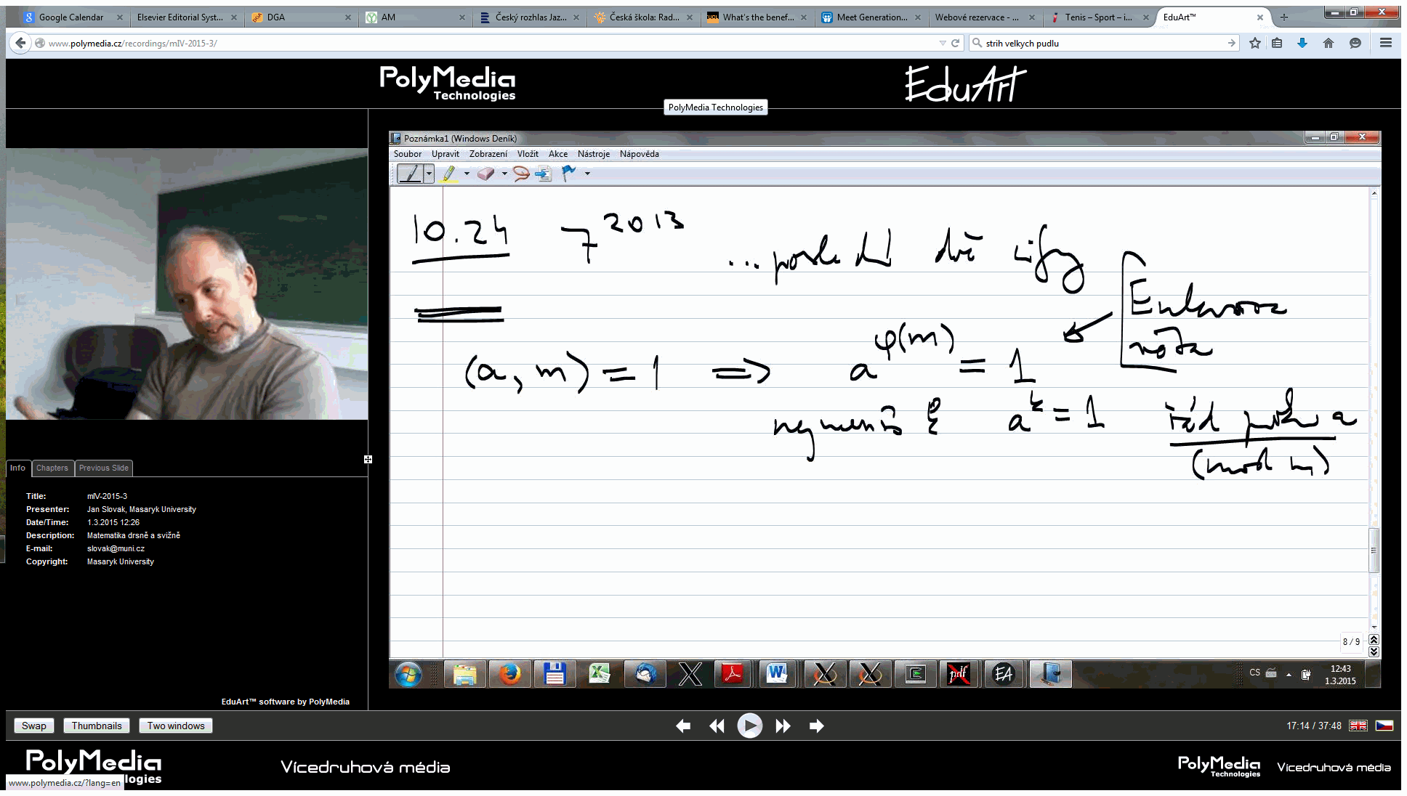

Fig. 1. Screenshot from streamed “practical presentation” by the author from March 1, 2015, (in Czech) preceding the lecture on the same topic in the week after
Source: www.polymedia.cz/recordings/mIV-2015-3

In general, it seems that the existence of the practical presentations (closely related to the main lectures and tutorials in both topics and time) is most appreciated by nearly all students. As expected by the psychology theory, some of them come back to the practical parts after they have seen the theoretical lectures; others enjoy the practical presentations before the lectures already. There is a small group of students having also the numerical seminars mentioned in point (3) – this proved to be a great idea and this is exactly the part which could be offered as complementary course in a MOOC like format to everybody.

Unfortunately we have not managed to initiate the fourth part from the list above to our satisfaction – the discussion and problem solution in small groups. This is another activity which could be perhaps managed via a platform mentioned in 2.1 above.

CONCLUSION

We have advocated main features of a platform which would allow the universities and the wide regional or international communities around them to enjoy active learning, to support and motivate the growth of talents, and to blend the lifelong education with public interest.
So far, there is no working platform satisfying all the requirements listed above in the Czech Republic.

Recently, a group of colleagues from several Czech universities, together with foreign partners, started to work on a project aiming at such a goal and we believe to have first results ready for tests and wide discussions by 2016.

LITERATURE

[1] ARUM, Richard. - ROKSA, Josipa. Academically Adrift: Limited Learning on College Campuses, Chicago: University of Chicago Press, 2011.
[2] ARUM, Richard. - ROKSA, Josipa. Aspiring Adults Adrift: Tentative Transitions of College, Graduates, Chicago: University of Chicago Press, 2014.
[3] Slovák, Jan. The paradigm change in STEM Education – has it happened already?. In: Building Sustainable R&D Centers in Emerging Technology Regions, Eds. D. Gibson, J. Slovák. Brno: Masaryk University, to appear in 2015.
[4] SLOVÁK, Jan - PANÁK, Martin - BULANT, Michal. Matematika drsně a svižně. Vyd. 1. Brno : Masarykova univerzita, 2013. 773 s. ISBN 978-80-210-6307-5. (electronic version free on www.math.muni.cz/Matematika_drsne_svizne)

Survey released by Sparks & Honey in April 2014, cf. http://www.sparksandhoney.com/work-index/

