The Image and Political Caricature in a French for Lawyers Classroom

Kateřina Sedláčková, Czech Republic

Kateřina Sedláčková works as teacher of Legal French, Academic French and French for Specific Purposes at Masaryk University Language Centre, Brno, Czech Republic. She enjoys intellectual exchanges with her students when encouraging them to actively use their knowledge. E-mail: k.sedlackova@mail.muni.cz.

Menu

Introduction
Target group
Description of visual stimulus
Goals
Procedure
Conclusion
Quotes
References
Images

Introduction

The aim of this text is to present quite a traditional activity with an image. However, once modified and retransmitted into a different context, it works effectively, permits to focus student’s attention to the topic of the lesson from another point of view and, moreover, it is highly appreciated by them. The activity in question is based on work with journalistic images, political cartoon genre, in a classroom of French for lawyers, level B2 of the CEFR.

The image holds an important position in teaching for many centuries (1). In language teaching, the pictorial input is primarily used as a trigger for the spontaneous verbal production through its ability to encourage imagination and creativity without limitation by verbal input (Muller 2009). It is precisely this lack of verbal input that opens its scope to all levels of language proficiency – a learner of A1 or C2 level can indeed comment on the same image (Muller 2010). Needless to remind that in the communicative approach, the image is a basic tool to make learners talk.

So, the primary objective of the image in a language classroom is to incite spontaneous speech. This essential objective undergoes changes in a class of LSP in a university context. The objective becomes more complex – tasks are oriented by a double focus: not only on language but also on the content. The language becomes an instrument of thought and a creativity vehicle while pursuing a particular extra-linguistic goal.

My example of activity is based on four images, one politically engaged image and three political cartoons. Political caricature is a genre in itself, extremely rich in meaning, with an inherent figurative grammar (Bonhomme 2010), containing often a verbal element. Unlike a simple image, political cartooning is rooted in time and particular context, so it is important to include their interpretation.

Target group

The target audience of this exercise is a classroom of university law students, level B2 of the CEFR, the subject of the lesson is the Universal Declaration of Human Rights, focussing on Freedom of Opinion, Expression, Information and Freedom of Media. Students are already familiar with this issue from previous lessons, they have worked on other fundamental freedoms. The purpose of this lesson is to encourage them to develop various aspects of the Freedom of Speech including using the appropriate language tools.

Description of visual stimulus

Each of the four images approaches the topic from a different perspective and applies different figurative language (tropes):

1
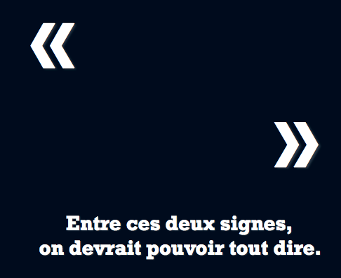

The first image leads to reflection on the essence of Freedom of Expression and Opinion. Students are confronted with a simple statement that drives them to take sides, which is not possible without finding a working definition of the freedom in question.

2

The second image, based on a very expressive metaphor, proposes to think about the limits of free speech on the web. The question how the Internet has influenced this freedom can also arise.

3
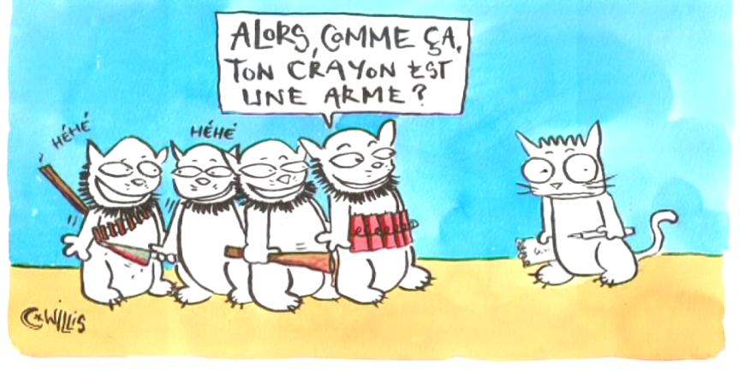

The third image starting from an explicit parallelism invites to reflection on the role of journalists.

4
4
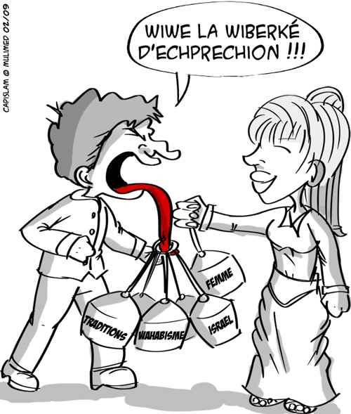
The fourth, once again, addresses the issue of the limits of freedom of expression. Based on the irony, it highlights the important social themes conditioned by cultural confrontations.

Goals
Theme: to deepen student´s knowledge of the concept of freedom of expression – to lead them to define it from different perspectives.
Language: practicing legal vocabulary, the use of grammar and syntax to express opinion, to defend a point of view, to argue and to persuade.

Extra-language: reflection on the given topic, interpretations from a pictorial input, confrontation of opinions, perspectives and interpretations, debates, collective construction of interpretation, and last but not least, training in critical thinking.

Procedure

Time: 40 min.
- Students are divided into four groups.

- Each group receives one image to analyse and to interpret. Their task is to work together on a common interpretation. To get to the interpretation, they must begin by describing the image and situate it in a temporal and civilizational framework. Then they are brainstorming on possible interpretations, jotting down keywords. Finally, they agree on an interpretation and deduce one aspect of Freedom of Press.

- Each group present their cartoon, their interpretation and the conclusions drawn to the other groups.

- The entire classroom cooperates on the definition of the concept of freedom of expression, trying to grasp its full extent. The teacher writes on the board the key words and concepts that students dictate and the ideas are gradually chiselled to achieve a consistent definition.

- It is proposed as an extension of this activity to ask students to write a short reflection on the limits of Freedom of Expression and to ink it in a more precise legal framework.

Conclusion

The activity works well because the images in education still work even if sometimes their function is reduced to mere entertainment and relaxation. In a classroom of language for specific purposes, the situation is different because of not only language but also thematic requirements without forgetting the need to develop basic soft-skills such as critical thinking, interpretive ability and finally the problem solution related to a specific scientific discipline. The political cartoon combines both - intellectual challenge and the fun aspect. Students do not like over-simple and banal subjects that do not arouse their curiosity and reflection and they greatly appreciate the refined humorous element present in political caricature.

Quotes

(1)
In the 17th century, a Czech pedagogue John Amos Comenius (Komensky) advocated the use of images in education: "If we want to communicate to students the safe knowledge of things, we have to go by sight and sensory perception." Translated from the French version quoted by Catherine Muller 2012: « Si nous voulons communiquer aux élèves une sûre connaissance des choses, il faut passer directement par la vue et la perception sensible » ([John Amos Comenius, Didactica Magna, 1638], french edition 2002 : 176)

References

Demougin, F. « Image et classe de langue: quels chemins didactiques? », Linguarumarena - VOL. 3, 2012, pp. 103 - 115
http://ler.letras.up.pt/uploads/ficheiros/10952.pdf
Muller, C. « La photographie, déclencheur de parole en classe de FLE : la fiction dans les interactions », Université ParisDurand J. Habert B., Laks B. (éds.), Congrès Mondial de Linguistique Française - CMLF'08 Paris, 2008, Institut de Linguistique Française
http://www.linguistiquefrancaise.org/articles/cmlf/pdf/2008/01/cmlf08049.pdf
Muller, C. « La photographie, un outil pour communiquer en classe de langue », Recherche et pratiques pédagogiques en langues de spécialité [En ligne], Vol. XXXI N° 1 | 2012 on line the 08 february 2013, consulted the 08 octobre 2015. URL: http://apliut.revues.org/2224 ;
Muller, C. « La photographie, déclencheur d’interaction en classe de langue : négotiations entre apprenants », Les Cahiers de l’Acedle, volume 6, numéro 1, 2009, consulted the 08th octobre 2015. URL: http://acedle.org/IMG/pdf/Muller_Cahiers-Acedle_6-1.pdf
Marc Bonhomme, « La caricature politique », Mots. Les langages du politique [on-line], 94 | 2010, consulted the 08th octobre 2015. URL : http://mots.revues.org/19858

Images

http://www.revue-medias.com/manifeste-pour-la-liberte-d,707.html
http://culturebox.francetvinfo.fr/expositions/peinture/liberte-dexpression-lestaque-invite-la-caricature-190433
http://meta-media.fr/2015/01/16/charlie-la-liberte-dexpression-defendue-dans-la-rue-menacee-sur-le-net.html
http://darouazzane.centerblog.net/6123503---------LIBERTE-D-EXPRESSION-OU-DIFFAMATION

