THE TIME HORIZON of the INFLATION FORECAST aS A FACTOR ITS RELIABILITY
FRANTIŠEK KALOUDAª
kalouda@econ.muni.cz
ª Masaryk University, Faculty of Economics and Administration, Department of Finance, Lipová 41a, 602 00 Brno, Czech Republic
Abstract
The paper is devoted to the reliability of the CNB´s inflation forecast in relation to the forecast time horizon. The aim of the paper is to examine the causality between the reliability of the CNB´s inflation prediction and the interval of the prediction.
The article uses commonly available data published by the CNB and information from the literature.
Methodology of the paper is based on the time series methods (correlation and regression) and trends analysis. The standard literary research, description, comparison and analytic-synthetic methods are used in this paper as well.
Such as preliminary results they are expected the relationship between the CNB´s inflation prediction and its time horizon (still not explored).
Key words
inflation, prediction, time horizon, reliability
JEL classification
C22, E22, E27, G31
- Paper introduction and objectives
In general terms, this paper discusses the management of the cost of capital in the Czech Republic, with a particular focus on the effect of inflation in this area. More specifically, the paper studies the reliability of inflation forecasts made by the Czech National Bank (CNB), taking into account the forecasting horizon.
The main objective here is to examine the effect of the length of the forecast period on the reliability of inflation forecasts as formulated by the CNB.
Thematically the paper draws upon previous research, significantly extending and complementing findings gathered so far. Expected results include, above all, the determination of the reliability of predicted inflation values when the time horizon of forecasting is considered as a parameter. In a broader context the paper also informs about the effectiveness of the CNB’s inflation targeting processes.
- Methodology and data
2.1 Methodology

This paper mainly employs a set of standard methods: researching available literature, description, comparison, and analytical-synthetic procedures.
With regard to the focus and expected results of the paper, the standard methodology set is extended to also include the application of the time series theory and selected statistical methods.
As far as the time series theory is concerned, the most beneficial for the aims of this paper turned out to be the analysis of the significance of lags for identifying relationships between time series (Arlt and Radkovský, 2001) in the form of “lag correlations” (Cyhelský and Souček, 2010, p. 57). The input data was not tested for “illusory correlations” (Blatná, 2009, p. 59) using the Durbin–Watson test (Hindls, Hronová and Novák, 1999) due to the relative lack of input data. Therefore, the results presented below need to be taken as tentative, meant to be updated and extended in the future.
The statistical methods used here include correlations (De Vaus, 2010; Davis, 1971) and data set characteristics (Radová, Dvořák and Málek, 2009; Swoboda, 1977).
The paper also utilizes means of graphical analysis (Arlt, Arltová and Rublíková, 2002), such as dot and line charts, to supplement the correlation calculation results (Wisniewski, 1996).
The calculations of data and their presentation in a graphical format were created using program support in the form of MS EXCEL product.
  - Data
The paper does not employ insider information in any form. That is, only data from publicly available sources have been used; in this particular case, the CNB’s archive of forecasts (http://www.cnb.cz/cs/menova_politika/prognoza/predchozi_prognozy/index.html – accessed 11/7/2017, 11:43). This source was consulted to obtain the inflation forecast values as predicted by the CNB.
The archive provides applicable data on inflation forecasts for the years 2010–2017. Within this time interval, the forecasts are defined by the following parameters:
- the moment of forecasting – always February of the preceding year,
- the look-ahead period
– four, or
– five quarters,
i.e. for the first (or second) quarter of the following year.
- the form of the CNB forecasts – in essence, these are point estimates with a one percentage point tolerance range on either side of the forecast.
For the years 2007–2009 the CNB forecast data is not fully comparable with the data for 2010–2016, and this concerns all three of the above-mentioned parameters. This is why the paper does not take the 2007–2009 data into consideration.
The actual inflation values are available on the Czech Statistical Office website (https://www.czso.cz/csu/czso/mira_inflace – accessed 17/8/2017, 12:23).
Because the paper discusses the real interest rate, the chosen inflation indicator was the “inflation rate expressed as an increase in the consumer price index related to the same month of the previous year.“ (https://www.czso.cz/csu/czso/mira_inflace – accessed 17/8/2017, 12:23).
Of the three monthly figures published for the particular quarter, and considering their actual values, either the median or the mode value was selected as representative.

3. Results and discussion

The need to keep the paper's range within acceptable limits has led to the decision that the results obtained should be presented in the most economical form, and the discussion should be limited to the absolutely necessary extent. Detailed data and information are available at the author of the paper.

3.1 Confrontation of the predicted and the actual inflation values (simple correlations)

3.1 Available results

The input data and the results of analyses carried out so far, considering a forecasting horizon of four quarters, are shown in Table 1. For a five-quarter inflation forecast horizon, the corresponding data are given in Table 2.

Table 1: The predicted and the actual inflation values (4-quarter forecast horizon)

forecast year / inflation target | inflation: CNB forecast / actual value | deviation: inflation target vs. actual value
2010 / 3.0 % ± 1.0 % | 1.4 % / 0.7 % | + 2.3 %
2011 / 3.0 % ± 1.0 % | 2.0 % / 1.7 % | + 1.3 %
2012 / 2.0 % ± 1.0 % | 2.0 % / 3.7 % | - 1.3 %
2013 / 2.0 % ± 1.0 % | 1.5 % / 1.7 % | + 0.3 %
2014 / 2.0 % ± 1.0 % | 1.7 % / 0.2 % | + 1.8 %
2015 / 2.0 % ± 1.0 % | 2.8 % / 0.2 % | + 1.8 %
2016 / 2.0 % ± 1.0 % | 1.1 % / 0.5 % | + 1.5 %
- .0 % ± 1.0 % | 2,0 % / 2.5 % | - 0.5 %
Source: Author’s own results using available input data
http://www.cnb.cz/cs/menova_politika/prognoza/predchozi_prognozy/index.html (accessed 11/7/2017, 11:43) and https://www.czso.cz/csu/czso/mira_inflace (accessed 17/8/2017, 12:23)

Table 2: The predicted and the actual inflation values (5-quarter forecast horizon)

forecast year / inflation target | inflation: CNB forecast / actual value | deviation: inflation target vs. actual value
2010 / 3.0 % ± 1% | 2.1 % / 1.2 % | + 1.8 %
2011 / 3.0 % ± 1% | 2.1 % / 1.8 % | + 1.2 %
2012 / 2.0 % ± 1% | 2.1 % / 3.5 % | - 1.5 %
2013 / 2.0 % ± 1% | 1.5 % / 1.6 % | + 0.4 %
2014 / 2.0 % ± 1% | 1.7 % / 0.1 % | + 1.9 %
2015 / 2.0 % ± 1% | 2.8 % / 0.7 % | + 1.3 %
2016 / 2.0 % ± 1% | 1.6 % / 0.1 % | + 1.9 %
2017 / 2.0 % ± 1% | 2.1 % / 2.3 % | - 0.3 %
Source: Author’s own results using available input data
http://www.cnb.cz/cs/menova_politika/prognoza/predchozi_prognozy/index.html (accessed 11/7/2017, 11:43) and https://www.czso.cz/csu/czso/mira_inflace (accessed 17/8/2017, 12:23)

Grafically, these data are shown in Figure 1 and Figure 2.

Figure 1: Inflation - prognosis ČNB and reality (horizon of prognosis 4 quarters; r=0,1)

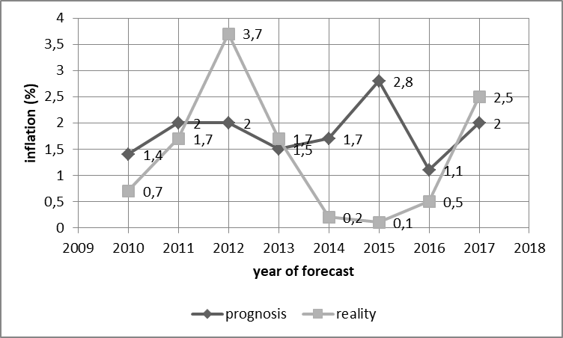
Source: adapted from http://www.cnb.cz/cs/menova_politika/prognoza/predchozi_prognozy/index.html (přístup 11.7.2017, 11:43) and https://www.czso.cz/csu/czso/mira_inflace (přístup 17.8.2017, 12:23)

Figure 2: Inflation - prognosis ČNB and reality (horizon of prognosis 5 quarters; r=0,2)

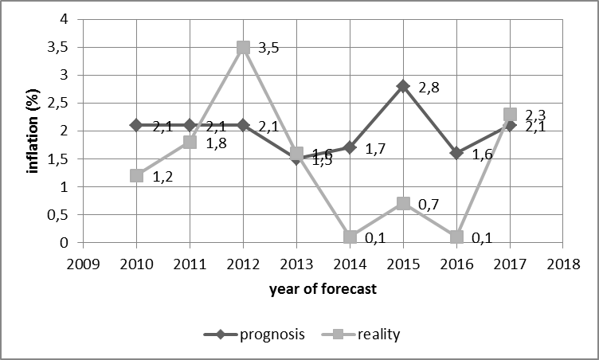
Source: adapted from http://www.cnb.cz/cs/menova_politika/prognoza/predchozi_prognozy/index.html (přístup 11.7.2017, 11:43) a https://www.czso.cz/csu/czso/mira_inflace (přístup 17.8.2017, 12:23)

The data shown in Table 1 and Table 2 makes it evident that the CNB’s own inflation target is rarely predicted with accuracy. For both forecasting horizons, the CNB’s inflation forecast was inaccurate in six out of eight cases (indicated by bold print in the tables).
In the first case (i.e. a four-quarter horizon), the correlation coefficient of the forecast and the actual inflation was + 0.1 (rounded to one decimal place). This is an extremely low value, which De Vaus (2010, p. 272) sees as “very small, insignificant, irrelevant, minor, virtually zero.”
For the five-quarter inflation forecast horizon, the correspondence between the inflation forecast and the actual value is expressed by a correlation coefficient of + 0.2 (rounded again). The value of this correlation coefficient is not very high, either. According to the same source (De Vaus 2010, p. 272) this means that the dependency of the monitored variables can be considered as “low to medium, negligible, weak or minor”.

3.2 The time horizon as a forecast reliability factor

Although the results obtained so far are essentially negative for assessing the effectiveness of the CNB’s forecasting activities, a certain kind of paradox can be observed here. The forecasts for a longer period (five quarters) seem to be slightly but still noticeably more reliable.
This allows making an empirically-based assumption that the time horizon can play a certain part in the reliability of the forecasts.
We will demonstrate the validity of this assumption in the next section of the paper. More precisely, it will be the first test of the method that should be able to prove the assumption declared. This method is lag correlations.
According to the CNB, the existing look-ahead period (approximately one year) is suitable in principle. Expert opinions vary but the prevailing argument is for extending this horizon, even up to three years (see Table 3).

Table 3: The length of the forecast period established by expert opinion

forecasting horizon | territory | source
one year | Czech Republic | www.cnb.cz
two to three trimesters | USA | Flammant (1995)
two years | USA | Jílek (2004)
one to three years | USA | Jílek (2004), according to Fed
three years | USA | Greenspan (2008)
Sources: Listed in the table.

An exact solution as regards the optimum length of the forecast look-ahead period is currently not known.
However, the practical impacts of this problem should not be underestimated, as “The determination of the lag with which variability in one economic time series is reflected in the variability of another series is an important practical task” (Arlt and Radkovský, 2001, p. 14 – highlighted by the authors).
Taking into account the limitations given by the amount of available data, we will use this data to test the validity of the assumption formulated at the end of subchapter 3.1. At the same time, the validity or accuracy of the expert opinions shown in Table 3 will be examined.
As a methodological tool we will use the above-mentioned concept of “lag correlations”, where the correlation coefficient is determined for a gradually increasing “lag” between actual and predicted inflation values.
The results of this process are shown in Table 4 (for a four-quarter horizon/look-ahead period) and Table 5 (for a five-quarter horizon/look-ahead period).
The graphical representation of the results of testing the reliability of inflation forecasts by the CNB for the lag or look-ahead period is contained in Figure 3 and Figure 4.

Table 4: Inflation – forecast and reality, basic and lag correlations (look-ahead period 4 quarters)

lag (in years) | correl. coefficient – exact value | correl. coefficient – rounded value
0 | 0.106549 | 0.1
1 | -0.179729 | -0.2
2 | 0.113174 | 0.1
3 | -0.516338 | -0.5
4 | -0.408369 | -0.4
Source: Author’s own results using available input data
http://www.cnb.cz/cs/menova_politika/prognoza/predchozi_prognozy/index.html (accessed 11/7/2017, 11:43) and https://www.czso.cz/csu/czso/mira_inflace (accessed 17/8/2017, 12:23)

Figure 3: Inflation – basic and lag correlations (look-ahead period 4 quarters)

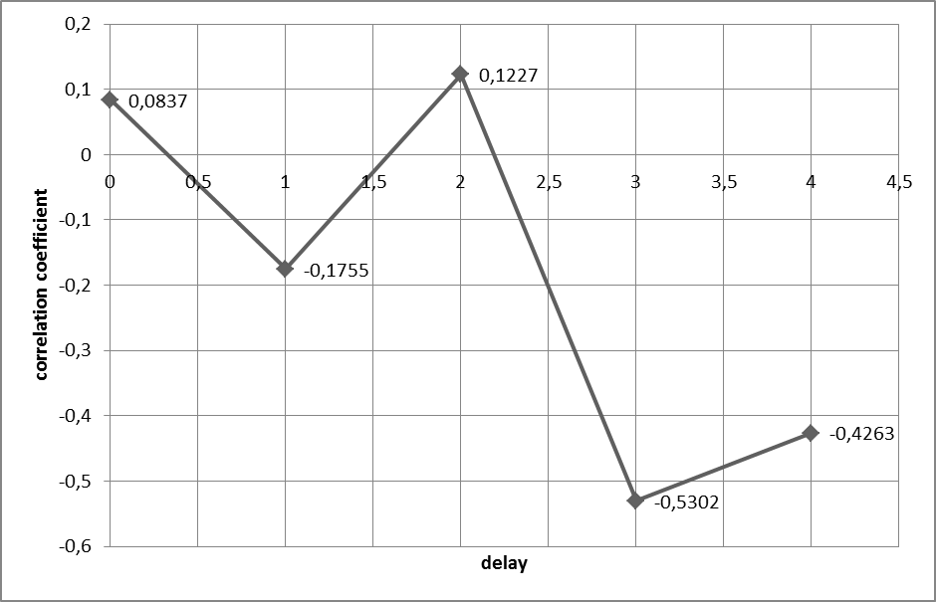

Source: adapted from http://www.cnb.cz/cs/menova_politika/prognoza/predchozi_prognozy/index.html (přístup 11.7.2017, 11:43) a https://www.czso.cz/csu/czso/mira_inflace (přístup 17.8.2017, 12:23)

Table 5: Inflation – forecast and reality, basic and lag correlations (look-ahead period 5 quarters)

lag (in years) | correl. coefficient – exact value | correl. coefficient – rounded value
0 | 0.1718 | 0.2
1 | -0.080701 | -0.1
2 | -0.079817 | -0.1
3 | 0.581490 | 0.6
4 | -0.962251 | -1.0
Source: Author’s own results using available input data
http://www.cnb.cz/cs/menova_politika/prognoza/predchozi_prognozy/index.html (accessed 11/7/2017, 11:43) and https://www.czso.cz/csu/czso/mira_inflace (accessed 17/8/2017, 12:23)

Figure 4: Inflation – basic and lag correlations (look-ahead period 4 quarters)

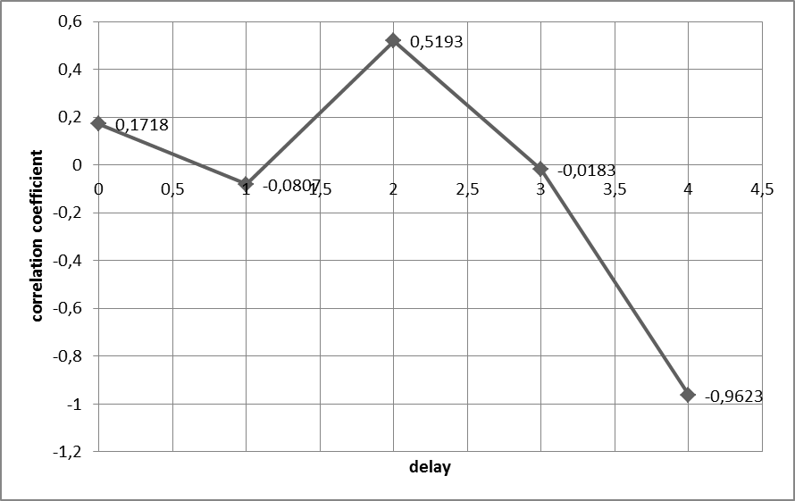
Source: adapted from http://www.cnb.cz/cs/menova_politika/prognoza/predchozi_prognozy/index.html (přístup 11.7.2017, 11:43) a https://www.czso.cz/csu/czso/mira_inflace (přístup 17.8.2017, 12:23)

- Conclusions
4.1 Partial conclusion 1 - The effect of the data available on the nature of the existing
Results

The optimum size of the input data set can be specified in the given case with great difficulty. Two partial problem areas prove to be significant.
Above all, it's the size of the input data set itself.
The procedure provided in Hindls et al. 2007 is not applicable here as the size of the underlying data set is not known. This problem cannot be tackled by the generally assumed convention (a set of dozens or hundreds of pairs of explanatory and explained variables is considered statistically significant). The set of the available input data cannot be compared with the desired dimension. Not even a compromise in the form of "30–40 sample units" (Hindls et al., 2007, p. 109) can be applied. The reason is again a small amount of input data.
However, the size of the input data set determines the significance of the specified correlation coefficient.
Its absolute size must be treated with caution. In our case, we can use the argumentation based on Cohen (1988). He considers the relationship between the observed variables statistically significant if:
- the correlation coefficient can be described as high, then
- the data sample can be both big and small.
It is clear that this condition is only met for the lag correlations of inflation forecast with the 5-quarter forecast horizon (see also conclusions of chapter 4.3).

4.2 Partial conclusion 2 - The predicted and the actual inflation values

The data presented (Table 1 and Table 2) show that as regards the accuracy of inflation forecasts formulated by the CNB, the actual inflation target is met in two out of eight cases only. This applies for both forecast horizons, i.e., 4-quarter forecast horizon and 5-quarter forecast horizon.
The correlation coefficient of predicted and actual inflation achieves negligible levels.
These results can be interpreted as follows: for practical business needs, the CNB’s inflation forecasts are, in fact, useless.

4.3 Partial conclusion 3 – The time horizon as a forecast reliability factor

The information presented above makes it quite evident that as far as the inflation forecast horizon is concerned, the existing practice of the CNB is hardly meaningful. Both discussed horizons (four or five quarters) appear to be too short. This is supported by the expert opinions given above, as well as by the statistical tests of the relevance of these forecasting horizons presented in this paper.
The results obtained so far indicate (taking into account the limitations arising from the relatively limited amount of input data) that interesting time horizons of inflation forecasts could be the following:
- for a four-quarter forecast horizon
- two years (in good accordance with Jílek (2004), or with information from the American FED circle, as mentioned in the same reference).
However, the problem is the negligible, practically null (DeVaus, 2010) reliability of this forecast. The actual usefulness of the forecast with this horizon appears as zero.
- for a five-quarter forecast horizon
- again two years (in good accordance with the references as in the first case).
Newertheless, the correspondence of the forecast with reality is in this case very different. Evaluation interval "substantial to very strong"(DeVaus, 2010, p. 272) can be used to express this level of agreement in the case of correlation coefficient of + 0.5. The mentioned reference considers this evaluation similar to the ones used by Cohen (1988) and Davis (1971). Further, expressions like large, high or major are used as alternatives for this level of agreement, which undoubtedly supports the significance of this level of agreement.
However, for both for and five-quarter forecast horizon are results of the paper in clear contrast with the existing practice of the CNB. Therefore these findings, too, indicate an apparent failure of the CNB’s forecasting activities.

4.4 Recapitulation of the partial conclusions

The analyses carried out so far suggest a (still tentative) conclusion that we need to be rather reserved as regards the overall assessment of the quality of the CNB’s inflation forecasting process.
Quite logically, this tentative conclusion also leads to challenging the practical usability of the CNB’s inflation rate forecast values on company level.
Similarly, these (again: still not definite) results cast doubt on the very meaningfulness of the CNB’s activities analysed in this paper.

References

[1] Arlt, J., Arltová, M.. Rublíková, E. 2002. Analýza ekonomických časových řad s příklady. Praha: Vysoká škola ekonomická. 2002. ISBN 80-245-0307-7
[2] Artl, J., Radkovský, Š. 2001. ANALÝZA ZPOŽDĚNÍ PŘI MODELOVÁNÍ VZTAHŮ MEZI ČASOVÝMI ŘADAMI. Politická ekonomie 49: (1), str. 58-73, VŠE Praha, Česká národní banka, 2001. ISSN 0032-3233 (Rukopis). Dostupné na: http://nb.vse.cz/~arlt/publik/AR_AZMVMCR_01.pdf (přístup 5.8.2016, 10:51)
[4] Blatná, D. 2009. Metody statistické analýzy. 4. vydání. Praha: BIVŠ, 2009. ISBN 978- 80-7265-143-6
[5] Cohen, J. 1988. Statistical Power Analysis for the behavioral Sciences. Hillsdale, NJ:
Lawrence Erlbaum Associates, 1988. ISBN 0-8058-0283-5
[6] Cyhelský, L., Souček, E. 2010. Statistické minimum pro studující při zaměstnání v pěti kapitolách. Liberec: Technická univerzita v Liberci, 2010. ISBN 978-80-7372-575-4
[7] Davis, J.A. 1971. Elementary Survey Analysis. Englewood Clifts, NJ: Prentice Hall,
1971.
[8] De Vaus, D.A. 2010. Analyzing Social Science Data. 50 Key Problems in Data Analysis.
London: SAGE Publications, 2010, p. 401. ISBN 978 0 7619 5937 3/978 0 7619 5938 0
[9] Flammant, M. 1995. INFLACE. Praha, HZ, 1995. Z francouzského originálu Inflation
přeložil Jiří Vysušil. ISBN 80-901918-4-3
[10] Greenspan, A. 2008. VĚK TURBULENCÍ. Praha: Fragment, 2008. Z anglického
originálu Greenspan, A. 2007. The Age of Turbulence. The Penquin Press (USA),
přeložil J. Orel. ISBN 978-80-253-0755-7
[11] Hindls, R., Hronová, S., a Novák, I. 1999. Analýza dat v manažerském rozhodování.
Praha, Grada Publishing, 1999. ISBN 80-7169-255-7
[12] Hindls, R., Hronová, S., Seger, J. a Fischer, J. 2007. Statistika pro ekonomy, 7. vyd.
Praha: Professional Publishing, 2007. ISBN: 80-86946-16-9
[13] https://www.cnb.cz
[14] https://www.czso.cz/csu/czso/mira_inflace
[15] http://www.cnb.cz/cs/menova_politika/cilovani.html#c2
[16] http://www.cnb.cz/cs/menova_politika/prognoza/predchozi_prognozy/index.html
[17] http://www.sportsci.org/resource/stats/effectmag.html/
[18] Jílek, J. 2004. Peníze a měnová politika. Praha: Grada Publishing, 2004. ISBN 80-247-
0769-1
[19] Radová, J., Dvořák, P. a Málek, J. 2009. Finanční matematika pro každého. 7. vydání.
Praha: Grada Publishing, 2009. ISBN 978-80-247-3291-6
[20] Swoboda, H. 1977. Moderní statistika. Praha: Svoboda, 1977. Z německého originálu
Knaurs Buch der moderne Statistik. München-Zürich: Droemer Knaur přeložildoc. Ing. J.
Císař, CSc. Členská knižnice 25-004-77
[21] Wisniewski. M. 1996. Metody manažerského rozhodování. Praha: Grada Publishing,
1996. 512 s. Z anglického originálu Quantitative Mezhods for Fecision Makers. London:
Pitman Publishing, přeložil doc. Ing. Václav Dolanský, CSc. ISBN 80-7169-089-9

