Universal Methods for Transgene Induction Using the Dexamethasone-Inducible Transcription Activation System pOp6/LhGR in Arabidopsis and Other Plant Species
Running Title: Methods of pOp6/LhGR induction using dexamethasone

Author(s): Marketa Samalova ^{1,2*}, Charlotte Kirchhelle ¹ and Ian Moore ¹
Contact information
marketa.samalova@ceitec.muni.cz, Tel. +420 5 4949 8476, Fax +420 5 4949 2640, Corresponding Author
charlotte.kirchhelle@plants.ox.ac.uk, Tel. +44 (0)1865 275 022, Fax +44 (0)1865 275 074
ian.moore@plants.ox.ac.uk, Tel. +44 (0)1865 275 040, Fax +44 (0)1865 275 074
1. Department of Plant Sciences, University of Oxford, South Parks Road, Oxford, OX1 3RB, UK
2. Current address CEITEC MU, Masaryk University, Kamenice 5, Brno, 625 00, Czech Republic

ABSTRACT
The use of chemically inducible systems for transgenes expression is a crucial requirement for modern plant biology research, as it allows (1) expression of transgenes that compromise plant viability or fertility when constitutively expressed and (2) spatio-temporal control of transgene expression levels. We describe the stringently regulated and highly responsive dexamethasone-inducible gene expression system pOp6/LhGR, which comprises of a chimeric transcription activator LhGR and a corresponding pOp6 promoter. Upon induction, the LhGR activator binds to the pOp6 promotor and induces expression of the target gene of interest. We provide detailed protocols for inducing transgene expression at different developmental stages and in different plant species and discuss dexamethasone stability and the use of its analogues. We also introduce new, versatile, GATEWAYTM compatible binary vectors that are now available for the pOp6/LhGR system.

Keywords: chemically inducible gene expression, glucocorticoid, dexamethasone

INTRODUCTION
Chemically inducible systems for regulated gene expression are extremely useful for basic plant biology research as well as biotechnology applications. They are especially required for expression of gene products that interfere with regeneration, growth or reproduction; expression at different stages of plant development and for a specific duration; conditional genetic complementation and co-suppression or overexpression studies. Temporal control can be particularly useful to de-convolve complex phenotypes related to transgene expression, as it allows monitoring the progressive development of phenotype, and may thus reveal primary effects before homeostatic mechanisms start to counter-act (e.g., Kirchhelle et al., 2016). Furthermore, the use of an appropriate promoter can restrict the target transgene expression to specific organs, tissues or even cell types. Inducible expression systems like pOp6/LhGR with their ability to control expression levels in space and time complement other technologies like amiRNA or the recent CRISPR-Cas9, creating a powerful set of tools for the generation of knock-down, knock-out or chimeric plants.
The development of chemical-inducible systems for tight control of plant gene expression is a challenging task and an ongoing effort. A number of properties are required for an ideal system, such as very low basal expression levels, high inducibility, specificity and dynamic range of response with respect to an inducer. Additionally, fast response and induction through various methods are desirable. An ideal system should work in several plant species and should not cause any adverse physiological effects in plants by itself or its inducer. The inducer is further required to show high specificity for the transgene, high efficiency at low concentrations and must not be found in target plants. Therefore, the components for such systems are usually derived from non-plant sources.
Inducible expression systems typically contain two transcription units: whereas the first unit employs a constitutive or tissue-specific promoter to express a chemical-responsive transcription factor, the second unit consists of multiple copies of the transcription factor binding site linked to a minimal plant promoter, which is used to express the target gene. Over the years, we have invested considerable effort to develop the dexamethasone-inducible transcription activation system pOp6/LhGR, which meets all the criteria outlined above (Craft et al., 2005; Samalova et al., 2005). It comprises of pOp, a chimeric promoter that consists of lac operators (typically 6 copies, hence pOp6) cloned upstream of a minimal CaMV 35S promoter (-50 to +8). On its own pOp6 does not produce detectable levels of transcript in plants (Craft et al., 2005). The chimeric transcription activator LhGR is a fusion between a high-affinity DNA-binding mutant of the Escherichia coli lac repressor, lacI^{His17}, the transcription-activation-domain-II of GAL4 from Saccharomyces cerevisiae, and the ligand-binding domain (LBD) of the rat glucocorticoid receptor (GR). In the absence of the steroid ligand dexamethasone (Dex), the transcription factor LhGR is trapped in an inactive complex via interaction of the GR LBD and heat-shock protein HSP90. However, upon induction with Dex, this complex is disrupted and the LhGR activator binds to the pOp6 promotor and induces expression of the target gene of interest. The activator LhGR and the reporter comprising of pOp6 and the gene of interest can be introduced into plants either on two separate T-DNAs, or on a single T-DNA. We discuss advantages of these strategies and present a new set of binary GATEWAYTM-compatible vectors for LhGR expression.
The protocols in this article describe the use of the inducible pOp6/LhGR transgene expression system for different stages of plant development and in a range of plant species. Basic Protocol 1 provides instructions for use of the system in Arabidopsis seedlings under multiple conditions, such as on agar-solidified plates and in liquid medium. Alternate Protocol 1 provides an alternative method suited for time-lapse microscopy during the entire induction period through use of imaging chambers. Basic Protocol 2 describes two methods of use of the system in later developmental stages through watering or painting of soil-grown Arabidopsis. Basic Protocol 3 focusses on the use of the pOp6/LhGR system in tobacco and other plant species.

STRATEGIC PLANNING
A number of vectors for transgene expression using the pOp6/LhGR system are already available (for details see Craft et al., 2005; Moore et al., 2006). Furthermore, a new set of versatile, GATEWAYTM compatible plasmids are described in the Background Information of this paper. They contain the activator (e.g. pBIN-LR-LhGR) and reporter (e.g. pOp6-GUS) on either two separate T-DNAs or a single T-DNA (e.g. pOpON2.1). Which one to choose depends on the type of application for which the system is used. In more complex genetic backgrounds (e.g. backgrounds with several recessive mutations), it is advantageous to use a construct that carries both the activator and reporter on a single T-DNA so that they can be introduced simultaneously. However, when such a vector is constructed, care must be taken to ensure that enhancers in the promoter that drive the activator do not activate the target promoter. On the other hand, separating the target promoter and the activator provides greater versatility. For example, when a gene is to be expressed in diverse patterns or at different developmental stages, a single reporter line can be activated in the desired pattern simply by retransforming with activator constructs or by crossing into pre-existing activator lines (Baroux et al., 2005; Moore et al., 2006). Recently, a comprehensive tool set of inducible activator/driver lines targeting most cell types in Arabidopsis, with the focus on the three main meristems (RAM, SAM and the cambium), was created by Schurholz et al. (2018).

BASIC PROTOCOL 1
Dexamethasone-inducible expression of transgenes in Arabidopsis seedlings
This protocol describes how to effectively induce transgene expression in Arabidopsis seedlings using two different set-ups: either on agar-solidified plates, or in liquid growth medium. The induction on plates with agar-solidified medium (Figure 1A) has the advantage that the macroscopic phenotype (e.g., root length) can be observed directly and repeatedly throughout the induction period. In liquid medium (Figure 1B), maximum efficiency of the induction can be achieved, however the phenotype can be distorted due to the growth conditions. Timing of the induction is flexible: the plants can be planted on Dex-containing medium for continuous induction from germination or transferred to Dex-containing medium at later developmental stages, depending on the experimental requirements. The methods are medium- to high-throughput and best suited for end-point studies.
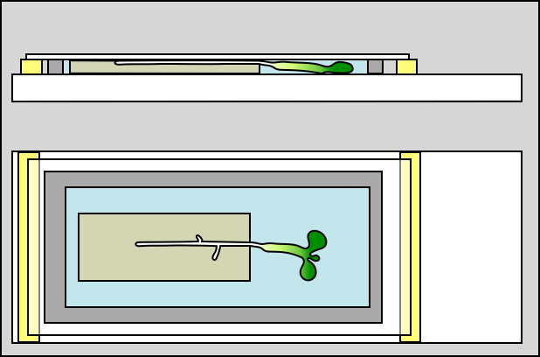
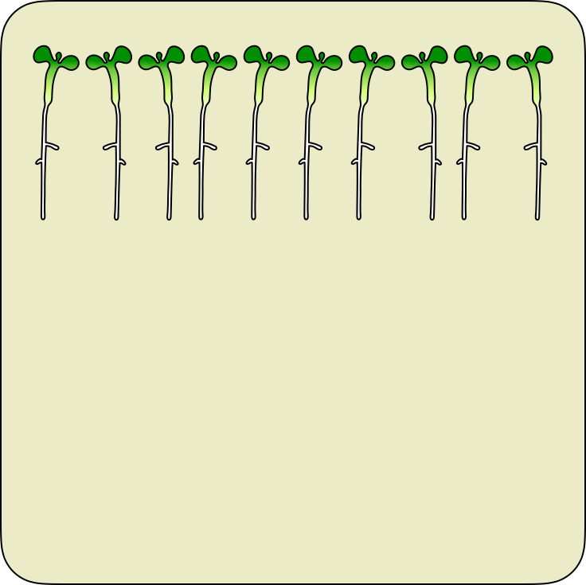
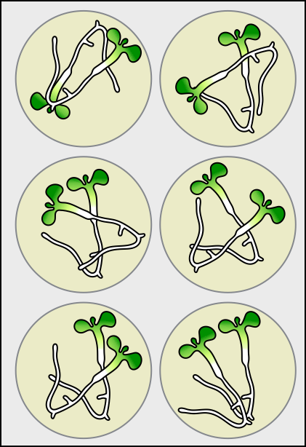
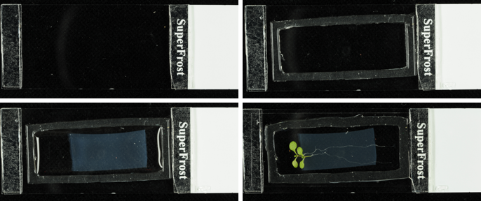
Figure 1
A
B
C
D
1
2
3
4

Materials
Arabidopsis thaliana transgenic seeds (transformed using floral dip method by Clough & Bent, 1998) that contain the reporter and activator constructs
Murashige and Skoog (MS) medium, agar-solidifed and liquid (see recipe in the Reagents and Solutions (R&S) section below)
Ethanol (Sigma-Aldrich)
Dexamethasone (Dex, Sigma-Aldrich)
Dimethyl sulfoxide (DMSO, Sigma-Aldrich)
1.5 ml microcentrifuge tubes
Whatman filter paper (Sigma-Aldrich), cut into 5x5 cm squares
1 ml Gilson pipette and sterile tips
Sterile toothpicks
Micropore surgical tape (3M UK plc)
Forceps
6 well plastic plates
Laminar flow hood
Plant growth cabinet (20ºC, 16h light/8h dark)

Germination of Arabidopsis seedlings under sterile conditions

- Prepare half-strength MS (½ MS) plates as described below in the Reagents and Solutions (R&S) section.
If continuous transgene induction from germination is desired, seeds need to be plated on ½ MS supplemented either with Dex or an equivalent amount of DMSO (see steps 6 and 7.1). If plants will be transferred to Dex-containing medium at a later stage of development, prepare plain ½ MS plates.
- Sterilize Whatman filter paper with 80 % ethanol and leave to dry in a laminar flow hood.
- Mix Arabidopsis seeds with 1 ml 80 % ethanol in a 1.5 ml microcentrifuge tube, incubate for 5 minutes, pipette the seeds onto Whatman filter squares and dry completely.
- Wet the tip of a sterile toothpick slightly by tapping it on a plate containing solidified ½ MS medium, pick seeds up individually with the toothpick and place onto the plate in a straight line, leaving a gap of at least 1 cm to the top rim of the plate. Seeds should be placed 5 – 8 mm apart. Close the plate with micropore surgical tape.
- Stratify seeds for 2-4 days at 4°C before transferring the plates to a plant growth cabinet (20°C, 16h-light/8h-dark) in vertical orientation.
We refer to seedling age throughout this paper – this refers to days after transfer into a growth cabinet.

Dexamethasone-inducible expression of transgenes on agar plates
- Prepare ½ MS plates supplemented with either an appropriate concentration of Dex from a 100 mM stock solution or an equivalent amount of DMSO (as a control) as described in the R&S section below.
Note the appropriate concentration of Dex may vary. Maximum induction of the pOp6/LhGR system can be achieved with approximately 1µM Dex (Craft et al., 2005), although depending on the transgene of interest, lower transgene expression levels may be desirable. Through application of sub-saturating concentrations of Dex, transgene expression can be titrated to desired levels (Craft et al., 2005).
- Transgene induction:
  - Plate seeds as described above onto plates containing Dex or DMSO to induce transgene expression from germination.
  - To induce transgene expression in older seedlings, germinate seedlings on plain ½ MS plates and grow for a desired period of time, then transfer seedlings onto plates containing Dex or DMSO using sterilized forceps.

Dexamethasone-inducible expression of transgenes in liquid medium
- Prepare liquid ½ MS medium following the description in in the R&S section and supplement liquid medium with an appropriate concentration of Dex (see step 6) from a 100 mM stock solution or an equivalent amount of DMSO (as a control), and aliquot into 6 well plates (5 ml per well).
- Using sterile forceps, transfer seedlings pre-grown on plates into the liquid medium, taking care roots are fully submerged and place them onto an orbital shaker (app 80 rpm, 20°C, 16h-light/ 8h-dark).
This protocol has been extensively tested for seedlings aged 5 – 12 days at the point of transfer and can be used for plants up to 4 weeks old. For practical reasons, we recommend using BASIC PROTOCOL 2 for older plants.

ALTERNATE PROTOCOL 1
Dexamethasone-inducible expression of transgenes in imaging chambers
This method describes how to induce transgene expression in Arabidopsis seedlings in imaging chambers (Figure 1C). The strategy is low- to medium-throughput and well suited for time-lapse studies involving repeated imaging using confocal laser scanning microscopy (CLSM) throughout the induction period (Kirchhelle and Moore, 2017). Imaging chambers are manufactured directly onto microscope slides using simple tools. In imaging chambers, seedlings rest on an agar slab and are submerged in perfluorodecalin (PFD), maintaining physiological growth conditions for at least 48 hours (Kirchhelle and Moore, 2017).

Materials
Poly(dimethylsiloxane) gum (Carolina Observation Gel, Carolina Biological Supply)
Perfluorodecalin (PFD, F2 Chemicals)
Glass cutter
Microscope slides (1 mm thickness, VWR International)
Double-sided tape
Razor blade
Cover slips (22x50 mm)

Create a Carolina Observation Gel gasket
- Cut 2-3 mm-wide strips from the end of a microscope slide using a glass cutter and glue glass strips onto a second microscope slide using double-sided tape (app 45 mm apart, Figure 1D.1). Prepare at least two slides like this (one imaging chamber for the Dex induction, one as a DMSO control), or more if desired.
- Place a ball of Carolina Observation Gel (approximately 2 cm diameter) onto the slide between the glass strips, wet a second slide with 100 % ethanol, and flatten the Carolina Observation Gel ball with the second slide to the height of the glass strips. If necessary, trim excess Carolina Observation Gel with a razor blade and repeat flattening.
- Wet a suitable cutter or razor blade with 100 % ethanol; remove part of the Carolina Observation Gel to create a central cavity. Carefully trim the gel with a razor blade around the outside to create a gasket with a final wall thickness of approximately 1-2 mm (Figure 1D.2).
The Carolina Observation Gel gasket prevents evaporation of perfluorodecalin from the imaging chamber while allowing gas exchange. The use of glass strips ensures uniform height of the chamber, allowing precise horizontal orientation of the cover slip required for down-stream microscopy.

Create an agar slab
- Prepare ½ MS medium as described in the R&S section below, but add 1.5 % (w/v) instead of 0.8 % (w/v) Difco Bacto agar.
- Glue two glass strips onto a microscopy slide as described in step 1 above, and place a cover slip onto the slide so that it rests on both glass strips. Prepare two slides like this to pour one agar slab containing Dex and one containing DMSO.
- Supplement melted ½ MS medium with either an appropriate concentration of Dex from the 100 mM stock solution or an equivalent amount of DMSO and mix thoroughly. Pipette the medium into the space below the cover slip on the microscopy slide until the space is completely filled (the surface tension of the medium is sufficient to prevent any leaks). Leave until the agar is set (2 – 5 mins).
The agar slab fulfills multiple functions: it provides the seedling with water and nutrients, it is used to supply Dex, and it keeps the seedling in its position, allowing repeated imaging of plant organs over several days. To ensure sufficient mechanical integrity to fulfil the latter purpose, the slab is solidified with 1.5 % (w/v) instead of 0.8 % (w/v) Difco Bacto agar.

Finish the chamber setup
- Shake a small volume of PFD in a falcon tube to air-equilibrate the PFD.
- Add a sufficient amount of air-equilibrated PFD to the well of the gel gasket to cover the bottom surface, but do not fill the chamber completely. This is to avoid trapping air bubbles under the agar slab as it is placed into the chamber.
- Remove the cover slip from the agar slab, cut off a piece of desired size and shape, and place it into the well of the gasket, leaving a gap of 2-4 mm between agar slab and gasket (Figure 1D.3).
- Fill the chamber completely with air-equilibrated PFD.
- Place one or more Arabidopsis seedlings pre-grown on plain ½ MS plates onto the agar slab with the cotyledons and hypocotyl hanging over the edge, floating in PFD.
We have successfully tested this protocol with seedlings aged 3 – 10 days at the point of transfer into the imaging chambers. Due to their size, it is difficult to accommodate older plants in imaging chambers.
- Apply a coverslip to close the chamber, gently pressing it down with the edge of a glass microscope slide until the cover slip rests on both glass strips (Figure 1D.4). The plants can now be imaged either continuously or in regular intervals using CLSM. If not imaged continuously, we recommend storing imaging chambers horizontally in a plant growth cabinet (20°C, 16h-light/8h-dark) to maintain physiological growth conditions.
In contrast to water, PFD readily allows gas exchange of the submerged plant tissue due to its high capacity for dissolving CO₂ and O₂ (1.9 g/ml for O₂ in PFD compared to 0.04 mg/ml in water) (Dias et al., 2004) whilst having minimal physiological effects on a variety of plants and plant tissues (Littlejohn et al., 2010; Sukumaran et al., 1972).

BASIC PROTOCOL 2
Dexamethasone-inducible expression of transgenes in soil-grown Arabidopsis
The protocol below describes how to effectively induce transgene expression in Arabidopsis plants grown in soil. While Basic Protocol 1 (BP1) is best suited to plants aged four weeks or less, Basic Protocol 2 (BP2) can be used for plants at any stage during their life cycle. We present two methods here: soil drenching or painting. While soil drenching can be used for systemic induction of transgene expression, painting allows local induction of the transgene in aerial tissues like leaves or inflorescences.

Materials
Arabidopsis seedlings pre-germinated on ½ MS medium for 7 – 10 days as described in Basic Protocol 1.
Dexamethasone (Dex, Sigma-Aldrich)
Ethanol (Sigma-Aldrich)
Tap water
Silwet L-77 (Fisher Scientific)
Commercial peat compost (Emerald Range Universal Compost, Goundrey`s Ltd, UK)
Vermiculite
22 cm x 35 cm plant trays with 24-cell inserts
Forceps
Gilson pipette and tips
Measuring cylinder (1000 ml)
Two plastic beakers for watering (1000 ml)
Fine paintbrush
Greenhouse or plant growth cabinet (20ºC, 16h light/8h dark)
Dexamethasone-inducible expression of transgenes in soil by watering
- Prepare a mixture of peat compost with vermiculite in 3:1 ratio (approximately 1200 g) and fill up inserts placed in plant trays.
- Using forceps, carefully transfer individual Arabidopsis seedlings into each compartment and cultivate them in the greenhouse or plant growth cabinets.
- Let the plants grow until the first inflorescence stem appears (or until the desired stage).
- Prepare 30 mM Dex stock solution in ethanol.
For treatment of soil-grown plants throughout their life cycle use ethanol as the solvent for Dex to prevent accumulation of DMSO in the soil.
- Dilute Dex from the stock solution to desired concentration, (typically 10 - 20 μM, but also note comments in BP1) or an equivalent amount of ethanol in tap water. To prevent cross-contamination, use different plastic beaker for each.
- For single treatment pour 900 ml of the Dex solution into the bottom of the tray.
- For continuous induction use repeated treatment and irrigate every 2-4 days with 300 ml of the Dex solution as the plants require water.

Dexamethasone-inducible expression of transgenes in soil by painting
Prepare the plants and the 30 mM Dex stock solution as described in steps 1-4 above.
- Dilute Dex from the stock solution, (typically 10 - 20 μM, but also note comments in PB1) or an equivalent amount of ethanol in tap water and add 0.02 % Silwet-77.
- For leaf induction, dip a fine paintbrush into the Dex solution and brush over both sides of each treated leaf carefully to prevent dripping into the soil.
- For flower induction, dip a fine paintbrush into the Dex solution and brush over the inflorescence.
Alternatively, for rapid induction in inflorescent tissues, cut the stems and stand them in the Dex solution directly.

BASIC PROTOCOL 3
Dexamethasone-inducible expression of transgenes in tobacco and other plant species
The protocols (BP1 and BP2) described above can be easily applied to different species of plants. The pOp6/LhGR system induces effectively transgene expression in tobacco (Nicotiana tabacum cv. SR1 Petit Havana) and other plant species (e.g. Oryza sativa) grown in vitro as well as in soil using following methods: induction on agar-solidified medium, in liquid medium, by soil drenching and local induction by painting (Samalova et al., 2005, and unpublished data).
Depending on the overall efficiency of the pOp6/LhGR system within individual species as well as on the size of plant, the concentration and amount of Dex used may vary. Furthermore, depending on the morphological and physiological characteristics of the plant species used, local induction protocols can be optimized through minor modifications. For example, in tobacco it is possible to apply Dex to the leaf axils that are then covered temporarily with parafilm to prevent the solution from running down the stem. For local induction of plants with thicker cuticule (e.g. rice) induction is more efficient when 0.1 % Tween is used instead of Silwet-77 as the surfactant.
As an illustration, in Table 1 we summarized the main changes in growth conditions and Dex-induction to the protocols BP1 and BP2 to adopt their use from Arabidopsis to tobacco and rice plants.
[*Table 1 near here]

REAGENTS AND SOLUTIONS
MS medium (Murashige, T. & Skoog, F. ,1962)
Dissolve 4.4 g (or 2.2 g for ½ MS) of MS salts (Sigma-Aldrich) in 1 liter of distilled water
Add 10 g (for 1 % v/w) or 30 g (for 3 % v/w) of sucrose
Adjust the pH to 5.7 with KOH (1M)
Add 8 g (0.8 % v/w) of Difco Bacto agar (omit this step when making liquid MS medium)
Sterilize medium through autoclavation (15 – 20 min)
Let medium cool down (50 – 55 ºC)
Pour media into round (app. 20 ml) or square (app. 50 ml) Petri dishes

MS plates supplemented with Dex or DMSO
Prepare 100 mM Dex stock solution in DMSO (store at -20 ºC)
Add either Dex to a desired concentration from the stock solution or an equivalent amount of DMSO (as a control) to the pre-cooled MS media (50 - 55 ºC from step 6 above) and mix thoroughly
Pour media into round (app. 20 ml) or square (app. 50 ml) Petri dishes

Dexamethasone
Dex is classified as a dangerous chemical (H360D, reproductive toxicity), therefore personal protective equipment (PPE) such as protective gloves and clothing, eye/face protection is recommended while working.

Dimethyl sulfoxide
DMSO is not a hazardous substance, however, PPE is also recommended (to avoid inhalation of vapor or mist).

COMMENTARY
Background Information
New vectors for transgene expression
We introduce new, versatile, GATEWAYTM compatible plasmids that are available for the pOp6/LhGR system (Figure 2). They can be obtained from the NASC stock centre and their sequences from the corresponding author upon request.

(a) SingleT-DNA activator and reporter construct: pOpOn2.1

(b) Activator: pBIN-LR-LhGR2
(c) Reporters: pOpIn1
pOpIn2
Figure 2

pOpOn2.1
Binary vectors carrying 35S-LhGR and the reporter cassette of pH-TOP (Craft et al., 2005) on the same T-DNA with a GATEWAY destination cassette downstream of pOp6Ω. This plasmid can be introduced into any genetic background to achieve inducible expression of a gene of interest in the CaMV 35S pattern. Note that the presence of the CaMV 35S promoter downstream of the pOp6 promoter may increase uninduced expression levels even though the two promoters are separated by 6kb. This plasmid was derived from the inducible RNAi vector pOpOff2 (Wieloposka et al., 2005) by digestion with KpnI and PmeI (to release the introns, antisense-GATEWAY cassette, and OCS polyadenylation sequence) and insertion of the OCS polyadenylation sequence from pV-TOP (Craft et al., 2005) as a KpnI-Ecl136II (SacI) fragment. Current data with pOpOn2.1 suggest that expression is more efficient than with pH-TOP (in the LhGR-4C S5/S7 activator background) but pOpOn2.1 has yet to be as thoroughly tested with highly toxic transgenes. The plasmid is spectinomycin resistant in bacteria and must be propagated in GATEWAY compatible strains such as DB3.1. Please note too that the GATEWAY cassette DOES NOT contain the Cm^{r} marker.
pBIN-LR-LhGR2
Promoterless optimized LhGR with upstream GATEWAY destination cassette for insertion of promoters. To test its functionality we inserted the CaMV 35S promoter and created pBL-35S::LhGR2 plasmid. The LhGR sequence incorporates the codon-optimized Gal4 sequence of LhG4^{AtO} (Rutherford et al., 2005). Promoter-LhGR2-pA cassettes can be removed by digestion with AscI and inserted into the reporter plasmid pOpIn2 (see below) to generate single T-DNA vectors for tissue-specific inducible expression. Based on binary vector pBINPLUS, the plasmid is kanamycin resistant in bacteria and must be propagated in GATEWAY compatible strains such as DB3.1.
pOpIn1
This reporter plasmid derived from pOpOn2.1 by deletion of the LhGR cassette and a downstream remnant of the 35S enhancer (present in the original pOpOff2 plasmid) and it is suitable for insertion of target genes at GATEWAY sites. The plasmid is kanamycin resistant in plants and so compatible with BASTA- and hygromycin-resistant enhancer trap lines (Rutherford et al., 2005; Moore et al., 2006). It is spectinomycin resistant in bacteria and must be propagated in GATEWAY compatible strains such as DB3.1. Please note that the GATEWAY cassette DOES NOT contain the Cm^{r} marker.

pOpIn2
Another reporter plasmid derived from pOpIn1 by deletion of the plant kanamycin resistance marker and replacement with a BASTA resistance marker. It is suitable for insertion of target genes at GATEWAY sites and, unlike pOpIn1, carries a unique AscI site for insertion of promoter::LhGR fusions generated in pBIN-LR-LhGR (see above) to generate single-T-DNA vectors with a variety of tissue-specific inducible expression patterns. As a proof of concept we inserted the LhGR2 driven by AtRPS5A promoter in this way and created pOpIn2-RPS5A plasmid. The plasmid is BASTA resistant in plants, so compatible with kanamycin and hygromycin-resistant driver lines (Rutherford et al., 2005; Moore et al., 2006). It is spectinomycin resistant in bacteria and must be propagated in GATEWAY compatible strains such as DB3.1. Please note that the GATEWAY cassette DOES NOT contain the Cm^{r} marker.
Troubleshooting
Dex stability in vitro and in vivo
In culture conditions, it is necessary to replace Dex at 10 μM every 5-7 days to sustain maximum rates of transcription, suggesting Dex is stable in vitro for 3-5 days. In Arabidopsis, the time for labile transcripts or proteins to return to uninduced levels after removal of the inducer ranged from 6-24h for the gene products we tested. This time is critically dependent on transcript and protein stability, and has to be established individually for every gene of interest. Transfer from Dex to IPTG-containing medium may further increase the rate at which the system is switched off.
Under greenhouse conditions, Dex is added whenever the plants are watered, typically every 2-4 days, though a single application can be sufficient to sustain activities of a stable protein like GUS for several weeks. In greenhouse studies involving long-term induction, it is preferable to use ethanol as a solvent despite its increased toxicity, as it is more volatile than DMSO, which accumulates in the soil over several weeks of watering.
Due to differences in solubility, Dex stock concentrations can be much higher in DMSO (at least 100 mM) than in ethanol (30 mM). Caution should be taken as the solvents can interfere with the plant development (Craft et al., 2005). Routinely, fresh stocks of Dex should be made every 2 weeks or so and stored at -20 ºC.
Dex analogues
Dex is differentially taken up, metabolized or compartmentalized by different plant species, therefore exhibits variability in induction efficiency and turn-over or half-life. If a new plant species is tested it is recommended to try other steroid hormone inducers such as deoxycorticosterone (DOC) or triamcinolone acetonide (TA) at concentrations comparable to Dex. For example, TA can be used as more efficient inducer in rice (Samalova, M. and Moore, I. unpublished).
Understanding the Results
In our hands, around 90% of primary transformants recovered based on antibiotic resistance that contain both the activator and the gene of interest are inducible. Induction levels are variable in different independent lines, and to obtain the best performing lines, 20-40 independent transgenic lines should be screened (Moore at al., 2006). There are several possibilities for examine the induction levels: (1) by observing the phenotype associated with expression of the gene of interest, (2) through Western blots against the target protein, (3) by using the GUS reporter (uidA gene) incorporated in most plasmids or (4) by performing the quantitative real-time PCR on the gene of interest. Each of these strategies has advantages and disadvantages, and thus may be more or less appropriate in any given situation. While the latter two are relatively straightforward to implement, they both suffer from inaccuracies: the correlation of GUS and reporter gene is relatively poor, although the best 1/3 of GUS lines included the best lines for reporter gene expression in previous tests (Moore et al., 2006). Similarly, qRT-PCR monitors mRNA levels, which may not accurately reflect protein levels present. Conversely, the first two methods are more difficult to implement as they depend on a quantifiable readout of a phenotype associated with expression of the transgene or the availability on an antibody against the protein of interest, respectively. However, if they can be implemented, they are likely more informative as they interrogate functionally relevant parameters.
In rare cases where the transgene is not expressed it is advisory to maximize the translation efficiency by ensuring that the initiation codon conforms to the consensus for efficient initiation in plants (Koziel et al., 1996) as well as codon optimize the sequence for the species in which the transgene is to be expressed. However, it must also be recognized that any transgene may be susceptible to post-transcriptional gene silencing (PTGS) if its transcripts accumulate to sufficient levels. In this case selecting lines with only single integration evet of the transgene might help to mitigate the effects.
Time Considerations
There are several things to consider when using the transgene expression system in plants. The most critical is the time it takes to generate the transgenic plants, which depends on the plant species. For example, Arabidopsis transgenic plants carrying a single construct with both activator and reporter sequences can be generated in 3 to 4 months, whereas tobacco transgenic plants take 6 to 9 months to generate. The time frame may be longer for systems in which reporter and activator are situated on separate constructs, which necessitates either crossing of separately transformed activator and reporter lines or re-transformation of pre-existing activator lines with reporter constructs (or vice versa). In many cases, is advantageous to work with homozygous lines (typically T3), which further extends the time frame for generating suitable plant material.
The time of Dex induction depends again on the plant species used and the type of experiment performed. For example, Arabidopsis seedlings can be induced in vitro from germination to about 4 weeks old. In soil, they can be induced from 1 to 12 weeks or until they reach the end of their life cycle. Induction of tobacco in vitro can be performed from germination to several months as tobacco is well adapted for growth in these conditions and in soil from 1 week to several months if necessary. In practice, how long a transgene will be induced in any given experiment heavily depends on the research question asked and may span much shorter periods of time.
BP1: 1 day – 4 weeks
BP2: 1 – 12 weeks
BP3: 1 day – 6 months

ACKNOWLEDGEMENT
To our great sadness, Ian Moore passed away during the preparation of this manuscript, which we dedicate to his memory. We want to thank all former members of Ian Moore's lab who contributed to the development of the system over the years, especially Luisa Camacho (for pOpON 2.1), Helen Townley (for pBIN-LR-LhGR2), Matthew Spencer and Audrey Gilson (for pOpIn2 and pBL-35S::LhGR2), Astrid Woollard (for pOpIn1) and Claudia Holzeiss-Canales (for pOpIn2-RPS5A). MS has received funding from the European Union’s Horizon 2020 research and innovation programme under the Marie Skłodowska-Curie and is co-financed by the South Moravian Region under grant agreement No. 665860. This study reflects only the author’s view and the EU is not responsible for any use that may be made of the information it contains. This work was further supported by John Fell Fund Award 153/131 and BBSRC research grant BB/P01979X/1 to IM and CK and Leverhulme Early Career Fellowship ECF-2017-483 to CK.

LITERATURE CITED
Baroux, C., Blanvillainh, R., Betts, H., Batoko, H., Craft, J., Martinez, A., Gallois, P., & Moore, I. (2005). Predictable activation of tissue-specific expression from a single gene locus using the pOp/LhG4 transactivation system in Arabidopsis. Plant Biotech J, 3, 91-101.
Clough, S.J. & Bent, A.F. (1998) Floral dip: a simplified method for Agrobacterium-mediated transformation of Arabidopsis thaliana. Plant J, 16, 735-743.
Craft, J., Samalova, M., Baroux, C., Townley, H., Martinez, A., Jepson, I., Tsiantis, M., & Moore, I. (2005). New pOp/LhG4 vectors for stringent glucocorticoid-dependent transgene expression in Arabidopsis. Plant J, 41, 899-918.
Dias, A., Freire, M., Coutinho, J.A., & Marrucho, I. (2004). Solubility of oxygen in liquid perfluorocarbons. Fluid Phase Equilibria, 222, 325-330.
Kirchhelle, C., Chow, C.-M., Foucart, C., Neto, H., Stierhof, Y.-D., Kalde, M., Walton, C., Fricker, M., Smith, Richard S., Jérusalem, A., et al. (2016). The specification of geometric edges by a plant Rab GTPase Is an essential cell-patterning principle during organogenesis in Arabidopsis. Developmental Cell, 36, 386-400.
Kirchhelle, C., & Moore, I. (2017). A simple chamber for long-term confocal imaging of root and hypocotyl development. J Vis Exp, e55331-e55331
Koziel, M.G., Carozzi, N.B., & Desai, N. (1996) Optimizing expression of transgenes with emphasis on post-transcriptional events. Plant Mol Biol, 32, 392-405.
Littlejohn, G.R., Gouveia, J.D., Edner, C., Smirnoff, N., & Love, J. (2010). Perfluorodecalin enhances in vivo confocal microscopy resolution of Arabidopsis thaliana mesophyll. New Phytol, 186, 1018-1025.
Moore, I., Samalova, M., & Kurup, S. (2006). Transactivated and chemically inducible gene expression in plants. Plant J, 45, 651-683.
Murashige, T. & Skoog, F. (1962) A revised medium for rapid growth and bioassays with tobacco tissue. Physiol Plant, 15, 493-497.
Samalova, M., Brzobohaty, B., & Moore, I. (2005). pOp6/LhGR: a stringently regulated and highly responsive dexamethasone-inducible gene expression system for tobacco. Plant J, 41, 919-935.
Sukumaran, N.P., Weiser, C.J., & Quamme, H. (1972). Use of fluid fluorocarbons to study freezing in plant-tissues. Plant Physiology, 50, 632-+.
Schurholz, A.-K., Lopez-Salmeron, V., Li, Z., Forner, J., Wenzl, C., Gaillochet, C., Augustin, S., Vilches Barro, A., Fuchs, M., Gebert, M., Vermeer, J. E. M., Lohmann, J. U., Greb, T., & Wolf, S. (2018). A comprehensive tool set for inducible, cell type-specific, gene expression in Arabidopsis. Plant Physiol, 178, 40-53.
Rutherford, S., Brandizzi, F., Townley, H., Craft, J., Wang, Y., Jepson, I., Martinez, A., & Moore, I. (2005). Improved transcriptional activators and their use in mis-expression traps in Arabidopsis. Plant J, 43, 769-788.
Wielopolska, A., Townley, H., Moore, I., Waterhouse, P., & Helliwell, C. (2005). A high-throughput inducible RNAi vector for plants. Plant Biotech J, 3, 583-590.

FIGURE LEGENDS
Figure 1: Induction of Arabidopsis seedlings. (A) Induction on agar-solidified growth medium. (B) Induction in liquid growth medium. (C) Induction in imaging chambers. (D) Step-wise guide to imaging chamber assembly. Reproduced in modified form from (Kirchhelle and Moore, 2017), with permission of JoVE (Journal for Visualised Experiments).
Figure 2: New, versatile, GATEWAYTM compatible plasmids available for use with the pOp6/LhGR system.
(A) A schematic representation of a single T-DNA activator and reporter construct pOpOn2.1.
(B) A schematic representation of an activator construct pBIN-LR-LhGR2. Note that promoter fusions can be isolated as an AscI fragment for insertion into pOpIn2 reporter plasmid (below).
(C) Schematic representations of reporter constructs pOpIn1 and pOpIn2. Note unique AscI site in the pOpIn2 for insertion of promoter::LhGR fusions generated in pBIN-LR-LhGR2 (above).

Table 1 Summary of changes of growth conditions and Dex-induction that differ from Arabidopsis thaliana in other plant species
 | Arabidopsis | Tobacco/rice
CULTIVATION CONDITIONS
Strength of MS media | ½ MS | MS (full)
Sucrose content in MS media | 1 % (w/v) | 3 % (w/v)
Size of pots (diameter) | 5 - 6 cm | 10 - 12 cm
Soil composition | Peat compost mixed with vermiculite 3:1 | Peat compost (mixed with sand 10:1)
Stratification of seeds | Yes | No
Growth conditions | 20 ºC, 16h light/ 8h dark cycle | 24 ºC, 16h light/ 8h dark cycle
DEX-INDUCTION
Dex concentration in vitro | 1 – 10 μM | Typically 20 μM
Dex concentration used in soil | 10 – 20 μM | Typically 20 μM
Single soil drenching | 900 ml/ tray | 50 ml/ pot
Repeated soil drenching | 300 ml/ tray every 2-4 days, no further watering necessary | 50 ml/ pot every 2-4 days, additional watering if necessary
Local induction | 1 -2 ml of Dex solution | 5 -10 ml of Dex solution
Additional local induction | - | Leaf axils, app. 0.5 ml of Dex solution, cover with parafilm

