**Competition in long distance transport: Impacts on prices, frequencies, and demand in the Czech Republic**

Hana Fitzová, Richard Kališ, Vilém Pařil, Marek Kasa

Hana Fitzová (corresponding author)

Masaryk University, Faculty of Economics and Administration

Lipová 41a

602 00, Brno

Czech Republic

[Hana.Fitzova@econ.muni.cz](mailto:Hana.Fitzova@econ.muni.czT), tel.: +420 54949 6904

Richard Kališ

University of Economics in Bratislava, Faculty of National Economy

Dolnozemská cesta 1

852 35, Bratislava

Slovakia

[Richard.Kalis@gmail.com](mailto:Richard.Kalis@gmail.com)

Vilém Pařil

Masaryk University, Faculty of Economics and Administration

Lipová 41a

602 00, Brno

Czech Republic

[Vilem.Paril@econ.muni.cz](mailto:Vilem.Paril@econ.muni.cz)

Marek Kasa

Železničná spoločnosť Slovensko, a. s.

Pri Bitúnku 2

040 01, Košice

Slovakia

[Kasa.Marek@slovakrail.sk](mailto:Kasa.Marek@slovakrail.sk)

#### Abstract

This article analyses the effect of different entry regulations on company conduct and traveller behaviour. The paper presents a comprehensive case study of three railway markets with significantly different entry policies using data on prices and frequencies together with a survey conducted to obtain revealed preferences. The study employs data from the three main lines in the Czech Republic. The two open access markets tended to provide significantly higher connection frequencies than the line with regulated entry did. Surprisingly, low price variation across the rail and bus markets suggests low monopoly power for the monopolised incumbent and its uniform price strategy across markets with different entry regulations. On the other hand, high price sensitivity among travellers confirms the importance of intramodal competition.

#### Keywords

Competition, Open access, Price strategy, Frequency, Elasticity

# Introduction

Open access competition on railways is gradually becoming more widespread, especially after the Fourth Railway Package of the European railway reforms (European Commission, 2016), mostly in Central Europe. The market structure is slowly changing as is passenger behaviour. This ongoing process of deregulation and market restructuring offers a unique opportunity to compare markets with different levels of transformation. The general effect of competition entry on price level, quality of provided services, and frequency is unquestionable.

However, the railway industry has several specifics. Therefore, it is necessary to be careful about the impacts of competitors on the market and demand. First, both intramodal and intermodal competition play an important role in transport behaviour. Therefore, regulated entry in the case of one transportation mode can be partially offset by deregulation in other transport modes. This is often the case for intercity bus and railroad competition. Furthermore, vertical integration of railways, together with high fixed costs, can make entries socially undesirable. Finally, from the traveller’s perspective, rail services will always remain heterogeneous due to such factors as the importance of departure times. Therefore, some non-zero market power always exists and may be challenging to regulate, if desired. For these reasons and some additional issues, open access for railroads remains the subject of ongoing discussion.

The aim of this paper is to analyse the effects of different types of railway competition on both firms’ conduct and travellers’ behaviour using price and frequency information together with elasticity analysis.

The Czech transportation market provides a unique opportunity for cross-section comparison due to the variability of competition across different lines. The markets to compare include the following long-distance transport routes: Prague–Brno, Prague–Ostrava, and Brno–Ostrava. The Prague–Ostrava market has been a competitive open-access line since 2011 with the unprecedented competition of three train providers (Czech Railways, RegioJet since 2011, and LeoExpress since 2013). The Prague–Brno market has represented a mixed market since 2016 with both the incumbent providing public service obligation (PSO) services and open access competitor RegioJet operating at its own risk (and also providing bus services via the parallel D1 motorway in competition mainly with FlixBus). Thus, this route is a case of intense intermodal coach and rail competition. The last relevant route, Brno–Ostrava, was operated as a PSO by a state-owned company (Czech Railways). In December 2019, however, the incumbent Czech Railways was replaced on the Brno–Ostrava line by RegioJet for the first time in history. This change is unfortunately not captured in our data. Nevertheless, individual transportation remains the only relevant alternative to the train on this route. Therefore, one needs to be careful in any direct comparison of these routes as it lacks public alternatives[1]. Moreover, this is the only route in our analysis that is not connecting a city with the capital. This can have some important implications for demand.

Regarding individual transportation, the Prague–Ostrava line has a very similar situation as there is no direct motorway connecting the two cities. The competitive intermodal route from Prague to Brno includes a relevant car alternative. According to our survey, however, 92% of both car drivers and their passengers do not use any other transport alternative on these routes. These travellers are thus the least flexible out of all relevant transport modes. Therefore, we included only public transport in our further analysis

Table 1 summarises the main attributes of each transport market.

Table 1 Markets and competition

|  |  |  |  |  |
| --- | --- | --- | --- | --- |
|  | Open access | PSO/incumbent | Intramodal competition | Intermodal competition |
| Prague–Brno | Yes (since 2016) | Yes | Yes | Yes |
| Prague–Ostrava | Yes (since 2011) | No | Yes | No |
| Brno–Ostrava | No | Yes | No | No[2] |

We utilised data on prices and frequencies from publicly available timetables and revealed preferences obtained from a survey to compare markets with different entry setups and structures. The case study analyses the three main lines in the Czech Republic with different regulatory frameworks. The lines comprise: a monopolised market, a fully open access with three railway competitors, and a mixed market including the incumbent contracted as a PSO and an entrant in business at its own risk. This last market is well-known for its tough intramodal as well as intermodal competition.

The rest of the paper is structured in the following way. First, we present a review of the literature on open-access entries and their effects on competition and travel behaviour. Then, we clarify the research question and explain the methodology. Descriptive statistics of the consumer survey follow. After that, we present elasticity estimations as a complementary analysis. Finally, we discuss the results, list the research implications, and provide conclusions.

# Literature review

Open-access competition on railways means a situation where the market is open, new entrants can enter it, and operations are not subsidised from public resources. Experience with open-access competition in passenger railway transport is quite limited – only a few countries have experienced this type of competition. Head-on entries on principal railway routes can be found only in Austria, the Czech Republic, Italy, Slovakia, and Sweden. Several case studies have analysed free entries on railroads and their effect on the given market. Almost all of these studies have confirmed a positive effect from competition on prices – Cascetta & Coppola (2013), Bergantino et al. (2015), Beria et al. (2016), and Desmaris & Croccolo (2018) for Italy; Tomeš et al. (2016) for the Czech Republic; Kvizda & Solnička (2019) for Slovakia; Tomeš & Jandová (2018) for the Czech Republic, Slovakia, and Austria; and Vigren (2017) for Sweden. Higher service quality and product differentiation are among the other positive effects from competition as documented in all of the aforementioned studies. However, competition is not the only factor determining prices, but also demand, capacity or willingness to pay (Beria & Bertolin, 2019). Competition also contributed to increased ridership (Fröidh & Nelldal, 2015). Accusations of unfair practices were not rare: price war in the Czech Republic (Tomeš et al., 2016), Slovakia (Kvizda & Solnička, 2019), and Austria (Tomeš & Jandová, 2018) or political action in Poland (Król et al., 2018). On the other hand, Bergantino et al. (2015) do not find evidence of predatory pricing by the incumbent, and Desmaris & Croccolo (2018) show that there is no blatant evidence of anti-competitive behaviour against the new operator in Italy. However, lower prices meant slowly growing revenues, which has caused problems with long-term profitability. Pressure on infrastructure capacity and the coexistence of open access and PSOs are other significant problems (Tomeš & Jandová, 2018), especially in the Czech Republic.

The findings of these case studies are in line with the modelled situation for a duopoly market in Broman & Eliasson, 2019. These authors found equilibrium with one dominant firm holding more than two thirds of the market. Such asymmetry stems from natural differentiation of companies through the heterogeneity of departure times. However, such an outcome is still preferable with respect to overall welfare compared to a profit-maximising monopoly. On the other hand, Wheat et al. (2018) found cost disadvantages for firms operating on open-access markets. This stemmed from both comparable costs for franchised operators and the loss the advantage to profit from increasing returns to scale common to monopolised markets. This was partially confirmed in a market with three competitors as described in Tomeš et al. (2016). All three of the operators remained unprofitable after opening competition on the Czech Prague–Ostrava line.

In addition to intramodal (railway) competition, intermodal competition between rail and coaches is also worth investigating, especially due to a parallel highway on the Prague–Brno route in the Czech Republic. Fare (Finez, 2014; Paulley et al., 2006), travel time or speed (Behrens & Pels, 2012; Fröidh, 2008), comfort (Fröidh & Byström, 2013, Allard & Moura, 2018), safety (Si et al., 2009), frequency (Raturi & Verma, 2019, Paulley et al., 2006), income (Toro-González, et al., 2020), the opportunity to work (Varghese & Jana, 2018), congestion (Droes & Ritvield, 2015), capacity (Daly et al., 2014), and station availability and parking (Eagling & Ryley, 2015; Pagliara et al., 2012) have been among the most important factors that influence passengers’ choices. Yen et al. (2018) mentioned trip characteristics, socio-demographic characteristics, frequency, the need for transfers, and easier accessibility. Frequency, transfers, traffic congestion, and shortages of parking spaces were discussed by Ben-Akiva & Morikawa (2002). Attitudes and perceptions have also affected the way individuals choose between different transport modes, in addition to price and product differentiation (Bahamonde-Birke et al., 2014).

Rail and bus intermodal competition led to price decrease on routes with intermodal competition compared to monopolistic routes (Gremm, 2018). In Aarhaug et al. (2018), competition from low-cost air carriers was significant for long-distance coach lines, whereas improved road infrastructure and rail services led to increased competition from private cars and rail for shorter coach lines. Moreover, Beria et al. (2018) showed that intermodal competition matters with results that bus routes overlapping with rail PSO are priced less, but interestingly this happens also for high-speed lines. This shows that the two markets are not independent. The level of intermodal long-distance passenger competition in France is high among coaches, BlaBlaCar, highspeed rail, and also low-cost airlines (Crozet & Guihéry, 2018). New deregulated bus services represent only about 2% of long-distance transport. However, intramodal competition is very strong. Burgdorf et al. (2018) analyse long-distance bus services in Germany. They show that price, speed, reliability, convenience, and the carriage of luggage are the most important determinants of modal choice.

As it is clear from the rich body of literature, competition in long-distance transport and especially in railway brings some indisputable benefits for passengers and transport system in general. Most of the aforementioned papers analysed the effects using mostly individual case studies of a single route or by analysing partial characteristics of the examined markets.

Our paper contributes to the existing empirical literature on competition and regulatory effects in long-distance passenger transportation by providing a robust analysis of the effects of different regulatory regimes and competition. We collected a vast amount of data with respect to prices, frequencies, and departure times for three different markets with different regulatory regimes to analyse the firm’s conducts. Moreover, we carried out two focus groups and additional surveys to understand passenger’s behaviour with respect to varying conditions on examined markets. Furthermore, we used signalling data from mobile operators to verify our survey sample composition.

# Research question, data, and methods

This section presents the research question and a methodology adequate to answer it.

## Research question

The regulatory framework represents an important element in long-distance transport markets. Therefore, the corresponding research question is to determine what effects bring open access in railway compared to more traditional PSO services and how different institutional frameworks influence behaviour of intermodal and intramodal competitors together with travellers on different markets. To answer this question, we carried out a survey to collect data on passengers’ mobility choices. In addition, we gathered data on prices and frequencies and then carried out elasticity analysis using discrete choice models.

## Frequency and price data collection

The first methodological step was based on frequency and price data collection for the relevant transport markets (the selected three routes) during the same time: from 9 November to 22 November 2019. We collected standard ticket purchases without any special tariffs or discounts (from relevant webpages). The data set consists of more than 12,000 bus and train connections and ticket prices on the relevant routes provided by Czech Railways, RegioJet, LeoExpress, and FlixBus.

Further, we merged these data with the mobility survey to adjust for possible different impacts from special tariffs (for students, seniors) in comparison with standard tickets. The level of senior and student discounts on public transport tickets is guaranteed at 75% by the Czech Ministry of Transport (excluding taxis and relatively new car alternatives such as car sharing and carpooling).

## Passenger survey data collection

As a preliminary launching research step before the mobility survey, we conducted two focus groups for the Prague–Brno transport market. We focused on the modal choice between bus and train, including the respondents’ relationships or loyalty to a service provider despite varying conditions – price, frequency, age category, and other socio-demographic features. These focus groups brought some preliminary results that helped in designing the main mobility survey.

The mobility survey aimed to identify the factors determining the use of a particular transport service by inspecting the preferences of passengers. The results of the survey served as feedback on the opinions, attitudes, and reasons on the basis of which passengers “choose” or “do not choose” a specific mode of transport and a specific company. The survey was carried out via systematic sampling, arranging the study population in accordance with selected routes and modes during October and November 2019. Interviewers carried out the data collection via face-to-face paper and pen interviews localised in trains and buses or at train stations, bus stops, or motorway rest areas. In the case of bus and train passengers, there were two phases of field data collection. In the first phase, the form and content of the questionnaire were verified by a pilot survey of 50 bus and train passengers. In the second phase, the survey was conducted using an optimised questionnaire.

In the case of modal choice focused on car passengers, there were also two phases, but with a slightly different design. The data collection was followed by verification with 10% of car respondents. Randomly selected respondents were queried through telephone inquiries and e-mail correspondence on the basis of screening questions to select respondents who had been on a car journey on a relevant route (Prague–Brno, Brno–Ostrava, or Prague–Ostrava) within the previous 14 days.

Our research comprises data for three train operators and two bus operators. Table 2 summarises the passenger survey data set, including all complete and relevant interviews. The original sample was even larger with 1887 respondents (see Appendix 1), but due to error answers, the final sample includes only 1521 responses; thus, the error rate was less than 20 % of all sample.

Table 2 Number of observations for different modes and operators

|  |  |  |  |  |
| --- | --- | --- | --- | --- |
| Mode | Company | Prague–Brno | Prague–Ostrava | Brno–Ostrava |
| Train | Czech Railways | 238 | 229 | 131 |
| RegioJet | 166 | 191 | – |
| LeoExpress | – | 108 | – |
| Bus | RegioJet | 172 | – | – |
| FlixBus | 183 | – | – |
| Car | – | – | – | 103 |

We also conducted a parallel study complementary to our key research in 2019 (pre-covid period) in accordance with our long-term research goals, which was aimed at mobile operator´s signalling big data on population mobility derived from SIM card movements (Ficek, 2019). Based on a very different trajectory of road and railway lines among Prague, Brno, and Ostrava we are able to provide quite precise modal share estimates. These results are furthermore supported by other relevant data about train crews (from Czech Railways company), the capacity of buses (the survey described above in chapter 3.3), from transport Census (Ministry of Transport, 2016) and from road cargo line haul toll monitoring (Ministry of Transport, 2019). Our big data estimates show modal and company transport shares strongly in accordance with our survey sample – see Appendix 2. There are more bus companies operating on relevant markets, but RegioJet and Flixbus represent about 84 % of all provided bus capacities.

## Elasticity analysis

We used a standardised methodology of discrete choice models with respect to different numbers of alternatives. All of our models were based on logistic regressions.

* Brno–Ostrava (BRQ–OSR): binary logistic regression
* Prague–Ostrava (PRG–OSR): McFadden’s conditional logistic regression
* Prague–Brno (PRG–BRQ): nested multinomial logistic regression

The monopolised line Brno–Ostrava had the simplest model. The single alternative train (the choice) was predicted relative to individual car transportation, which was the unchosen alternative in this case. Therefore, the model is closed in the sense of travelling, and we did not consider outside alternatives, comprising people currently not travelling at all. For an introduction to discrete choice models, see Greene (2009), and for an application, see Tomeš & Fitzová (2019).

The Prague–Ostrava market was modelled with McFadden’s conditional logistic regression (McFadden, 1973). The three alternatives (trains) compete within the line; therefore, a binary choice is no longer relevant. There are two options to model such a market. The more common option is multinomial logistic regression, which is focused on the individual unit and uses only the individual’s characteristics to explain a choice, and the less common is conditional logistic regression (Hoffman & Duncan, 1988). In the second option, there are two forms of independent variables: alternative specific (varying across and within cases, e.g. price) and case-specific (constant within cases, e.g. travel purpose). Our explanatory variables included both types, and so we used the conditional option.

The last market, Brno-Prague, is well known for its intense intramodal competition. The well-known problem of the independence of irrelevant alternatives (see McFadden, 1974) can be solved by grouping similar alternatives into groups or nests. In our case, there are two bus alternatives and two train alternatives. This methodological approach was standardised based on the available literature, such as Koppelman & Bhat (2006) and applications in Forinash & Koppelman (1993) and Polydoropoulou & Ben-Akiva (2001).

Finally, the elasticities were calculated the same way across different models. First, the original fitted values and adjusted fitted values were calculated. In the case of price elasticities, all observations were adjusted by increasing price and frequency by 1%. The individual elasticity for the given mode and company was then calculated by subtracting the original and adjusted fitted value. The market elasticities for transport mode were calculated as the average across individual elasticities.

# Exploratory data analysis

The following chapter shows the overall context of the passenger long-distance transport market in the Czech Republic. It provides an exploratory analysis focused on the frequency of connections, prices and our survey sample design.

## Long-distance transport markets in the Czech Republic

The research focused on long-distance transport lines connecting three key metropolitan areas (OECD, 2020) – Prague, Brno, and Ostrava. Brno and Ostrava are centres of the Jihomoravský and Moravskoslezský NUTS 3 regions (see Figure 1), while Prague is a NUTS 3 region itself and also the regional centre for the neighbouring Středočeský region. As we are interested in long-distance travel, we define the entire NUTS3 regions as the relevant area.

Figure 1 Metropolitan population

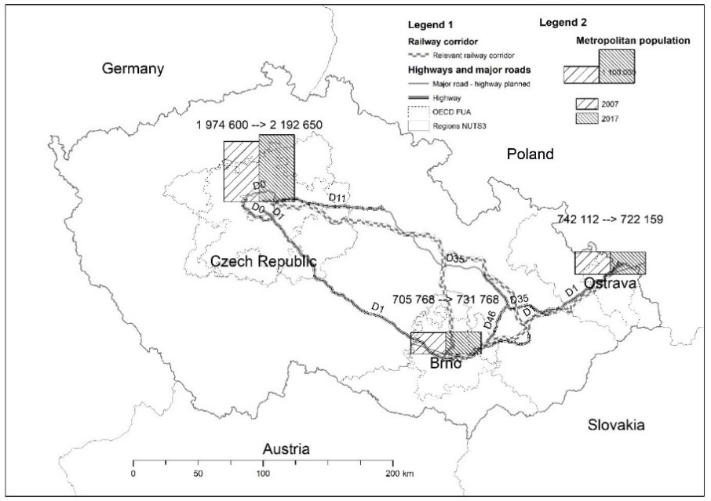

Sources: OECD, 2020; ArcČR ver.3.3, 2020; own processing

Table 3 shows the population, GDP per capita, and the unemployment rate for the metropolitan areas of interest.

Table 3 Metropolitan stats – population density, GDP per capita, and unemployment rate

|  |  |  |  |  |  |  |  |  |  |
| --- | --- | --- | --- | --- | --- | --- | --- | --- | --- |
| **Relevant NUTS 3 regions** | **Population density** | | | **GDP per capita (EUR)** | | | **Unemployment rate** | | |
| **2007** | **2017** | **change** | **2007** | **2017** | **change** | **2007** | **2017** | **change** |
| Prague and Středočeský | 207.06 | 228.68 | +10.4% | 580,468 | 715,428 | +23.3% | 2.79 | 3.25 | +0.47pp |
| Jihomoravský | 157.82 | 164.08 | +4.0% | 337,998 | 450,135 | +33.2% | 5.61 | 5.05 | –0.56pp |
| Moravskoslezský | 230.21 | 222.49 | –3.4% | 307,168 | 392,827 | +27.9% | 7.84 | 6.42 | –1.42pp |

Sources: OECD, 2020; Pařil & Viturka, 2020, own processing.

Table 3 shows significant long-term changes in metropolitan structure in the Czech Republic. The metropolization process in Prague and Středočeský region surrounding the Czech capital is obvious regarding increasing population density in these two regions driven by suburbs in Prague´s neighbourhood. Continuing suburbanization and metroplization process occur in Jihomoravský region surrounding Brno. However, in Moravskoslezský region with the capital of Ostrava, the decrease of population density exhibits the long-term depopulation process. Furthermore, Prague and its metropolitan area have a significant economic performance with a very low unemployment rate that reflects the hegemon economic position of the Czech capital.

## Connection frequency

In addition to prices, the frequency of connections is another essential variable influenced by the level of intramodal and intermodal competition as well as the openness of the railway markets. Table 4 provides the average number of connections per day over a week.

Table 4 Connections per day

|  |  |  |  |  |
| --- | --- | --- | --- | --- |
| Mode | Company | Prague–Brno | Prague–Ostrava | Brno–Ostrava |
| Bus | FlixBus | 18 |  |  |
| RegioJet | 22 |  |  |
| Train | Czech Railways | 32 | 18 | 16 |
| RegioJet | 10 | 12 |  |
| LeoExpress |  | 7 |  |
| Total |  | 82 | 37 | 16 |

Figure 2 shows the saturation of the routes during workdays. Every mark represents departure time of a single connection. The colours distinguish direction within the route. There were clear and significant differences among the markets. On average, there was a train or bus connection every 20 minutes between Brno and Prague and every 32 minutes between Prague and Ostrava but only every 74 minutes between Brno and Ostrava.

Figure 2 Saturation of routes



Note: Blue marks represent the directions from Brno to Ostrava, from Prague to Ostrava, and from Prague to Brno. Black marks represent return trips accordingly. Different symbols show different companies within the markets.

First, observe the frequency on the Prague–Brno line. The number of current connections reaches the limit of the existing capacity for train connections. There are slightly more train connections within the duopoly Prague–Brno market than there are on the Prague–Ostrava route with three competitors. However, the frequencies for Czech Railways on particular markets differed significantly. There were 18 trains on the Prague–Ostrava route, which is very similar to the monopolised market of Brno–Ostrava, but only roughly half of the capacity of the most competitive market, Prague–Brno.

In addition to higher peak frequencies, higher off-peak times frequencies are also connected to a higher level of competition. Services on the Brno–Ostrava line were provided only 16 hours per day during the workday compared to more than 21 hours for the other two analysed markets (or 19 hours for the Prague–Brno line excluding bus alternatives).

In summary, competition seems to have played an essential role regarding the frequency in both the number of connections and the proportion of the day serviced by public service operators.

## Pricing strategy assessment

The analysis focused on bus and train tickets provided by the incumbent Czech Railways (CD) and its key competitors RegioJet (RJ), LeoExpress (Leo), and FlixBus (Flix). Figure 3 presents standard ticket pricing box plots for the relevant transport markets, taking into account route, mode, and provider. The lines inside the inner part of the boxes represent the medians, the crosses show the means, and the dots are outliers.

Figure 3 Standard (anytime single) prices (euro cents per km)

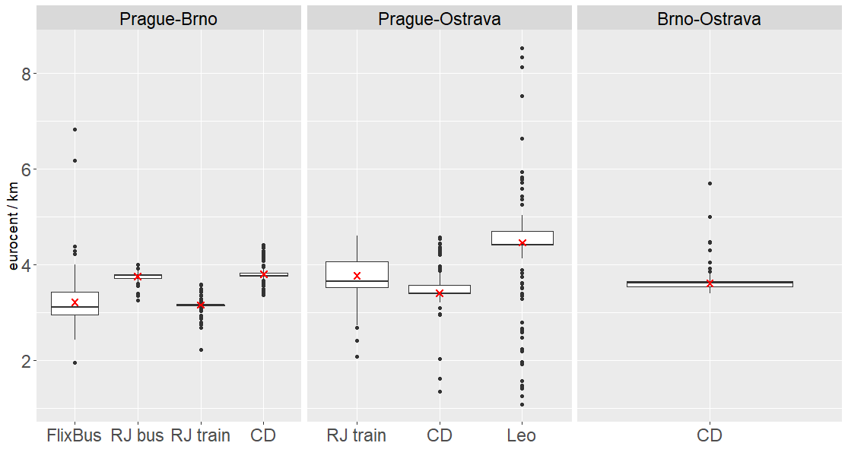

The route from Prague to Ostrava exhibited the greatest price volatility. This is quite an important finding because this passenger transport market is the only fully open train market in the Czech Republic, with three competitors – the incumbent Czech Railways and the two other competitors RegioJet and LeoExpress. The price strategy of LeoExpress was the most flexible. LeoExpress prices varied between 1 and 7 euro cents per km while those of the incumbent and RegioJet were mostly 3.5–4 euro cents per km.

The lowest volatility was observed on the Prague–Brno route for RegioJet buses and trains and also the incumbents’ trains, especially when compared to the much more flexible prices of FlixBus.

Figure 4 depicts prices on the relevant transport markets including passenger discounts. These discounts are based primarily on the aforementioned 75% discounts for seniors and students. However, there are many other options provided by particular operators. Czech Railways provided several kinds of loyalty cards: IN25 (25% discounts on each ticket with an initial deposit of CZK 450/EUR 17 per year),[3] IN50 (50% discounts with an initial deposit of CZK 2,990/EUR 112 per year); IN100 (100% discounts with an initial deposit of CZK 19,990/EUR 752 per year); and INbusiness (100% discounts including first-class tickets with an initial deposit of CZK 35,000/EUR 1,316 per year). RegioJetoffered credit tickets (with an initial deposit of at least CZK 300/EUR 11 granting discounts on each ticket of around CZK 5/EUR 0.19).

Figure 4 Tariff prices including classes and discounts (euro cents per km)

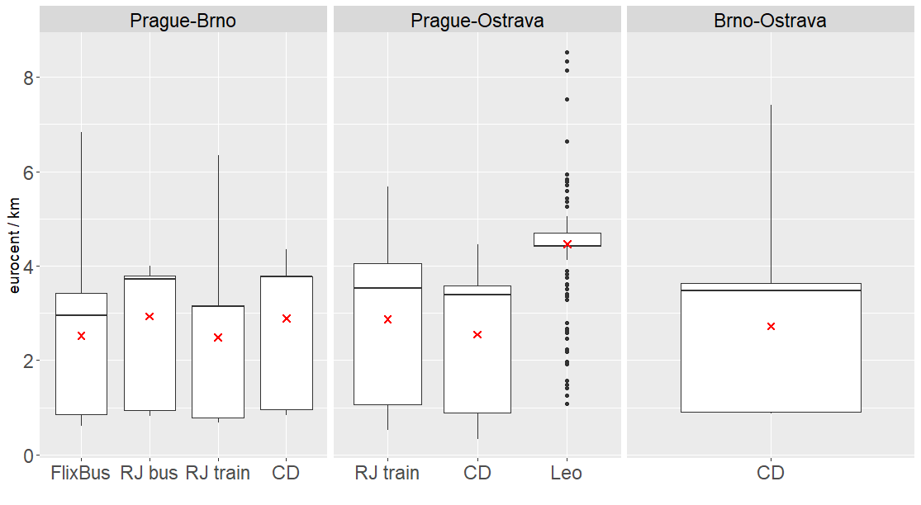

Operators offered different types of services. Czech Railways’ fast trains offered second class, first class, and business class. RegioJet offered four types of services: Low cost, Standard, Relax, and Business. LeoExpress provided Economy, Business, and Premium tickets (however, premium passengers were very rare as the price was 3 to 5 times as much; therefore, this class was excluded from the sample).

The inclusion of tariffs, discounts, and classes had a substantial impact on the minimum prices and the first quartile prices, which were much lower (see Figure 4) than in the previous case. This fact might have been caused by the composition of the population sample (see Figure 7). LeoExpress prices showed the narrowest interquartile range and the highest final ticket price per kilometre bought by passengers (the mean was about 2 euro cents per kilometre higher than those for other modes and providers) as students and seniors represented a minimal share of the passengers. In summary, almost one third of passengers took advantage of 75% discounts. Similar level of prices has been observed in Slovakia, where seniors and students have been able to travel even with 100% discounts since 2014. Available data from 2018 shows that the share of 100% discount holders including seniors and students on the passenger rail market in Slovakia was more than 37% of all rail passengers in Slovakia (ZSSK, 2019). This fact highlights the important position of senior and student passengers in long-distance domestic public transport.

## Survey passenger characteristics

This section describes the main features of the data set regardless of route. First, we analysed the age structure of the travellers, especially the share of students and seniors, which is important due to the 75% discount for these groups. Adult travellers formed 67% of the sample, students 25%, and seniors 8%. However, there were significant differences among the operators – RegioJet attracted significantly more students (31%). The average and median ages were 38 and the inner 50% of the travellers were between 26 and 50 years old. Trains were the most common means of transport for seniors, and slightly less so for adults and students.

Figure 5 depicts the frequency of travelling for different modes and operators. Most passengers did not travel multiple times per week. Most of the travellers travelled 1–3 times per month or less. The structure of the frequency was similar across various modes and operators. However, occasional travellers (once per year) chose private operators (RegioJet, LeoExpress) more frequently than the incumbent, which had the highest share of regular travellers.

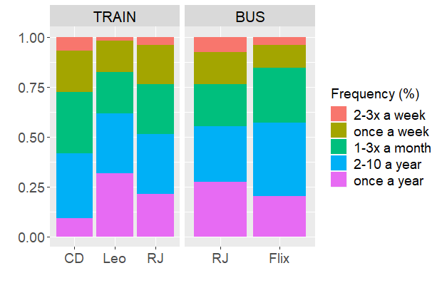Figure 5 Passengers’ frequency of travelling

Figure 6 shows the types of tickets bought. Most passengers used economy class (Economy or Standard in RegioJet and Economy in LeoExpress). The share of economy tickets was highest for the incumbent. RegioJet provided two types of higher comfort tickets (Relax and Business).

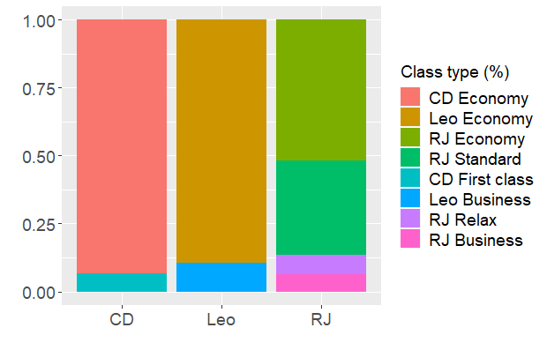Figure 6 Train ticket types

Furthermore, about 24% of Czech Railways travellers used an IN card, which enabled users to buy tickets at a discount (e.g. a yearly IN25 card provides a discount of 25% for CZK 450 per year). Similarly, 23% of RegioJet passengers used RegioJet credit tickets, which also enabled buying cheaper tickets but was free of charge.

Figure 7 shows the type of economic activity the passengers of the various transport modes and operators were engaged in. Employees (51%) and businessmen (12%) formed the largest part of the travellers, but their proportions were slightly different for the various modes and operators. Businessmen represented 25% of all LeoExpress passengers. Students represent another large group (24%); they substantially preferred RegioJet.

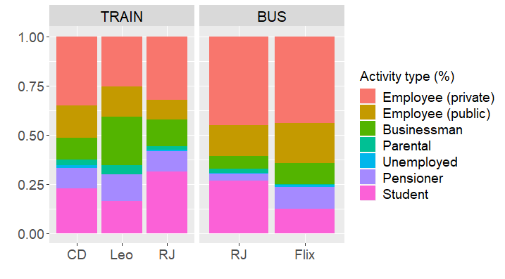Figure 7 Economic activity

In summary, the structure of the passengers’ economic activity played an essential role. Seniors and students preferred trains, with students preferring the higher quality services provided especially by RegioJet trains.

# Models and elasticity assessment

This section presents the results of the model estimations and computed elasticities. In our research, the elasticity analysis represents a supplementary means of identifying the relationship between the level of competition on the markets and behaviour using revealed preferences obtained through a survey of all analysed markets.

## Model estimations

Due to different specification of the models, the predictors differed slightly. In general, we controlled for both mode and company-specific variables, including ticket price and frequency. Elasticities were calculated with respect to these variables. The specification of Model 3 did not enable the use of frequency. The existing alternative to Czech Railways between Brno and Ostrava was only individual car transportation, which is not consistent with any frequency information.

Second, the socio-demographic characteristics were specific to individuals and did not vary across modes or companies. The variables of travel purpose and passenger travel frequency were used in all three models. In addition, in the Prague–Brno model, the highest completed education was used to better distinguish among the available options.[4] Last, the need to change was captured as a dummy variable at the departure, the origin, or both. Detailed variable descriptions for all three models can be found in Appendix 3.

Table 5 presents estimations for the final models. The interpretation varied slightly across models, and therefore only the sign is interpreted here. Observe that in all three models the unobserved utility (or probability of choice) was lower with increasing price. The impact was significantly different from zero. Connection frequency was, on the other hand, positively correlated with the probability of choice, e.g. the utility of consumption. This parameter was, however, not significantly different from zero in the case of Model 1. This could be interpreted as being related to the already high number of connections per day between Brno and Prague.

Model 1 contains both mode-specific as well as mode and company-specific variables. Moreover, the variables are always interpreted in comparison to a benchmark, which is in all three cases the omitted option. For example, the statistically significant variable *One_day_travel* refersto trips shorter than one full day. These consumers had lower utility for using the bus as compared to the train. As can be seen, the constants were significantly lower for both bus options compared to Czech Railways trains. On the other hand, in the case of RegioJet trains, the constant utility was higher but not statistically significant. The constant utility could with some caution be interpreted as unobserved comfort. Lastly, the parameter *Tau* in the case of the nested version of the discrete choice model captures the dissimilarity between options (companies) in the specified groups (modes). *Tau* is always lower than one, although for the bus mode it was not significantly different from one, which can be interpreted as showing a high dissimilarity between bus alternatives.

Table 5 Estimation results

|  |  |  |  |  |
| --- | --- | --- | --- | --- |
| **Variable** | **Company/mode** | **Model 1** | **Model 2** | **Model 3** |
|  |  | BRQ–PRG | PRG–OSR | OSR–BRQ |
| Ln_price |  | −1.575** | −0.565*** | −1.749*** |
|  |  | (0.73) | (0.212) | (0.435) |
| Ln_frequency |  | 0.35 | 1.176*** |  |
|  |  | (0.38) | (0.278) |  |
| Old_X_public |  | 0.607*** |  |  |
|  |  | (0.203) |  |  |
| One_day_travel | Bus | −0.704*** |  |  |
|  |  | (0.165) |  |  |
| Origin_change | Bus | −0.299* |  |  |
|  |  | (0.166) |  |  |
| Constant | FlixBus bus | −1.952** |  |  |
|  |  | (0.85) |  |  |
| Constant | RegioJet bus | −1.851** |  |  |
|  |  | (0.836) |  |  |
| Constant | RegioJet train | 0.249 |  |  |
|  |  | (0.463) |  |  |
| *Tau* | Bus | 0.983 |  |  |
|  |  | (0.778) |  |  |
| *Tau* | Train | 0.603** |  |  |
|  |  | (0.239) |  |  |
| Origin_change | LeoExpress Train |  | −0.275 |  |
|  |  |  | (0.368) |  |
| Destination_change | LeoExpress Train |  | −2.965*** |  |
|  |  |  | (0.684) |  |
| Weekend | LeoExpress Train |  | −0.435 |  |
|  |  |  | (0.329) |  |
| Constant | LeoExpress Train |  | 0.718 |  |
|  |  |  | (0.485) |  |
| Origin_change | RegioJet Train |  | 0.403 |  |
|  |  |  | (0.376) |  |
| Destination_change | RegioJet Train |  | −0.833* |  |
|  |  |  | (0.427) |  |
| Weekend | RegioJet Train |  | −0.084 |  |
|  |  |  | (0.262) |  |
| Constant | RegioJet Train |  | 0.005 |  |
|  |  |  | (0.426) |  |
| Change | CD Train |  |  | 1.419*** |
|  |  |  |  | (0.519) |
| Constant | CD Train |  |  | 1.895** |
|  |  |  |  | (0.953) |
| Number of observations |  | 3,036 | 1,584 | 205 |
| Note: standard errors in parentheses; asterisks (***, **, and *) correspond to the significance level (1%, 5%, and 10%, respectively). The number of observations is calculated as the number of passengers from the survey multiplied by available alternatives, i.e., we have four alternatives for PRG-BRQ and 759 surveyed passengers. For connection OSR-BRQ, we excluded travellers from abroad. | | | | |

Model 2 explains the Prague–Ostrava market. In both cases, the constant was not significantly higher in comparison to the state-owned provider. Except for the variable *Destination_change*, all of the other predictors were not significantly different from zero. For both private companies, consumers had significantly lower utility when there was a change in destination.

Again, Model 3 does not show the binary variables for travel purpose and travel frequency. The need to change at the destination or origin had a positive effect on the traveller’s utility, which runs contrary to expectations. This can be explained by the poor alternative options. Therefore, the network of the incumbent with integrated regional trains can be fully utilised for fast trains.

The predictive power of the models was calculated as the share of the correct choice prediction compared to all predictions for the given mode and company (see Table 6). In other words, the highest probability[5] for the chosen alternative was compared to the consumer’s actual choice. If the prediction was the same as the real choice, the fit was right, and if it was not the same, the fit was not right. Last, the sum of all correct predictions was divided by the total number of chosen observations for the given mode and company.

Table 6 Predictive power of models

|  |  |  |  |  |
| --- | --- | --- | --- | --- |
| **Company** | **Mode** | **Model 1** BRQ–PRG | **Model 2**  PRG–OSR | **Model 3**  OSR–BRQ |
| FlixBus | Bus | 23.5% |  |  |
| RegioJet | Bus | 27.9% |  |  |
| Czech Railways | Train | 62.2% |  |  |
| RegioJet | Train | 42.2% |  |  |
| LeoExpress | Train |  | 21.3% |  |
| RegioJet | Train |  | 48.7% |  |
| Czech Railways | Train |  | 68.6% |  |
| Czech Railways | Train |  |  | 87.8% |
| (choice == 0) | Other |  |  | 75.7% |

Model 1 correctly predicted 62.2% of all choices by travellers that used Czech Railways trains on Prague–Brno connections and 42.2% for those using the second train company, RegioJet. However, the model correctly predicted only 23.5% of FlixBus choices and 27.9% of RegioJet bus choices. Overall, the prediction power for bus modes was lower. Similarly, the fit of Model 2 was better for companies with higher market shares, namely Czech Railways and RegioJet trains. However, the fit was rather poor for LeoExpress trains. The best performance was provided by Model 3, which was able to correctly predict 87.8% of all choices for Czech Railways trains.[6]

## Elasticities with respect to price and frequency

The coefficients for prices and frequencies from Table 5 provide little explanatory value due to unobserved and individual-specific utility. Therefore, the market demand elasticities for travel alternatives were estimated.

Table 7 gives the calculated elasticities with respect to price for PRG-BRQ and PRG-OSR routes. Table 8 shows result for the specific long-distance transport market BRQ-OSR.

Table 7 Elasticities with respect to price on PRG-BRQ and PRG-OSR markets

|  |  |  |  |  |  |
| --- | --- | --- | --- | --- | --- |
| BRQ–PRG | | | | | |
| Company | FlixBus | RegioJet bus | RegioJet train | Czech Railways |  |
| FlixBus | −1.12 | 0.47 | 0.32 | 0.30 |  |
| RegioJet bus | 0.44 | −1.15 | 0.30 | 0.28 |  |
| RegioJet train | 0.29 | 0.29 | −1.68 | 0.74 |  |
| Czech Railways | 0.39 | 0.39 | 1.05 | −1.33 |  |
| PRG–OSR | | | | | |
|  | Czech Railways | LeoExpress train | RegioJet train |  |  |
| Czech Railways | −0.28 | 0.20 | 0.22 |  |  |
| LeoExpress train | 0.10 | −0.40 | 0.11 |  |  |
| RegioJet train | 0.18 | 0.20 | −0.33 |  |  |

The interpretation of the calculated elasticities with respect to price is as follows: a 1% increase in price for FlixBus would lead to a 1.12% decrease in FlixBus’s share. Furthermore, the 1.12% decrease in FlixBus’s share would lead to a 0.44% increase in RegioJet’s bus share, a 0.29% increase in RegioJet’s train share, and a 0.39% increase in Czech Railways’ share.

Table 8 Elasticities with respect to price on BRQ-OSR market

|  |  |  |  |  |  |
| --- | --- | --- | --- | --- | --- |
| BRQ–OSR* | | | | | |
|  | Czech Railways |  |  |  |  |
| Czech Railways | −0.38 |  |  |  |  |

*\*Note:* The route BRQ-OSR is a different case as it does create a connection with the capital city, and further, there is no alternative (competition) on this route. Thus, the computed elasticity for this route is not determined for direct comparison with the results from the other two routes; however, it is still a relevant market connecting two important municipalities and, in many ways, comparable to the other two markets. Therefore, we provide an estimation of price elasticity also for this third market.

In terms of elasticity analysis, three interesting results are observable. First, the existence of intermodal competition seems to have had a stronger effect on elasticity of demand than another intramodal competitor did. Moreover, the results do not provide any sign of brand loyalty on the part of consumers. Furthermore, the market power of Czech Railways within the Brno–Ostrava connection seems to have been low with respect to price. Even though elasticity analysis is not stand-alone proof of any of these conclusions and each one requires separate investigation, the direct- and cross-price elasticities are essential indicators of the findings.

Table 9 presents elasticities with respect to frequency, i.e. percentual changes of connections (or, in other words, capacity). A 1% increase for FlixBus connections on the Prague–Brno line would increase the company’s market share by 0.25%. Such an increase would, in term, reduce the market shares of RegioJet buses by 0.10%, RegioJet trains by 0.07%, and Czech Railways by 0.09%. In this case, the elasticities for the Prague–Brno market are not statistically different from zero. As mentioned previously, the elasticities for the Brno–Ostrava market were not estimated due to the model specification.

Table 9 Elasticities with respect to frequency

|  |  |  |  |  |  |
| --- | --- | --- | --- | --- | --- |
| BRQ–PRG | | | | | |
| Company | FlixBus Bus | RegioJet Bus | RegioJet train | Czech Railways |  |
| FlixBus Bus | 0.25 | −0.10 | −0.07 | −0.07 |  |
| RegioJet Bus | −0.10 | 0.26 | −0.07 | −0.06 |  |
| RegioJet train | −0.07 | −0.07 | 0.37 | −0.16 |  |
| Czech Railways | −0.09 | −0.09 | −0.24 | 0.30 |  |
| OSR–PRG | | | | | |
|  | Czech Railways | LeoExpress train | RegioJet train |  |  |
| Czech Railways | 0.58 | −0.42 | −0.46 |  |  |
| LeoExpress train | −0.20 | 0.84 | −0.24 |  |  |
| RegioJet train | −0.38 | −0.42 | 0.69 |  |  |

In general, the lower the frequency was, the higher the elasticity of change was. Therefore, even though we cannot estimate elasticity with respect to frequency for the Brno–Ostrava line, the expectation would be findings of a highly elastic market.

# Findings and discussion

The results for prices and frequencies for different entry setups provide, at first sight, a surprising contradiction. First, we observe little variability in price across markets with significantly different market structures. On the other hand, the findings for frequencies are in line with expectations.

There is almost no geographic price discrimination from the incumbent Czech Railways, i.e. it employs a uniform price strategy across the analysed markets. Together with conditions based on PSOs, this leaves very little space for price manoeuvres by the incumbent on the monopolised Brno–Ostrava market. [7]Therefore, we did not observe higher prices (on average) within the monopolised market compared to those on the more competitive lines. Moreover, there is a documented effect in the previous literature of competition on price level through, for example, two observed price wars on the Prague–Brno and Prague–Ostrava lines shortly after open access was introduced.

However, the connection frequency is a different story. There was great variation in the number of connections across markets. This is in line with previous findings of equilibria with one dominant firm (most likely the incumbent) and smaller entrants. Not only was the number of connections per day higher in case of open access lines, but also more of the day was served. This suggests that players tended to compete for both peak and off-peak times.

The elasticity analysis of market demand both confirmed previous findings and opened new questions. First, the lack of differences in price elasticities between the monopolised market and the market with three railway companies confirmed the results of the price analysis itself (i.e. little price discrimination and overall low market power on the monopolised Brno–Ostrava market).

There was, however, a striking difference in elasticities with respect to price between the Prague–Brno and Prague–Ostrava markets. Three possible reasons are discussed here. First, the documented price war on the Prague–Brno line occurred before the survey, which may have contributed to travellers’ price sensitivity. Second, the intense competition on this railway line was even intensified by equally tough competition between bus alternatives. Finally, there were, on average, 82 connections between Brno and Prague during a regular workday. This specific connection has very limited market power, which normally stems from departure time differentiation. Therefore, market demand was highly elastic to price even for negligible changes.

Lastly, the market structure enabled us to test for consumers’ brand loyalty. However, we did not find any tendency to prefer a brand alternative to a mode alternative from a competitor. As mentioned before, however, this is based on our supplementary elasticity analysis, which suffers from several shortcomings.

# Research implications

A cross-section comparison of markets with varying entry regulations and competition did not show variability in price level, but did show a clear positive impact of entry on the connection frequency. The monopolised PSO market did not encourage higher connection frequencies in comparison to the more competitive lines. Moreover, consumers’ price sensitivity was higher for relevant intermodal competition. The low level of price variability between markets may have had several causes; we tend to believe that one of the most important was the low monopoly power of the incumbent Czech Railways. Therefore, the market power of a sole player could be reasonably reduced by combining PSOs and competition on other markets, as in the case of the Brno–Ostrava line.

On the other hand, if a high frequency of connections is desired, it has not been achieved without intense competition in the Czech Republic. On average, there is a train every 30 minutes on competitive lines compared to a gap of more than 70 minutes on the monopolised connection. Last, if possible, not only intramodal alternatives should be encouraged, but intermodality as well. The closeness of substitution can play an important role in maintaining low market power. This was the case for the high elasticity within the Prague–Brno line and therefore the expected low market power for firms. As expected, consumers clearly benefited from competition. If maximising consumer surplus is the aim for regulators and managers, competition or at least some kind of competitive tendering should always be preferred.

Several questions remain open and provide space for further research. The effect of free entry on the consumer side of welfare seems to be unquestionable. However, overall welfare is still an issue. Moreover, even on markets with a relatively high number of firms, the firms remained naturally differentiated with some local monopoly power due to departure time heterogeneity. The question arises of how high the real market power of such firms is and what the regulatory policies are on the open-access market.

# Conclusions

We have provided a comprehensive analysis of the effects of different entry regulations on competition and travellers’ decision processes. To this end, we studied three different Czech lines: Prague–Brno, Prague–Ostrava, and Brno–Ostrava. These differed significantly in both railway entry policies and market structure. Moreover, the intense railway competition on the Prague–Brno market was further intensified by intramodal competition with bus alternatives.

Our findings are in line with the existing literature describing a positive effect from railway competition for consumers. However, we could not find significant price level differences across markets with varying entry regulations. We believe that this is an effect of the low monopoly power of the incumbent Czech Railways. It seems that the incumbent’s pricing policy does not distinguish between routes. Given the estimated price elasticity, the policy is certainly not profit maximising on these routes. The pricing strategy is based on what is fair rather than what is profitable, and this strategy makes it seem unacceptable to discriminate by route. On the other hand, we identified a clear relationship between entry setup and increased connection frequency. Both findings are further supported by estimated market demand and firm-specific elasticities. In the case of price sensitivity, there seems to have been a significant effect from intramodal competition. Furthermore, intense competition increased the number of connections per day significantly. On the other hand, the connection frequency was much lower on the monopolised PSO market. Even though we were not able to estimate elasticity there directly, we expect sensitivity to market demand with respect to frequency to be reasonably high.

In summary, the paper contributes to the existing empirical literature on the competition and regulatory effects in long-distance passenger transportation. The paper has the potential to provide new arguments for ongoing policy discussion on trade-offs between open access regime and more traditional regulation on railways. Moreover, by collecting a vast amount of supplementary data on prices and frequencies, together with conducted surveys, we fulfil the existing gap in the academic literature on comparisons of markets under different regulatory regimes.

# Acknowledgements

This article is the output of the project “New Mobility – High-Speed Transport Systems and Transport-Related Human Behaviour”, Reg. No. CZ.02.1.01/0.0/0.0/16_026/0008430, co-financed by the Operational Programme Research, Development and Education.

# References

Aarhaug, J., Farstad, E., Fearnley, N., & Halse, A. H. (2018). Express coaches: An up-hill battle after liberalization? *Research in Transportation Economics*, 72 SI, 82-91. <https://doi.org/10.1016/j.retrec.2018.07.031>

Allard, R. F., & Moura, F. (2018). Effect of transport transfer quality on intercity passenger mode choice. *Transportation Research Part A: Policy and Practice*, *109*, 89-107. <https://doi.org/10.1016/j.tra.2018.01.018>

ArcČR ver.3.3. (2020) ESRI ARC GIS data set for the Czech Republic. ARCDATA PRAHA: Prague. <https://www.arcdata.cz/produkty/geograficka-data/arccr-500> (Accessed: 21 July 2020)

Bahamonde-Birke, F., Kunert, U., Link, H., & Ortuzar, J. (2014). Liberalization of the Interurban Coach Market in Germany: Do Attitudes and Perceptions Drive the Choice between Rail and Coach?. <https://papers.ssrn.com/sol3/papers.cfm?abstract_id=2506615> (Accessed: 21 July 2020)

Behrens, C., & Pels, E. (2012). Intermodal competition in the London-Paris passenger market: High-Speed Rail and air transport. *Journal of Urban Economics*, 71(3), 278-288. <https://doi.org/10.1016/j.jue.2011.12.005>

Ben-Akiva, M., & Morikawa, T. (2002). Comparing ridership attraction of rail and bus. *Transport Policy*, *9*(2), 107-116. <https://doi.org/10.1016/S0967-070X(02)00009-4>

Bergantino, A. S., Capozza, C., & Capurso, M. (2015). The impact of open access on intra-and inter-modal rail competition. A national level analysis in Italy. *Transport Policy*, 39, 77-86. <https://doi.org/10.1016/j.tranpol.2015.01.008>

Beria, P., Redondi, R., & Malighetti, P. (2016). The effect of open access competition on average rail prices. The case of Milan – Ancona. *Journal of rail transport planning and management*, 6(3), 271-283. <https://doi.org/10.1016/j.jrtpm.2016.09.001>

Beria, P., Nistri, D., & Laurino, A. (2018). Intercity coach liberalisation in Italy: Fares determinants in an evolving market, *Research in Transportation Economics*, 69, 260-269, https://doi.org/10.1016/j.retrec.2018.07.029

Beria, P., & Bertolin, A. (2019). Evolving long-distance passenger services. Market concentration, fares and specialisation patterns in Italy. *Research in Transportation Economics*, *74*, 77-92. <https://doi.org/10.1016/j.retrec.2019.01.004>

Broman, E., & Eliasson, J. (2019). Welfare effects of open access competition on railway markets. *Transportation Research Part A: Policy and Practice*, 129, 72-91. <https://doi.org/10.1016/j.tra.2019.07.005>

Burgdorf, C., Eisenkopf, A., & Knorr, A. (2018). User acceptance of long distance bus services in Germany. *Research in Transportation Economics*, *69*, 270-283. <https://doi.org/10.1016/j.retrec.2018.07.023>

Cascetta, E., & Coppola, P. (2013). Competition on fast track: an analysis of the first competitive market for HSR services. *Procedia - Social and Behavioral Sciences*, 111, 176-185. <https://doi.org/10.1016/j.sbspro.2014.01.050>

Crozet, Y., & Guihéry, L. (2018). Deregulation of long distance coach services in France. *Research in Transportation Economics*, *69*, 284-289. <https://doi.org/10.1016/j.retrec.2018.07.021>

Daly, H. E.; Ramea, K., Chiodi, A., Yeh, S., Gargiulo, M., & Gallachoir, B. O. (2014). Incorporating travel behaviour and travel time into TIMES energy system models. *Applied Energy*, 135, 429-439. <https://doi.org/10.1016/j.apenergy.2014.08.051>

Desmaris, C., & Croccolo, F. (2018). The HSR competition in Italy: How are the regulatory design and practices concerned?. *Research in Transportation Economics*, *69*, 290-299. <https://doi.org/10.1016/j.retrec.2018.05.004>

Droes, M. I., & Rietveld, P. (2015). Rail-based public transport and urban spatial structure: The interplay between network design, congestion and urban form. *Transportation Research Part-B Methodogical*, 81 (Part 2), 421-439. <https://doi.org/10.1016/j.trb.2015.07.004>

Eagling, J., & Ryley, T. (2015). An investigation into the feasibility of increasing rail use as an alternative to the car. *Transportation Planning and Technology*, 38(5), 552-568. <https://doi.org/10.1080/03081060.2015.1039234>

European Commission. *Mobility and transport – Railway packages* [online]. EC, (2016). <https://ec.europa.eu/transport/modes/rail/packages/2013_en> (Accessed 21 July 2020)

Greene, W. (2009). Discrete choice modeling. *Palgrave Handbook of Econometrics* (473-556). London: Palgrave Macmillan.

Ficek, M. (2020). Handover documentation of Big Data contract research in the framework of project New mobility - high-speed transport systems and transport behavior of the population (CZ.02.1.01/0.0/0.0/16_026/0008430) , CE Traffic, Prague, p. 87.

Finez, J. (2014). Fare setting by the French National Railway Company (SNCF), a social history of pricing. From uniform fares to yield management (1938-2012). *Revue Francaise de sociologie*, 55(1), 5-39. <https://doi.org/10.3917/rfs.551.0005>

Forinash, C. V., & Koppelman, F. S. (1993). Application and interpretation of nested logit models of intercity mode choice. *Transportation Research Record*, 1413, 98-106.

Fröidh, O. (2008). Perspectives for a future high-speed train in the Swedish domestic travel market. *Journal of Transport Geography*, 16(4), 268-277. <https://doi.org/10.1016/j.jtrangeo.2007.09.005>

Fröidh, O., & Byström, C. (2013). Competition on the tracks – Passengers’ response to deregulation of interregional rail services. *Transportation Research Part A: Policy and Practice*, 56, 1-10. <https://doi.org/10.1016/j.tra.2013.09.001>

Fröidh, O., & Nelldal, B. L. (2015). The impact of market opening on the supply of interregional train services. *Journal of Transport Geography*, *46*, 189-200. <https://doi.org/10.1016/j.jtrangeo.2015.06.017>

Gremm, C. (2018). The effect of intermodal competition on the pricing behaviour of a railway company: Evidence from the German case. *Research in Transportation Economics*, 72, 49-64. <https://doi.org/10.1016/j.retrec.2018.11.004>

Hoffman, S. D., & Duncan, G. J. (1988). Multinomial and conditional logit discrete-choice models in demography. *Demography*, *25*(3), 415-427. <https://doi.org/10.2307/2061541>

Koppelman, F. S., & Bhat, C. (2006). A Self Instructing Course in Mode Choice Modeling: Multinomial and Nested Logit Models. Washington, D.C.: Federal Transit Administration.

Król, M., Taczanowski, J., & Kołoś, A. (2018). The rise and fall of Interregio. Extensive open-access passenger rail competition in Poland. *Research in Transportation Economics*, *72*, 37-48. <https://doi.org/10.1016/j.retrec.2018.06.008>

Kvizda, M. & Solnička, J. (2019). Open access passenger rail competition in Slovakia – Experience from the Bratislava–Košice line. *Journal of Rail Transport Planning & Management*, 12, 100143. <https://doi.org/10.1016/j.jrtpm.2019.100143>

McFadden, D. (1973). Conditional logit analysis of qualitative choice behavior. In P. Zarembka (ed.), *Frontiers in Econometrics* (105-142). New York: Academic Press.

McFadden, D. (1974). The measurement of urban travel demand." *Journal of Public Economics*, 3(4), 303-328. <https://doi.org/10.1016/0047-2727(74)90003-6>

Ministry of Transport (2016). Transport Census 2016. Available online: <https://www.rsd.cz/wps/portal/web/Silnice-a-dalnice/Scitani-dopravy>

Ministry of Transport (2019). Highway Toll Data 2019.

OECD (2020). OECD.stat Metropolitan areas – Metropolitan statistics 2001–2018. https://stats.oecd.org/Index.aspx?DataSetCode=CITIES (Accessed 2 July 2020).

Pagliara, F., Manuel Vassallo, J., & Román, C. (2012). High-speed rail versus air transportation: Case study of Madrid–Barcelona, Spain. *Transportation Research Record*, 2289(1), 10-17. <https://doi.org/10.3141/2289-02>

Pařil, V., & Viturka, M. (2020). Assessment of priorities of construction of high-speed rail in the Czech Republic in terms of impacts on internal and external integration. *Review of Economic Perspectives*, 20(2), 217-241. <https://doi.org/10.2478/revecp-2020-0010>

Paulley, N., Balcombe, R., Mackett, R., Titheridge, H., Preston, J., Wardman, M., ... & White, P. (2006). The demand for public transport: The effects of fares, quality of service, income and car ownership. *Transport policy*, *13*(4), 295-306. <https://doi.org/10.1016/j.tranpol.2005.12.004>

Polydoropoulou, A., & Ben-Akiva, M. (2001). Combined revealed and stated preference nested logit access and mode choice model for multiple mass transit technologies. *Transportation Research Record*, 1771(1), 38-45. <https://doi.org/10.3141/1771-05>

Raturi, V., & Verma, A. (2019). Competition between high speed rail and conventional transport modes: Market entry game analysis on Indian corridors. *Networks & Spatial Economics*, 19(3), 763-790. <https://doi.org/10.1080/03081060.2020.1701666>.

Si, B., Zhong, M., & Gao, Z. (2009). Bilevel programming for evaluating revenue strategy of railway passenger transport under multimodal market competition. *Transportation Research Record*, 2117(1), 1-6. <https://doi.org/10.3141/2117-01>

Tomeš, Z., Kvizda, M., Jandová, M., & Rederer, V. (2016). Open access passenger rail competition in the Czech Republic. *Transport policy*, 47, 203-211. <https://doi.org/10.1016/j.tranpol.2016.02.003>

Tomeš, Z., & Jandová, M. (2018). Open access passenger rail services in Central Europe. *Research in Transportation Economics*, 72, 74-81. <https://doi.org/10.1016/j.retrec.2018.10.002>

Tomeš, Z., & Fitzová, H. (2019). Does the incumbent have an advantage in open access passenger rail competition? A case study on the Prague–Brno line. *Journal of Rail Transport Planning and Managemen*‏*t*, 12, 100140. <https://doi.org/10.1016/j.jrtpm.2019.100140>

Toro-González, D. Cantillo, V., & Cantillo-García, V. (2020). Factors influencing demand for public transport in Colombia. *Research in Transportation Business & Management*, 36, 100514. https://doi.org/10.1016/j.rtbm.2020.100514

Varghese, V., & Jana, A. (2018). Impact of ICT on multitasking during travel and the value of travel time savings: Empirical evidences from Mumbai, India. *Travel Behaviour and Society*, 12, 11-22. <https://doi.org/10.1016/j.tbs.2018.03.003>

Vigren, A. (2017). Competition in Swedish passenger railway: Entry in an open access market and its effect on prices. *Economics of Transportation*, 11–12, 49-59. <https://doi.org/10.1016/j.ecotra.2017.10.005>

Wheat, P., Smith, A. S., & Rasmussen, T. (2018). Can competition for and in the market co-exist in terms of delivering cost efficient services? Evidence from open access train operators and their franchised counterparts in Britain. *Transportation Research Part A: Policy and Practice*, 113, 114-124. <https://doi.org/10.1016/j.tra.2018.03.004>

Yen, B. T. H., Mulley, C., & Tseng, W.-C. (2018). Inter-modal competition in an urbanised area: Heavy rail and busways. *Research in Transportation Economics*, 69, 77-85. <https://doi.org/10.1016/j.retrec.2018.04.007>

ZSSK (2019). Železničná spoločnosť Slovensko, a. s., department of long-distance and international transport services and products. Internal data on the number of passengers using senior and student discounts.

# Appendix 1 Original passenger survey sample and questionnaire

|  |  |  |  |  |
| --- | --- | --- | --- | --- |
| Mode | Company | Prague–Brno | Prague–Ostrava | Brno–Ostrava |
| Train | Czech Railways | 312 | 263 | 142 |
| RegioJet | 201 | 204 |  |
| LeoExpress | 0 | 113 |  |
| Bus | RegioJet | 202 |  |  |
| FlixBus | 200 |  |  |
| Car | - | 129 | 18 | 103 |

*Note: This table shows original structure of our passenger survey.*

*Source: passenger survey – see chapter 3.3, authors*

**Questions:**

* Interviewer:
  + Mode
  + Company
  + Time
  + Location
* Interviewed:
  + Where do you travel from and where (municipality, region)?
  + How long are you driving?
  + Do you use fare type?
  + What type of fare do you have?
  + What class are you currently traveling in (train only)?
  + To what extent do you usually use individual transport modes or carriers when traveling on the selected routes (Prague, Brno, Ostrava)?
  + To what extent do the following reasons affect your choice of transport mode / specific carrier?
    - High frequency of connections (car availability)
    - Possibility to use a customer (discount) card
    - Price
    - Speed
    - Safety of operation (accident)
    - Personal feeling of safety in the coach/vehicle (attack)
    - Reliability / Less delayed connections
    - Comfort (place for feet, etc.)
    - Level of services (refreshments, Wi-fi, steward, magazines, etc.)
    - Possibility to work in a vehicle
    - Other: …
  + Gender
  + Age
  + Education
  + Employment
  + Driver's license holder

# Appendix 2 Modal & Intercompany Share

Sample of survey modal and company shares

|  |  |  |  |  |
| --- | --- | --- | --- | --- |
| Mode | Company | Prague–Brno | Prague–Ostrava | Brno–Ostrava |
| Train | Czech Railways | 31% | 43% | 56% |
| RegioJet | 22% | 36% | 0% |
| LeoExpress | 0% | 20% | 0% |
| Bus | RegioJet | 23% | 0% | 0% |
| FlixBus | 24% | 0% | 0% |
| Car | - | - | - | 44% |

*Note: This table shows relative share structure of our passenger survey.*

*Source: passenger survey – see chapter 3.3, authors*Big data verification modal and company shares based on average modal occupancy

|  |  |  |  |  |
| --- | --- | --- | --- | --- |
| Mode | Company | Prague–Brno | Prague–Ostrava | Brno–Ostrava |
| Train | Czech Railways | 39% | 53% | 45% |
| RegioJet | 24% | 31% | 0% |
| LeoExpress | 0% | 15% | 0% |
| Bus | RegioJet | 18% | 0% | 0% |
| FlixBus | 19% | 0% | 0% |
| Car | - | - | - | 55% |

*Note: This table shows relative share structure of big data model on modal split on relevant routes based on general load factor according to each mode of transport.*

*Source: SIM card´s movement big data (Ficek, 2020)*Big data verification modal and company shares based on specific company occupancy in rail (ČD, RegioJet a LeoExpress)

|  |  |  |  |  |
| --- | --- | --- | --- | --- |
| Mode | Company | Prague–Brno | Prague–Ostrava | Brno–Ostrava |
| Train | Czech Railways | 39% | 53% | 45% |
| RegioJet | 24% | 31% | 0% |
| LeoExpress | 0% | 15% | 0% |
| Bus | RegioJet | 18% | 0% | 0% |
| FlixBus | 19% | 0% | 0% |
| Car | - | - | - | 55% |

*Note: This table shows relative share structure of big data model on modal split on relevant routes based on general load factor according to each mode of transport and each individual company on train market.*

*Source: SIM card´s movement big data (Ficek, 2020)*

# Appendix 3 Variable description

|  |  |  |  |
| --- | --- | --- | --- |
|  | Individual specific | Alternative specific | Variable description |
| Ln_price | Yes | Yes | Log of price in EUR, adjusted for discounts |
| Ln_frequency | Yes | Yes | Log of number of connections per day |
| Old_X_public | Yes | Yes | Interaction variable 1 for people born before 1977 and using Czech Railways at the same time, otherwise 0. |
| One_day_travel | Yes | No | 1 if travel duration < one day, otherwise 0 |
| Origin_change | Yes | No | 1 if origin municipality for traveller is not equal to resident municipality for traveller, otherwise 0 |
| Destination_change | Yes | No | 1 if destination municipality for traveller is not equal to resident municipality for traveller, otherwise 0 |
| Change | Yes | No | 1 if destination or origin municipality for traveller is not equal to resident municipality for traveller, otherwise 0 |
| Weekend | Yes | No | 1 if day of travel is Saturday or Sunday, otherwise 0 |
| Travel purpose fixed effects | Yes | No | A) Business trip; B) travel to work; C) study; D) family, friends; E) tourism – 1 day; F) tourism – overnight; G) private affairs; H) other |
| Education fixed effects | Yes | No | Elementary, secondary without qualifications, secondary with qualifications, tertiary |
| Travel frequency fixed effects | Yes | No | 4+ times per week, 2–3 times per week, once per week, 1–3 times per month, 2–10 times per year, once per year |

1. There are some bus services on the Brno–Ostrava line, but they usually have many more stops and a much longer travel time compared to the train (more than 3 hours by bus compared to a little more than 2 hours by train). According to our preliminary research based on focus groups, there are very few people using this mode of transport on this line. Buses are used only for travelling shorter sections, such as to Olomouc.
2. As already mentioned, the relevance of intermodal competition is low.
3. There were also IN cards for 3 months and 3 years.
4. This was used mainly due to groups of students using bus and private train companies more often than others.
5. For Model 3 and standard logistic regression, the threshold of 50% was used to distinguish the chosen alternative.
6. In the case of Model 3, McFadden’s was also calculated as 0.41.
7. Connection Brno-Ostrava is provided under a netto contract. This obligation is determined such that it transfers some risk on the provider since the Ministry of Transport does not fix the prices. The price regulation only determines maximum prices; these can be increased by 20% for a maximum of 20% of connections per day. This allows some flexibility for price determination in otherwise very stable price strategies of Czech Railways company.