The Cost of Suburbanisation: Spending on Environmental Protection
Vilém Pařil, Barbora Ondrůšková, Aneta Krajíčková, Zelenáková Petra

This article is the output of the project “New Mobility - High-Speed Transport Systems and Transport-Related Human Behaviour”, Reg. No. CZ.02.1.01/0.0/0.0/16_026/0008430, co-financed by the “Operational Programme Research, Development and Education”. This article was supported by Specific University Research: Manifestations of Overtourism and Their Evaluation in Terms of Sustainability Pillars MUNI/A/1561/2020.

The Cost of Suburbanisation: Spending on Environmental Protection
The subject of this paper is an analysis of the cost of suburbanisation based on municipal expenditure on the protection of the environment in the Czech Republic. The goal is to assess disparities between different municipalities and evaluate the relevance of these differences to suburbs in comparison to other areas. The analysis is based on a methodological framework of CEPA environmental expenditure corresponding with the Czech public-sector budget financial structure. This study has three essential areas for Czech municipal expenses: water protection (with emphasis on wastewater treatment plant and infrastructure), waste management and biodiversity and landscape protection corresponding with public municipal greenery. We used the Ministry of Finance´ State Treasury Monitor dataset, providing significantly detailed and precise data on municipal expenses for all 6,255 municipalities in 2010–2015 and compared relevant expenses in the Czech Republic’s OECD metropolitan and non-metropolitan areas. The results show that municipalities with the most outstanding water protection expenses per capita are exposed to a suburbanisation burden and are situated in neighbourhoods of Czech metropolitan centres. Disparities between municipalities clearly show that water protection costs per capita in less populous municipalities are three times those in bigger towns. The reason lies in the enormous fixed costs of building and operating the required environmental infrastructure. On the other hand, the most extraordinary spending on maintaining public greenery was found in the metropolitan cores, showing that there is greater demand for public greenery where there is no open countryside. Regarding waste management, there is no apparent relationship with localisation in suburban areas.
Keywords: suburbanisation, costs, municipal expenditure, environmental protection
Subject classification codes: JEL R51, Q56
1. Introduction
The issue of suburbanisation is largely discussed in the research literature in relation to such areas as land use management (Pendall, 1999), urban studies – in particular the problem of urban sprawl (Ewing, 1997) – and transport (Brueckner, 2000; Qin, 2017; Ahlfeldt and Feddersen, 2018). Other studies cover long-term population patterns and public perceptions of living in the suburbs (Goodling et al., 2015). Suburbanisation can be defined as “a complex and changing process that results in the creation of suburbs, with suburbs being a form of land use or a form of development that takes place close to, yet outside of, major cities, and which are substantially influenced materially by the economy and ways of life of these central urban areas” (Woodbury, 1955). Suburbanisation can be characterised as when urban populations disperse over a larger area encompassing urban neighbourhoods (Edmonston, Davies, 1976). Within a broader definition, the literature usually refers to the following characteristics of suburbanisation, especially in Western countries, namely the internal decentralisation of the population within agglomerations, the expansion of lower-density housing in close proximity to cities, and the blurring of the boundaries between urban and rural areas, including sociological changes in the attitudes of such populations (Tammaru, 2001). In a broader definition, some authors prefer suburbanisation as the situation where the enlargement of areas surrounding cities is more intensive than the city’s growth (Hardi et al., 2020).
Ewing (1997) distinguished between suburbanisation itself and creating urban sprawl. Ewing (1997) defines sprawl as “leapfrog or scattered development; commercial strip development; and large expanses of low-density or single-use development as well as by such indicators as low accessibility and lack of functional open space”. He also identified issues including inflated public spending, loss of resource lands and a waning sense of community. Pendall (1999) showed that local governments relying on ad valorem property taxes to fund services and infrastructure tended to create sprawl more than those that relied on a broader tax base. Brueckner (2000) identified three key forces driving suburbanisation: growing population, rising incomes and falling commuting costs. Qin (2017) showed through the example of high-speed railway network development in China how transportation costs affected urban peripheral patterns. Areas with upgraded railway lines experienced reductions in GDP and GDP per capita following the upgrade, which was largely driven by a concurrent drop in fixed-asset investment.
In our research we assessed the costs of suburbanisation involved in local government expenditure directly aimed at environmental protection. Evaluating the impact of suburbanisation on municipal budgets is relatively rare, even though such an approach can be found as far back as the mid-twentieth century (Hawley, 1951). Our approach compared spending by municipalities influenced by suburbanisation (very often in Czech metropolitan or agglomeration centres) with those that are not. This approach united assessments from temporal, spatial and financial perspectives in correspondence with the European Union emphasis on Territorial Impact Assessment (Camagni, 2009; EU, Committee of the Regions, 2015; Nosek, 2017) instruments and allowed the economic valuation of long-term socio-geographic patterns.
In the Czech Republic, the most suitable case of suburbanisation is the capital city of Prague and the development of its neighbouring area. Although Ourednicek (2003) presents the post-1990 development in Prague as a shining example of suburbanisation tendencies, in the context of the post-2000 development, the 1990s development can be considered as the relatively slow growth of built-up areas in the Prague hinterland up to 1999. On the contrary, the pervasive development of suburbanisation in the years 1999-2009, when suburban development was recorded not only in the immediate vicinity of the hinterland of the capital city but also in areas further away from the border (Franke, 2015). The development in these two periods is represented in Figure 1 representing the change of population density (in percentage) as an indicator of suburbanisation in two periods corresponding with the national Census in 1991, 2001 and 2011. These two figures emphasise the phenomenon of suburbanisation, especially in the OECD defined metropolitan areas surrounding their metropolitan cores. The acceleration of the phenomenon after the year 2001 is evident.
Regarding other regional centres in the Czech Republic, suburbanisation tendencies in different periods are shown. Brno is the first example as the second-largest city in the Czech Republic, followed by Plzeň and České Budějovice. On the other hand, these tendencies have not been statistically demonstrated in Ostrava (Nevedel, Paril, 2014). There is current literature showing continuing residential suburbanisation process after 2010 in the neighbourhood of both Czech capital Prague (Zevl, Ourednicek, 2021) and regional centres such as Brno (Stastna et al., 2018), Olomouc (Biolek et al., 2017), České Budějovice (Kubeš, 2015), Hradec Králové, Liberec and Ústí nad Labem (Obrebalski, 2017).

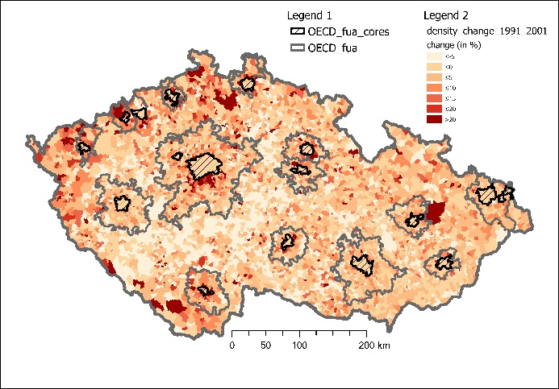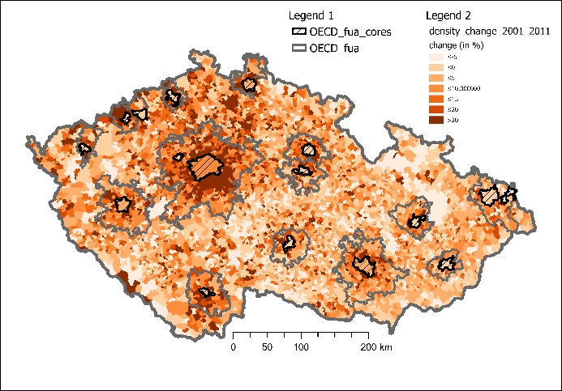
Fig. 1. Change in population density in the period 1991 to 2001 (left) and 2001 to 2011 (right) (in %, CZSO, 1991, 2001)

Our study focuses on suburbanisation costs that are handled primarily on the municipal level. Thus our research question corresponds with the costs to develop and manage new usually residential areas in the municipalities in the vicinity of metropolitan cores compared to other municipalities. Our motivation for analysing the costs of suburbanisation in the Czech Republic at the municipal level comes from the overlooked long-term costs of developing lower-density residential areas. Representatives often disregard these costs with the prospect of higher municipal tax revenues that result from a higher municipal population. From our point of view, the direct environmental costs (showed directly in municipal accounting) of such development are not insignificant, but they can occur with some delay.
In the following parts of the paper, we first provide a part “2 Literature review” on the environmental impacts of suburbanisation and environmental protection with its interconnections to financial accounting on the local or municipal level. In the next part, “3 Data” and methods, we show different environmental accounting systems reflected in the Czech public accounting system. This system corresponds with the following description of the critical financial database we use for our analyses. Then we show in part “4 Results” that the most vital environmental costs handled on the municipal level lies in water protection (4.1), waste management (4.2) and landscape and biodiversity protection (4.3). The next part of the paper represents results consequently in these three areas. In part “5 Discussion”, we discuss particularities and limits of our research, and in part “6 Conclusion”, we provide key findings and the potential to further research and application for the public sector budgetary system.

2. Literature review
There is a vast literature on the environmental impacts or consequences of suburbanisation. Burchell et al. (1998) assessed the cost of urban sprawl in several areas: public and private investment and operating costs, transportation and travel costs, land and natural habitat preservation costs, impacts on quality of life, and consequences in social issues related to living in the suburbs. Adelmann (1998) specified before all environmental impacts of suburbanisation with loss of farmland (Liang et al., 2015), excessive removal of native vegetation and as a result, reduced diversity of species (confirmed by Wang et al., 2017). Associated impacts are an increased proportion of non-permeable surfaces and, consequently, increased stormwater runoff and a higher risk of flooding (Hardi et al., 2020). Johnson (2001) categorised other environmental impacts corresponding with previous studies with loss of environmentally fragile lands, reduced regional open space, more significant air pollution, higher energy consumption, decreased aesthetic appeal of landscape corresponding with the monotonous (and regionally inappropriate) residential visual environment. Margules and Meyers (1992) also emphasise ecosystem fragmentation usually associated with the transport infrastructure, but of course, suburbanisation is accompanied strongly by transport networks development. Novak and Wang (2004) analysed the impacts of suburban sprawl on Rhode Island’s landscape. They found that the land transition in the study area contributed to the scarification of forest land and consequently to a declination of the ecological connectivity. Forest fragmentation by urban sprawl was confirmed even in rural areas by Radeloff et al. (2005).
Environmental protection is a multi-objective issue for local government. Jia Lin Ni et al. (2014) distinguished between three levels: macro-environment, mid-range environment (often referred to as meso-environment) and micro-environment. The macro-environment is mainly studied in large communities, for example, from a national or transnational perspective. Jia Lin Ni et al. (2014) drew attention to the very heterogeneous conditions and the associated great variety of data with many common relations that have to be cautiously and sensitively interpreted. The mid-range environment relates to a small group of individuals, for example, within a region or municipality, while the micro-environmental level is understood as one person’s environment (Jia Lin Ni et al., 2014). Miškolci (2013) has said that the state and development of the environment have time and space dimensions:
- The spatial dimension of the environment speaks of the different nature of environmental problems in defined areas. Depending on the intensity, concentration, dissemination and options of addressing environmental impacts, local, regional (and interstate) and global problems can be distinguished;
- The time dimension of the environment recognises that approaches to the origin and solution of environmental problems are conditioned historically and socially. Future developments and the lives of future generations are largely influenced by the long-term use of natural resources and other environmental interventions.

In approaching the comprehensive protection of natural resources, it is crucial that individual actors are involved. The most important of these are, of course, states that set up a legislative framework, global corporations and national businesses (Surroca et al., 2010) that optimise the locations of their activities or divisions according to differing legislation. However, less important actors also play a relevant role, whose importance is determined by the number of subjects. On the one hand, it is not only about end-users but also about entrepreneurs or small and medium-sized enterprises whose research is often targeted, for example, on the tourism sector in relation to local development (Mondéjar-Jiménez. 2016). Nevertheless, the emphasis on eco-innovation in this sector is less than in the industrial sector (Brandenburg, 2015). On the public-sector side, individual regions, towns or municipalities, which often have to deal with conflicting goals, play an important role. An example is tourism that has positive local impacts on employment and services, but places an increased burden on the environment (Mondéjar-Jiménez et al., 2016). The municipal view is a key aspect of this article.
Spending on the environment is the cornerstone of its protection and a widely debated issue, focusing primarily on corporate or business spending (Vargas-Vargas et al., 2010) and national spending. Less explored is public expenditure at a regional or municipal level. There are many self-governing entities within one national economy – in the case of the Czech Republic, 14 regions and 6,255 municipalities. The management of these entities causes the duplication of some activities within the economy as a whole and involves additional transactional costs (Pannell et al., 2013). This paper examines how the system of municipal environmental accounting is set up (Hajek, 2003) and its relation to environmental protection (Soukopova and Bakos, 2013) with an emphasis on expenditure (Heideri, 2012) and the possibilities of its evaluation (Sarra et al. 2017). Using this approach, it is possible to use financial indicators and their geographical visualisation to evaluate their effectiveness and to outline other relevant relationships (Hajkowicz et al., 2005).
We see a certain gap regarding our specific research focus on municipal environmental expenses concerning population changes in suburban areas. It is partly discussed in the Czech context with results provided by Maštálka and Valíková (2014). They showed in the Pardubice metropolitan area that there is no statistically significant relationship between population increase in suburbs and the increase of total municipal operating profit/result expected by municipalities supporting the development of residential areas. In Spain, Hortas‐Rico (2014) analysed the relationship between urban sprawl and local budget using data for 4,000 Spanish municipalities from 1994 to 2005 with the conclusion that sprawl considerably increases demand for new infrastructure. Gielen et al. (2021) calculated the effect of urban sprawl on the local administration’s expenditure, particularly on the cost of essential public municipal services for 542 municipalities in the Autonomous Community of Valencia. They showed that urban sprawl has a significant and positive effect on the unit cost of local public services, which results in inefficient urban growth from the economic point of view. Their results show which kinds of municipal services are highly cost-sensitive to urban sprawl areas, and these are, e.g. waste management, water supply and distribution, road cleaning or public lighting. These results correspond highly with our research, and we consequently enrich these areas with public greenery and calculate the cost differences.

3. Data and methods
Soukopová (2011) identified the level of spending as one of the key indicators for assessing the level of environmental care, creating healthy living conditions and the prerequisites for economic growth, both at the national, regional and municipal level, as well as at the corporate level. In general, environmental expenditure can be characterised as expenditure on actions and activities aimed at the prevention or subsequent elimination of environmental damage (Soukopová, 2011). According to environmental protection expenditure accounts (EPEA), environmental expenditure goes on activities aimed at preventing, reducing or eliminating pollutant production and release, as well as remediating the damaged environment. One of the basic criteria is that environmental protection is the primary objective of these activities. Activities that have a positive impact on the environment, but whose primary objective is not environmental protection, are not included in environmental activities. Environmental expenditure is further characterised by:
- environmental protection (CEPA, SERIEE, 1994);
- funding sources;
- types of expenditure (Soukopová and Bakoš, 2013).

Environmental-economic accounting (EEA) provides a conceptual framework for integrating environmental statistics and their relationship to the economy, including the environmental impacts of the economy and its economic benefits. A relatively comprehensive set of indicators and descriptive statistics on the so-called “green economy”, natural resources and sustainable development (United Nations Statistics Division, 2014) can be derived from these accounts. The System of Environmental-Economic Accounting (SEEA) contains internationally agreed terms, definitions, classifications and accounting rules for the production of internationally comparable environmental data and their relationship to the economy. The SEEA is the most flexible system in the sense that implementation of its rules can reflect in each country its specific and current situation and priorities. The UN Committee of Experts on Environmental-Economic Accounting (UNICEEA) oversees the SEEA (United Nations Statistics Division, 2016). The introduction of the SEEA to the EU member states in 1993 has meant that the above-mentioned internationally comparable indicators have already been developed. These include, e.g. CEPA (SERIEE, 1994), the Classification of Environmental Protection Facilities (CEPF, Eurostat, 2002) and the Classification of Resource Use and Management Activities and expenditure CRUMA (SERIEE, 2002; Falticelli and Ardi, 2007).
Our research approach corresponds with the CEPA classification, which uses EPEA, environmental protection expenditure accounting, which was compiled to answer the following questions:
- How many companies and how many consumers pay, and in what form, for the protection of the environment?
- How is it financed and by what bodies (analysis of the financial sources of this expenditure)?
- What are the economic activities aimed at protecting the environment (analysis of the environmental protection services provided)? (Eurostat, 2002).

CEPA is a general, multipurpose, functional and the most commonly used classification of environmental protection expenditure. It is used to classify activities as well as products, actual expenditure and other environmental-related transactions (SERIEE, 2002). It includes the following areas of nature protection: air and climate protection, wastewater management, waste management, the protection and management of soil, groundwater and surface water, the reduction of noise and vibration, the protection of biodiversity and landscape, protection against radioactivity, science and research, other environmental protection activities, the administration and regulation of environmental protection, education, training and information activities related to indivisible expenditure and activities not elsewhere classified (SERIEE, 2002).
Reflection of the environmental accounting system in the Czech public accounting system is shown in Table 1. The dataset used in our study from the State Treasury Monitor of Ministry of Finance in the Czech Republic (2017b) is based on this accounting scheme. It is our study’s critical financial data source.
Table 1. Structure of environmental protection expenditure
Category: | Paragraph: | Description:
Water protection | 2321  2322  2329  2331  2333 | Drainage and treatment of sewage, sludge  Prevention of water pollution  Drainage and wastewater treatment (not elsewhere classified).  Modifications of water management of watercourses (reconstructions etc.)  Adjustment of small watercourses
Air protection | 2115  2542  3711  3712  3713  3714  3715  3716  3719 | Warming and energy-saving programmes  Meteorology  Removal of solid emissions  Gaseous emissions  Changes in heating technology  Measures to reduce greenhouse gas production  Changes in production technologies to eliminate emissions  Monitoring of air protection  Other air protection activities
Waste management | 2122  3721  3722  3723  3724  3725  3726  3727  3728  3729 | Collection and processing of secondary raw materials  Collection and transport of hazardous waste  Collection and transport of municipal waste  Collection and transport of other wastes  Use and disposal of hazardous waste  Use and disposal of municipal waste  Use and disposal of other waste  Prevention of waste generation  Waste management monitoring  Other waste management
Soil and groundwater protection | 2342  2541  3731  3732  3733  3734  3739 | Anti-rooting protection  Geology  Soil and groundwater protection against polluting infiltrations  Soil decontamination and groundwater purification  Soil and groundwater monitoring  Prevention and remediation of salinisation  Other protection of soil and groundwater
Protection of biodiversity and landscape | 1037  2334  3741  3742  3743  3744  3745  3749 | Complex socio-economic functions of forests  Revitalisation of river systems  Protection of species and habitats  Protected parts of nature  Recultivation of land as a result of mining activities  Anti-erosion, anti-avalanche and fire protection  Caring for the appearance of villages and public greenery  Other activities for nature and landscape conservation
Reduction of physical effects  factors | 3751  3753  3759  3771  3772  3773  3779 | Design and application of anti-noise devices  Monitoring to detect noise and vibration levels  Other noise and vibration control activities  Anti-radon measures  Radioactive waste  Monitoring to detect the level of radiation  Other radiation protection activities
Environmental protection administration | 3761  3762  3769 | Central Government Administration in Environmental Protection  Other organisations of state administration in environmental protection  Other ecology management
Other ecological activities | 3780  3791  3792  3793  3799 | Environmental research  International cooperation on the environment  Ecological education  Environmental programmes in transport  Ecological issues and programmes
Source: Decree 323/2002 of Ministry of Finance (2017a).
The data presented in Table 1 above covering the period from 2010 to 2015 includes 6,581,924 financial transactions related to self-government expenses and earnings in the Czech 6,255 municipalities from which relevant transactions on environmental expenses, according to Table 1, has been extracted and then analysed. The year 2010 is the launching year of the State Treasury Monitor of the Ministry of Finance. Thus, older data are not available in acceptable format and detail to analyse a more extended period starting before 2010. That would potentially enable a more precisely study period corresponding with increasing pressure on metropolitan areas identified below after 2000.
To identify the costs of suburbanisation in municipalities the OECD metropolisation database was used (OECD, 2020) and, according to OECD methodology, we defined three categories of municipality in the Czech Republic:
- OECD functional urban centres comprising 15 cities or towns (Brno, Chomutov, Jihlava, Liberec, Most, Olomouc, Ostrava, Pardubice, Zlín, Praha, Plzeň, Karlovy Vary, České Budějovice, Hradec Králové, Ústí nad Labem)
- situated in OECD functional urban areas (abbreviation “FUA”);
- municipalities not situated in OECD functional urban areas (abbreviation “NON-FUA”).
This categorisation allows identifying the real cost differences and contributes to answering the question whether it is more costly for a municipality to be situated near a metropolitan centre (at least as regards environmental protection expenses). Focused municipalities lie in the OECD metropolitan functional urban areas (OECD FUAs) that covers 2,495 municipalities, from which 15 are metropolitan cores that are not subject to the suburbanisation process. Thus, these OECD FUAs excluding metropolitan cores includes 2,480 municipalities from 6,255, which means 39,6 % of all municipalities in the Czech Republic. As an indicator of suburbanisation, we used the change of population density (presented in %).
The research for this paper examined the cost of suburbanisation as reflected in municipal expenditure on environmental protection in the Czech Republic. According to the financial or budget importance and relevance to the municipal self-government agenda, three principal areas are considered: water protection, waste management and the protection of biodiversity and the landscape. The relevance of these areas is shown in Fig. 2, which sets out the structure of municipal environmental expenditure (according to Table 1). The analysis includes 6,255 municipalities in the Czech Republic.

Fig. 2. Structure of municipal expenditure on the environment 2010–2015 (%). Source: Ministry of Finance (2017b).

There has been a trend of rising municipal environmental expenditure over the years, which was mildly disrupted by a decline in 2012 and 2013, years in which the Czech Republic faced an economic crisis and many economic activities declined (including the protection of the environment). Fig. 3 shows environmental expenditure in the period 2010–2015. It shows that municipalities allocated more funds to operating expenditure than investment.

Fig. 3. Municipalities’ operating and investment expenditure on environmental protection in the Czech Republic in the period 2010–2015. Source: Ministry of Finance (2017b), CZSO (2020), own elaboration.

4. Results
In the following part of the paper, we consequently provide results on three key areas where municipalities spend their expenses as shown in Fig. 2: water protection, waste management and biodiversity and landscape protection corresponding with municipal public greenery.

4. 1. Water protection
One of the issues in the Czech Republic associated with global climate change is the threat of water shortage, presaged by regular summer droughts. Water management is becoming a strategic issue for most countries, not only as a result of resource depletion but also due to continuing metropolisation that creates suburban zones and affects water quality (Yang et al., 2013). Fig. 4 shows average municipal operating and investment expenditure on water protection.
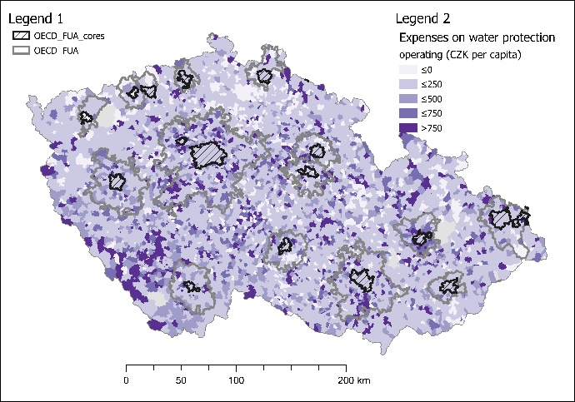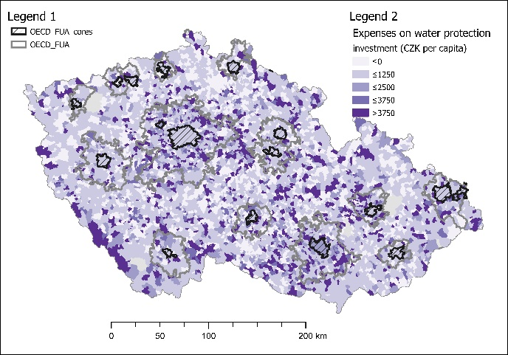
Fig. 4. Yearly arithmetic average of operating (left) and investment (right) expenditures per capita on water protection by municipalities in the Czech Republic in 2010 to 2015. Source: Eurostat (2020), CZSO (2020), Ministry of Finance (2017b), own elaboration.

The black hatched areas at the location of large cities (OECD metropolitan core centres) and their surroundings indicate values ​​up to CZK 250 per inhabitant for operating expenditure and up to 1,250 CZK per inhabitant for investment, the former including around Prague and Brno but apparently not Ostrava. Overall results show that municipalities in functional urban areas (FUAs) on average pay up to 17% more for water protection than municipalities not situated in FUAs. On the other hand, metropolitan centres pay only 19% as much as NON-FUA municipalities, which means there are large economies of scale. The highest additional costs for suburban water protection are paid near Olomouc (76% more), Prague (50%) and Brno (47%).
The available data show that the level of expenditure on water protection is inversely related to the population of the municipality – the smaller the population, the greater the average per capita expenditure. To demonstrate this relationship, it is necessary to take into account the uneven distribution of municipalities in the individual size categories, which stems from the fact that most municipalities in the Czech Republic are small, so they fall into size categories of up to 300 and up to 1,000 inhabitants. For this purpose, Fig. 5 shows the average results for all municipalities by size category in the period 2010–2015 and this new average therefore shows the link between the population of the municipality and the average expenditure per capita. There is a step-change at the 5,000-inhabitant level. The fact that larger municipalities spend less per capita on water protection on average is because of the fixed costs involved in constructing wastewater treatment plants. Large municipalities need to spend the same minimum amount as small municipalities, but serve a larger number of inhabitants, so there are some economies of scale and the final average amount per capita is therefore lower for larger municipalities than for municipalities under 5,000.

Fig. 5. The influence of municipality population on average expenditure per capita on water protection. Source: Ministry of Finance (2017b), CZSO (2020), own elaboration.

4.2. Waste management
Waste management is a key issue in the consumption of environmental resources, and intersects the entire hierarchical structure of economic chains. This area is important for a wide range of actors from global corporations and supranational organisations to individual cities and municipalities (Turan, 2016; Inglezakis, 2016). The long-term goal is to achieve a circular economy (Verger, 2017; Moreau et al., 2017; Murray et al., 2017), which is characterised by recycling as much as possible of waste products (Del-Moral-Ávila, 2016). Waste-management costs are one of the most important items of municipal budgets. The size of the municipality and the range of services it provides in waste management influence the cost. The differences in the amounts spent by municipalities for these services are enormous, although the range of services provided by individual municipalities in the Czech Republic is similar (Soukopová and Malý, 2012). Waste management accounts for more than 50 % of all operating expenditure (in municipalities up to 500 inhabitants) on environmental protection and more than 4% of total municipal budgets. For municipalities of up to 500 inhabitants, it represents more than 6% of total operating expenditure, a very significant proportion.
The cost of waste management is increasing, especially the cost of collecting and sorting waste; and the number of waste collection points is also increasing due to suburbanisation. More frequent waste collections are needed; the subsequent processing and disposal of waste is an expanding business. Since effective waste disposal improves the quality of life for citizens, the principles not only of efficiency but also of effectiveness need to be emphasised.
Our results regarding expenditure on waste management show that, unlike the previous case study on water protection, this service is provided at a lower cost in functional urban areas (FUAs) compared to NON-FUAs. FUAs provide this service 1.87% less costly compared to nationwide municipality average while for NON-FUAs it is 1.32% more expensive. Seemingly the difference is not very significant. The highest costs compared to the municipality average can be found in the following FUA areas: Most (64%), then Zlín (16%) and Chomutov (15%). In Prague, costs are higher but only by about 7%. FUA centres again confirm the importance of economies of scale in providing waste services – they reach an average level of 78% compared to the nationwide municipality average.
The colour distribution in the operating expenditure map (Fig 6) coincides almost exactly with the borders of Bohemia, Moravia and Silesia. In Bohemia (western part) and Silesia (north-east), higher operating expenditures are shown, in contrast to higher investment expenditure in Moravian municipalities (south-east).
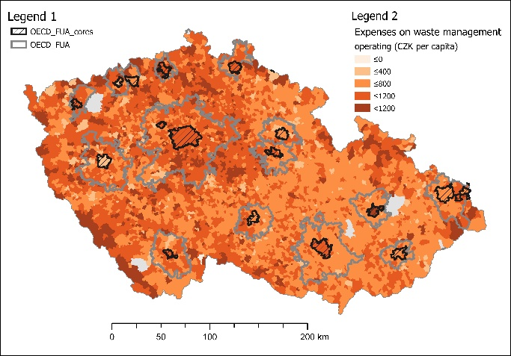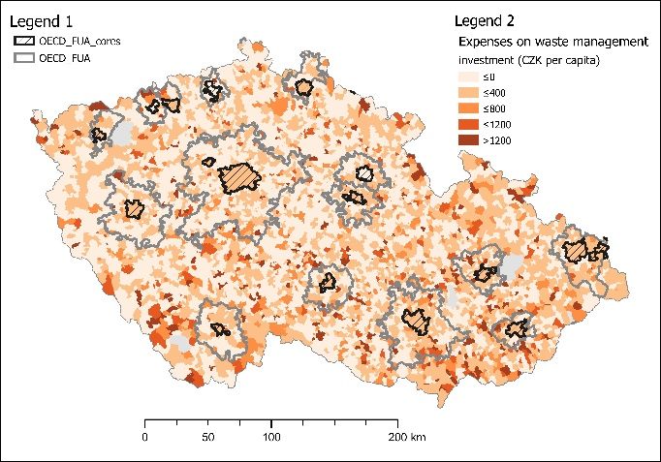
Fig. 6. Yearly arithmetic average operating (left) and investment (right) expenditure per capita on waste management by municipalities in the Czech Republic in 2010 to 2015. Source: Eurostat (2020), CZSO (2020), Ministry of Finance (2017b), own elaboration.

Municipalities in Bohemia and Silesia outsource many more of their waste management services from private companies than in other regions. In contrast, Moravian municipalities provide waste management services in-house, resulting in greater investment expenditure and lower operating expenditure. Another possible explanation for very high expenditure in some areas is that these places are predominantly found in hilly locations where they are more likely to face worse geographical and weather conditions; additionally, they often lie in nationally protected areas. This results in higher operating costs due to more complex waste management logistics. The investment by municipalities in waste management visible in Fig. 6 shows, as is generally held, that municipalities spend significantly less on investment than operating expenditure in the area of waste management.
When we look at costs per capita, we see that population size doesn’t influence average expenditure on waste management, in contrast to the cost of water protection. In waste management, operating costs are decisive, and these are directly proportional to the amount of waste produced, which in turn is directly related to the population of the municipality. Average per capita spending on waste management was thus about the same in all size categories of municipality in the Czech Republic in 2010–2015 (see Fig. 7).

Fig. 7. The influence of municipal population on average expenditure per capita on waste management. Source: Ministry of Finance (2017b), CZSO (2020), own elaboration.

4.3. Protection of biodiversity and landscape
The last case of non-marginal environmental municipality expenditure in the Czech Republic is biodiversity protection. Despite the fact that nature conservation is primarily the domain of the administrations of national parks, protected landscape areas, and the Nature and Landscape Conservation Agency, municipalities spend considerable amounts not only on public green maintenance to improve people’s quality of life, but also on bio-corridor systems that serve as natural infrastructure of overriding importance (Peimer et al., 2017; Grodzinska-Jurczak and Cent, 2011). Fig. 8 shows many areas with a zero or very small average amount of operating and investment expenditure on the protection of biodiversity and landscape, indicating that investment in this category of environmental protection is not a high priority for most municipalities in the Czech Republic.
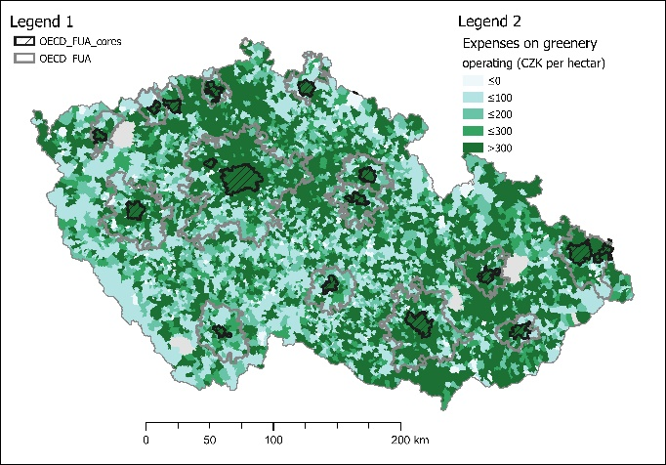
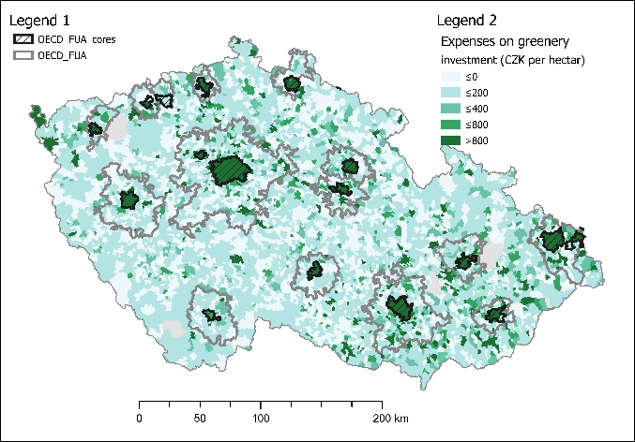
Fig. 8. Yearly arithmetic average operating (left) and investment (right) expenditure per hectare on protecting biodiversity and landscape by municipalities in the Czech Republic in 2010 to 2015. Source: Eurostat (2020), CZSO (2020), Ministry of Finance (2017b), own elaboration.

The overall results on protecting biodiversity and landscape indicate the significance of this environmental component as municipalities in FUAs show 30% more costs but this significance seems to be restricted to urban centres, which spend 20 times more than non-urban areas.
The highest average operating expenditures for the protection of biodiversity and landscape were found in the municipalities of Horní Bříza (28,855 CZK/ha), Prague (23,662 CZK/ha), Valdice (21,298 CZK/ha), Mladá Boleslav (20,728 CZK/ha), Teplice (18,655 CZK/ha), Liberec (14,839 CZK/ha), Havířov (14,137 CZK/ha), Plzeň (11,813 CZK/ha), Prostějov (11,703 CZK/ha) and Modrá (11,001 CZK/ha), while the average for all municipalities was about 630 CZK/ha. This list of the top ten spending municipalities comprises before all of statutory cities/towns (thus larger towns or cities) and several villages – Horní Bříza in the Plzeňský region with 4,200 inhabitants, Valdice in the Královéhradecký region with 1,400 inhabitants and Modrá in the Zlín region with 700 inhabitants. The village of Modrá lies in the landscape-protected area of Chřiby and is known for its historical and cultural value. In the village there are important archaeological sites from the times of Great Moravia, which are now open to the public through the Archeoskanzen Modrá, which falls under the administration of the municipality (Modrá, 2015). Maintaining the open-air museum, taking care of the landscape and botanical garden “Living Water” could explain the municipality’s significant expenses. The village of Valdice is located close to the landscape-protected area of Český ráj (Bohemian Paradise), more precisely outside the Prachovské Skály Nature Reserve, so the costs of nature protection are fully borne by the municipality, and this is probably reflected in the amount of its expenditure for this area of environmental protection. Primacy in average costs, however, belongs to Horní Bříza, which includes some of the largest deposits in the Czech Republic of kaolin, a clay used in ceramics and papermaking. Some deposits have been exhausted, and in 2013 the Ministry of the Environment submitted a proposal for the creation of a new mining area (Ministry of Environment, 2013). Reclamation of the original quarries involves spending from the municipal budget, which is included in expenditure for the protection of biodiversity and the landscape under paragraph 3743: Recultivation of land as a result of mining and mining activities. The highest average spending of all municipalities in the Czech Republic suggests that recultivation is ongoing. Data analysis, however, shows that, when accounting for spending on biodiversity and landscape protection, Horní Bříza has mistakenly included only items covered by paragraph 3745: Care for the appearance of municipalities and public greenery; and paragraph 3749: Other nature and landscape conservation activities. These paragraphs are widely used in municipality accounting. However, in no other is the expenditure on items in these paragraphs so high.

5. Discussion
Analysis revealed that in the period 2010–2015 the municipalities of the Czech Republic allocated most environmental spending to water protection, waste management and the protection of biodiversity and landscape. In contrast, the protection of soil and groundwater, air quality protection and the reduction of physical factors were only marginal categories and were allocated minimum financial resources. Total annual municipal spending in each year oscilated around 18 billion CZK for operating expenditures and 16 billion CZK on investment (see Fig 3). Thus, total municipal operating expenditure on environmental protection exceeded the amount of investment; the only exception was in 2015 when investment was higher by about CZK 200 million. This was due to the final draw-down of finance from European structural funds for the period 2007–2014. A sufficient supply of clean water is crucial for life on Earth and municipal spending to ensure sustainable access to water is very high. Analysis of this expenditure reveals that most of it goes on drainage and sewage treatment. When constructing wastewater treatment plants, fixed costs are similar for all municipalities, so proportionately cheaper for large cities than for less populous municipalities. A point of step-change was found in the range of municipalities of different sizes: those with populations of less than 5,000 showed significantly higher average expenditure per capita than more populous municipalities. Analysis shows much higher expenditure on water protection in the surroundings of large metropolitan cities such as Prague, Brno, Ostrava and Pilsen. Neighbouring municipalities face strong suburban influence from these economic centres. The paper shows that municipal development activities of new residential suburban areas are highly connected to the increasing water protection expenditures.
A different situation was found in the case of waste management. Here, the main expenditure is on waste collection and disposal, the amount of which is directly proportional to the amount of waste produced, which depends on the number of residents. The average per capita expenditure on waste management in the municipalities of the Czech Republic was approximately the same for all size categories. The cost of waste management showed a growing trend, which can be expected with increasing consumption and thus increasing waste, but the similarly increasing investment expenditures were marked by a decline in 2013, when the Czech economy experienced an economic crisis.
The third significant item of environmental expenditure by municipalities is for the protection of biodiversity and landscape, which means taking care of the appearance of the area and public greenery. The greatest level of expenditure in this category was by the village of Horní Bříza, which includes the largest deposits of kaolin. Some of these have been exhausted, while new mines are being created and the original ones are undergoing a process of land reclamation as a result of mining activities, which is also the title of one of the paragraphs in the area of ​​biodiversity and landscape protection. Therefore, it seems natural that the municipality would show increased expenditure under this heading. It was found, however, that the municipality recorded, probably mistakenly, disproportionately high expenditures only under the headings of municipal appearance and public greenery and other activities for nature and landscape protection. In general, the budgets of specially protected areas of the Czech Republic, such as national parks or other landscape-protected areas, also include ​​biodiversity and landscape protection, so the total expenditure of municipalities in this category does not reach the same level as in the case of water protection.

6. Conclusions
Our research focuses on identifying direct environmental costs of suburbanisation on the municipal level with emphasis on distinguishing municipalities in the metropolitan areas and the rest of the country. In assessing municipal expenditure disparities from 2010 to 2015 and identifying a way to evaluate their relevance, this paper has shown key areas of municipality expenditure on environmental protection in the Czech Republic, including all 6,255 municipalities. These are water protection, waste management and biodiversity and landscape protection, often corresponding with public greenery. Less populous municipalities are at a disadvantage in paying for water protection than larger ones, as they cannot achieve the same economies of scale. Smaller municipalities with less than five thousand inhabitants pay at least twice more than bigger ones (in some cases even four times). Both in water protection and biodiversity and landscape protection, research shows how municipalities in Czech metropolitan areas are under pressure from suburbanisation and how this leads to municipal budgets with both more significant investment and higher operating costs to provide essential city services such as sewage systems and wastewater treatment plants or to manage public greenery. Especially in water protection, municipal costs per capita in metropolitan areas (defined as OECD functional urban areas) are 17% higher than in other municipalities.
On the other hand, metropolitan centres (such as Prague, Brno, regional centres and relevant district centres) achieve significant economies of scale and bring costs to one-fifth compared to municipalities outside functional urban areas. Regarding biodiversity and landscape protection, the situation is different because the costs are highest in metropolitan centres, but we can see the same tendency showing that costs for this service in metropolitan areas are higher than in the rest of the country. This pattern is not identified in waste management, where urban areas are on a very similar cost level to the rest of the country.
The paper shows a basic approach to comparing the large number of municipality budgets and provides a key evaluation framework that reveals it is possible to increase the quality of municipality financial management not only in view of efficiency (“doing things right”) but also in Drucker’s (1967) view of “effectiveness as doing the right thing”. In this context, our results provide essential findings providing evidence that the phenomenon of suburbanisation leads to higher direct environmental costs and burdening municipal budgets in relevant areas in long-term periods, including many years. Public sector representative often disregards this effect. Our findings also show there is potential in the public sector budgetary framework to find a more effective system of financing environmental services on the municipality level. Simply, general budgetary rules are not respecting significant municipal disparities corresponding with local conditions and population categories. Our results raise some follow-up questions for further research. One of these areas is, of course, analysing an even more extended period regarding at least one decade between two population Censuses (e.g., 2011 and 2021, when the results will be available) as a critical research enlargement is also to enrich the analysis of more factors leading to higher costs such as altitude or slope of the terrain. To be able to cover the total municipal costs of suburbanisation, it is important to search for other relevant costs that correspond with the approach of Guilen et al. (2021).

Reference
Adelmann, G. W. 1998. Reworking the landscape, Chicago style. The Hastings Center Report, 28(6), S6-S11.
Ahlfeldt, G. M., and A. Feddersen. 2018. From periphery to core: measuring agglomeration effects using high-speed rail. Journal of Economic Geography 18(2): 355-390.
Biolek, J., Andráško, I., Malý, J., & Zrůstová, P. 2017. Interrelated aspects of residential suburbanization and collective quality of life: A case study in Czech suburbs. Acta geographica Slovenica, 57(1), 65-75.
Brandenburg, M. 2015. Low carbon supply chain configuration for a new product - a goal programming approach. International Journal of Production Research 21(SI), 6588-6610.
Brueckner, J. K. 2000. Urban sprawl: Diagnosis and remedies. International Regional Science Review 23(2): 160-171.
Burchell, R., Shad, N. A., Listokin, D., Phillips, H., Downs, A., Seskin, S., Davis, J.S., Moore, T., Helton, D., Gall, M. 1998. The costs of Sprawl. Revisited. Transportation Cooperative. Research Program Report. 39.
Camagni, R. 2009. Territorial Impact Assessment for European regions: A methodological proposal and an application to EU transport policy. Evaluation and Program Planning 32(4): 342-350.
CZSO. 1991. Population Census Data. Historical lexicon of municipalities of the Czech Republic - 1869 – 2011. https://www.czso.cz/csu/czso/historicky-lexikon-obci-1869-az-2015.
CZSO. 2001. Population Census Data. Historical lexicon of municipalities of the Czech Republic - 1869 – 2011. https://www.czso.cz/csu/czso/historicky-lexikon-obci-1869-az-2015.
CZSO. 2011. Population Census Data. Historical lexicon of municipalities of the Czech Republic - 1869 – 2011. https://www.czso.cz/csu/czso/historicky-lexikon-obci-1869-az-2015.
CZSO. 2020. Population in Municipalities – 1 January 2020. https://www.czso.cz/csu/czso/population-of-municipalities-1-january-2019
Del-Moral-Ávila M.J. 2016. Study of an annual waste recycling index in Spain. Environmental Engineering and Management Journal 15(7), 1465-1472.
Drucker, P. 1967. The effective executive. Harper Row: New York.
Edmonston, B., & Davies, O. 1976. Population suburbanization in the Western Region of the United States, 1900-1970. Land Economics, 52(3), 393-403.
EU, Committee of the Regions. 2015. Renewed Territorial Impact Assessment Strategy.
Eurostat 2020. Administrative units/Statistical units. https://ec.europa.eu/eurostat/web/gisco/geodata/reference-data/administrative-units-statistical-units.
Eurostat 2002. Environmental protection expenditure accounts: results of pilot applications. Office of Official Publications of the European Communities: Luxembourg.
Eurostat. 1994. Système européen pour le rassemblement de l’information économique sur l’environnement SÉRIE 8E. Office statistique des Communautés européennes: Luxembourg.
Eurostat. 2002. Environmental Protection Expenditure Accounts – Compilation Guide. Office of Official Publications of the European Communities : Luxembourg.
Ewing, R. 1997. Is Los Angeles-style sprawl desirable?. Journal of American Planning Association 63(1): 107-126.
Falticeli, F. and C. Ardi. 2007. The Classification of Resource Use and Management Activities and expenditure (CRUMA). Istat - Resource Use and Management Expenditure Accounts of SERIEE: Rome.
Franke, D. 2015. Development of suburbanization in the hinterland of Prague monitored by remote sensing. In 15th International Multidisciplinary Scientific Geoconference SGEM 2015, pp. 1027-1034.
Gielen, E., Riutort-Mayol, G., Miralles i Garcia, J. L., & Palencia Jimenez, J. S. 2021. Cost assessment of urban sprawl on municipal services using hierarchical regression. Environment and Planning B: Urban Analytics and City Science, 48(2), 280-297.
Goodling, E., J. Green, and N. McClintock. 2015. Uneven development of the sustainable city: shifting capital in Portland, Oregon. Urban Geography 36 (4): 504-527.
Grodzinska-Jurczak, M., and J. Cent. 2011. Expansion of Nature Conservation Areas: Problems with Natura 2000 Implementation in Poland?. Environmental Management 47(1), 11-27.
Hajek M. 2003. Structure of environmental public expenditure in the CR. Finance a uver 53(1-2), 60-74.
Hajkowicz S., J.M. Perraud. and W. Dawes. 2005. The strategic landscape investment model: a tool for mapping optimal environmental expenditure. Environmental modelling & software 20(10), 1251-1262.
Hardi, T., Repaská, G., Veselovský, J., & Vilinová, K. 2020. Environmental consequences of the urban sprawl in the suburban zone of Nitra: An analysis based on landcover data. Geographica Pannonica, 24(3), 205-220.
Hawley, A. H. 1951. Metropolitan population and municipal government expenditures in central cities. Journal of Social Issues, 7(1‐2), 100-108.
Heidari, I. 2012. Environmental management accounting with an emphasis on it cost. Life science journal-acta zhengzhou university overseas edition 9(4), 511-517.
Hortas‐Rico, M. 2014. Urban sprawl and municipal budgets in S pain: A dynamic panel data analysis. Papers in Regional Science, 93(4), 843-864.
Inglezakis V. 2016. Waste management in Romania: operating data and application of a decision support tool. Environmental Engineering and Management Journal 15(3), 511-519.
Johnson, M. P. 2001. Environmental impacts of urban sprawl: a survey of the literature and proposed research agenda. Environment and planning A, 33(4), 717-735.
Kubeš, J. 2015. Analysis of regulation of residential suburbanisation in hinterland of post-socialist'one hundred thousands' city of České Budějovice. Bulletin of Geography. Socio-economic Series, (27), 109-131.
Liang, C., Penghui, J., Manchun, L., Liyan, W., Yuan, G., Yuzhe, P., ... & Qiuhao, H. 2015. Farmland protection policies and rapid urbanization in China: A case study for Changzhou City. Land use policy, 48, 552-566.
Margules, C. R., & Meyers, J. A. 1992. Biological diversity and ecosystem fragmentation--an Australian perspective. Ekistics, 59(356-357), 293.
Maštálka, M., Valíková, N. 2014. Context of suburban trends in the Pardubice region in 17th International Colloquium on Regional Sciences, pp.683-689.
Ministry of Environment. 2013. Stanovení dobývacího prostoru Kaznějov III a dobývání další části výhradního ložiska kaolinů Kaznějov – jih 2 a části ložiska Horní Bříza Trnová [Determination of Kaznějov III mining area and extraction of the next part of the Kaznějov - South 2 kaolin deposit and bearing parts Horní Bříza Trnová]. Informační systém EIA: Prague.
Ministry of Finance. 2017. Decree 323/2002 of Ministry of Finance.
Ministry of Finance. 2018. State Treasury Monitor in Czech Republic 2017. https://monitor.statnipokladna.cz/datovy-katalog/transakcni-data
Miškolci, S. 2013. Environmentální politika v regionálním rozvoji: teoretická východiska, koncepce a nástroje [Environmental Policy in Regional Development: Theoretical Basis, Concepts and Tools]. Mendel University: Brno.
Modrá. 2015. Program rozvoje obce Modrá na období od 2016 do 2025 [Municipality Development Program on the period 2016 to 2025]. Municipality of Modrá: Czech Republic.
Mondéjar-Jiménez J.A. 2016. World heritage cities declaration and sustainable development in European cities. Environmental Engineering and Management Journal 15(7), 1447-1454.
Mondéjar-Jimenez, J., C. Sevilla-Sevilla, and A. Garcia-Pozo. 2016. Environmental, social and economic dimension in the hotel industry and its relationship with consumer perception. Environmental Engineering & Management Journal 15(7): 1519-1526.
Moreau V., M. Sahakian, P. van Griethuysen, and F. Vuille. 2017. Coming Full Circle Why Social and Institutional Dimensions Matter for the Circular Economy. Journal of industrial ecology 21(3) Special Issue, 497-506.
Murray A., K. Skene, and K. Haynes. 2017. The Circular Economy: An Interdisciplinary Exploration of the Concept and Application in a Global Context. Journal of business ethics 140(3), 369-380.
Nevedel, L., Paril, J. 2014. Population growth in the hinterland regional cities in the Czech Republic in 2001-2011, 17th International Colloquium on Regional Sciences, pp.669-676.
Ni, J. L., L. Cai, and J. K. Wang. 2014. Application research on the coupled human-environment ecosystem vulnerability assessment in different spatial and temporal scales. Applied Mechanics 535, 255-265.
Nosek, Š. (2017). Nástroj Territorial Impact Assessment a jeho aplikace v českém prostředí. [Territorial Impact Assessment tool and its application in the Czech environment]. Urbanismus a územní rozvoj 20(5): 3-4.
Novak, A. B., Wang, Y. Q. 2004. Effects of suburban sprawl on Rhode Island's forests: A landsat view from 1972 to 1999. Northeastern Naturalist, 11(1), 67-74.
Obrebalski, M. 2017. Demographic potential in functional areas of the selected medium-sized cities in Poland and the Czech Republic. Geoscape, 11(1).
OECD. 2020. OECD Metropolitan areas in the world. https://www.oecd.org/regional/regional-statistics/metropolitan-areas.htm
Ourednicek, M. 2003. The suburbanisation of Prague. Sociologický časopis-Czech Sociological Review, 39(2), 235-253.
Pannell D. J., A. M. Roberts, and G. Park. 2013. Improving environmental decisions: A transaction-costs story. Ecological economics 88, 244-252.
Peimer, A., A. Krzywicka, D. Cohen, K. Van den Bosch, V.L. Buxton, N.A. Stevenson, and J. W. Matthews. 2017. National-Level Wetland Policy Specificity and Goals Vary According to Political and Economic Indicators. Environmental Management 59(1), 141-153.
Pendall, R. 1999. Do land-use controls cause sprawl?. Environment and Planning B – Planning & Design 26(4): 555-571.
Qin, Y. 2017. No county left behind? The distributional impact of high-speed rail upgrades in China. Journal of Economic Geography 17(3): 489-520.
Radeloff, V. C., Hammer, R. B., & Stewart, S. I. 2005. Rural and suburban sprawl in the US Midwest from 1940 to 2000 and its relation to forest fragmentation. Conservation biology, 19(3), 793-805.
Sarra, A., M. Mazzocchitti, and A. Rapposelli. 2017. Evaluating joint environmental and cost performance in municipal waste management systems through data envelopment analysis: Scale effects and policy implications. Ecological indicators 73, 756-771.
Soukopová J., and E. Bakos. 2013. Methodology and Information System for Evaluating Environmental Protection Expenditure Efficiency at the Local Level. Environmental software systems: fostering information sharing, IFIP Advances in Information and Communication Technology 413, 560-570.
Soukopová J., and I. Malý. 2012. Vliv konkurence na výši výdajů na nakládání s odpady obcí Jihomoravského kraje, [The impact of competition on the amount of expenditure on waste management in the municipalities of the South Moravian Region]. Waste Forum, Prague: CEMC 4, 173-183.
Soukopová, J. 2011. Výdaje obcí na ochranu životního prostředí a jejich efektivnost. Littera: Brno.
Stastna, M., Vaishar, A., Vavrouchova, H., Masicek, T., & Perinkova, V. 2018. Values of a suburban landscape: Case study of Podoli u Brna (Moravia), The Czech Republic. Sustainable Cities and Society, 40, 383-393.
Surroca, J., J.A. Tribo, and S. Waddock. 2010. Corporate responsibility and financial performance: The Role of Intangible Resources. Strategic Management Journal 31(5), 463-490.
Tammaru, T. 2001. Suburban growth and suburbanisation under central planning: The case of Soviet Estonia. Urban studies, 38(8), 1341-1357.
Turan N.G. 2016. Municipal solid waste characteristics and management in sinop, Turkey. Environmental Engineering and Management Journal 15(1), 13-18.
United Nations Statistics Division. 2014. System of Environmental-Economic Accounting. https://seea.un.org/sites/seea.un.org/files/seea_cf_final_en.pdf
United Nations Statistics Division. 2016. UN Committee of Experts on Environmental-Economic Accounting (UNCEEA).
Vargas-Vargas M., M.L. Meseguer-Santamaria, J. Mondejar-Jimenez, and J.A. Mondejar-Jimenez. 2010. Environmental Protection Expenditure for Companies: A Spanish Regional Analysis. International journal of environmental research 4(3), 373-378.
Verger Y. 2017. A Basis for Sraffian Ecological Economics. A Comment on Martins' "Ecosystems, Strong Sustainability and the Classical Circular Economy". Ecological economics 138, 249-251.
Wang, H., Shi, Y., Zhang, A., Cao, Y., & Liu, H. 2017. Does Suburbanization Cause Ecological Deterioration? An Empirical Analysis of Shanghai, China. Sustainability, 9(1), 124.
Woodbury, C. 1955. Suburbanization and suburbia. American Journal of Public Health and the Nations Health, 45(1), 1-10.
Yang, L.P., K. Mei, X.M. Liu, L.S. Wu, M.H. Zhang, J.M. Xu, and F. Wang. 2013. Spatial distribution and source apportionment of water pollution in different administrative zones of Wen-Rui-Tang (WRT) river watershed, China. Environmental Science and Pollution Research 20(8), 5341-5352.
Zevl, J. J., Ourednicek, M. 2021. Measuring the morphology of suburban settlements: Scale-dependent ambiguities of residential density development in the Prague Urban Region. Moravian Geographical Reports, 29(1), 27-38.

Institute for Transport Economics, Geography and Policy, Department of Economics, Faculty of Economics and Administration, Masaryk University, email: vilem@mail.muni.cz, +420 608 177 138, Lipová 41a, Brno, 602 00, Czech Republic.
Zebra Technologies CZ s.r.o, email: ondruskova.bar@gmail.com, +420 777 271 459, Vlněna 526/7, Trnitá, 602 00 Brno, Czech Republic.
Department of Regional Economics and Administration, Faculty of Economics and Administration, Masaryk University. Masaryk University, email: aneta.krajickova@mail.muni.cz, +420 608 068 633, Lipová 41a, Brno, 602 00, Czech Republic.
Atlas Copco s.r.o., Czech Republic, email: petra.zelenakova@gmail.com, +420 773 621 228, Holandská 10, 639 00, Brno, Czech Republic.

