**Passenger Air Traffic and the Border Effect in Central Europe**

*Vilém Pařil[1], Zdeněk Tomeš[2], Karolína Urbanovská[3], Marcel Horňák[4]*

**Keywords**

Border effect, passenger transport, flight mode

**Acknowledgements**

This article was supported by the project “New Mobility – High-Speed Transport Systems and Transport-Related Human Behaviour”, Reg. No. CZ.02.1.01/0.0/0.0/16_026/0008430, co-financed by the Operational Programme Research, Development and Education.

**Visualization**

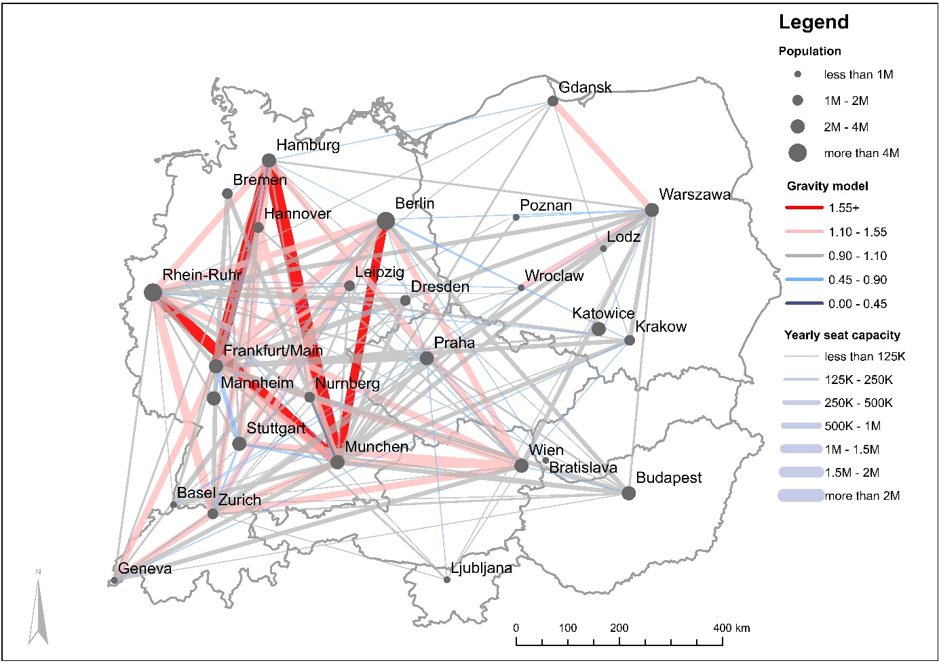

*Source: Flightradar24 (2017), Seatguru (2018), OECD (2019), Eurostat (2020)*

**Keywords**

Central Europe, passenger transport, flight mode

**Introduction**

Central Europe is the region where Western and Eastern Europe meet. It is a border region between old and new EU member countries deeply integrated by the single market and freedom of movement. However, there are significant differences in histories, economies, and institutions between the former post-communist countries of Poland, the Czech Republic, Slovakia, Hungary, and Slovenia and the traditional market economies of Germany, Austria, and Switzerland. Our visualization is an opportunity to investigate how air traffic among them has developed. The countries of the former communist bloc were economically integrated before 1989. It can therefore be interesting to investigate whether this integration has persisted or whether the business and touristic flows from the post-communist countries were redirected towards new markets. In addition, the Central European countries are to a significant degree asymmetrical. The dominant population and economic unit is Germany, which creates a gravity locus for the others. At the same time, Germany is the only country with significant domestic air traffic. The other countries are much smaller, with low or negligible domestic air traffic. Poland is the obvious exception. The question is how much gravity force Germany manifests and how strong other potential interregional links, such as among post-communist or German-speaking countries, are.

**Methods**

The visualization reflects flight seat capacity among metropolitan areas with supranational importance in Central Europe. The metropolitan areas were defined as the sum of the respective core area and hinterland area (OECD, 2019). The population limit was defined as one million inhabitants, but in Slovakia, Slovenia, and Switzerland the limit was diminished to 500,000 inhabitants. Data on frequency came from Flightradar24 (2017). The data covered an average scheduled spring week in 2017 for 46 domestic and 96 international connections among 29 cities. We concentrated on typical business flights and wanted to eliminate summer tourist flows. Based on aircraft type, the average seat capacity was calculated according to Seatguru (2018). Final data recalculated to yearly capacity were verified by data from Eurostat (2020). The advantage of the Flightradar24 data lies in its immediate and precise information on flights. The combination of Flightradar24 and Seatguru provided a useful source of open access data on flights with the advantage of showing the online status of flights. This alternative also works as verification for other sources. We also calculated a simple gravity model as a benchmark for estimating potential air traffic flows among the analysed metropolitan areas. The parameters of the gravity model were population and GDP as attractive forces and distance and travel time as repulsive forces. In the visualization, we show in red those flows with a ratio of actual capacity to estimated capacity higher than 1.1 and in blue those flows with an actual–estimated capacity ratio lower than 0.9.

**Phenomenon**

The visualization confirms the dominant position of Germany. Domestic flights in Germany usually had the highest ratio of actual ridership against the underlying gravity model. There were also strong ridership flows from other German-speaking countries and cities toward Germany. Air traffic flows within Germany and among German-speaking cities in different countries were therefore the dominant factor in the area. Also interesting are the patterns of air traffic in the post-communist countries. The connections to Germany were weaker for these countries than in the case of Austria and Switzerland. However, the air connections among them were even weaker. The economic integration of post-communist countries has diminished after the fall of communism. However, unlike with German-speaking countries, Germany was not similarly dominant in determining their airflows. Due to geographical proximity, the Vienna airport worked as a gate to the West for some post-communist countries. In addition, without the advantage of sharing the same language, some post-communist countries oriented toward another metropolis in the EU. Poland had an exceptional position among the Central European countries. It is large enough to create an air market but too economically weak to create an economic area competing with Germany. The result is that a domestic air passenger market emerged in Poland. However, there was no international hub, not even for post-communist countries.

In summary, two factors caused the dominance of Germany. The first factor is the sheer largeness and importance of the German economy, which is by itself a strong attractive force. The second factor is the lack of national and language borders in Germany, which are abundant in the rest of Central Europe. Even when these borders are almost invisible in regular business and tourist movements, the research shows that borders have had a diminishing impact on mutual air transport links (Hazledine 2009, Klodt, 2004). In addition, recent evidence from Dobruszkes (2021) documented that 75% of the most important global air transport flows are domestic. The vast internal market in Germany without any national or language barriers was an excellent impetus for stimulating domestic air traffic flows. The connecting international traffic stimulated the emergence of international hubs in Germany (Frankfurt, Munich, Berlin). Germany’s intensity of domestic air traffic is an attractive force for connecting traffic from neighbouring countries.

The domestic air capacities in Poland were weaker, probably due to Poland’s lower economic level. Although the liberalization of air transport in post-communist countries has caused a significant increase in both domestic and international air connections in Poland (Jankiewicz – Huderek-Glapska 2016), their levels remained significantly behind the frequencies that can be observed in Germany. Unlike Germany, Poland did not possess an important air hub that could concentrate domestic traffic for international departures. On the other hand, the polycentric structure in Germany with important airport hubs (Munich, Frankfurt) located on the edges of the territory created an excellent opportunity for strong national air traffic flows. The other important factor in determining air flows was the position of Vienna as an important international hub for Central European traffic. A great deal of long-distance international traffic started or ended in Vienna with interconnecting short flights across Central Europe. The position of other international hubs (Warsaw, Prague) was weaker. The post-communist countries (Poland, Czech Republic, Slovakia, and Hungary) were quite surprisingly dominantly oriented towards air connections with Western Europe. The volume of internal post-communist traffic was relatively low. This corresponds with the findings of Seidenglanz et al. (2021) for international passenger railway traffic in Central Europe. The geography of Central Europe is typified by the existence of small countries with many borders.

Given that we analysed short-distance air traffic connections, competition with high-speed rail (HSR) may be an issue here. Some intra-Germany connections have good HSR services. The high air traffic demand on crucial German links is a testimony to the viability of these connections in the transport market. Conversely, the supply of HSR connections on international lines is much more limited, especially in post-communist countries, despite the EU’s efforts to improve this situation. Our visualization can also be a tool for assessing where there is potential for international HSR services. The results have the limitation that they have been obtained from seat capacity and not from the actual passenger flows.

**Conclusions**

Our visualization captures air traffic capacities among major agglomerations in Central Europe. Many countries are too small to have significant domestic air traffic. Two larger countries, Germany and Poland, dominated national air traffic in the region. Especially the domestic air traffic within Germany captured most traffic flows in the area, even though many international connections could have had the same potential.

Air traffic in Central Europe is limited by the small area of national states and effective competition from other transport modes for short distances. Large countries with polycentric settlement structures tended to generate strong national air traffic. The long-term economic and geopolitical links among Germany, Switzerland, and Austria resulted in strong gravity forces for interconnecting air traffic flows among these countries, with the most intensive force manifesting among German cities. On the other hand, the interconnections within post-communist Central Europe were rather weak, with more air traffic oriented towards German-speaking countries. The contribution of this visualization lies not only in the identification of the most important air passenger routes in the area but also the policy implications. Many countries in the region are considering plans for HSR construction, such as Berlin–Prague–Vienna and Warsaw–Budapest. This visualization can help to identify demand potential that could be diverted from air to HSR.

**References**

Dobruszkes, F., 2021. A global business? Mapping the densest passenger airline routes. Journal of Transport Geography, 92, 102941.

Eurostat, 2020. Air passenger transport by reporting country and routes. <https://ec.europa.eu/eurostat/data/database> [retrieved 2020-12-11].

Flightradar24, 2017. Real-time commercial aircraft flight tracking. <https://www.flightradar24.com/> [retrieved 2018-04-18].

Hazledine, T., 2009. Border effects for domestic and international Canadian passenger air travel. *Journal of Air Transport Management*, 15(1), 7-13.

Jankiewicz, J., & Huderek-Glapska, S., 2016. The air transport market in Central and Eastern Europe after a decade of liberalisation – Different paths of growth. Journal of Transport Geography, 50, 45-56.

Klodt, H., 2004. Border effects in passenger air traffic. Kyklos, 57(4), 519-532.

OECD, 2019. Statistics on metropolitan areas. <https://stats.oecd.org/Index.aspx?DataSetCode=CITIES> [retrieved 2019-03-20].

Seatguru, 2018. Aircraft seat identification. <https://www.seatguru.com/> [retrieved 2018-04-18].

Seidenglanz, D., Taczanowski, J., Król, M., Horňák, M., & Nigrin, T., 2021. Quo vadis, international long-distance railway services? Evidence from Central Europe. Journal of Transport Geography, 92, 102998.

**Acknowledgments**

This article was supported by the project “New Mobility – High-Speed Transport Systems and Transport-Related Human Behaviour”, Reg. No. CZ.02.1.01/0.0/0.0/16_026/0008430, co-financed by the Operational Programme Research, Development, and Education.

1. Corresponding author. Institute for Transport Economics, Geography and Policy, Department of Economics, Faculty of Economics and Public Administration, Masaryk University, Brno, Czech Republic, email: [vilem@mail.muni.cz](mailto:vilem@mail.muni.cz), phone: +420 608 177 138.
2. Institute for Transport Economics, Geography and Policy, Department of Economics, Faculty of Economics and Public Administration, Masaryk University, Brno, Czech Republic, email: [zdenek.tomes@econ.muni.cz](mailto:zdenek.tomes@econ.muni.cz).
3. Department of Regional Economics and Administration, Faculty of Economics and Public Administration, Masaryk University, Brno, Czech Republic, email: [karolina.urbanovska@recetox.muni.cz](mailto:karolina.urbanovska@recetox.muni.cz).
4. Department of Economic and Social Geography, Demography and Territorial Development, Faculty of Natural Sciences, Comenius University, Bratislava, Slovakia, email: [marcel.hornak@uniba.sk](mailto:marcel.hornak@uniba.sk).