α-Fe Nanoparticles Prepared by Microwave Plasma Decomposition of Iron Pentacarbonyl
B. David^{1a}, N. Pizúrová¹, O. Schneeweiss¹, T. Hoder^{2b}*, V. Kudrle², J. Janča²
¹Institute of Physics of Materials, AS CR, Brno, Czech Republic
²Faculty of Science, Masaryk University, Brno, Czech Republic
ªdavid@ipm.cz, ^{b}hoder@physics.muni.cz, ^{c}kudrle@physics.muni.cz
Keywords: microwaves, Fe(CO)₅, iron, nanoparticles.
Abstract. The nanocrystalline iron powder has been prepared by the introducing of Fe(CO)₅ vapor into the microwave induced argon discharge. A microwave 2.45 GHz source was operated at 430 W. The reaction was performed in a quartz tube passing through the microwave waveguide. The in-situ passivation using air was applied after synthesis. The powder was characterised by TEM, XRD, and Mössbauer spectroscopy. According to our TEM investigation, the produced passivated powder included aggregated core-shell nanoparticles. The cores consist of α-Fe and the shell is supposed to be iron oxide (indicated by TEM). The presence of α-Fe and iron oxides was confirmed by XRD and Mössbauer spectroscopy. The mean coherence domain size of α-Fe cores was estimated to be 30 nm. The synthesized nanopowder exhibits ferromagnetic behaviour.
Introduction
Magnetic properties of iron-based materials could be highly enhanced if particles in the nanometer size were prepared. These nanoparticles also show promis for industrial applications such as catalysis, magnetic recording and biomedical applications. A few methods are currrently available for the preparation of iron-based nanoparticles: arc discharge method [1,2], laser pyrolysis of gas phase reactants [3], thermal decomposition of precursors [4], reverse micelles method [5], microwave plasma synthesis [6,7], and some others.
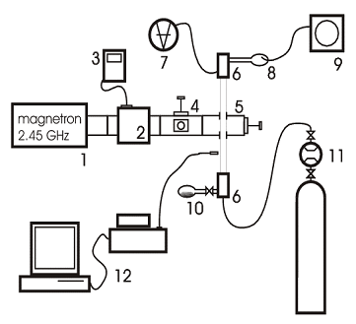
Figure 1. Experimental setup: 1 microwave generator, 2 ferrite circulator, 3 reflected power detector, 4 impedance matching, 5 surfaguide launcher, 6 brass flanges, 7 baratron gauge, 8 trap for solid products, 9 oil rotary pump, 10 iron pentacarbonyl reservoir, 11 Ar gas line, 12 spectrometer Jobin-Yvon TRIAX 320.
Experimental
Decomposition of Fe(CO)₅ was performed in microwave induced plasma (2.45 GHz) with surface wave at power level of 430 W. The vapor of Fe(CO)₅ was transported from reservoir to the discharge by argon as a carrying gas. The products of reaction were trapped at the filter in the direction of the rotary pump. Experimental setup is shown in Fig. 1. Discharge proceeds in quartz tube (inner diameter of 1.7 cm, length of about 60 cm). Apparatus was contiuously evacuated by rotary pump.

After the apparatus was pumped to 3 Pa, argon was added (100 sccm supply rate). The total pressure before iron pentacarbonyl introduction was about 430 Pa. During the experiment the Fe(CO)₅ supply flow was manually increased. The pressure increased from 430 Pa to over 1360 Pa, according to Fe(CO)₅ flow rate increase from 0 sccm to 10 sccm due to simultaneous filter clogging. Experiment duration was 2.5 hour. After experiment, the produced nanopowder was exposed to the air at 100 sccm for a few hours.
In order to obtain the rotational temperatures (as an indicator of the real gas temperature) we measure the optical emission spectra. We used the spectrometer Jobin-Yvon TRIAX 320.
The morphology and composition of the synthesized nanopowder were characterized by transmission electron microscopy (TEM) and X-ray diffraction (XRD). Mössbauer spectra were measured at standard transmission geometry with ⁵⁷Co in Rh source. Isomer shift was evaluated with respect to α-Fe. The computer processing of spectra yielded the values of relative spectrum area A (ar.%), hyperfine magnetic induction B_{HF}, isomer shift δ, and quadrupole splitting ε_{Q}.
Results and discussion
We computed rotational temperatures from two different spectral bands. Through the use of these temperature values we describe the discharge before and during iron pentacarbonyl application.
The rotational temperatures were computed by means of Boltzmann plot namely from OH radical (before and after the pentacarbonyl addition) and from C₂ Swan band spectra (after pentacarbonyl addition) [8]. The maximum rotational temperature appears directly in the waveguide and equals (620 ± 80) K. When we computed rotational temperatures for the increasing iron pentacarbonyl concentration from OH radical, we obtained values: (450 ± 30) K, (470 ± 50) K, and (470 ± 40) K. If we compared the temperatures computed from C₂ and OH we concluded that the rotational temperature stays more or less constant during pentacarbonyl addition.

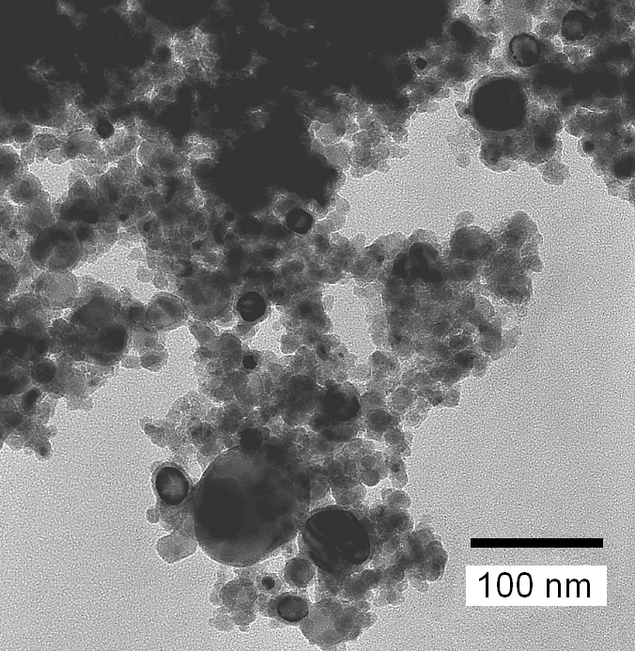 | 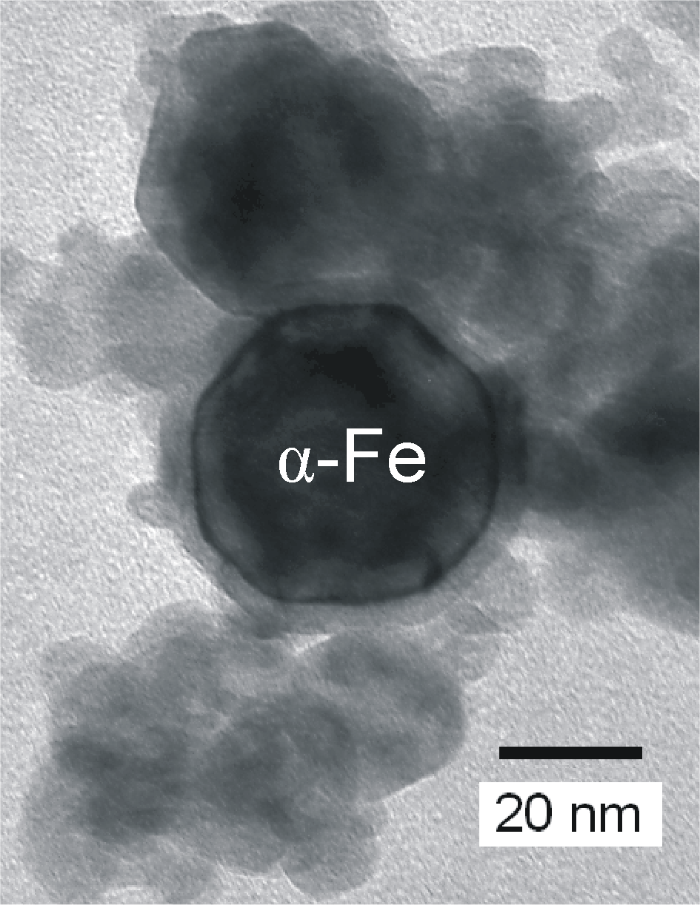
Figure 2. TEM image for the synthesized and passivated nanopowder | Figure 3. TEM image of an α-Fe particle  with iron-oxide shell

The mass of produced nanopowder was not bigger than a few hundred milligrammes. The powder consisted of iron-based nanoparticles. The typical TEM picture of produced nanoparticles can be seen in Fig. 2. The produced passivated powder included also core-shell nanoparticles and the typical TEM image of a core-shell nanoparticle is in Fig. 3. The cores are formed by α-Fe and the shell is supposed to be iron oxide Fe₃O₄/γ-Fe₂O₃ (indicated by dark field TEM).
Figure 4. XRD pattern for the produced nanopowder
The presence of α-Fe and iron oxides α-Fe₂O₃ and Fe₃O₄/γ-Fe₂O₃ was confirmed also by XRD (Fig. 4) [9]. The mean coherence domain size of α-Fe nanoparticles was estimated from the most intensive X-ray diffraction line of α-Fe to be 30 nm (Scherrer formula).
Mössbauer spectroscopy was used to investigate the phase composition of the sample. The α-Fe sextet was clearly identified in the spectrum measured at 293 K (Fig. 5a). Due to superparamagnetic effects and particle size distribution (resulting in B_{HF} distribution), it is hard to assign the other sextets and doublets in this spectrum to concrete phases.
Figure 5. Mössbauer spectra for the synthesized sample measured at indicated temperatures with displayed components: (a) only one spectral component shown: α-Fe sextet with B_{HF} = 33.1 T shown (light gray filler, 55 ar.%); (b) all spectral components shown: α-Fe sextet with B_{HF} = 34.0 T (light gray filler, 60 ar.%), Fe_{X}O_{Y} component comprises 7 sextets (B_{HF} = 53.5, 50.8, 49.8, 48.8, 45.5, 42.5, 39.0 T), (network filler, 28 ar.%), Fe-O/Fe-C component includes 3 sextets (B_{HF} = 29.8, 27.2, 16.0 T) (dark gray filler, 10 ar.%), Fe³⁺ doublet with δ = 0.43 mm and ε_{Q} = 0.2 mm (dashed line, 2 ar.%).
The spectrum measured at 25 K (Fig. 5b) includes the α-Fe sextet. We have further identified sextets with B_{HF} ≥ 39 T in the spectrum. These sextets can be undoubtedly assigned to iron oxides because of their high B_{HF} values [10]. We have grouped into one Fe_{X}O_{Y} component. The Fe-O/Fe-C component can be assigned either to small iron oxide particles or to Fe-C particles.
Summary
Iron based nanoparticles were produced by means of microwave plasma decomposition of iron pentacarbonyl in the argon buffer gas. The calculation of rotational temperatures indicated that this parameter does not practically change during the increase of iron pentacarbonyl concentration. Duration of experiment was arround 2.5 hours and not more than several hundred milligrammes of nanopowder were produced. The core-shell nanoparticles were observed in the TEM pictures. The TEM analysis proved the α-Fe core of these nanoparticles. The shell is supposed to be iron oxide (Fe₃O₄/γ-Fe₂O₃). From the XRD pattern the mean coherence domain size of α-Fe nanoparticles was estimated to be 30 nm. The presence of α-Fe and iron oxide phases was proved also by Mössbauer spectroscopy.
Acknowledgement
This work was supported by the Grant Agency of the Czech Republic (contract No. 202/04/0221) and the Ministry of Education, Youth and Sport (contract No. 1M6198959201, MSM0021622411).
References
[1] S. Seraphin, D. Zhou, J. Jiao: Filling the carbon nanocages, J. Appl. Phys. Vol. 80 (1996) p. 2097
[2] G.M. Shi, Z.D. Zhang, H.C. Yang: Al₂O₃/Fe₂O₃ composite-coated polyhedral Fe nanoparticles prepared by arc discharge, J. Alloy. Compd. Vol. 384 (2004) p. 296
[3] X.-X. Bi, B. Ganguly, G.P. Huffman, F.E. Huggins, M. Endo, P.C. Eklund: Nanocrystalline α-Fe, Fe₃C, Fe₇C₃ produced by CO₂ laser pyrolysis, J. Mater. Res. Vol. 8(7) (1993) p.1666
[4] N.A.D. Burke, H.D.H. Stoever, F.P. Dawson: Magnetic nanocomposites: Preparation and Characterization of Polymer-Coated Iron Nanoparticles, Chem. Mater. Vol. 14 (2002) p. 4752
[5] E.E. Carpenter, S. Calvin, R.M. Stroud, V.G. Harris: Passivated Iron as Core-Shell Nanoparticles, Chem. Mater. Vol. 15 (2003) p. 3245
[6] J.R. Brenner, J.B.L. Harkness, M.B. Knickelbein, G.K. Krumdick, C.L. Marshall: Microwave plasma synthesis of carbon supported ultrafine metal particles, NanoStructured Materials Vol. 8 (1997) p. 1
[7] R. Kalyanaraman, Sang Yoo, M.S. Krupashankara, T.S. Sudarshan, R.J. Dowding: Synthesis and consolidation of iron nanopowders, NanoStructured Materials Vol. 10 (1998) p. 1379
[8] G.V. Marr: Plasma Spectroscopy (Elsevier, 1968).
[9] ICSD Databse release 2004/1, FIZ Karlsruhe, Germany; JCPDS PDF-4 Full File 2004 Database, ICDD, Newton Square, Pennsylvania, U.S.A.; DIFFRAC^{plus} TOPAS, Bruker AXS GmbH, Karlsruhe, Germany.
[10] N.N. Greenwood, T.C. Gibb: Mössbauer spectroscopy (Chapmann and Hall, 1971).

