Masaryk University
Faculty of Arts

Department of English and American Studies

English Language and Literature

Anna Formánková

The Ultimate Villain: Renditions of Arthur Conan Doyle’s Professor Moriarty in Time

Bachelor’s Diploma Thesis

Supervisor: doc. Michael Matthew Kaylor, Ph.D.
2013

I declare that I have worked on this thesis independently,
using only the primary and secondary sources listed in the bibliography.
……………………………………………..
Anna Formánková

I would like to thank my supervisor, doc. Michael Matthew Kaylor, Ph.D.,
for his patience, kind help and valuable advice.

Table of Contents
1 Introduction 5
2 The Basil Rathbone Series: Holmes vs. Moriarty 3:0 7
2.1 Double Crime and Presage of War 7
2.2 Holmes, Moriarty and Nazi Germany 12
2.3 Missing Fingers, Hypnotic Woman 16
2.4 Every Moriarty Dies 19
3 Moriarty In-between 22
4 The Games Moriarty Plays 24
4.1 Lord Blackwood vs. Professor Moriarty 24
4.2 The Games Are Afoot 25
5 Jim Moriarty: Consulting Criminal for the 21st Century 31
5.1 The End of Sherlock Holmes 36
6 Conclusion 43
7 Appendix 48
8 Works Cited 51
9 Resumé 54
10 Summary 55

Introduction
Since his character was created in 1886, Sherlock Holmes has ranked among the most famous and most successful fictional detectives of all times. With more than 254 screen depictions, Holmes has become the most portrayed literary human character in film & television. He is considered to be a universal hero and, as such, he needs a counter-character, a villain against whom Holmes can define himself: Professor James Moriarty.
In the original Holmes canon, Professor Moriarty fully features in only a single story, The Final Problem, in which he is described as a criminal mastermind, “a genius, a philosopher, an abstract thinker” (Doyle, ‘The Final Problem’ 440) and Holmes’s ultimate evil enemy, whose intellect matches his own is the only one who has the potential to beat Holmes in the battle of wits. Since Moriarty has been introduced into the life of Sherlock Holmes, he has been brought to life many times on screen, too, personifying the ultimately evil element in the Holmes stories. Nevertheless, Moriarty has represented many different concepts of evil over time, depending on the contemporary historical and political situations, but also on the objective of the film or series. Professor Moriarty has been used as a tool, or a symbol of the influence and impact of evil, many times on much wider scale than the original Holmes canon suggested.
The present thesis concentrates on the representation of evil and interpretation of the function of the Professor Moriarty character in three different Holmes adaptations. The purpose of this work is to present and analyse the role of Professor Moriarty in the various screen renditions of the Holmes canonical stories, including the symbolical value of the character as such.
As for the organisation of this thesis, the first chapter elaborates on the character of Professor Moriarty in the 1939-1946 American franchise starring Basil Rathbone as a Consulting Detective, “the only one in the world” (Doyle, ‘The Sign of Four’ 76). The chapter discusses one at a time three movies of the franchise which feature Professor Moriarty, examining the symbolical meaning of the character, as well as the then significance of Moriarty, with an emphasis on the role of the World War II environment in the individual movies. In the last subchapter, all three appearances of Professor Moriarty are compared, and the role of the character in connection to the then international situation is analysed.
The purpose of the second chapter is to discuss the role of Professor Moriarty in Guy Ritchie’s Sherlock Holmes franchise, concentrating on Moriarty’s perception of the world and the manipulation of his environment. The chapter also elaborates on the importance of the symbolism and practical application of the game of chess, which is an important element connected with the Moriarty character.
The last chapter examines the character of Jim Moriarty, who is the villainous figure in the BBC series Sherlock, which sets the originally Victorian characters into the contemporary era, modernising both their life goals and their approach towards their milieu. Individual features of Jim Moriarty’s characters are analysed, and it also discusses the elaborate means of destroying Sherlock Holmes which Moriarty employs.
In the conclusion, the employment of the character of Professor Moriarty and his onscreen versions are compared, and also the purpose and symbolic meaning of each rendition is examined.

The Basil Rathbone Series: Holmes vs. Moriarty 3:0
Starring as Sherlock Holmes in one of the most famous and most critically acclaimed Holmes series, Basil Rathbone confronted Professor James Moriarty three times in total. George Zucco attempted to steal the Crown Jewels in The Adventures of Sherlock Holmes, Lionel Atwill planned to sell bomb plans to the Nazis in Sherlock Holmes and the Secret Weapon, and Henry Daniell tried to push Holmes off the roof in The Woman in Green, all of them impersonating “the Napoleon of Crime” (Doyle, ‘The Final Problem’ 440). Nevertheless, each of the aforementioned adventures ends with Professor Moriarty dead, defying Conan Doyle’s original intentions. The primary purpose of introducing the character of Professor Moriarty into Sherlock Holmes’s storyline was to end the activities of the famous detective; originally, Moriarty stepped out of the shadows to bring the life of Sherlock Holmes to an end. Arthur Conan Doyle was resolved to terminate Holmes’s life, even if [he] buried [his] banking account along with him (Doyle, Memories and Adventures 93-94). However, in each of the above mentioned movies, Professor Moriarty dies, leaving Sherlock Holmes as much alive as he was before. Moriarty might bring destruction upon the Consulting Detective, but not in these instalments; the character of the master villain serves different purposes in these stories.

Double Crime and Presage of War
The Adventures of Sherlock Holmes is the first movie in which Basil Rathbone’s Sherlock Holmes meets Professor Moriarty, and the very beginning reveals the state of the relationship between the Consulting Detective and his nemesis. Holmes claims that he admires Moriarty’s brain so much he would “like to present it pickled in alcohol to the London Medical Society” (Werker, Holmes 1939, 00:03:43), whereas Moriarty intends to “break” (Werker, Holmes 1939, 00:04:04) Holmes. They could not wish for each other’s destruction more.
Professor Moriarty is “going to bring out right under [Holmes’s] nose the most incredible crime of the century” (Werker, Holmes 1939, 00:04:05) and he invents a very clever way to perform this act. As Moriarty himself claims, Sherlock Holmes is “as a spoiled boy who [ ... ] looses interest in one toy as soon as he’s given another” (Werker, Holmes 1939, 00:07:35). Therefore, Professor presents Holmes “with two toys in the order in which [Moriarty] mean[s] him to have them” (Werker, Holmes 1939, 00:07:41). The whole idea is simple: Professor Moriarty constructs a series of family murders to distract Holmes from the planned delivery of valuable emerald from India and from the subsequent opening of the vault which contains the Crown Jewels – Moriarty’s goal.
One of the striking issues regarding Moriarty’s double crime is the fact that he devises a whole series of multiple murders to divert Holmes’s attention. And Professor Moriarty does not stop at planning; he has a man murdered “to fascinate and tantalise [Holmes’s] imagination” (Werker, Holmes 1939, 00:07:55) and, therefore, to augment Holmes’s interest in the case. ‘Murder for murder’s sake’, a term derived from the French ‘L'art pour L'art’ (Art for Art’s sake), fully encompasses Moriarty’s scheme to murder a man just for the sake of murdering him. However, this aspect of Professor Moriarty’s nature would never be regarded as a character flaw, but more likely as a mental disorder, because the general belief stands that
no one will commit a murder if he can attain in any other way the object to which the murder is instrumental. [ ... ] [A murder] is not to be considered as intrinsically pleasurable; the murderer kills his victim because the latter is his enemy, not because he enjoys killing in the abstract (Murder for Murder’s Sake)
There are “three motives [that] cover the whole ground of [murderer’s] guilt” (Murder for Murder’s sake): murderer’s hatred for the victim, the desire of the murderer to own some of the victim’s possessions or the victim presenting an obstacle in murderer’s intentions. “If none of them are found to apply, then we are driven to conclude that [the murderer] must be insane” (Murder for Murder’s Sake). Should Professor Moriarty ever be charged with murder, he would be acquitted on all charges because the society refuses “to believe that human nature is wicked enough to enjoy wickedness per se, or solely because it is wicked” (Murder for Murder’s Sake). As the character of Professor Moriarty has been developed solely for the purpose of personifying evil and, therefore, he truly is wicked by nature, he presents a direct contradiction to the aforementioned thesis. However, since the premise excludes the possibility that a character as Professor Moriarty may ever exist; there is no chance that he might be prosecuted for his character’s wickedness itself.
The idea of engaging Sherlock Holmes and Scotland Yard in the case develops further as well. Lloyd Brendon is killed under very particular circumstances the peculiarity of which “should absorb Mr. Holmes’s interest” (Werker, Holmes 1939, 00:08:05) to such an extent that he decides to involve himself in the case and, eventually, even uncovers Moriarty’s engagement with the case because Professor Moriarty wants Holmes to know who has beaten him. Moriarty desires to be observed and admired as well, showing off his villainous skills. Sherlock Holmes seems to be the perfect candidate for such an observation, since he admires Moriarty’s brain (Werker, Holmes 1939, 00:03:41) and his mental abilities. Nonetheless, he must not disrupt Moriarty’s action; Holmes should observe the geniality of Moriarty’s plan retrospectively, only after Moriarty performs “the most incredible crime of the century” (Werker, Holmes 1939, 00:04:05) at the Tower of London, not having any chance to foil Professor Moriarty’s schemes.
For Moriarty dead Lloyd Brendon presents a mere casualty of the whole issue and this fact illustrates Moriarty’s distorted perception of the value of human life. The crucial evidence regarding this issue is provided in Moriarty’s speech to his valet, who failed to attend to the Professor’s flowers the way he should have:
Nothing is as important as the care of my flowers. Through your neglect this flower has died. You’ve murdered a flower. [ ... ] And to think that for merely murdering a man I was incarcerated for six whole weeks in a filthy prison cell. [ ... ] A travesty on justice. [ ... ] But for this crime, Dawes, you should be flogged, broken on the wheel, drawn and quartered... and boiled in oil! (Werker, Holmes 1939, 00:09:32)
This passage clearly shows that the “incomparable emfurium magenta” (Werker, Holmes 1939, 00:09:13), a mere plant, is much more important to Moriarty than a human being. His value system differs greatly from that of an ordinary man.
Beyond his relationship towards other people, the theft of the Crown Jewels is very important for Professor Moriarty. Only the fact itself that he decides to perform the trick and subsequent theft on his own – even though he usually “does little himself; he only plans” (Final Problem 404) – shows what a significant act the heist symbolises to Moriarty. He even shaves the beard he has “worn [ ... ] for years” (Werker, Holmes 1939, 01:12:44) and disguises himself as a policeman to confuse Watson and Holmes. This time Moriarty carries on his evil plan on his own. If he manages to steal the Crown Jewels and compromise Sherlock Holmes, his mission will be beyond successful. The main objective of the whole plan is to destroy Sherlock Holmes and Professor Moriarty cannot trust to perform the ultimate act of destruction anyone else but himself.
It is not only the financial matter that would be affected if Moriarty accomplished his scheme, but the politics of the country would be greatly impacted on both national and international levels, too. Professor Moriarty aims at the Crown Jewels, however, he chooses to use the moment when the famous Star of Delhi, “probably the largest emerald in the world” and “a gift to Her Majesty from the Maharajah of Rapur” (Werker, Holmes 1939, 00:15:16), is to be delivered to the country and safely stored in the royal vault. Should the emerald be stolen or damaged, it would not only be a great loss, but also possibly the start of an international conflict. Maharajah of Rapur would most certainly not welcome the news that Scotland Yard was unable to take care of his gift to Her Majesty. Such an incident could cause a tension inside of the British Empire and the already tense relationship between Great Britain and her provinces might only get worse. The rest of the world might notice that Her Majesty’s control over her colonies is not as strong as it used to be and the whole situation might result in early collapse of the British Empire. Moreover, the loss of the Crown Jewels and the metaphorical ‘fall’ of the Tower would mean not only the end of the Empire, but also the end of the Great Britain itself, since British national identity would be greatly afflicted by the lost of the national treasure.
Given the time and international situation at the time of the release of the movie, the aforementioned threats might easily be applied on the contemporary situation in Europe as well. Through his plan, Moriarty threatens the national safety and international peace; he personifies the evil force in the world of Sherlock Holmes and his actions might destroy the world’s equilibrium. Released just two days before France and Great Britain declared war on Germany, The Adventures of Sherlock Holmes foreshadowed the future events; the allegory of Moriarty as Germany became uncanny. Unlike the 1942 Sherlock Holmes and the Secret Weapon, the film was not set in the contemporary Britain; it was “the last time [Basil Rathbone] was seen striding through the fog in his Inverness cape and deerstalker” (Davies 43). Despite this fact, the film’s appeal and message were very topical. Frank S. Nugent wrote in his review for New York Times: “Nothing dates Conan Doyle so terribly these days as the fact that his villainous Professor Moriarty persists in declaring war on Scotland Yard instead of just making it” (Nugent). The atmosphere of the eve of war is captured in Moriarty’s behaviour and actions; he is talking rather than acting most of the time, captioning the indecisiveness of the world powers and their lack of will to act.

Holmes, Moriarty and Nazi Germany
When the world faces the biggest international conflict in history, it needs Sherlock Holmes to help it fight against Nazi Germany and Moriarty; because there is never so much evil that Moriarty could not add some more. In Sherlock Holmes and the Secret Weapon, Holmes and Watson help the British government to save Doctor Tobel and his invention – a bomb of revolutionary construction – from the Germans, who would like to use it against the Allies. The plot thickens when Professor Moriarty enters the conflict, with the interim of acquiring the plans of the invention and selling them to the Nazi Germany. Since this very moment the “battle of wits” (Neill, Holmes 1942, 00:39:20) is afoot.
Sherlock Holmes and the Secret Weapon does not follow any of the original stories. Including only several small details from the Holmes canon – such as the code of the Dancing Men which Tobel uses to communicate with his co-workers – the film concentrates on the contemporary situation. The United Kingdom is at war, and who else should help the country than one of the most famous British heroes, Sherlock Holmes. And where Sherlock Holmes is, there his nemesis will be also: in this updated version of the traditional battle between good and evil, Moriarty is presented as a Nazi collaborator, a part of the World War II evil force. While Sherlock describes his plans as “a staggering blow against your own country” (Neill, Sherlock Holmes and the Secret Weapon, 00:39:53), Moriarty admits that “that doesn’t concern [him] overly” (Neill, Holmes 1942, 00:39:55). Moriarty clearly does not care about damaging his own country and, moreover, plans to sell Tobel’s invention to the enemy. These are aspects which make him a German collaborator. However, the question remains whether Moriarty really is one.
There is no doubt that Moriarty stands on the side of the evil, as he always does. Nevertheless, at the time of World War II the states involved are divided between the ‘good’ and ‘evil’, pro-German and anti-German; the general assessment of every character is influenced by the contemporary bipolarity; however, the mercurial Professor Moriarty does not completely fit this scheme. Moriarty’s main interest is his own ‘game’. He is concerned about his own profit and about the future of his own organisation; he does not care about anything else. When a character like Moriarty discovers that he “shall make greater profit from this affair than all [his] other adventures put together” (Neill, Holmes 1942, 00:40:00), there is nothing that can stop him from putting that plan of action into practice. The villain’s claims: “My main interest in this affair is the chance it gives me to battle with [Sherlock Holmes] again” (Neill, Holmes 1942, 00:39:39), a claim that seems at that moment doubtful. Profit or the battle of “superior intellects” (Neill, Holmes 1942, 00:39:20)? For Moriarty, the whole issue represents only a mere redistribution of the items and possessions in question, in such a way that all the parties involved are satisfied. He is not interested in the further impact of his activities on the rest of the world, unless the reaction directly affects his business. Therefore, Moriarty can hardly be regarded as a traitor or collaborator, since the matters of state and states have never concerned him.
Although Moriarty might appear to be one of the many Fascist collaborators, he is not one of them. Professor Moriarty is a strong individualist and would never incline to integrate himself into homogenised Fascist society which “attempts to unify through ‘uniformity’ [ ... ] by abolishing differences of character, belief, etc. [ ... ] citizens to [become] individual instances of a single ‘national character’” (Paxton). Moriarty’s maverick nature would not allow him to become a follower of a regime which does not let him do as he wishes, since he always applies his own methods. Both his goals and the means of getting his own way are dramatically different to those of an ordinary man. Professor Moriarty is in no way ordinary; even his methods of killing differ greatly from the Nazi means of murder. While the “Holocaust was characterized by the efficient and systematic attempt on an industrial scale to assemble and kill as many victims as possible” (Frost), Moriarty becomes more personal – the more so when the victim in question is Sherlock Holmes. At first suggesting the ways of killing worth of “ordinary cutthroat” (Neill, Holmes 1942, 00:59:54) only – “the gas chamber, a couple of hemlock or a simple bullet through [Holmes’s] head” (Neill, Holmes 1942, 00:59:35) – Moriarty then willingly adopts a very original and much more “imaginative” (Neill, Holmes 1942, 01:00:07) way of destruction introduced by Holmes: the victim is pierced with needles and left to bleed to death. This is a slow method unlikely to appeal to a Nazi interested in mass murder that is quick and efficient. And not even the very obvious means of murdering Sherlock Holmes suggested, the “gas chamber” (Neill, Holmes 1942, 00:59:35) has to bear the World War II subtext. The original meaning might not refer to the means of killing used during the World War II, but it might serve as a reference to the William Gillette’s play instead; nevertheless, the inevitable connotations of the holocaust era do not allow for this meaning to become more prominent.
What Professor Moriarty represents in the film is a third party. Moriarty creates a category all his own. He breaks the dichotomy of the Good and Evil, constructing a category of ‘disinterested Evil’: although Moriarty represents an evil force of a certain kind, he is not concerned with the matters of any other party and engages in activities of only his own. There might be a war, but it is of no particular interest to Moriarty. The moment he steps outside the system, he sets up a structure of his own, “the web” (Doyle, ‘The Final Problem’ 440). As much as it is an independent structure, it might interfere with the rest of the world and possibly take it over. Moriarty plays this game of his; however, he stands outside the conflict. The game of chess he has set up does not include him as one of these sides. He is the metaphorical player who moves the pieces on the board – an aspect of Moriarty’s control strategy which is further developed in Guy Ritchie’s Sherlock Holmes: A Game of Shadows.
A movie which was probably meant to present the bipolar system, to set up the difference between the parties and to let the viewer realise the black-and-white reality of World War II, presents a new kind of evil instead: a whole new category set up apart from the war world. Instead of presenting an evil Moriarty working with the Nazis, and striving for the common goal, it shows Moriarty aiming for his own goals and trading with the Nazis as one of the many stages of the process.

Missing Fingers, Hypnotic Woman
The war is over in Europe; however, deadly deeds are omnipresent. The Woman in Green is the last film of the series which features Moriarty and his evil schemes. This time Scotland Yard faces a series of so-called ‘Finger Murders’; several young women were killed and their killer always took a trophy with him: the girl’s finger. Since the very beginning of the case, Sherlock Holmes suspects Moriarty. Although there have been reports of Moriarty being “hanged in Montevideo well over a year ago” (Neill, Woman 1945, 00:28:44), the detective believes that “someone was hanged in Montevideo under that name” (Neill, Woman 1945, 00:28:46), though his enemy is still alive. Later Holmes discovers that all suspects had been hypnotised to believe they committed the murder; and, due to false evidence, they could be blackmailed afterwards. He “will stake [his] reputation” (Neill, Woman 1945, 00:28:49) to prove that the head of the whole scheme is Moriarty himself.
Since the war is over, Holmes may return to solving the ‘usual’ sort of crimes which happen in England. Though the ‘Finger Murders’ seem to be a series of crimes which might be considered as standard up to a certain point, Sherlock Holmes knows that these deeds are not done by anyone ordinary. In The Woman in Green Holmes suspects Moriarty immediately, despite the fact that he is considered to be dead. The combination of the style of the murders and their victims shows that these have been thoroughly planned crimes. Moreover, Sherlock seems to be touched by the nature of that crime; and, according to him, there is no other criminal who would be capable of such an evil crime than “the most brilliant and ruthless intellect the world has ever known” (Neill, Woman 1945, 00:28:28): Professor Moriarty. A villain who also immediately after Holmes’s great deduction appears and confirms his involvement in the case, “strongly advising” Sherlock to “drop this case” (Neill, Woman 1945, 00:33:25).
The most interesting issue included in the last Moriarty film is the means of taking control over the blackmailed victims. Professor Moriarty has always been very inventive, but hypnotism has a special ring to it. As it has been mentioned previously, Moriarty revels in everything extraordinary and quite uncommon; therefore, hypnotism is a very convenient way for him to bring a crime into practice. The concept of ‘Murder for Murder’s sake’, murdering for the act of murder itself, has been introduced before and Moriarty of this adaptation follows it as well. What to Doctor Watson seems as “a lot of mumbo-jumbo”, (Neill, Woman 1945, 00:47:25) means to Professor Moriarty very clever and elegant way of manipulating the selected victims, as if Moriarty has adopted Thomas De Quincey’s theory of ‘Murder considered as one of the Fine Arts,’ according to which even murder might be perceived as a certain form of art and a personal statement. Hypnotism is definitely an artful and graceful concept. Needless to say that the aesthetics of hypnotism strongly contrasts with the nature of the murders themselves – the dreamy state of hypnosis rather contradicts the naturalism of cut-off fingers. On the other hand, contrast is one of the basic principles of art. If Professor Moriarty aims for a certain artistic effect – an actuality which is very probable, regarding Moriarty’s attitude towards his crimes – contrasting the neat means of manipulation with the gruesome nature of the murders would definitely create an absorbing aesthetical tension.
Moriarty himself is not the one inducing hypnosis in the chosen blackmail victims. He has a competent accomplice, young Lydia Marlowe. Lydia is “about thirty, nice figure, blonde, lustrous eyes” (Neill, Woman 1945, 00:41:57), exactly as Sherlock Holmes described her. She is the one who invites her male victims for a drink and then induces hypnotic state in them. The contrasting regards Lydia as well; though she claims – and she seems to truly believe it – that she cannot “bear to see [hypnotism] used for trivial purposes” (Neill, Woman 1945, 00:55:21), yet she uses it to bring destruction upon men instead of using it to “help and heal” (Neill, Woman 1945, 00:55:19).
Another interesting issue regarding Lydia is her looks. She is described by Holmes as a young blonde with gleaming eyes; after a more thorough examination, it can be observed that her appearance is actually that of Aryan race in the Nazi sense of the word, the prominent ‘master’ race which was supposed to rule the world according to the Nazi ideology. The ideal members of Aryan race are “blond, tall, long-skulled, with narrow faces, pronounced chins, narrow noses with a high bridge, soft hair, widely spaced pale-coloured eyes, pinky-white skin colour” (Bergman). Lydia matches all the aforementioned features, therefore, she really can be considered a member of the über race and even though it is never mentioned in the film itself, Lydia may represent the Nazi force. Since the movie has been released at the end of the war, she, as well as the Nazi ideology, does not hold the prominent position in the plot; however, she is present and she is on the side of evil, helping Moriarty to implement his devilish plans. She might be regarded as Moriarty’s counterpart, the Nazi element of the evil force which has separated from the whole represented by Professor Moriarty and which complements his efforts at the moment when the Nazi force is no longer preeminent. Nonetheless, Lydia, as well as Moriarty, are defeated the end of the film, symbolising the end of the war. Both the Nazi force and all of the evil, which imperilled England for years, have been eliminated at the end.

Every Moriarty Dies
The original destiny of Professor Moriarty was to sacrifice his own life in order to liquidate Sherlock Holmes. Arthur Conan Doyle created Moriarty so he could quite literally tighten his grip on Holmes and pull him along into the waters of Reichenbach where both the hero and villain should have found their death. However, in the films of the Basil Rathbone series, only Professor Moriarty dies. The aforementioned movies let Holmes lives on, whereas the villain always dies, each of the deaths having its own meaning and purpose.
After the thwarted attempt of stealing the Crown Jewels, George Zucco’s Moriarty in The Adventures of Sherlock Holmes fights with Sherlock Holmes on the roof of Tower. Although the combat seems to be rather equal at first, Holmes’s bluff wins him tactical advantage and with the unexpected final blow of Holmes’s fist Moriarty falls off the roof into the depths below. The infamous end of the Professor Moriarty does not, however, attract any attention whatsoever. Neither Holmes, nor Watson talk about Moriarty’s death; his evil scheme is one last time clarified to Watson in the last scene and then the film concludes with simple joke concerning killing flies.
Regarding the contemporary situation, Moriarty’s death did not in any way mean an end of neither war, nor fight with the evil forces. The film was released at the beginning of the World War II and the fight with the evil had only just begun. Professor Moriarty died and to kill him was as simple as to kill a fly, the allegory presented in the following scene including reflections on killing an actual fly. Nevertheless, the fight against the Nazi forces and evil as such is no trivial business. The evil more than a fly resembles a hydra, mythical creature with many heads and magical power of regeneration: should any of the heads be ever severed another two would grow in its place. Evil, as well as the heads of hydra, multiply exponentially and there is a long way ahead of Sherlock Holmes and the whole world to defeat the evil and win the ultimate fight of good and bad.
The death of Moriarty in Sherlock Holmes and the Secret Weapon happens to be yet another of Sherlock’s tricks. Holmes is pointing his gun at Moriarty while the latter is describing the clever mechanism of his sophisticated trap. When Watson arrives to help Holmes and calls his name, Moriarty takes advantage of Holmes’s momentarily lack of attention and runs away. The next moment a loud scream is heard; Professor Moriarty gets caught into his very own trap, falling “sixty feet into the sewers below” (Neill, Holmes 1942, 01:06:42). All that Rathbone’s Holmes has to say is “Poor Moriarty” ( Neill, Holmes 1942,01:06:52), immediately continuing with ironic “I neglected to warn him. It seems some careless person came across his trap door and left it open” (Neill, Holmes 1942, 01:06:55).
The whole movie ends with a patriotic sequence including Holmes and the rest of the characters professing their belief and pride of their country that stands tall and never gives up. Professor Moriarty is dead and after all he did, it serves him right that his life ended. Evil forces have lost another battle, though there is still a long way to go to defeat them completely.
The long chain of World War II events ends when Henry Daniell as Moriarty dies. Trying to escape the police forces, James Moriarty jumps from the roof top where the final scene of The Woman in Green takes place and lands on a ledge of the building opposite. However, he loses his balance and falls down of the ledge. Metaphorically re-enacting the closing scene from Doyle’s The Final Problem – as well as Zucco’s and Atwill’s villains in The Adventures of Sherlock Holmes and Sherlock Holmes and the Secret Weapon before – Daniell’s Professor Moriarty dies and symbolically ends the fight against the evil.
The film was released in June 1945 when the main stage of the World War II was over and Britain, as well as the rest of the world, was settling accounts with their enemies. When Moriarty falls to his doom, Watson comments: “An evil man, Holmes, but what a horrible death” (Neill, Woman 1945, 01:06:40) to which Holmes retorts: “Better than he deserved” (Neill, Woman 1945, 01:06:42). Holmes refers to the fact that Moriarty’s death is quick and rather merciful, unlike that kind of sentence he truly deserves. And this comment might as well be interpreted as a reaction towards the end of the war. The evil forces are ‘dead’ and rightfully punished; nevertheless, the penalty for what they had caused might have been even more severe.
Together with Professor Moriarty’s plot-lines the whole story of the World War II unfolds within the Basil Rathbone Sherlock Holmes series. Starting with 1939 The Adventures of Sherlock Holmes, Moriarty represents the threat which is about to imperil Europe and consequently, the whole world; even though he is killed, his death represents only the beginning of the combat with evil. With World War II fully in motion, the 1942 Sherlock Holmes and Secret Weapon shows the enemy in action. Moriarty engages in the war mechanisms and demonstrates how dangerous the Nazi regime can be. His death means only one victorious battle of the many more which are yet to follow and which have to be won as well. By the end of the war in 1945 The Woman in Green concludes the whole war against the evil forces. Moriarty dies and the whole pursuit of peace comes to an end, Holmes and the whole Britain victorious.

Moriarty In-between
In the second half of the 20th century, adaptations of the Holmes canon stories flourished. The Consulting Detective has appeared on both the silver screen and television tens of times, starting with Peter Cushing’s rendition of Holmes through the famous Russian series Adventures of Sherlock Holmes and Doctor Watson to Jeremy Brett’s Holmes in the 1980’s ITV series. The fascination with the character continued through the beginning of the 21st century as well, including both TV films and series – such as Sherlock Holmes and the Case of the Silk Stocking or BBC series Sherlock – and big motion pictures, for example Guy Ritchie’s Sherlock Holmes franchise.
The character of the Consulting Detective and his faithful companion has been adopted for the screen many times and as much as the Holmes hero appeals to the audiences, the adaptations feature villains as well and Professor Moriarty has been included into many of them, too. The present thesis focuses on the on-screen versions of Moriarty which has brought a new point of view on the character, presenting him not only as the tool of Holmes’s destruction and the ultimate super villain, but also giving him a different meaning and purpose in the plot, including the analogies to contemporary political and social issues hidden within the character and its actions. Most of the adaptations from the aforementioned era which featured Professor Moriarty use him in the original sense of the Holmes canon. Moriarty serves as an instrument of Sherlock Holmes’s devastation, no matter whether it is a faithful canon adaptation, such as the period series The Adventures of Sherlock Holmes, or an adaptation which deviates from the original stories, for instance Sherlock Holmes and the Deadly Necklace. These are valid adaptations containing the character of Sherlock Holmes and Professor Moriarty, though they do not include the different perspective which could contribute to the present thesis and its aim; therefore, two of the latest renditions of the Holmes canon have been chosen, since they have the qualities to benefit and support the thesis’s aim.

The Games Moriarty Plays
One of the biggest contemporary Holmes productions must not lack the evil Professor Moriarty; therefore, Guy Ritchie’s 2009 Sherlock Holmes film provides a glimpse of the character only to introduce him as a major villain in the 2011 sequel Sherlock Holmes: A Game of Shadows.

Lord Blackwood vs. Professor Moriarty
The first film of the franchise has its own villain, Lord Blackwood, who plans on taking over the political powers in Britain and reclaiming the American settlements. Using magic tricks and blind faith of his followers, Blackwood manages to kill several important people and he nearly carries out his plans, but Sherlock Holmes averts that. Even though Lord Blackwood’s schemes are elaborated, all his actions give the feeling of a sophisticated magic performance. Blackwood relies on the impression that his show leaves, but as Sherlock Holmes sees it: “There was never any magic. Only conjuring tricks” (Ritchie, Holmes 2009, 01:46:13). However, Professor Moriarty does not resort to using tricks and effects. His performance is more solid and accomplished; he is the proper villain.
To show the contrast and difference between Lord Blackwood and Professor Moriarty, the latter is properly presented only during the final scenes of the Sherlock Holmes film when Sherlock and Doctor Watson realise Professor Moriarty was not after the poison which Blackwood planned to use, but after the remote control device. Even though his face stays secret, Moriarty’s profile is slowly uncovered: a university professor who, unlike Lord Blackwood, performs all his designs secretly and his true intentions remain unknown until he carries out his plans completely. Irene Adler, who is used by Moriarty to distract Holmes, warns the Consulting Detective not to “underestimate him” (Ritchie, Holmes 2009, 01:50:30) because “he’s just as brilliant as [Holmes is]... and infinitely more devious“ (Ritchie, Holmes 2009, 01:50:34). Only the second movie of the franchise, Sherlock Holmes: A Game of Shadows, should show how true Adler’s warning is.

The Games Are Afoot
When Sherlock Holmes and Doctor Watson return to solve crimes in Sherlock Holmes: A Game of Shadows, Professor Moriarty is a mystery no more. Unlike the original Moriarty of the Holmes canon who comes to London as ex-Professor after “he was compelled to resign his chair” (Doyle, ‘The Final Problem’ 440) due to “dark rumours [that] gathered round him” (Doyle, ‘The Final Problem’ 440), this version’s Moriarty is still a very successful and respectable Professor of Mathematics who tours Europe, presenting his theories at various universities. James Moriarty is a well-known public figure, and this side of his personality serves him as a disguise and a cover for his other, not respectable activities. Hardly anybody would believe that such an esteemed person could be able to devise such devilish plans – a fact Professor Moriarty counts on when putting his schemes into practice.
For Moriarty the world is a chess board. His favourite game, chess – its elegance, strategy and artistic appeal – resonates in real life and he applies its rules to his schemes. The most important pieces on Moriarty’s board are France and Germany. What seems as a verge of conflict between two countries is, in fact, an artificially provoked situation, a plan devised by Moriarty, and serves one purpose: to provoke a conflict which would be very profitable for Professor Moriarty. Since he owns both “the bullets and the bandages” (Ritchie, Holmes 2011, 01:50:37) via shares in various holdings and companies, he would be able to supply both sides of the war. And not only supply, he would be the one in control of the war itself, unlike the original Professor Moriarty who “does little himself [ ... ] Is there a crime to be done, a paper to be abstracted, [ ... ] a house to be rifled, a man to be removed—the word is passed to the Professor, the matter is organized and carried out” (Doyle, ‘The Final Problem’ 440). Moriarty of Holmes canon organises matters for the others, whereas the 2011 version of Professor Moriarty wants the metaphorical throne for himself.
The chess pieces on a board present a whole world to Moriarty: he plays the game and moves the pieces, but he stands above the whole system, controlling the game with the ‘player’ control strategy he has devised. He is always one step ahead of Holmes who only tries to amend as much damage as he can. The situation is reflected in the final Reichenbach scene, where Sherlock Holmes and Professor Moriarty play an actual game of chess. Moriarty plays with white pieces which – according to the rules – means that the first turn is his: in every round Moriarty is the one who starts and who strikes first. As much as this situation suggests that Holmes is Moriarty’s chess opponent playing the other set of chess pieces, Professor Moriarty proves otherwise. To him Sherlock Holmes is only one of the pieces on the board, and he manifests this fact at the scene in Paris opera. When Holmes deduces that a bomb should be hidden in a set piece, he finds a chess piece there instead. Moriarty has anticipated Sherlock’s actions and has let him know that not Holmes, but Moriarty is in charge of the game.
Apart from the great game of politics and wealth in which James Moriarty tries to take over the situation in Europe, a more personal game takes place between Sherlock Holmes and himself. Though Moriarty has “the utmost regard for [Holmes’s] talents“ (Ritchie, Holmes 2011, 00:37:30), “[his] respect for [ ... ] Mr Holmes is the only reason [Holmes is] still alive” (Ritchie, Holmes 2011, 00:39:37). Holmes and Moriarty admire each other’s skills and magnificent minds; however, the “two gentlemen find themselves at crossed purposes” (Ritchie, Holmes 2011, 00:38:40). Therefore, their forces have to collide.
Moreover, Professor Moriarty makes the conflict even more personal by attacking Holmes through people close to him. Irene Adler dies of poisoning because she “had succumbed to [her] feelings for [Sherlock Holmes]” (Ritchie, Holmes 2011, 00:09:55). Then Holmes asks Moriarty to “take [ ... ] into consideration” (Ritchie, Holmes 2011, 00:37:00) that Doctor Watson will “no longer be party to [his] investigation” (Ritchie, Holmes 2011, 00:36:55); nevertheless, Professor Moriarty declines. As he puts it, “when two objects collide there is always damage of a collateral nature” (Ritchie, Holmes 2011, 00:38:29).
Regarding Doctor Watson, a secondary game of its own develops, including Doctor Watson and Sebastian Moran, the loyal henchman of Professor Moriarty – as Sherlock Holmes remarks, using chess terminology, he and Moriarty “both have two bishops” (Ritchie, Holmes 2011, 01:45:06). The paths of the two minor figures on Moriarty’s virtual chess board collide when the minds of Holmes and Moriarty clash. As their closest followers, Watson and Moran stand against each other ready to lay down their lives for the cause of their friends’ affairs. Their rivalry is also augmented by the fact that both Watson and Moran served in the army at the time of war in Afghanistan: While Doctor Watson is a celebrated veteran, former Colonel Moran’s reason for leaving was a “dishonourable discharge” (Ritchie, Holmes 2011, 01:10:20).
Sherlock Holmes plays the ultimate world peace game with Professor Moriarty and he is not willing to let him win. When Moriarty asks Sherlock: “Are you sure you want to play this game?” the Consulting Detective retorts: “I’m afraid you’d lose” (Ritchie, Holmes 2011, 00:39:22). Holmes and his friends manage to avert the immediate danger of war as they expose the assassin whose task – assigned by Moriarty – was to kill the German ruler. James Moriarty, however, tries to show Holmes the real enemy he fights:
“Didn’t you find it strange that the telegram you sentdidn’t inspire any action to stop me? You see, hidden within the unconscious is an insatiable desire for conflict. So you’re not fighting me so much as you are the human condition. All I want to do is own the bullets and the bandages. War on an industrial scale is inevitable. They’ll do it themselves within a few years. All I have to do is wait” (Ritchie, Holmes 2011, 01:50:07).
Moriarty implies that he should not be blamed for starting a conflict because the conflict will start with his help or without it. Nevertheless, as much as the desire for conflict might be coded within the human nature, Professor Moriarty provokes the potential participants and actually encourages them in actions which are undesirable and which can only bring destruction upon the world. Moriarty blames the human condition and the inevitability of war; “a natural passion for destruction [and] a primal urge to reduce life to inert matter” (Gordon). However, since future is in no way definitive, he cannot foretell whether the war will happen. Therefore, he initiates the first steps to ensure he will be the one to benefit from it. Professor Moriarty tries to excuse his actions by supplying the evidence of unavoidability of conflict; nevertheless, “the confident and worldly pessimism that accepts war as an irremediable fact of human life is an attitude we can no longer afford: it’s an extravagant complacency” (Gordon). The fact that Moriarty uses the current situation to gain profit from it only shows how dangerous he is. The man who starts a war to earn money and power is the true enemy of Sherlock Holmes, not the eager-to-fight society.
Ritchie’s Moriarty plays games with everyone and everything: the noble game of chess embodies the whole world to him. He moves the pieces on the chess board, fully in control of the world around him. This Professor Moriarty is really a professor and instead of hiding in the shadows as the original Moriarty does, he takes part in public life, secretly pulling the strings of his criminal web, moving the pieces on the board and troubling Sherlock Holmes as a really worthy nemesis of his. The film also presents the clash of Holmes and Moriarty over the theory of the inevitability of war. In the contemporary situation, this issue addresses the many conflicts taking place all over the world and questions the stances of the individual parties, as well as their actions and decisions made by only few people, but deciding about lives of millions. As for the organisation of Moriarty’s network and his attitude towards his personal appearance, he represents a clear analogy to the mafia bosses of today. On one hand, Professor Moriarty acts a well-known public person with many activities, some of them beneficial to the society; he finds interest in the social problematic, he adds to the prosperity of the country. On the other hand, he engages in ‘underground’ activities of criminal nature which present the true character of his interests. His engagement as a Professor is a mere cover and only few people know about his real ‘profession’. Anyone who would like to expose his secrets and reveal the true nature of his business must be liquidated – in this case it is the omnipresent Consulting Detective, Sherlock Holmes and his party. Moriarty is a head of a criminal organisation and he truly behaves like one. In this respect, the film appeals to the contemporary audience and it addresses the problematic issues of the society nowadays.

Jim Moriarty: Consulting Criminal for the 21st Century
Great detective needs a great foe; Steven Moffat and Mark Gatiss created not only a modern Sherlock Holmes, a sleuth for the 21st century, but also a nemesis worthy of the new millennium: Jim Moriarty the Consulting Criminal. Though not the first version to modernise Holmes, BBC Sherlock introduced a whole line of innovations, yet is one of the most faithful of Holmes adaptations.
The notion of some dark force in the shadows, the grey eminence, appears for the first time in the final scene of the first episode, A Study in Pink. The serial killer who “spoke to [the victims] and they killed themselves” (McGuigan, “A Study in Pink”, 01:04:02) reveals to Sherlock Holmes he has “a sponsor” (McGuigan, “A Study in Pink”, 01:16:32), a man who motivates the murderer to kill more people in exchange for more money for his children. Moreover, the person is a ‘fan’ of Sherlock’s. However, the man’s name is “a name that no one says and [the killer is] not gonna say it either.” (McGuigan, “A Study in Pink”, 01:17:13) But then the essential questions are asked:
“Who’d sponsor a serial killer?”
“Who’d be a fan of Sherlock Holmes?”
(McGuigan, “A Study in Pink”, 01:16:45)
Moriarty’s name is disclosed at the very end of the episode when Sherlock forces the killer to reveal it. Nevertheless, the name is just a name; the question remains: who is Moriarty?
What Jim Moriarty definitely is not is the Holmes-canon aging ex-Professor of Mathematics. Andrew Scott delivers a young, dashing Consulting Criminal character whose genius intellect does not allow him to relax for a moment: “All [his] life [Jim Moriarty has been] searching for distraction” (Haynes, Reichenbach, 01:09:04). Moriarty’s “über genius” (BBC, 00:00:21) mind needs to be stimulated all the time. With no previous important public role – unlike the original Professor Moriarty – Jim hides in the shadows of illegality all the time; he pulls strings of his criminal web: and, when no challenging task appears to amuse him, he becomes bored. And when boredom strikes, the criminal mastermind starts looking for various ways of entertainment. By the time Moriarty comes across a website with ‘Science of Deduction’ in the title, he knows that he has found his next distraction: Sherlock Holmes. Moriarty then starts to play a game; because what is a better distraction for an infinitely bored genius then an intellectual battle against a worthy opponent, capable of keeping up with his ever-evolving ideas.
Moriarty creates the problems which Sherlock Holmes solves and Holmes complicates Moriarty’s work so the Consulting Criminal has to invent another ways of pursuing his goals. Even though they stand on different sides, they appreciate the genius and ideas of each other. Theirs is mutual appreciation bordering on a form of professional affection. At times their relationship even reminds one of a light flirtation, which originates mostly on Moriarty’s side, ranging from cheeky “Hello, sexy” (McGuigan, “The Great Game,” 00:15:10) to innuendos such as “Is that a British Army Browning L9A1 in your pocket, or are you just pleased to see me?” (McGuigan, “The Great Game,” 01:22:00). Though Sherlock certainly does not lag behind when he claims: “I felt we had a special something” (Haynes, Reichenbach, 01:16:39), said in the middle of the court hearing in The Reichenbach Fall.
However, the tension between the two of them is omnipresent. They are trying to outwit each other at every possible moment. One of the fitting examples is Moriarty’s visit to 221B Baker Street in The Reichenbach Fall. Jim Moriarty is climbing the stairs leading to 221B when one of the steps creaks as he steps on it. At that moment, Sherlock, who was playing his violin until that moment, stops playing to acknowledge Moriarty’s presence. Upon that realisation, Moriarty stops moving, too. To prove he is above that tiny accident, Sherlock starts playing again; only then Moriarty continues climbing up the staircase. “The two man have their first standoff and they haven’t even been in the same room yet” (BBC, 00:01:52). And the power play continues. As Moriarty enters the room, Sherlock immediately replies: “Most people knock. But then I assume you’re not most people” (Haynes, Reichenbach, 00:21:48), leaving Moriarty to decide whether this comments on his bad manners, or just assumes that a person like Moriarty does not have to knock. Nevertheless, Moriarty reacts by sitting in Holmes’s armchair, even though he was offered the other one. In response Sherlock, knowing that Moriarty is left-handed, hands him a cup of tea with the handle turned to the right, forcing Moriarty to turn the cup around. These are very small details, but to them even the tiniest details matter; therefore, even this micro power-play has its significance.
As much attention as Jim Moriarty pays to details, he likes to be rather dramatic, using big gestures and employing various means of showing of his abilities and power. This feature of his character becomes most evident when he plans the crimes he is asked to deliver. The very first crime Sherlock Holmes faces is a series of false suicides performed by a cab driver who plays a ‘Russian roulette’ of sorts with his victims – the murderer is sponsored by Moriarty. Later Holmes and Watson face a Chinese mafia which Moriarty sent after Holmes – the two of them nearly get killed during a circus performance. Then in The Great Game Moriarty starts a proper game: countdowns, casualties, riddles. Every of these cases can end with an enormous explosion. In A Scandal in Belgravia, Moriarty toys with the Royal family, using ‘Dominatrix’ Irene Adler as a tool to exploit Holmes’s abilities. And finally, in The Reichenbach Fall Moriarty gives his biggest performance, the downfall of the great detective, including “the crime of the century” (Haynes, Reichenbach, 00:10:16): breaching the security the Tower of London, Bank of England and the Pentonville prison – and also the re-enactment of a Grimm’s fairy tale.
Moriarty, though, shows off his personal theatrical talent as well. Jim Moriarty cannot refrain from delivering an acting performance when he has opportunity to do so. As Sherlock Holmes claims, “that's the frailty of genius. [ ... ] It needs an audience” (McGuigan, “A Study in Pink”, 00:48:32). Therefore, he appears as Jim from the IT in the St Bart’s hospital and he even dates Molly Hooper, the assistant at pathology, just to get closer to Sherlock. Later he appears as a cab driver, driving Sherlock Holmes around London without him knowing. And his final performance as Rich Brook in the apartment of Kitty Riley, the investigative journalist who plans to publish her big exposé of the fake detective, is worth of an acting award. One moment he is a poor actor who was paid to become Moriarty, though when John and Kitty look away and only Sherlock sees him, he turns into a ruthless villain. Moriarty loves showing off and there is nothing that could prevent him from it.
All the above mentioned traits of Moriarty’s character reflect the one respect in which Jim Moriarty differs from all the renditions of Professor Moriarty before. Steven Moffat and Mark Gatiss claim that their Moriarty “isn’t like the Moriarty” (BBC, 00:00:14). They managed to create a character different from the Holmes canon, though he shares certain aspects with his canon model. Jim Moriarty is “properly mad” (BBC, 00:00:30), the character contains a certain “bone-deep weariness with existence” (BBC, 00:00:38) behind his eyes. BBC Moriarty presents a villain who has no ethical boundaries; he always does as he pleases and nothing can make him change his mind. The desire to murder just for the sake of murder appears again, too. As well as the Professor Moriarty before him, Jim Moriarty kills people just to catch Holmes’s attention, either through the cab driver whom Moriarty sponsors to kill people for him, or by himself: in The Great Game Moriarty himself talks through the voices of the victims and counts down the hours left for them to live. Moriarty shows a certain feeling of superiority towards the others, very likely based on the fact he dares to kill people just for the sake of killing them:
the man who was in the habit of systematic and undiscoverable murder would look upon himself as in a manner distinct from and superior to the rest of mankind, and this feeling of superiority would seem to him to he founded on a basis more secure than that of intellectual eminence, and broader and deeper than that of individual character. (Murder for Murder’s sake)
Jim Moriarty often denounces others to be “ordinary” (Haynes, Reichenbach, 01:09:20), even Sherlock Holmes, Moriarty’s “best distraction” (Haynes, Reichenbach, 01:09:08), is eventually pronounced to be “ordinary, just like [the others]” (Haynes, Reichenbach, 01:09:23). Moriarty feels invincible and thanks to his mental abilities, he considers himself to be untouchable as well: his criminal network, the “web” (Haynes, Reichenbach, 00:16:16) in centre of which Moriarty dwells assures that “no one ever gets to [him] and no one ever will” (McGuigan, “The Great Game,” 01:23:20). Even though Sherlock is the one who has “come the closest” (McGuigan, “The Great Game,” 01:23:28), the Consulting Detective does not manage to get close enough to catch Moriarty. The Consulting Criminal does not miss any opportunity to demonstrate who is in charge of the game he plays with the world; he is the king and in The Reichenbach Fall he sits on the literal throne of the United Kingdom.

The End of Sherlock Holmes
Although Moriarty found a worthy opponent in Sherlock, all his actions are aimed at the destruction of the Consulting Detective. Even though he serves as the best distraction, Holmes will never stop interfering with his work, and Jim Moriarty is not a man who would let anyone cross his path or ruin his plans. Therefore, Moriarty devises a very complex plan on Holmes’s liquidation; because the more elaborate scheme, the more amusement it brings to Moriarty.
The grand scheme on destruction of Sherlock Holmes has been in works since the very first moment they met in The Great Game:
“Do you know what happens if you don’t leave me alone, Sherlock? To you?”
“Oh, let me guess. I get killed.”
“Kill you? No, don’t be obvious. I mean I’m gonna kill you anyway someday. I don’t wanna rush it though. I’m saving it up for something special.” (McGuigan, “The Great Game,”01:25:21)
The string of events – starting with Sherlock Holmes ruining the Government plans via a text to Irene Adler, collaborating with Moriarty, asks him to decipher, through the inability of Holmes to ensure that Jim Moriarty ends up in prison, to Holmes’s public shaming in the newspapers – which should end up in Holmes’s utter devastation; therefore, is much longer than anyone would expect. Since the very first meeting with Holmes, Jim Moriarty has been planning how exactly he should bring his enemy down. However, the whole event might as well be cancelled. At one moment Moriarty leaves the pool and lets Holmes and Watson alive, at the other he is back and because he’s “sooo changeable” (McGuigan, “The Great Game,” 01:27:54), he decides they “can’t be allowed to continue” (McGuigan, “The Great Game,”01:28:01). The only reason that prevents Jim to kill both Holmes and Watson is a call Jim Moriarty receives, presumably from Irene Adler. As Sherlock comments, Moriarty “get[s] a better offer” (McGuigan, “A Scandal”, 00:02:49) than killing Holmes and Watson just yet. The sudden impulse to kill Sherlock and John on the spot disappears as quickly as it came to Moriarty’s mind before. Irene offers him another way to entertain himself and he grabs it. He can always kill Sherlock later – and that is exactly what he plans to do.
The previous attempt at killing the Consulting Detective has been interrupted, but this time Jim Moriarty will not fail. His elaborate plan of Sherlock Holmes’s destruction may commence. Every Moriarty before decided to solve the final problem in person; although Moriarty “does little himself” (Doyle, ‘The Final Problem’ 440), the problem of Sherlock Holmes deserves to be solved by the criminal mastermind himself. In case of Jim Moriarty the situation slightly differs. Even though he is present at the moment of the conclusion, Sherlock Holmes does not die by the literal hand of Moriarty as so many Holmeses before. Jim Moriarty is not the one who pushes Sherlock from the roof. He creates such conditions that Holmes has no other option than jump of the roof himself.
Moriarty follows several simple steps which are designed to lead to Sherlock Holmes’s doom. First, he draws attention to his own person. The “crime of the century” (Haynes, Reichenbach, 00:10:16), taking the security systems of the three most important institutions in the country out of operation is an action which certainly catches attention of everyone. Second, he ensures that he is not found guilty of the aforementioned crimes despite the fact that he lets Scotland Yard catch him on the spot and presents no evidence to defend himself.
Third, Jim starts the ultimate downfall of Sherlock. Moriarty serves Holmes a challenging case which nobody but Sherlock has the abilities to solve. The Consulting Criminal knows that Holmes will deal with the case without the slightest problem. And this is the moment he has been waiting for. Moriarty starts planting doubts in minds of the others. The skill Sherlock Holmes used to be admired for now turns into a reason for suspicion: how could he deduce where the kidnapped children were just from one footprint? “The footprint. That’s all he has.” (Haynes, Reichenbach, 00:45:40) Nobody would really doubt Sherlock before, but when the saved girl screams hysterically upon meeting Holmes, the suspicions start to multiply. Suddenly, the whole career of Sherlock Holmes is re-evaluated and the decisive question is raised: “What if it’s not just this case? What if he’s done this [ ... ] every single time?” (Haynes, Reichenbach, 00:52:30) What if Holmes has always been a fraud?
At this moment Moriarty gives the reputation of Sherlock Holmes the final blow: he introduces Rich Brook, “an actor Sherlock Holmes hired to be Moriarty” (Haynes, Reichenbach, 00:59:21). Kitty Riley, the investigative journalist, will give the world “conclusive proof” (Haynes, Reichenbach, 00:59:56) of Holmes’s involvement and all of a sudden, “there is no Moriarty. There never has been” (Haynes, Reichenbach, 00:59:15). Sherlock Holmes is about to be exposed as a fake detective who hired an actor to play James Moriarty, his arch nemesis. “He’s got [Sherlock’s] whole life story” (Haynes, Reichenbach, 01:01:40), therefore, it is much easier for Moriarty to make everyone believe Holmes is a fake. “That’s what you do when you sell a big lie. You wrap it in truth to make it more palatable” (Haynes, Reichenbach, 01:01:42). It is all “one big lie [ ... ] but people will swallow it because the rest of it is true” (Haynes, Reichenbach, 01:05:22). Jim Moriarty knows how people around Holmes think and he knows how they would react. They were facing arrogant and impossibly intelligent Sherlock for a long time; the jealousy and envy built up during the years. At the end “everybody wants to believe. That’s what it makes so clever” (Haynes, Reichenbach, 00:55:50).
After all what Moriarty did to his career, Sherlock Holmes has no other option than playing along. Although he claimed he was not “willing to play” (Haynes, Reichenbach, 00:50:07) the game, he has to. Holmes and Moriarty are very similar in many respects but one: Sherlock Holmes cares about the others. Even though he tries to convince Jim Moriarty that people do not matter to him, they “both know it’s not quite true” (McGuigan, “The Great Game,” 01:25:55); therefore he gives Sherlock “extra incentive”( Haynes, Reichenbach, 01:12:52): “Your friends will die if you don’t. [ ... ] Three bullets, three gunmen, three victims. There’s no chance of stopping them now. Unless my people see you jump” (Haynes, Reichenbach, 01:12:55). Sherlock decides to save his friends and jump albeit his ‘suicide’ only confirms Moriarty’s theory of the great fake detective.
Parallels can be drawn between Moriarty’s solution of the Final Problem and the way the cab driver made his victims swallow the deadly pill in A Study in Pink. The main principle of the game, as the cab driver claims, “is not a chance, it’s chess” (McGuigan, “A Study in Pink”, 01:12:36). The cab driver manipulated his victims into choosing the wrong pill; Jim Moriarty explains the no-win situation to the Consulting Detective and shows him the only possible solution. Another interesting point is the fact that nobody has ever chosen to be shot right at the spot. When the cab driver offered his victims either a gunshot or a 50-50 chance with the pills, “no one’s ever gone for [the gun shot]” (McGuigan, “A Study in Pink”, 01:17:41). It was the same with Holmes facing Moriarty’s threat:
“I can still prove that you’ve created an entirely false identity.”
“Oh, just kill yourself; it’s a lot less effort.” (Haynes, Reichenbach, 01:12:26)
But Sherlock keeps on trying to find a different solution than jumping off the St Bart’s roof. The whole analogy might be an inspiration to Moriarty; he might find the cab driver’s strategy appealing. On the other hand, but it might as well be just a repetition of his previous plans – as clever as he was, the cab driver might be given instructions by Jim Moriarty.
The whole point of Moriarty’s plan is to bring destruction upon Sherlock Holmes. But he does not want him to be dead only, he wants to bring Holmes on his knees before he publicly executes his whole life and career. The Reichenbach Fall is not just a name of the painting Sherlock recovered. It represents the fall in every sense of the word: Sherlock’s fall from the St Bart’s roof, but mainly, his fall from grace. When they first meet, Jim promises Sherlock: “I’ll burn you. I’ll burn the heart out of you” (McGuigan, “The Great Game,” 01:25:42). But he did not mean the literal heart, but the core of Sherlock Holmes; the essence of his life and the point of his existence: his reputation, his genius mind, his identity as a brilliant Consulting Detective. Moriarty gives Holmes a chance to choose, but one way or the other, part of Sherlock Holmes’s heart should die: either his life’s essence or the only friends he has.
The last point Jim Moriarty makes is his own suicide. By killing himself he gives Sherlock no other option than to commit suicide. For Moriarty it is worth dying for. Firstly, it will help him make his point and it will make Sherlock do what he wants. Secondly, for Moriarty the world is boring, extremely boring: “All [his] life [he has] been searching for distractions; [Holmes was] the best distraction and now [he doesn’t] even have [him]. Because [he has] beaten [him]” (Haynes, Reichenbach, 01:09:04). Moriarty’s biggest distraction has been ruined and now he does not have anything else that would keep him entertained. “Ordinary people” (Haynes, Reichenbach, 01:09:20) with their ordinary deeds cannot stimulate his mind enough. As it was mentioned before, there is a “suggestion of bone-deep weariness with existence” (BBC, 00:00:38) in Moriarty’s eyes. Life is not worth living for him, he could never be “just staying” (Haynes, Reichenbach, 01:09:00) alive, so why would he bother.

Jim Moriarty is an embodiment of all the possibilities of the contemporary world. He is an international master villain who can influence every branch of human activities. Moriarty invented a completely new identity for himself, he infiltrated the most significant institutions in the country and there is hardly a crime he could not put into practice. His character shows how easy it is to influence the press and the new media, the power of the Internet and what effect may a rumour about few lines of omnipotent computer code have. In contrast to Ritchie’s Professor Moriarty, Jim Moriarty is completely hidden from the public sphere, a fact which makes it even easier to create a completely new identity for himself.
Moriarty plays with human minds and his power game of chess can influence the whole world. He is the villain for the 21st century, for the new millennium. He has abilities, contacts and means to disrupt the world by a snap of his fingers. The key to all the power lies in human minds which he can manipulate masterfully and that is the reason why Jim Moriarty represents the biggest threat to the world order.

Conclusion
When reflecting on his previous literary career in early 1890s, Arthur Conan Doyle pondered over the success of Sherlock Holmes and “saw that [he] was in danger of having [his] hand forced, and of being entirely identified with what [he] regarded as a lower stratum of literary achievement. Therefore as a sign of [his] resolution [he] determined to end the life of [his] hero” (Doyle, Memories and Adventures 93). For that purpose, Doyle introduced the character of Professor Moriarty in 1894; he invented “the Napoleon of crime, [ ... ] the organizer of half that is evil and of nearly all that is undetected in” London (Doyle, ‘The Final Problem’ 440). To get rid of Holmes, Doyle created an adversary worthy of the Sherlock Holmes’s character.
Arthur Conan Doyle never commented on the character of the villain who was supposed to bring destruction upon Doyle’s Consulting Detective. Apart from the character appearing in The Final Problem and later briefly featuring The Valley of Fear, Doyle never disclosed anything more about his mysterious master villain. The reason for this might be the fact that Doyle considered Professor Moriarty as the mere tool of Holmes’s ruin. He was resolved to end the life of “poor Sherlock, even if [he] buried [his] banking account along with him” (Doyle, Memories and Adventures 94), using Moriarty as an instrument which should carry out the unfortunate deed of terminating Sherlock Holmes’s life. On the other hand, Doyle might have never mentioned Holmes’s nemesis on purpose. The mystery of the character and its role as a personification of the omnipresent evil force in the Holmes canon has always appealed to the readership, and every admirer of the Sherlock Holmes’s world could interpret the essence of Professor Moriarty in their own way. The universality of the character, as well as its mysterious nature and loosely defined sphere of activity and meaning, offers a wide spectrum of possible employment of Moriarty in various renditions of his story. Nearly every adaptation of the Holmes canon, sooner or later, includes the character of Professor Moriarty and uses him to represent the aspect of the evil spectrum, which seems to be the most valid for the particular version.
The Sherlock Holmes movie franchise which started in 1939 with The Hound of Baskervilles and continued until 1946 when the last film Dressed to Kill was released, presented Professor Moriarty in three out of thirteen films in total. Basil Rathbone as Sherlock Holmes and Nigel Bruce as his loyal friend Doctor Watson met three different incarnations of the infamous Professor Moriarty, each of them having diverse motivations and intermediate goals, though all of them creating a compact image of the evil ex-Professor.
In Adventures of Sherlock Holmes, Professor Moriarty, played by George Zucco, presents Sherlock Holmes with “two toys” (Werker, Holmes 1939, 00:07:41), two problems to be solved. Moriarty devises a double crime, making Holmes to engage with the so-called ‘red herring’ one while he is engaged elsewhere, trying to “bring out right under [Holmes’s] nose the most incredible crime of the century” (Werker, Holmes 1939, 00:04:05). Just to attract Holmes’s attention, Moriarty does not hesitate to murder two people, presenting the world with his wicked essence. With the film released in 1939, Moriarty and his actions encompass the atmosphere of the eve of the World War II. He is the evil to imperil whole Europe soon; and, even though Zucco’s Moriarty dies at the end of the film, his death represents only one victorious battle of the war on evil which is yet to come.
The second rendition featuring Professor Moriarty, this time personified by Lionel Atwill, shows the ultimate “battle of wits” (Neill, Holmes 1942, 00:39:20) between Holmes and Moriarty on the full-on World War II background. Sherlock Holmes and the Secret Weapon was filmed in 1942 and Professor Moriarty strives to obtain Dr. Tobel’s missile plans, so he can sell them to the Nazis – an endeavour which Sherlock Holmes foils. Although the film seems to present Moriarty as a Nazi collaborator, the evidence included in the film, combined with the nature of Moriarty’s character, prove otherwise. Moriarty is an individualist who would never join a cult and would never become one of hundreds of thousands following this delusional leader. His engagement with the Nazis is purely purposive; and, once he gets what he is striving for, the issues connected to the Nazi movement no longer “concern [him] overly” (Neill, Holmes 1942, 00:39:56). Since the film was part of the American war propaganda, Professor Moriarty, as a person connected to the Nazis, dies, defeated by the hero, Sherlock Holmes. However, even though Moriarty is dead, the evil force is still alive.
The last instalment featuring the evil Professor Moriarty, The Woman in Green, is set in London in 1945. Though the war is over, a mysterious series of so-called ‘Finger Murders’ – killings of young females with their fingers cut off – terrifies the city, and Scotland Yard is baffled. Holmes suspects Moriarty, though the villain has been reportedly hanged in Montevideo. Holmes is ready to “stake his reputation” to prove that “Moriarty is alive and [ ... ] in London” (Neill, Woman 1945, 00:28:48). Later on, Holmes validates his claim when he discovers that Moriarty hired a young hypnotist Lydia who helped him to carry out the murders. The last and final death of Professor Moriarty in this series – when Moriarty tries to escape the justice and falls off a window ledge – symbolises the end of the villain in the film series. Professor Moriarty is defeated, as is his Aryan collaborator Lydia Marlow: finally, the evil which imperilled and threatened the country during the war has been beaten. The three movies of the series, which feature the character of Professor Moriarty, copy the course of World War II, starting with a mere threat of evil in Adventures of Sherlock Holmes, through a full-on war engagement featuring Sherlock Holmes and the Secret Weapon, to the final defeat of the evil force in The Woman in Green.
Professor Moriarty of the Guy Ritchie’s Sherlock Holmes franchise is a war theoretician, whose aim is to start a war, which is, in his opinion, inevitable anyway, and to benefit from it, supporting and supplying both sides of the conflict. What seems the life of an honourable Professor of Mathematics is a mere cover for Moriarty’s life of a criminal mastermind, hiding beneath an academic gown. Whereas the original Moriarty tends to carry out sophisticated schemes for others, Moriarty as played by Jared Harris aims for his personal profit only. According to him, the “insatiable desire for conflict” (Ritchie, Holmes 2011, 01:50:21) is the basic “human condition” (Ritchie, Holmes 2011, 01:50:30), and nothing can be done to repress it. Since Sherlock Holmes tries to foil Professor Moriarty’s plans for triggering a world war, since he stays “in the way of the realisation of [ ... ] ulterior purpose of” (Murder for Murder’s sake) Moriarty’s, the villain has no other option than to liquidate him. This time Moriarty does not devise an elaborate plan for Holmes’s ruin: he only needs Sherlock Holmes not to interfere with his schemes. Moriarty’s endeavour to rule the world and to ‘master’ the game of chess he plays with everyone and everything around him reflects the contemporary political and social attitudes. As if Moriarty was a mafia boss who only cares about his schemes and secretly pulls strings in the background of the world power play, while publicly, he pretends to care about the world and other people’s aims.
Jim Moriarty, Sherlock Holmes’s nemesis in the BBC series Sherlock, has “a brain of the first order” (Doyle, ‘The Final Problem’ 440), though he gets bored very easily. All his life he is “searching for distraction” (Haynes, Reichenbach, 01:09:06) and when he finds it in the form of Consulting Detective Sherlock Holmes, he starts to toy with him. Moriarty invents various ways of playing “this little game” (McGuigan, “The Great Game,” 01:24:01), however, he gets bored with Holmes eventually, because the detective falls into the category of ‘ordinary’, stupid people. At that moment he sets off his plan for the ultimate downfall of Holmes. He does not intend to kill him only, he wants to ruin everything that has been ever precious to Holmes and to “burn the heart out of [him]” (McGuigan, “The Great Game,”01:25:47), destroying the essence of the great detective: his reputation. The psychopathic villain personifies the infinite possibilities the contemporary criminals have. As a Consulting Criminal, Jim Moriarty manages to breach the security of the most important institutions in country; he is able to create a completely new identity for himself, too. Teaming up with mafia organisations, individual outlaws and even the state employees, he can dominate the world. If he wanted, he “could blow up NATO in alphabetical order” (Haynes, Reichenbach, 00:24:42). There is nothing more dangerous than omnipotent criminal in the age of modern technologies.
The character of Professor Moriarty represents a phenomenon of the villain who, defined by only a short story appearance, manages to capture an individual’s strive for personal gain and success, as well as personify the universal notion of evil. As Holmes’s ultimate nemesis, Moriarty featured many adaptations and the renditions of his character has varied greatly. Although he has been used mainly as the definitive means of Holmes’s destruction, he has always managed to embody the more general concept of evil as well. Creators of films tend to reflect the contemporary atmosphere in which the film is made and Professor Moriarty presents the ultimate tool which can represents the evil force on the wider scale, no matter whether in modern or period adaptation. Moriarty often serves as a medium for communicating the problems and phenomena which define, characterise or afflict the contemporary period the most.

Appendix
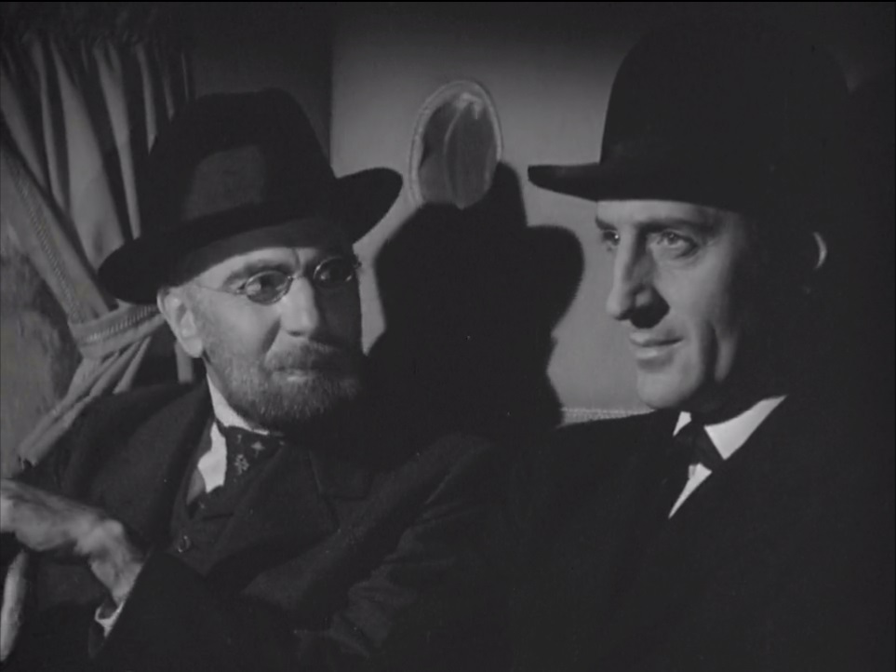

Fig. 1. George Zucco as Professor Moriarty and Basil Rathbone as Sherlock Holmes in the 1939 film The Adventures of Sherlock Holmes (00:03:52).

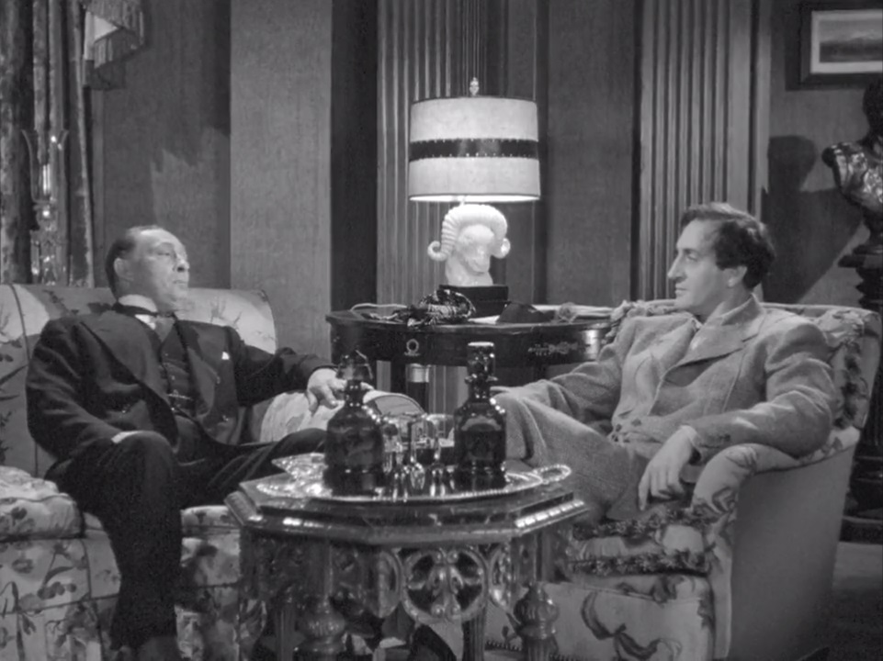

Fig. 2. Professor Moriarty as played by Lionel Atwill and Rathbone’s Sherlock Holmes in Sherlock Holmes and the Secret Weapon (00:59:34).

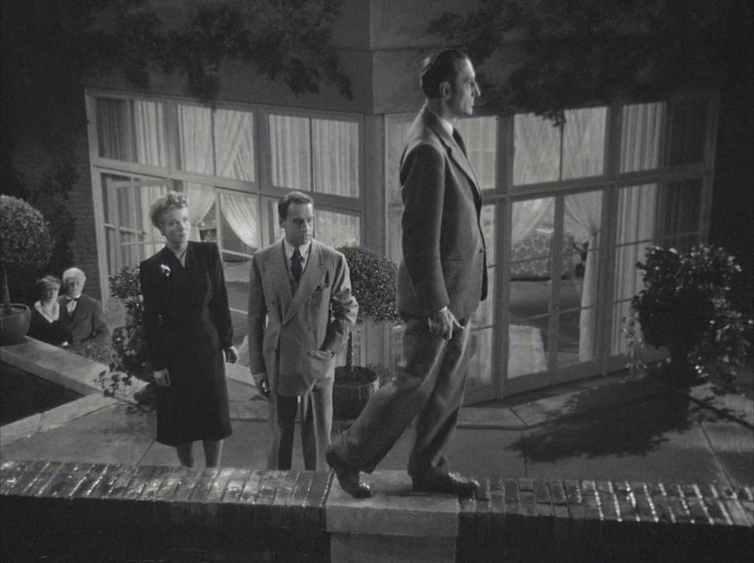

Fig. 3. Hillary Brooke as Lydia Marlowe, Moriarty’s collaborator, Henry Daniell as Professor Moriarty and Basil Rathbone as Sherlock Holmes in the final scene of The Woman in Green (01:04:08).

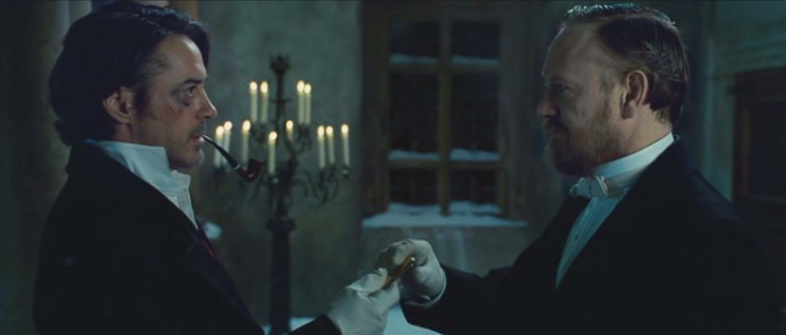

Fig. 4. Sherlock Holmes as played by Robert Downey Jr with Professor Moriarty played by Jared Harris in the final moments of Sherlock Holmes: A Game of Shadows (01:54:08).

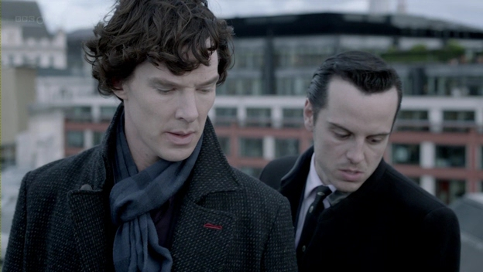

Fig. 5. Benedict Cumberbatch as Sherlock Holmes and Andrew Scott as Jim Moriarty in the rooftop scene in the last episode of Series 2 of BBC Sherlock, ‘The Reichenbach Fall’ (01:11:53).

Works Cited
The Adventures of Sherlock Holmes. Dir. Alfred L. Werker. Screenplay by Edwin Blum and William A. Drake. Perf. Basil Rathbone, Nigel Bruce, George Zucco. 20th Century Fox Film Corporation, 1939. Film.
Bergman, Jerry. “Darwinism and the Nazi race Holocaust.” Creation. Creation Ministries International. Web. 17 Nov. 2013.
<http://creation.com/darwinism-and-the-nazi-race-holocaust>.
Butler, Chris. “British Rule in India (c.1600-1947).” The Flow of History. 2007. Web. 17 Nov. 2013. <http://www.flowofhistory.com/units/eme/18/FC123.>
Davies, David Stuart. Starring Sherlock Holmes. Rev. ed. London: Titan Books, 2007. Print.
Doyle, Arthur Conan. ‘The Final Problem.’ The Complete Sherlock Holmes. New York: Barnes & Noble, 2009. Print.
---. Memories and Adventures. Boston, Little, Brown, and company,1924. Web. 21 Nov. 2013. <http://www.unz.org/Pub/DoyleArthur-1924>.
---. ‘The Sign of Four.’ The Complete Sherlock Holmes. New York: Barnes & Noble, 2009. Print.
Frost, Martin. Holocaust. Web. 28 October 2013. <http://www.martinfrost.ws/htmlfiles/holocaust.html#Efficiency>
Gordon, Jeffrey. “Is War Inevitable?” Philosophy Now. Philosophy Now, 2013. Web. 22 Nov. 2013. <http://philosophynow.org/issues/66/Is_War_Inevitable>.
“The Great Game.” Sherlock. Dir. Paul McGuigan. Screenplay by Mark Gatiss. Perf. Benedict Cumberbatch, Martin Freeman, Andrew Scott. Hartswood Films, 2010. DVD.
Guiness World Records News.‘Sherlock Holmes Awarded Title for Most Portrayed Literary Human Character in Film & TV.’ Guiness World Records. May 14 2012. Web. 17 Nov. 2013. http://www.guinnessworldrecords.com/news/2012/5/sherlock-holmes-awarded-title-for-most-portrayed-literary-human-character-in-film-tv-41743/
Mark Gatiss and Steven Moffat on Moriarty. BBC. 15 January 2012. Web. 10 November 2013. <http://www.bbc.co.uk/programmes/p00n89k4>.
“Murder for Murder’s Sake.” The Spectator 25 Sept.1880: 12. Spectator Archive, 2013. Web. 17 Nov. 2013.
<http://archive.spectator.co.uk/article/25th-september-1880/12/murder-for-murders-sake>.
Nugent, Frank S. “The Adventures of Sherlock Holmes (1939); Fog-Bound Thriller Is Roxy's 'Adventures of Sherlock Holmes, With Basil Rathbone as the Sleuth”. New York Times 2 Sept. 1939. The New York Times Company, 2013. Web. 17 Nov. 2013. <http://www.nytimes.com/movie/review?res=9D02E6DC1330E53ABC4A53DFBF668382629EDE>.
Paxton, Lee. Elements of Fascism: An Interpretation. Thanatos Unbound. Web. 28 October 2013. <http://www.thanatosunbound.co.uk/texts/Elements%20of%20Fascism.pdf>.
“The Reichenbach Fall.” Sherlock. Dir. Toby Haynes. Screenplay by Stephen Thompson. Perf. Benedict Cumberbatch, Martin Freeman, Andrew Scott. Hartswood Films, 2012. DVD.
Sherlock Holmes. Dir. Guy Ritchie. Screenplay by Michael Robert Johnson, Anthony Peckham, Simon Kinberg and Lionel Wigram. Perf. Robert Downey Jr., Jude Law, Mark Strong. Warner Bros, 2009. DVD.
Sherlock Holmes: A Game of Shadows. Dir. Guy Ritchie. Screenplay by Michele Mulroney and Kieran Mulroney. Perf. Robert Downey Jr., Jude Law, Jared Harris. Warner Bros, 2011. DVD.
Sherlock Holmes and the Secret Weapon. Dir. Roy William Neill. Screenplay by Edward T. Lowe Jr., Scott Darling and Edmund L. Hartmann. Perf. Basil Rathbone, Nigel Bruce, Lionel Atwill. Universal Pictures, 1942. Film.
“A Study in Pink.” Sherlock. Dir. Paul McGuigan. Screenplay by Steven Moffat. Perf. Benedict Cumberbatch, Martin Freeman, Phil Davis. Harswood Films, 2010. DVD.
The Woman in Green. Dir. Roy William Neill. Screenplay by Bertram Millhauser. Perf. Basil Rathbone, Nigel Bruce, Henry Daniell. Universal Pictures, 1945. Film.

Resumé
Tato práce se soustředí na zobrazení a ztvárnění zla, a také na interpretaci role postavy Profesora Moriartyho ve třech adaptacích původních povídek Artura Conana Doyla. Práce se zabývá následujícími adaptacemi: sérií filmů společnosti Universal z let 1939-1946, konkrétně filmy The Adventures of Sherlock Holmes, Sherlock Holmes and the Secret Weapon and The Woman in Green; filmy Sherlock Holmes a Sherlock Holmes: Hra Stínů z dílny režiséra Guy Ritchieho a seriálem z produkce BBC Sherlock. Cílem této práce je osvětlit a zanalyzovat roli postavy Profesora Moriartyho ve výše zmíněných adaptacích originálních Doylových povídek. Práce se zaměřuje jak na vlastní povahové rysy a jednání Profesora Moriartyho, tak na symbolickou a reprezentativní hodnotu postavy jako takové.

Summary
The present thesis concentrates on the representation of evil and interpretation of the function of the Professor Moriarty character in three different Holmes adaptations: the Universal film series starring Basil Rathbone and Nigel Bruce (particularly the films The Adventures of Sherlock Holmes, Sherlock Holmes and the Secret Weapon and The Woman in Green), the Guy Ritchie’s Sherlock Holmes franchise and the BBC series Sherlock. The purpose of this work is to present and analyse the role of Professor Moriarty in the aforementioned screen renditions of Holmes canon stories, including the particular features of the character, as well as the symbolical and representative value of the character as such.

According Guinness World Records, there have been 254 screen versions of the character by May 2012. Since that time two other adaptations has been revealed: CBS Elementary and Russian Sherlock Holmes, which makes the count 256 adaptations in November 2013.
See Guinness World Records news
The relationship between the Great Britain and India was damaged in 1857 when the Indian Mutiny took place, starting by local uprising against the British in Meerut and developing into series of revolts which were eventually suppressed by the British Army. The event resulted in dissolving the British East Indies Company and full British control over India. Few years before the events of Holmes canon take place; The Indian National Congress was founded in 1885, leading the independence movement (Butler).
Many of the early Sherlock Holmes adaptations were based on William Gillette‘s play Sherlock Holmes, written in 1898. One of the important scenes of the play is set in Stepney Gas Chamber.
As important as the device seems to be in the first movie, it does not appear in the second instalment at all. If Moriarty obtained such a device, he would most definitely use it; therefore, the question is why the remote control never appears again.
Guy Ritchie’s film presents Professor Moriarty as a mathematical celebrity of a very high public esteem who could be hardly accused of any evil plotting. A Holmes 1962 film Sherlock Holmes and the Deadly Necklace takes this theory a step further: in this adaptation Professor Moriarty becomes an archaeology expert widely known all around the world who is to be knighted by the Queen of England herself.
When Holmes discovered what Moriarty’s plans are he sent a telegram to his brother Mycroft warning the British Government and the nations of Europe of Moriarty’s schemes.
The first adaptation to place the Holmes canon characters into the contemporary environment was the Basil Rathbone series with Holmes and Watson fighting the World War II enemy.
The modern Sherlock Holmes does not publish his observations in newspaper articles, he has his own website named ‘Science of Deduction.’
The whole scene has been adopted from the 1945 adaptation The Woman in Green starring Basil Rathbone and Henry Daniell (BBC, 00:01:24).
The British secret services managed to catch Jim Moriarty. They were trying to interrogate him, but Moriarty said nothing until Sherlock’s brother Mycroft, an employee of the British Government, disclosed information from Sherlock’s life. Only then Jim Moriarty started talking. There is a small nod towards this fact in The Hounds of Baskerville and the whole situation is explained by Mycroft in The Reichenbach Fall.

