MASARYK UNIVERSITY

FACULTY OF EDUCATION
Department of English Language and Literature



Comparison of the first and the fourth editions of English File coursebook:
Analysis of development

Bachelor Thesis
Brno 2020

Supervisor: Author:
Mgr. Irena Headlandová Kalischová, Ph.D. Marek Antal

Bibliographical record
Antal, M. (2020) Comparison of the first and the fourth editions of English File coursebook: Analysis of development: bachelor thesis. Brno: Masaryk University, Faculty of Education, Department of English Language and Literature. The supervisor of the bachelor thesis: Mgr. Irena Headlandová Kalischová, Ph.D.
Bibliografický záznam
Antal, M. (2020) Comparison of the first and the fourth editions of English File coursebook: Analysis of development: bakalářská práce. Brno: Masarykova univerzita, Fakulta pedagogická, Katedra anglického jazyka a literatury. Vedoucí bakalářské práce: Mgr. Irena Headlandová Kalischová, Ph.D.

Abstract
The thesis "Comparison of the first and the fourth editions of English File coursebook: Analysis of development" deals with the role of coursebooks in English language teaching (ELT), the importance of the coursebook evaluation process in order to choose the appropriate materials for ELT classes, and the actual evaluation of the first and the latest editions of a selected ELT coursebook. The thesis is divided into two parts. The theoretical part focuses on the theory of the use of coursebooks in ELT and the coursebook evaluation process, introducing various approaches and criteria of evaluation. The practical part uses the gathered knowledge to compare and analyse the first and the latest editions of English File coursebook according to a checklist which was developed for the purpose of this thesis. The aim of the thesis is to show how the two editions differ, and how the coursebook itself has developed since the first edition was published.
Keywords
ELT coursebook, evaluation, checklist, comparison, analysis, development, language skills
Abstrakt
Tato práce s názvem Srovnání prvního a čtvrtého vydání učebnice angličtiny English File: Analýza vývoje se zabývá rolí učebnice ve výuce anglického jazyka, důležitostí procesu evaluace učebnic za účelem výběru vhodných materiálů pro výuku anglického jazyka a vlastní evaluací prvního a čtvrtého vydání vybrané učebnice angličtiny. Práce je rozdělena do dvou částí. Teoretická část se zaměřuje na teorii použití učebnic pro výuku anglického jazyka, procesem evaluace učebnic a představením různých přístupů a kritérií evaluace. Praktická část srovnává a analyzuje první a poslední vydání učebnice angličtiny s názvem English File za využití poznatků získaných v teoretické části, především checklistu, který byl vytvořen pro účely této práce. Cílem práce je ukázat, jak se tato dvě vydání od sebe liší a jak se samotná učebnice vyvinula od jejího prvního vydání.
Klíčová slova
učebnice anglického jazyka, evaluace, checklist, srovnání, analýza, vývoj, jazykové dovednosti

Declaration
I hereby declare that I have worked on this bachelor thesis on my own and that the information I used has been fully acknowledged in the text and included in the reference list.
Prohlášení
Prohlašuji, že jsem bakalářskou práci vypracoval samostatně, s využitím pouze citovaných literárních pramenů a zdrojů uvedených v seznamu literatury v souladu s Disciplinárním řádem pro studenty Pedagogické fakulty Masarykovy univerzity a se zákonem č. 121/2000 Sb., o právu autorském, o právech souvisejících s právem autorským a o změně některých zákonů (autorský zákon), ve znění pozdějších předpisů.
Souhlasím, aby práce byla uložena na Masarykově univerzitě v Brně v knihovně Pedagogické fakulty a zpřístupněna ke studijním účelům
In Brno, 6.8.2020 Marek Antal

_______________________

Acknowledgements
I would like to thank Mgr. Irena Headlandová Kalischová, Ph.D. for her helpful advice and patience, and for supervising my bachelor thesis.
Table of Contents
Introduction 8
1 THEORETICAL PART 10
1.1 Coursebooks in ELT 10
1.1.1 Defining a coursebook 10
1.1.2 The role of coursebooks in ELT 10
1.1.3 Use of coursebooks in ELT – advantages and disadvantages 11
1.1.4 Types of coursebooks 12
1.2 The need for coursebook evaluation 15
1.3 Coursebook evaluation 16
1.3.1 Types of evaluation 16
1.3.2 Coursebook evaluation according to Cunningsworth 17
1.3.3 Coursebook evaluation according to Ellis 18
1.3.4 Coursebooks evaluation according to Daoud and Celce-Murcia 19
1.3.5 Coursebook evaluation according to Průcha 20
1.3.6 Coursebook evaluation according to Grant 21
1.3.7 Criteria of evaluation 23
2 PRACTICAL PART 26
2.1 Overview of English coursebooks for pre-intermediate level 26
2.2 English File – general description 27
2.2.1 English File 2 27
2.2.2 English File Pre-intermediate, fourth edition 28
2.3 Content analysis 29
2.3.1 First edition - English File 2 29
2.3.2 Fourth edition - English File Pre-intermediate 36
2.4 Comparative analysis of the first and the fourth editions 44
Conclusion 51
3 List of References 54
4 List of Appendices 57

Introduction
The ability to speak at least one foreign language is almost an inevitable necessity nowadays, in the 21st century, considering how multi-cultural the world is and considering the opportunities to study, work, travel, and live abroad. Undoubtedly, English has become and still is the most commonly used language all over the world. Therefore, English language teaching (ELT) has become an essential part of national curricula not only in the Czech Republic but in most countries in the world. Moreover, even people who did not have the chance to study English during their school studies, for instance, because of political or social reasons, nowadays decide to start learning the English language in order to adapt to the multi-cultural society.
In an ELT course, teachers can use various teaching aids to arouse learners' interest in the subject, make both the teaching and learning process more exciting and enjoyable, and maximise the outcome of the process. The prevailing teaching aid in most ELT courses is a coursebook. Therefore, the selection of the right coursebook is a crucial decision that authorities and teachers must make because it can have a massive impact, either positive or negative, on the teaching and learning process.
Even though there are a few brand new English coursebooks published every year, the most used ELT coursebooks are usually the proven and well-known series which have been on the market for a long time. However, even these coursebooks must adapt to new trends and the development in the teaching and learning process. This is achieved by publishing new updated editions. Nevertheless, some teachers often refuse to change their present editions for the newest ones for several reasons. First, it is expensive for schools and teachers as they must buy the whole package including a student's book, workbook, teacher's book, audio CDs and culture DVDs. Second, some teachers do not want to change their routine as they are used to the older editions, and it is less time consuming to teach according to them than getting used to new coursebooks and changing their lesson plans.
I have experienced both cases as a learner as well as a teacher. In both cases, it has always been the English File series of coursebooks. I have used all levels of this series as a learner, and still use most of the levels even as a teacher. In English lessons at grammar school, where I studied for eight years, I always used older editions of coursebooks even though my friends from other schools used the newest ones. When we asked our English teachers, the most common answer was that it would be too expensive both for us, the learners, as we had to pay for English coursebooks, and for the school. On the other hand, when I started teaching at a private language school, all courses were taught using New English File coursebooks, which is the second edition of the English File series, even though the third edition was already published and available for many years. When I wanted to know why the school did not buy the newest editions, they said that it would be expensive and most importantly, the teachers themselves did not want them as they did not want to get used to new coursebooks, new topics and recordings, and change their routine lesson plans.
Therefore, the thesis deals with the evaluation of ELT coursebooks and the comparison and analysis of the first and the latest editions of an ELT coursebook. The coursebook chosen for the analysis is a part of English File series, English File Pre-intermediate, and it was chosen because of my own experience with this series and all levels both as a learner and a teacher. I decided to analyse the pre-intermediate level for two reasons. First, it is a level I use on an everyday basis with young adult and adult learners in English courses and second, the first edition consisted of only two levels, beginners/elementary and pre-intermediate.
The aim is to show how the two editions differ, discuss the development and its possible contribution to the teaching and learning process, and answer the question if it is worth, necessary, and useful to buy and teach using new editions of coursebooks.
The thesis is divided into two parts, theoretical and practical. The theoretical part introduces a theoretical background on coursebooks, their types, role and use in ELT. Since the thesis aims to evaluate, compare, and analyse English coursebooks, the theoretical part also presents different approaches to coursebook evaluation and analysis, including various criteria and checklists. The practical part then deals with the comparison and analysis of the first and the fourth editions based on a checklist, which was created for the purpose of the thesis.

THEORETICAL PART

Coursebooks in ELT
This chapter deals with the basic facts regarding the terminology and the use of coursebooks in ELT, as well as the crousebook evaluation itself. A clear definition and understanding of the basic terms and principles are essential in order to understand them because they often appear in the thesis and other things are based on them.

Defining a coursebook
There are two words in English that very similar regarding its form and meaning, and that are commonly used when speaking about the same thing: a coursebook and a textbook. It is necessary to consider which term is more appropriate to use in this thesis. Cambridge Dictionary defines a coursebook as "A book used by learners when they do a particular course of study", and Oxford Advanced Learner’s Dictionary says that it is "A book for studying from, used regularly on a particular course of study". On the other hand, a textbook is "A book that contains detailed information about a subject for people who are studying that subject" ("Cambridge Dictionary" n.d.) and "A book that teaches a particular subject and that is used especially in schools and colleges" ("Oxford Online Dictionary", n.d.).
From the given definitions, it is not possible to clearly state which term is more appropriate and not even the methodologists are consistent in using one term only. However, the term coursebook prevails and seems to be more complex as the word course implies that it consists of all materials necessary for and English course. Therefore, the term coursebook is used in the thesis to achieve consistency.
According to the given definitions, the aim of ELT coursebooks is to provide learners with the necessary knowledge of the English language itself, language skills and essential information about English speaking countries. Furthermore, it prepares learners for interaction with people from English speaking countries and of different cultural background.

The role of coursebooks in ELT
Coursebooks are the most noticeable feature of a teacher’s methodology and can significantly influence and contribute to a syllable of a course. There has always been a debate over the importance, the usefulness, and the role of coursebooks in ELT classrooms (Allwright, 1981, Harmer, 2007). The question is whether coursebooks can help learners to achieve better results. O’Neill (1982) provides four justifications for the use of coursebooks in ELT classes. The justifications are:
- A large portion of a coursebook’s material can be suitable for learners’ needs, even if not explicitly designed for them.
- Coursebooks allow learners to look ahead to what they are going to do, or to look back and refresh what they have done. They remove the element of a surprise in learners’ expectations.
- Coursebooks have the practical aspect of providing material which is well-presented, and which would be possible to replace by teachers only at high cost in terms of both money and the time.
- Well-designed coursebooks allow both teachers and learners for improvisation and adaptation, including spontaneous interaction in the class. (O'Neill, 1982)

Use of coursebooks in ELT – advantages and disadvantages
There are, for sure, certain advantages and disadvantages of using a coursebook in ELT classrooms. On the one hand, some authors view coursebooks as an invaluable resource and claim that they have a vital and positive role in the everyday job of teaching and learning English. O’Neill says, "Since language is an instrument for generating what people need and want to say spontaneously, a great deal must depend on spontaneous, creative interaction in the classroom" (O’Neill, 1982, p. 111). There are several things which almost any group studying English will have in common; a common core of needs shared by a variety of groups in different places studying under different conditions at different times (O’Neill, 1982). Therefore, coursebooks should be accessible to a variety of learners without regard to learners’ learning goals, as well as being adaptable to the diversity of teachers and teaching styles. Ranalli (2003) agrees with O’Neill and provides the reader with an example of the creation of Global Coursebook "Which can be used by pupils at a particular level and age group anywhere in the world, regardless of culture."
For teachers, the coursebooks significantly serve as a great resource of materials and activities, as well as a resource of supplementary materials, e.g. audio CDs, video/DVD materials, or interactive software. Most of the coursebook also provide well-detailed and coherent syllabus, including detailed procedures for the lessons and lesson plans, which could be invaluable support for inexperienced teachers and could save the teachers a significant amount of time.
For learners, on the other hand, the coursebooks provide a grammar, pronunciation, and vocabulary reference for revision, and serve as a means of language control and the perception of progress, as the units are always progressively completed.
On the other hand, there are opponents of coursebooks who argue about their relative benefits and consider them to be superficial in its coverage of language points. Although a coursebook might be an essential teaching aid in some way, it cannot determine the full content and outcome of a language course. According to Allwright (1981), coursebooks take a limited role in the process of learning a language. However, coursebooks certainly serve both the learners and the teachers as an essential source of information.

Types of coursebooks
The following chapter is based on Grant (1990) and his classification of coursebooks because no other comprehensive and thorough description of types of coursebooks, which would be suitable for the purpose of this thesis, was found during the literary research.
With a high number of different kinds of coursebooks, there are many options to divide them into some categories, but it is not possible to say which division is the right one. It is not even possible to have just one correct answer to which division is the right one as different approach can be applied to make the categories, and according to Grant (1990), many teachers have their way of categorising coursebooks. As an example, he suggests learner-centred and teacher-centred materials, materials divided according to the language of instructions, the aim of the materials, the specific type of English and many more.
Grant tries to make two broad categories of coursebooks, even though he realises that it is not always possible to place a coursebook within either of these categories. These categories are traditional coursebooks and communicative coursebooks.
The term traditional is not used to describe the date when a coursebook was published, but rather a type of coursebook; therefore, traditional textbooks might be still published today. Traditional coursebooks are described as those which try "To get learners to learn the language as a system" (Grant, 1987, p. 13). The following list of characteristics is based on Grant’s definition of traditional coursebooks. These coursebooks:
- emphasise the forms, or patterns, of language (the grammar) more than the communicative functions of language
- focus on reading and writing activities
- use a great deal of L1 (speaker’s first language)
- emphasise the importance of accuracy
- focus rather narrowly on the syllabus and examinations
Although traditional coursebooks might be easy to use by both teachers and learners, the result of using them is that at the end of the studies learners know the grammar (the system) of a language, but they cannot communicate (use) it.
On the contrary, Grant states that the communicative coursebooks try to create "Opportunities for the students to use the language in the classroom, as a sort of ‘halfway house’ before using it in real life" (Grant, 1987, p.13). Although communicative coursebooks might vary a lot, the characteristics they all should have in common according to Grant are as follows:
- emphasis on the communicative functions of language,
- reflection of students’ needs
- emphasis on four language skills and good balance among them
- reflection of the authentic language of everyday life
- encouraging working in groups or pairs
- emphasis on fluency and not only on accuracy (Grant, 1987, p.13)
Besides, Grant claims that English might be still taught in a way that neither the skill nor the language is likely to be used in everyday life. Therefore, he gives examples of communicative activities that help learners to use the language they learn in real life, namely listening to authentic language (e.g. recording of an airport announcement, phone call), implementing information-gap exercises (giving learners a purpose for communication), reading a text in order to find particular information, and expressing themselves in writing in a real situation (e.g. writing a postcard or completing an application form).
However, Grant admits that even some non-communicative activities might be useful as well if they suit learners’ learning styles - or teachers’ teaching styles. These activities, suggested by Grant, are dictations, grammatical explanations, accuracy exercises such as blank-filling and sentence completion (Grant, 1987, p. 15).
To decide whether a coursebook is traditional or communicative, Grant offers a quick test which is comprised of four easy steps.
Firstly, the language used in the coursebook is analysed. If the dialogues used in the coursebook seem artificial and unnatural, then it is probably a traditional one. On the other hand, if the dialogues are real-life examples of communication (e.g. newspaper articles, interviews, book excerpts...), then the coursebook is communicative.
Secondly, if the content of language exercises and activities presented in the coursebook are likely to occur in real life as well, it is a communicative coursebook.
Thirdly, the test examines if the activities emphasise accuracy rather than fluency. In case most of the activities are tightly controlled by the teacher, so that the learners do not make any mistakes, then it is a traditional coursebook. On the contrary, when the coursebook provides enough fluency practice, making learners talk to each other in pairs or groups and expressing what they really want to say, there is a risk of their making mistakes. However, communicative coursebooks accept this risk.
Finally, the test focuses on the question of whether the coursebook emphasises study or practice. A coursebook which spends much time studying particular language forms without providing enough practice in real-life situations is not communicative.
According to this test, most of the coursebooks that are published nowadays would be categorised as communicative ones.

The need for coursebook evaluation
With so many different coursebooks on the market, it is crucial to choose the right coursebook for an ELT course because it can have a massive impact on teaching and learning process as teachers would make references to the coursebooks (Cunningsworth 1995, Harmer 1991). Cunningsworth claims that the quality of a coursebook might be so important that it can determine the overall success or failure of an ELT course. Therefore, ELT teachers should be able to evaluate coursebooks that they will use in their course to maximize the success of the course. Choosing an improper coursebook can lead to learners' failure in acquiring the language rather than contributing positively to learners' development. Moreover, Tomlinson (2008, p. 3) says that many coursebooks contain serious pedagogical flaws and practical shortcomings.
According to Tomlinson (2008, pp. 3-7), the cause of learning failure has two parts. Firstly, teachers focus on the teaching of linguistic items instead of focusing on opportunities for learners to acquire the language, and they do so because it is often both expected and required by the society, i.e. by parents, publishers, authorities and by learners too. Secondly, authors of coursebooks often focus on their intuition and create materials that they think would be the best for the users instead of considering the actual need of learners and how learners could benefit from using the coursebook.
The most common and major reason for coursebook evaluation is the intention to adopt new coursebooks in ELT courses (Cunningsworth, 1995). This happens when teachers can choose coursebooks themselves, and thus are responsible for their choice. However, according to a survey conveyed by Tomlinson, only 15 per cent of coursebooks are selected by teachers. On the other hand, the coursebooks are mostly selected by an authority (up to 85% of coursebooks are selected by authorities), e.g. institution/ director of studies/ colleagues (Tomlinson, 2008, p. 8). In such a case, it is beneficial if the teachers are able to analyse and identify particular strengths and weaknesses of the coursebooks, so that the optimum use can be made of their strong points, while their weaker fields can be strengthened through adaptation or substitution of materials from other coursebooks (Cunningsworth, 1995).
Because of the above, it is essential to convey ELT coursebook evaluation in order to support the attainment of both teaching and learning goals effectively. The wrong choice of coursebooks could negatively affect both teaching and learning.

Coursebook evaluation
Coursebook evaluation can be understood as a selective and subjective process of critical analysis based on the given criteria, which is not the same under any circumstances. There are countless pedagogical factors which influence the coursebook evaluation and thus even using the same criteria in different evaluation does not lead to the same results. The pedagogical factors, which cause that one material suits one group but does not fit the other, are a different age, nationality, cultural background, methodology, personal involvement and more. Therefore, no material could be generally applied to all ELT courses. However, according to Grant (1990), there are three conditions that a coursebook should comply in order to be the best possible for a specific group of learners. The conditions are as follows:
- It should suit the needs, interests and abilities of learners.
- It should suit the teacher (The best book in the world will not work in your classroom if you have good reasons for disliking it).
- The coursebook must meet the needs of official public teaching syllabuses or examinations. (Grant, 1990, p. 118)
According to Cunningsworth (1995), a coursebook evaluation involves a careful selection of materials which analyse whether they reflect the actual needs of the learners, the aims, methods and values of a specific teaching course. The evaluation examines if the content and methodology meet the requirements for a language teaching context.

Types of evaluation
There are many authors, books and articles that deal with different approaches to evaluation of coursebooks and criteria of a good coursebook. Individual authors introduce diverse methods and set various ways of evaluation. For example, Alan Cunningsworth examines different types of ELT coursebooks and the process of choosing them according to specific criteria; Rod Ellis introduces two approaches of materials evaluation according to when the evaluation itself is done, Jan Průcha examines the topic from the point of view of a pedagogical researcher, Neville Grant likens the process of coursebook evaluation to everyday life situations for an easier understanding. The mentioned authors and some others like A. Daoud, Marianne Celce-Murcia, Marry Spratt, and Penny Ur, were chosen to examine and compare different approaches to coursebook evaluation, and to provide the author with useful information for the practical part of the thesis.

Coursebook evaluation according to Cunningsworth
Cunningsworth (1995, p. 15) states that "The process of evaluation can be introduced before a coursebook is used, during its use and after use". It all depends on the circumstances and the purpose of the evaluation. The "pre-use evaluation", which aims at the future potential use, might be the most common, yet the most difficult as teachers have no experience of using the coursebook. When considering whether to keep or replace a well-established but ageing coursebook which is already part of an ELT course, "in-use evaluation" might be used. The third (and last) type of coursebooks evaluation that Cunningsworth states is "post-use evaluation"; it provides retrospective evaluation which can be used to identify the strengths and weaknesses that occur over a period of use and helps with decision making whether to keep the same coursebook in future.
The author lists four guidelines for material evaluation. Guideline one states that "Coursebooks should correspond to learners’ needs. They should match the aims and objectives of the language-learning programme" (Cunningsworth, 1995, p. 15). It is necessary to set a goal of the course first and only then choose a coursebook which would facilitate the expected outcome rather than to determine the outcome based on the coursebook.
Second guideline reads that "Coursebooks should reflect the uses (present or future) which learners will make of the language. Select coursebooks which will help to equip learners to use language effectively for their own purpose" (Cunningsworth, 1995, p. 15-16). The course should have a clear view of what learners need to use the language in relevant situations effectively. It is essential to choose the content according to the future goals of the learners. Therefore, engaging learners’ interests and challenging their intellect by promoting progressively higher levels of autonomy and self-reliance can motivate them to become more independent in their language use.
Guideline three says that "Coursebooks should take account of learners’ needs as learners and should facilitate their learning processes, without dogmatically imposing a rigid method" (Cunningsworth, 1995, p. 16). The author suggests that coursebooks can help learners to learn in various ways by breaking down selected language items (e.g. grammar, functions, skills) into manageable units and ordering them from the familiar to the unfamiliar and from more accessible to more difficult. Coursebooks should allow learners to use styles of learning which best suit them offering learners some choice in the way they learn. Coursebooks should also challenge learners in order to keep them motivated. This can be done by periodic quizzes which are designed to highlight what learners know rather then what they do not know.
Last guideline, guideline four, states that "Coursebooks should have a clear role as a support for learning. Like teachers, they mediate between the target language and the learner" (Cunningsworth, 1995, p. 17). He specifies the exact role of coursebooks and highlights that coursebooks should serve as a material both for teachers and learners. Coursebooks primarily supply models of English according to the level of proficiency and provide learners with exercises and activities in order to promote fluency in the use of English.

Coursebook evaluation according to Ellis
Ellis (1997) describes two forms of coursebook evaluation in his essay "The empirical examination of language teaching materials", predictive and retrospective. To provide a basic definition, both evaluations are used by teachers; the predictive evaluation is designed to make recommendations about what products need to be used, and the retrospective evaluation is structured to evaluate items that have already been used.
According to Ellis (1997, pp. 36-37), the purpose of predictive assessment is to compare accessible coursebooks to choose the one that best suits their goals. This sort of appraisal can be performed in two respects. The first is to focus on tests provided by qualified academics and teachers. The second is to perform one's own statistical assessment rather than depending on the assessments of others. Both forms of this test can, however, be included. Retrospective testing is used to support teachers to determine if the individual textbook is worth having. Alternatively, put it another way, whether the textbook satisfies all specifications. Such a test also contains the concerns about whether the textbook should be used again or whether it should be replaced with a new one. Retrospective tests can also be carried out in two forms. The first approach can be impressionistic evaluation, which ensures that teachers determine the tasks function during the language course so that at the end of the course, they can create a summative decision of the resources used. The second way of doing a retrospective evaluation is an empirical evaluation. The empirical evaluation is a more systematic approach; however, it is less efficient and time-consuming.

Coursebooks evaluation according to Daoud and Celce-Murcia
Another approach to coursebook evaluation was presented by Daoud and Celce-Murcia (1979, pp. 302-303). They divided the process of coursebook evaluation into three major stages: survey, analysis, and judgement. There is also a pre-stage before these three main stages called preparatory stage, which is the collection of preliminary information.
The stage of collecting the preliminary information involves collecting background information about the learners (age, English level, reasons for learning, etc.), information about the syllabus of the course (focus given to each ability, the emphasis given to the language field, etc.) and institutional data (class size, time for English, sort of physical environment or assistance, etc.). The three main stages may be interpreted as stages that follow one another.
The first phase, called a survey, can be performed after collecting all the preliminary information. The survey involves skimming through the coursebook sections, through the introduction, the contents list, the texts, and the glossary. The survey is completed by distinguishing the unsuitable coursebooks and the coursebooks that seem to fulfil the preliminary criteria stated. The second step, called analysis, implies a careful examination of the coursebook and the teacher's manual. The research is carried out by capturing and arranging data according to the topics given below.
"The textbook: a. Subject matter, b. Vocabulary and structures covered, c. Exercises, d. Illustrations, e. Physical make up. The teacher´s manual: a. General features (answers for exercises, index with references, etc.), b. Type and amount of supplementary exercises for each language skill, c. Methodological/pedagogical guidance in the presentation of lessons/exercises and the use of aids, d. Linguistic background information." (Celce-Murcia, 1979, pp. 302-303)
The last stage, judging, finishes the evaluation process. It requires evaluating other aspects of the coursebook, namely qualitative and quantitative coursebook elements. This evaluation method is performed by using a prepared checklist of criteria in which each criterion is evaluated by a certain number of points. Chapter 2.2.7.2 deals with this checklist.

Coursebook evaluation according to Průcha
Evaluating and analysing coursebooks require a certain knowledge of research methods. Průcha (1998) states that nearly all methods which are part of the empirical pedagogical research can be used for the analysis of coursebooks. The following list of methods for coursebook evaluation and analysis is based on Průcha:
- Quantitative methods – methods using various statistical operations to analyse the coursebook characteristics. These methods compare the occurrence and frequency of measurable elements. The elements which can be measured can be verbal and non-verbal, for example, words, sounds, exercises, photos, etc.
- Methods of content analysis – methods focusing on evaluation of the quantitative coursebook characteristics (e.g. methods of semantic analysis or methods of information theoretical analysis).
- Methods of questioning – methods gathering and evaluating some evidence about coursebook characteristics within the educational process. These methods usually use interviews and questionnaires to get the evidence.
- Methods of observation – methods not commonly used in coursebook evaluation. However, Průcha says that a lot of research works dealing with the observation of using coursebooks in real courses have been conveyed abroad.
- Methods of testing – methods using specific tests for certain groups of learners to compare the use of different coursebooks.
- Experimental methods – methods exploring the effects of certain changes of coursebook content in comparison with the original coursebook.
- Comparative methods – methods comparing two or more coursebooks from a certain point of view. This method is usually used for comparing new editions of coursebooks with the previous ones.
According to this list, the methods which are used in the practical part of the thesis are the content analysis, quantitative methods, and comparative methods.

Coursebook evaluation according to Grant
When talking about coursebook evaluation, Grant (1987, pp. 118-119) starts with stating that teachers should be able to evaluate any coursebook regardless the fact whether they were able to choose it, or they were ordered to use it by authorities. The process of evaluation which Grant suggests is the first step when deciding how the book should be used to maximize the outcome in the classroom, and how it should be adapted.
According to Grant, the process of evaluating a coursebook is like a process of buying a new coat as we tend to ask the same questions in both situations. The questions are as follows:
- Does it fit?
- If it fits, how well does it fit – and how does it compare with others that also fit?
- (Later!) Does it still fit? This question becomes relevant after you have had it for a time (Grant, 1987, pp. 118-119).
Considering these three questions, Grant infers three stages of coursebook evaluation, which are as follows:
- Initial evaluation
- Detailed evaluation
- In-use evaluation

Initial evaluation
Grant (1987, pp. 119-120) say that the initial evaluation might be used when teachers need to quickly assess coursebooks and decide whether the coursebook is worth exploring in more detail. Even though it is not easy to evaluate a coursebook in a short period of time, teachers should not judge them hastily. To find out whether a book is worth further interest, Grant suggests applying the CATALYST test. The name of the test represents the eight criteria by which we can decide whether a coursebook is suitable for our classroom, and the name also represents the role a coursebook should play in the classroom, i.e. the catalyst as in a chemistry laboratory. Each of the letters represents the key question that teachers should ask themselves when evaluation a coursebook using initial evaluation:

- Communicative? – is the coursebook communicative?
- Aims? – Does it fit in with our aims and objectives?
- Teachable? – Does the course seem teachable?
- Available Add-ons? - Are there any useful additional materials such as teacher’s book, tapes, workbooks, etc.?
- Level? – Does the level seem about right?
- Your impression? – What is your overall impression of the course?
- Learner's interest? – Are your learners likely to find the book interesting?
- Tried and tested? – Has the course been tried and tested in real classrooms?
- One of the main criteria – cost – goes without saying! (Grant, 1987, p. 120).
Considering the CATALYST test, Grant emphasizes that when it is the very minimum that should be applied when evaluating a coursebook in order to decide whether to apply it in the course or not.

Detailed evaluation
The detailed evaluation is a step following the CATALYST test. This type of evaluation aims to compare the selected coursebook with other available coursebooks in terms of the suitability for the course. Grant says that the ideal way is to try the course using the coursebook to see how well it works; however, this is possible mainly in private language schools and not in the public educational systems. Therefore, many teachers must rely on their own judgement in choosing new materials (Grant, 1987, p. 121). In doing so, Grant introduces a three-part questionnaire which should help to decide how far a coursebook meets the three essential questions. i.e. Does the course suit the learners? Does it suit the teacher? Does it suit the syllabus? To overview the whole questionnaire, see Appendix 1.

In-use evaluation
The last stage of the evaluation process represents the continuous re-evaluation during the use of a coursebook in order to see if it works in the classroom. This evaluation should be applied even though the teacher does not consider changing or replacing the coursebook and in all situations. (Grant, 1987, p. 121)

Criteria of evaluation
There is no universal set of criteria that could be used for every coursebook evaluation. Different systems that are used for coursebook evaluation provide us with different checklists that consist of various aspects of teaching interaction. These aspects depend on the targeted field of evaluation and are formed into specific criteria of evaluation. These criteria are essential for any coursebook evaluation and must be clearly set before the evaluating process itself is started.
The criteria can be divided into general or specific ones. "General criteria are suitable for any language-teaching material while specific criteria are appropriate only for certain course of group of learners" (Ur, 2012, p. 199). Probably the most important general criterion is to match the coursebook with the aim and goals of the programme given. It is clear that the aim and goals of the learners of primary grades would be different from the aim and goals of learners of law or philosophy.
Various authors have introduced different checklist over time. The next paragraphs deal with the most important ones for the purpose of this thesis.

Criteria according to Ur
In the book Course of English language teaching, Ur introduces the following list of general criteria:
- Objectives explicitly laid out in an introduction, and implemented in the material
- Approach educationally and socially acceptable to target community
- Clear attractive layout; print easy to read
- Appropriate visual materials available
- Interesting topics and tasks
- Varied topics and tasks, so as to provide for different learner levels, learning styles, interests, etc.
- Clear instructions
- Systematic coverage of syllabus
- Content clearly organized and graded (sequenced by difficulty)
- Periodic review and test sections
- Plenty of authentic language
- Good pronunciation explanation and practice
- Good vocabulary explanation and practice
- Good grammar explanation and practice
- Fluency practice in all four skills
- Encourages learners to develop own learning strategies and to become independent in their learning
- Adequate guidance for the teacher; not too heavy preparation load
- Audio cassettes
- Readily available locally (Ur, 2012, p. 200)

Criteria according to Daoud and Celce-Murcia
The checklist introduced by Celce-Murcia (1979, pp. 304-305) can be used for both coursebook evaluation and teacher's manual evaluation. The checklist itself is very detailed; thus, for the purpose of the thesis, only the basic criteria of the checklist are mentioned. For the complete checklist, see Appendix 2.
The most important criteria mentioned in the checklist are:
- Subject matter
- Vocabulary and structures
- Exercises
- Illustrations
- Physical make-up (Celce-Murcia, 1979, pp. 304-305)

Criteria according to Spratt
Spratt (2005) introduces some other vital questions that could be used and answered in the coursebook evaluation process. The most important questions that could be used for the purpose of the thesis are:
- Does the visual material help learners to understand context and meaning?
- Will the topics be motivating to suit the age, gender, experience, and personal interests of your learners?
- Does it provide a clear enough context and explanations for learners to understand new language?
- Does it give learners enough opportunities to use the language? (Spratt, 2005, p. 110)
With all the different criteria and checklists mentioned in this chapter, designed by various researchers, it is evident that it is not possible to arrange all of them in a unified checklist because of different division and terminology. However, all the criteria have been considered and used for creating a new checklist. This checklist is therefore used in the practical part of the thesis. The checklist is divided into two parts, general criteria, and specific criteria.
In some checklists, the criteria are divided into general and specific ones. The general criteria are usually those analysing the attraction of the material, layout, the way the objectives are explained, series of coursebooks, additional materials (online sources, photocopiable materials, interactive applications etc.), availability or cost. However, this thesis analyses and compares two different editions, the first and the fourth, of the same coursebook. The fourth edition was published 22 years later than the first one; therefore it would be irrelevant to compare the attraction or availability and cost of the editions.
The general criterion is:
- General layout of the material – overall impression
The specific criteria include:
- Nature of topics and texts (motivating to suit the age, gender, personal interests)
- Treatment of skills and linguistic elements (tasks for speaking, writing, listening, and reading, grammar explanations and practice, vocabulary and pronunciation activities)
- Review and test sections, sections for self-evaluation
- Clear explanations to understand new grammar and clear instructions to do the exercises
- Authentic language
PRACTICAL PART

PRACTICAL PART
The practical part of the thesis deals with the content analysis and comparison of two different editions, the first and the last, of an English coursebook. It is divided into four major parts. The first one provides a brief overview of pre-intermediate English coursebooks available on the market and introduces some statistics of the most used coursebooks of selected level in Czech schools. The second and central part deals with the content analysis of the first and latest edition of the selected coursebook according to the criteria introduced in the theoretical part of the thesis. The last part concludes the research and introduces the closing comparison of the two editions, giving answers to the questions mentioned in the introduction.

Overview of English coursebooks for pre-intermediate level
Today's market provides both teachers and authorities with a large variety of English language coursebooks. Such a wide range of various materials makes it often very difficult to choose the right coursebook. It has been already discussed in the thesis that during the process of choosing the right coursebook, there are different factors influencing teachers and their decision making during this process. This paragraph is, therefore, going to focus on the influencing features that coursebooks have.
When going through the offer of coursebooks on the market, the first obvious thing that is noticeable besides different names is that there are different levels of coursebooks. The coursebook levels can be distinguished according to the level of learners (beginner, elementary, pre-intermediate, intermediate, upper-intermediate and advanced), The Common European Framework of Reference for Languages (A1, A2, B1, B2, C1, C1), or the stages of school education (pre-school, primary school, lower-secondary, upper-secondary, university).
The second feature that could be considered is the desired outcome of the coursebook and its specialization into a particular field of English language (general English, business English etc.) Other possible features considered might be whether a coursebook is a part of a larger series of coursebooks or an independent one.
According to a survey conducted by Sládková (2017) in 70 Czech secondary schools, the most frequently used coursebook is Maturita Solution, followed with New Headway and New English File. However, there are many more coursebooks on the market which are used both in state schools and private language schools. Some of them are, for instance, New Opportunities, Real Life, Time to Talk, Insight, Maturita Focus or Angličtina pro jazykové školy.

English File – general description
English File is a series published by Oxford University Press, the world's authority on the English language. The first edition of English File coursebooks was published in 1996 as a two-level course for adults and young adults, including coursebooks English File 1 (for beginners and false beginners) and English File 2 (for pre-intermediate learners). Since then, three other editions have been published – The New English File, English File Third Edition and English File Fourth Edition.
All English File coursebooks are monolingual, which means that only English is used throughout the whole book for instructions, comments, notes etc. However, the newer editions are also available in an edition for Czech market, including English-Czech wordlist at the end of the book.
The English File coursebook was chosen for the purpose of the thesis mainly because of the author's own experience with it both as a learner and a teacher. The pre-intermediate level was then selected because the author teaches pre-intermediate courses and can share his personal experience and opinion on the outcome of the thesis.

English File 2
English File 2 is the first edition of a coursebook for pre-intermediate learners published in 1997. The authors were Clive Oxenden, Paul Seligson, and Christina Latham-Koening. The course was available in a package including the coursebook itself, a workbook with key, a teacher's book, a student's 'Listen and speak' cassette and class cassettes. According to the description on the book cover, the English File 2 is a course which reflects the realities of both learning and teaching. The aim of the coursebook is to give learners a real sense of progress with its realistic syllabus with achievable language objectives, organized approach to revision and reference work, and integrated home-study programme. According to the authors, the main assets of the coursebook are as follow:
- Lessons integrating the main syllabus strands of the course. A special focus on grammar, pronunciation, and vocabulary. Constant revision and recycling.
- Systematic pronunciation work. A memorable and learner-friendly introduction to English sounds.
- An emphasis on graded listening materials and tasks.
- Travel with English. Functional language, practical communication in international 'survival' contexts.
- Revision and extension. Consolidation of core lessons through skill works.
- Vocabulary file. Systematic vocabulary revision with useful study tips.
- Grammar file. Self-check grammar reference in language accessible to the learners.
- Word bank. An active picture dictionary resource to make learning memorable. (Oxenden et al., 1997)

English File Pre-intermediate, fourth edition
English File Pre-intermediate, fourth edition, is a brand-new edition published in 2019 by Oxford University Press. The authors are the same as of the first edition with Jerry Lambert joining the team. It is a part of a seven-level course covering levels A1 to C1 according to the Common European Framework of Reference for Languages (CEFR).
The coursebook is available in a package which also includes a workbook with key, a teacher's guide with teacher's resource centre, class audio CDs, class DVDs, and online practice for learners.
The key features of the newest edition are:
- New and updated texts, topics and listenings, based on feedback from English File teachers.
- New Teacher's Resource Centre which allows teachers to manage all resources and teaching materials in one place online.
- New video listening activity integrated into each even-numbered file. These short documentaries and dramas make class time more dynamic and exciting.
- New student's book classroom presentation tool that shows the course content on screen, making it easier than ever for teachers to deliver heads-up, engaging lessons.
- New online practice which provides learners with extra practice activities for each file and allows them to check their progress.
- Online practice includes new Sound Bank videos, with unique opportunity to watch and listen to a clear model of the English sounds and new interactive videos where learners can take part in the video drama themselves.
- Award-winning Say it app that develops learners' confidence with pronunciation and allows them to see their intonation and stress. (Lethem-Koenig, et al., 2019)

Content analysis

First edition - English File 2

General criteria

General layout – the overall impression
Although the English File 2 coursebook was published in 1997, the layout is modern, colourful, clear, and straightforward. The cover page shows a symbol, which, in my opinion, represents a compass; a symbol which may indicate that the knowledge of English enables people to travel and communicate anywhere in the world. The whole coursebook contains 144 pages and consists of six main parts. The first part is a grammar review of all the grammar from the previous level (English File 1), followed by a table of contents, which provides a clear overview of topics, grammar, and vocabulary in each unit. After the actual units, there is a part which focuses on communication practice, the tapescripts of listening exercises travel phrasebook, and a word bank.
In the coursebook, there are nine files altogether, each having four separate units (except File 9, which has three units only). All units are elaborated in the same way throughout the whole coursebook. Every unit covers two pages with the topic of the unit written at the top of the first page of the unit. Above the topic, there is always written in blue colour what grammar the unit focuses on, and in black what vocabulary is covered so that learners know what to expect when they start a new unit. Most of the units include a major reading or listening exercise with follow-up speaking activities, grammar focus with a simple explanation and grammar practice, and a pronunciation exercise. The units are completed with various pictures. At the end of each file, there is a section called Travel with English focusing on functional language and practical communication, another section Revision and Extension, Focus on…section dealing with all language skills one at a time, and Vocabulary file and Grammar file, both revising the previous file.

Specific criteria

Nature of topics and texts (motivating to suit the age, gender, and personal interests), diversity of activities
The coursebook is aimed for young adults and adults, and the topics and texts presented in the book correspond to this fact. It introduces a lot of interesting topics from various areas of everyday life since each unit covers a different topic (thirty-five different topics in total). For instance, there are topics like weather and climate, environment, family life, travelling, famous people, film and theatre, places in English speaking countries, etc. All topics were certainly chosen in order to suit the age, gender and personal interests of targeted learners so that everybody can find there something of their interest.
The unit topics are usually introduced with some pictures and photos; however, it is usually some text which covers most of the unit. It is mostly articles, stories, dialogues, or quizzes. In some units, the texts are very long and can cover almost the whole page, but there are always many follow-up activities to divide the work with the text and make it more exciting and enjoyable.
There is a lot of activities and exercises in all the units, but they usually follow the same pattern, which makes it a bit repetitive and boring. However, it is understandable that there is a limited number of ways how to present, for instance, grammar, reading, or listening activities and exercises. The activities in the coursebook focus not only on all four language skills, but also on grammar practice, vocabulary, pronunciation, and other activities like games, projects, songs etc.
The following table shows the frequency of different activities in the coursebook. It is very difficult to count the activities and put them into groups as there is no naming of them except pronunciation, grammar focus and grammar practice. The rest of the activities is only numbered with subsequent tasks marked by letters (e.g. 1a, 1b and 1c). Therefore, for the purpose of this thesis, only activities with either a name or number were considered. The characteristics of the activities and tasks are discussed in the following paragraphs.
Table 1. The number of activities in English File 2
Type of activity | Number of activities | Number of activities (%)
Speaking | 98 | 22
Listening | 58 | 13
Reading | 60 | 14
Writing | 41 | 9
Grammar presentation | 44 | 10
Grammar practice | 49 | 11
Vocabulary | 40 | 9
Pronunciation | 30 | 7
Revision tests | 8 | 2
Games and songs | 13 | 3
Total number | 441 | 100

Treatment of skills and linguistic elements

Productive skills
Speaking and writing tasks (which are also called productive or active skills because learners need to produce language while doing these) together cover almost 31% of all the activities in the coursebook. Speaking itself is represented by 98 exercises, which means it is the most common type of exercises in the coursebook. This statistic only confirms the description of the coursebook, which says that there is a special emphasis on speaking.
Almost every unit starts with some warm-up speaking activity somehow connected to the topic of the unit. For example, in unit 1B, which deals with the present simple and the daily routine of a Hollywood star, there is a task to tell a partner about learner's typical day. In unit 4A, which focuses on comparative adverbs and adjectives when describing different cities in the world, the task is to describe photos of different places in the world. However, it is not only warm-up activities at the beginning of the units, but students are also asked to express their feelings, opinions, and experiences about different topics. Therefore, it is mostly cooperation and interaction between students which is encouraged, providing students with many opportunities for pair work and group work. The most common speaking activities in the coursebook are describing photos and pictures in general, dialogues, interviews, asking and answering questions, expressing opinion and experience, and role-plays. Overall, most of the activities focus on fluency and only a few focuses on accuracy (these are usually ones practising grammar). Moreover, there is a page called Focus on speaking, which provides students with useful tips on how to learn and how to improve speaking English. There are four tips altogether:
- If you don't know a word or phrase, don't just stop. Try to find another way to express it with words you know.
- You can always say more than you think. Don't worry about making mistakes. The important thing is to communicate what you want to say.
- Think what you want to say before you speak. It gives you confidence.
- Practise speaking English as much as you can. The more you practise, the more confident you'll feel. (Oxenden et al., 1997, p. 61)
On the other hand, there are not as many writing activities as speaking ones. There are 41 writing tasks, which can be divided into two types. First, there are writing tasks which often follow reading or listening exercises or grammar practice. These activities, copying and doing exercises, include completing given texts with missing words, creating sentences using particular grammar, and asking and answering questions in written form. The other type of writing tasks is to create a longer piece of text, like a paragraph or an article, according to a given topic. Thus, it can be classified as guided writing. Following examples of writing tasks can be found:
- Write a paragraph about you. Use the Student profile (a preceding reading exercise) to help you.
- Write a paragraph about your job/a friend's job.
- Write an advert for your town or country. Invent some good slogans.
- Write your own love story. Imagine as many details as you can. (Oxenden et al., 1997)
Even though the writing tasks are always connected to the topic of a unit, and there is always some piece of similar writing presented, there are no instructions on how to write that particular piece of writing in the whole coursebook. There is not even the part Focus on writing even though there is this part focusing on all the other skills. Thus, learners must rely on the teacher's help only.

Receptive skills
Receptive skills tasks, which are reading and listening (because learners do not need to produce language to do these, they just receive and understand it), represent 26% of all the activities in the coursebook. They usually follow one another and are often connected; therefore, the number of both reading and listening activities is almost the same.
Concerning the listening activities, both listening for the general idea and listening for specific information activities are included in the coursebook. They can be divided into three steps: pre-listening, while listening, and post-listening. All three kinds are equally presented in the coursebook. The pre-listening activities mostly focus on setting the context, generating interest, and on activating the vocabulary and language. The most common while-listening activities are listen and repeat tasks, filling in gaps, ticking items, listen and check, information transfer, and pronunciation. Post-listening activities are usually represented by check and summarize activities, discussions, information exchange, and problem-solving. There is also one page called Focus on listening, which summarizes why learners often find this skill difficult and give them useful tips on how to improve listening skills. It encourages learners to practice listening outside the class by watching films and TV shows in English, listen to songs, and talking to English-speakers as much as possible.
Reading activities include pre-reading activities, which are, for instance, brainstorming, skimming the text, predicting, describing photos and pictures, or speaking about what the text and the topic might be about. The actual reading activities include all five types of reading comprehension, i.e. lexical, literal, interpretative, applied, and affective comprehension, are present throughout the whole coursebook. There are, for instance, true or false activities, answering questions who, what, when, where etc., matching vocabulary with its definitions, or finding and completing information from the text. The Focus on Reading part introduces Easy Readers, which are books with simplified grammar and vocabulary adapted to the targeted level of English.

Grammar presentation and practice
The proportion of grammar presentation and grammar practice activities is also well balanced in the coursebook. There are 41 grammar presentation and 44 grammar practice activities, so together, they represent about 21% of all activities.
Grammar presentation exercises are called Grammar Focus, and they are a combination of both inductive and deductive grammar teaching and learning. However, the majority of these exercises are deductive as there is usually just one or two example sentences immediately followed with the general rule, which is then applied through the grammar practice part. Learners are usually asked to complete tables or sentences, match sentences with definitions of the used grammar, and choose correct words. These exercises are always followed with grammar practice activities which help learners to remember and practice the new piece of grammar. These usually include completing sentences or texts with correct missing words, choosing the correct form or order of words, writing sentences using the new grammar, matching sentences and expressions with definitions etc.
The overview of the grammar and vocabulary in the coursebook according to the unit topics would be very extensive; therefore, the table of contents can be seen in Appendix 3.

Vocabulary
There is always at least one vocabulary exercise in each unit, and there are forty of them in total, which represents 9% of all activities. They often focus on acquiring new words and phrases with further practice in the Word Bank part at the end of the coursebook. There is also a Vocabulary file part at the end of each unit for learners to revise the vocabulary from the previous unit.
Most of the vocabulary tasks present vocabulary 'out of context', aand learners focus primarily on the words and phrases in a vocabulary file and word bank. These activities are usually introduced with instructions as match the pictures with words, match the words and definitions, and complete the sentences with words from the box.

Pronunciation
Pronunciation activities concentrate on English sounds, including the table with IPA symbols used for English words and pronunciations at the end of the book, word stress, sentence stress and intonation. Learners learn and practice pronunciation mostly by listen and repeat exercises; however, there are also tasks to underline stressed syllables, underline stressed words or cross out words with a different sound.

Review and test sections
The coursebook provides learners with a revision and extension section at the end of each file except File 9, so there are eight of these sections in total. Most of them revise linguistic elements and skills from the preceding file and extend the topics with more listening, reading, and speaking exercises. There are also six songs with printable worksheets in the teacher's book. At the end of each file, there is also a section for self-evaluation called Grammar File which summarizes the grammar from the previous file so that learners can read the rules and check if they understand and remember it correctly. If they understand it, they can tick a box next to each piece of grammar. However, this section lacks any exercises, so learners' self-evaluation is based only on theoretical knowledge.

Clear explanations to understand new grammar and clear exercise instructions
As it was mentioned before, grammar presentation in this coursebook uses both inductive and deductive approach. When there are some explanations of new grammar, the grammar rules are always very brief. In the deductive exercises, the rules are usually presented with one sentence only, followed with a few example sentences and practice. The inductive exercises usually work with highlighted sentences and phrases from reading exercises to show the targeted grammar or completing various charts.
The exercise instructions in the coursebook are brief and precise. In the table of contents at the beginning of the coursebook, there is a table with a key to symbols used with some of the exercises, so that learners know what kind of exercise they are going to do. There is a symbol for communication, listening, grammar, vocabulary, revision, travel with English, Focus on section, and a sword bank. To give more detailed instructions and explain the task, or when there is no symbol, imperative sentences or questions are used, for instance:
- Listen and answer the questions.
- Talk to a partner about the topic.
- Write the questions for the answers.
- Match the pictures and phrases.
- Do you like detective stories? Discuss it with a partner.

Authentic language
Even though there are a lot of texts, recordings, and pictures in the coursebook, none of them includes a note that they are adapted from any copyright materials. Therefore, it might seem that there are no authentic materials whatsoever. However, on the very last page of the book, the publisher and authors list the articles, extracts, and adaptations which were used in the coursebook from the copyright materials. The list contains 23 printed materials, for example, A life in the day of Sir Anthony Hopkins, used in unit 1C, adapted from an article by Gearth Pearce, Sherlock Holmes Short Stories by Sir. A. Conan Doyle, or Cyrano de Bergerac taken from Elliot's Guide to Films on Video. There are also songs, illustrations, photographs, and logos listed together with names of the copyright holders. On the other hand, the list does not say anything about the recordings used for listening activities. Therefore, it can be assumed that the recordings were created for the purpose of the coursebook and they cannot be considered authentic materials. To see the whole list of authentic materials, see the scan of the acknowledgements in Appendix 4.

Fourth edition - English File Pre-intermediate

General criteria

General layout – the overall impression
Published in 2019, the English File Pre-intermediate, fourth edition, is a brand-new, modern, and updated coursebook whose design is simple yet attractive. The design of the cover page refers to the first edition as it depicts the same blue symbol, which the editors modernized and modified in order to suit the design standards of the present days (see Appendix 7). The authors of the fourth edition are Christina Latham-Koenig, Clive Oxenden, Jarry Lambert and Paul Seligson. There is a reference on the front page that Paul Seligson and Clive Oxenden (not Christina Latham-Koenig though, probably because she is the co-author of English File 2 only, not English File 1) are the original co-authors of English File 1 and English File 2. The coursebook contains 197 pages in total and opens with a table of contents, followed by 12 units, communication section, writing section, tapescripts of recordings, grammar bank, vocabulary bank, irregular verbs, appendix, sound bank, and English-Czech wordlist.
Each file consists of three independent units (i.e. thirty-six units in total). At the end of odd-numbered files (1, 3, 5, 7, 9, and 11), there is always a unit called Practical English, even-numbered files (2, 4, 6, 8, 10, and 12) contain Revise and Check units of the previous two files. All units follow the same pattern. There is always a headline with the topic of the unit. Below the headline, there are three coloured boxes which preview what the unit focuses on - blue with key grammar, green with vocabulary, and pink with pronunciation. The units always contain a combination of exercises focusing on reading, listening, speaking, grammar, vocabulary, and pronunciation (at least of every kind), and sometimes there are also writing and video listening tasks. The proportion of visuals to text is about 1:3, which makes the layout well-arranged and uncluttered.

Specific criteria

Nature of topics and texts (motivating to suit the age, gender, and personal interests
The slogan of the coursebook is "English File, gets you talking". Therefore, it offers a large variety of exciting and sometimes thought-provoking topics and texts from assorted areas of everyday life, for its targeted group, young adults and adults. Even though some topics could be considered boring and well-worn, for example, family, shopping, travelling, food, or sport, they are elaborated differently and complemented with a lot of authentic materials. Other topics, like, for instance, relationships, dating, bad habits, and work, require learners to have some experience and knowledge to understand them and to be able to work with them. Therefore, everybody can find there some topics to suit their age, gender, and personal interests. When learners start a new unit, the first thing they probably notice is the pictures and photos, then the texts like articles, stories, quizzes, and questionnaires, and also different colours which distinguish different types of exercises and make the content well-arranged and clear.
The activities and exercises focus on practising not only the four language skills, as most of the coursebooks, but there is a big emphasis on vocabulary, grammar, pronunciation, and fluency (i.e. speaking skills). There are also many activities joining two or more skills together, for example, vocabulary and grammar, listening and speaking, reading and listening, pronunciation and speaking and so on. Finally, the order of activities is always different than in the previous unit to make the units less repetitive and boring.
The following table shows the frequency of different activities in the coursebook. It is easier to count the activities than in the first edition because all the activities are labelled according to the main purpose of it. Therefore, there are usually five or six main activities in a unit. It is important to say that some activities cannot be classified into one group only as they combine more types of activities together. The characteristics of the activities and tasks are discussed in the following paragraphs.
Table 2. The number of activities in English File Pre-intermediate, fourth edition
Type of activity | Number of activities | Number of activities (%)
Speaking | 120 | 25
Listening | 78 | 17
Reading | 42 | 9
Writing | 37 | 8
Grammar presentation | 36 | 8
Grammar practice | 78 | 17
Vocabulary | 38 | 8
Pronunciation | 36 | 8
Revision tests | 6 | 1
Games and songs | 0 | 0
Total number | 471 | 100

Treatment of skills and linguistic elements

Productive skills
In the fourth edition, productive skills form the core of the coursebook, with nearly one-third of all the activities involved. However, the most common type of activity is speaking as there are 120 of them out of 471. It is no surprise, considering the slogan of the book.
Even though not all units start with activities labelled as speaking, there is always some sort of speaking warm-up activities which introduce the main topic. They are, for instance, to look at some photos, read some headlines, or think about some questions or the topic itself, discuss them with a partner, share learners' personal experience, express their feelings and opinions.
Then there are activities labelled as speaking whose primary purpose is to practise and improve mainly speaking skills, and they are sometimes combined with vocabulary, reading, listening, pronunciation and grammar activities. There is also a separate part at the end of the coursebook called communication, providing additional communication practice for pair work. Speaking activities mostly focus on fluency, yet there are also some activities, usually speaking and grammar, which focus on accuracy as well. The most common speaking activities are describing photos and pictures, dialogues, interviews, asking and answering questions, expressing an opinion, sharing experience, structured and creative role-play, and problem-solving.
The writing activities consist of two types, doing exercises and guided writing with a real-life purpose. The first type, doing exercises, often complements grammar, reading, and listening activities, in the form of completing a text with missing words, but overall, there are not many exercises of this type. On the other hand, there is more emphasis on guided writing as there are seven separate pages concerning it. The writing activities are divided into seven parts according to the type of written text, namely:
- describing yourself
- describing a photo
- an informal email
- describing where you live
- a formal email
- a biography
- an article
These activities guide learners to write longer texts step by step by offering examples, models, useful language, frameworks, and advice. It is evident that such emphasis on guided writing activities provides learners with enough opportunities to prepare for the writing part of exams, like 'maturita' exam or Cambridge exams.

Receptive skills
Reading and listening activities represent 26% of all the activities in the coursebook, yet there are almost twice as many listening activities as reading ones.
Listening activities are usually quite extensive and often come in combination with other activities, like speaking, reading, grammar and pronunciation. There are not only recordings which a teacher plays from a CD but also activities including videos, parts of films or TV shows. There are various kinds of audio materials, for instance, stories, dialogues, interviews, or TV and radio programmes. Some of them were created for the purpose of the coursebook, like a story in unit 2C, but many recordings are authentic, which is further discussed in chapter Authentic materials. All activities include pre-listening, while-listening, and post-listening activities equally. First, pre-listening activities usually set the context and drag learners' attention to the topic, introduce vocabulary and language, and ask learners to share their opinion and experience in order to give them a higher chance to understand the listening properly. Second, while-listening activities focus on the listening subskills which are listening for the general idea (gist), listening for specific information, and listening for the speaker's attitude or opinion. This is done through gap-fill tasks, listen, and check tasks, true or false tasks, ticking items, information transfer, or answering questions. Finally, post-listening activities help learners reflect on their listening experience. The most common post-listening activities in the coursebook are check and summarise, discussions, information exchange, and problem-solving.
Reading activities mostly follow the same pattern throughout the coursebook. They always start with some pre-reading activities as brainstorming about the topic, predicting, describing pictures, and speaking about the text itself. The core reading activities focus on reading and checking comprehension, including lexical, literal, interpretive, applied, and effective comprehension. The tasks themselves are, for example, to complete the text with missing words and phrases, correct the wrong information, and decide whether information from the text is true or false. The reading activities are then often concluded with a pair or group discussion. The nature of texts, which are mostly adapted from the press, is discussed in the chapter Authentic materials.

Grammar presentation and practice
Despite the fact that grammar presentation and practice form one-fourth of the activities, there is always only one activity in each unit concerning grammar. Almost all the activities within the units use the inductive approach of teaching grammar, which means that learners discover and notice the existing patterns for themselves before they practice them. These inductive grammar activities usually use the targeted language from previous reading, listening, speaking, and vocabulary exercises, which means that learners acquire the patterns even before they think about them as grammar. These tasks include, for instance, putting sentences in the correct order, matching sentence halves, completing sentences and texts with missing words, circling the correct words and phrases, listening and writing down phrases or sentences, and answering questions. Only then, when learners realize the patterns and rules, there is a reference to a grammar bank at the end of the book. This grammar bank includes thirty-six parts (one per unit), and each part summarizes grammar from a particular unit. It concludes the rules, show how to use the grammar in different situations, and highlights common mistakes. This overview is then complemented with two gap-fill exercises which focus on accuracy. The table of contents, including presented grammar topics in all units, can be seen in Appendix 5.

Vocabulary
Activities which are labelled as vocabulary represent 8% of the total number of activities in the coursebook. However, there are many more as most of them are based on incidental vocabulary learning approach. This approach means that learners encounter vocabulary in language use, like speaking, listening, reading, or writing. On the other hand, there are also activities promoting intentional vocabulary learning - activities whose intention is to learn the targeted vocabulary 'out of context'. These activities are included in the vocabulary bank. All vocabulary, which learners are supposed to learn in this course, are listed in the English-Czech wordlist. This wordlist contains 803 words and phrases. In the vocabulary bank, learners can also read about some confusing words and how to use them, for instance, the difference between verbs to carry, to wear, and to dress, adverbs across and through, or prepositions away and back.
Although the coursebook is published by a British publishing house and presents mainly British English vocabulary, it also shows some differences between British and American English vocabulary in the reading and listening activities, like a bill and a check, trainers and sneakers, a shop and a store etc. It is also discussed in chapter Authentic language.

Pronunciation
When overviewing the recordings, pronunciation, and phonetic transcriptions of words in the wordlist presented in the coursebook, it is evident that it is mostly British English which is presented to learners (for instance, the letter 'r' is not pronounced after a vowel within a syllable, or the /ɑː/ vowel sound in words like dance, chance, can't etc.). However, there are some recordings in American English as well, for instance, in unit 3B, there is a conversation between an American man and his British girlfriend, in unit 6A there is an excerpt from an American radio programme, or in unit 11A there are American and British people remembering their studies.
Moreover, in the Practical English section, there is a story which focuses on the language and cultural differences between England and the United States of America. The story is about Rob, an Englishman from London, and Jenny, an American from New York. They both work for the same company in their home countries, and Rob is travelling to the US for an internship. The story shows both characters in different situations, for example, in the hotel, at the restaurant, or in the shops. Therefore, learners can watch and listen to British and American English, compare and discuss some similarities and differences, and consequently, it could help them realize what accent they would like to practice and speak with. On the other hand, there are also recordings presenting non-native English speakers, either within the units or in the Revise and Check section (see chapter Authentic materials). For example, in units 2A and 7B, there are speakers from Spain and Estonia.
There are thirty-six pronunciation activities in the coursebook, plus six more in the Revise and Check sections. The activities aim not only at English sounds, word stress, sentence stress and intonation but also weak forms and linking. There is also a pronunciation bank which includes an overview of vowel and consonant sounds, distinguishing short and long vowels, diphthongs, and voiced and unvoiced consonant sounds. The activities include tasks to listen and repeat, listen and match, listen and write, circle words with a particular sound, and underline stressed syllables or words.

Review and test sections
There are six Revise and Check sections at the end of every other file, revising the previous two files. All these sections always include the same exercises – grammar, vocabulary, pronunciation, and three Can you…exercises which focus on reading comprehension, listening and watching to authentic interviews with native English speakers and speaking about the topics from previous two files.
The grammar revision exercises contain 15 sentences, and the task is to circle the correct missing word. There are two exercises to revise vocabulary, one to circle the odd word out, the other one to complete sentences with missing words. Pronunciation exercises revise sounds and stressed syllables.

Games and songs
Even though there are no games and activities in the Student's book, it is important to say that the Teacher's book provides teachers and learners with various printable materials. There are communication, vocabulary, grammar and song printable worksheets to complement the units in the Student's book; however, because the author of the thesis did not manage to buy the Teacher's book of the first edition, as it is not possible to buy it in any bookshop anymore, it would be misleading to consider these activities in the actual comparison.
Clear explanation to understand new grammar and clear exercise instructions
Since most of the grammar activities in the units use the inductive approach, there are usually no explanations to understand new grammar. Instead, there are some sentences and extracts from previous exercises with highlighted words and phrases. However, the grammar bank at the end of the book provides a clear explanation, giving a lot of examples of how and when to use that grammar, and providing learners with commonly confused issues and useful advice.
The instructions are always brief and clear; there are no special symbols or pictures. The instructions usually consist of short imperative sentences and questions, for example:
- Listen and check.
- Ask and answer the questions in pairs.
- Write an email asking for information.
- Listen. Which animals can you hear?
- Look at the photos. What style of clothes do you prefer?

Authentic language
The fourth edition of the English File coursebook is full of authentic materials, including printed, visual, audio, and audio-visual materials.
Most of the printed authentic materials, which are usually included in reading and speaking activities, are adapted from the press, so learners have the chance to read real-life interviews, articles, and stories. The articles are usually adapted from the British press, but there are also some adapted from the American press, so learners can compare and learn British and American vocabulary. Others, like in units 9B or 10A, are adapted form websites.
Concerning the audio materials, most of the authentic recordings are extracts from real radio programmes and TV shows, for example, a radio interview with a journalist in unit 1B, an internet podcast about cleaning home in unit 4A, or a radio programme about getting up early in 10B.
The authentic audio-visual materials can be found in units 6C and 10C. In the first one, there is a short film called What do our dreams really mean, and in the other one, there is a short documentary called Invented by women. Moreover, in every Revise and check section, there is a video from the real world, in which a reporter interviews random people in the streets. These people are not only British but also people from all over the world living in the United Kingdom, so learners can listen to different English accents and dialects and learn interesting things about different cultures.
Visual authentic materials like street signs, shop windows and maps, are included in units 4B, 7C or 8A, while unit 4C contains some real tweets from the Twitter website.
See the whole list of adapted materials in Appendix 6.

Comparative analysis of the first and the fourth editions
The aim of this chapter is to use the information obtained in the previous chapters to compare the analysed editions and discuss their similarities and differences.
Although the two editions were published more than two decades apart, the newest edition still carries many of the features of the first edition concerning the general layout. It is no surprise considering the fact that both books were published by the same authors under the same publishing house. The symbol on the cover page, though modernized, stays the same, as well as the blue colour which marks the pre-intermediate level. The number of pages in both coursebooks is different; there are 144 pages in the first edition and 196 in the fourth one; however, the wordlist, which is included in the fourth edition but not in the first one, covers 29 pages, so the actual difference in the number of pages is 23 pages.
Both coursebooks are divided into files and units, and even though the overall number of units is almost the same (35 units in the first edition, 36 units in the fourth one), the way the units are formed into files differs. In the first edition, there are four units in each file, but these four units lack any logical connection regarding the topic, grammar, or vocabulary. On the other hand, in the fourth edition, there are three units in each file which complement each other and develop the previous units regarding mainly the topic and grammar. It is mostly grammar and grammar topics which form the core of the coursebook, which makes it easier for both teachers and learners to orient in the coursebook. I personally prefer the way of subdivision in the fourth unit as the units within one file are always connected mainly concerning the presented grammar and topics. This way of subdivision can help learners keep track of their progress better as the files are not too lengthy, and it can also be motivating as each file is finished with either a Practical English section or a Revise and check section, both offering interesting, authentic materials. The following table shows an example of the units in the same file. File 2 in the first edition introduces present perfect tense and compares it with past simple tense, whereas the fourth unit presents in File 2 past simple and past continuous tenses first, and present perfect tense is discussed later in File 4.
Table 3. The comparison of the division of units in files
Edition | Unit | Name | Grammar | Vocabulary
First edition | 2A | Classical experiences | Have you ever…?, present perfect or past simple? | ever/never, irregular past participles, classical music
 | 2B | What's your job really like? | Have to / don't have to (obligation) | Job adjectives, jobs
 | 2C | Going back to the past | Can / can't (permission), you… | Appearance, clothes
 | 2D | What's the word? | Relative pronouns | Shapes and materials
Fourth edition | 2A | OMG! Where's my passport? | Past simple, regular and irregular verbs | Holidays
 | 2B | That's me in the picture! | Past continuous | Prepositions of time and place: at, in, on
 | 2C | One dark October evening | Time sequencers | Verb phrases

The units in both editions follow the same pattern – a headline introducing the topic of the unit, a preview of grammar and vocabulary, the central part including pictures and texts, and some activities connected with the topic and the materials. However, in the first edition, almost half of each unit consists of grammar focus and grammar practice filling exercises, whereas in the fourth edition, most of each unit consists of authentic texts and pictures and a few filling exercises only. This change in the layout of units shows that the newest edition focuses on the development of communication skills much more than the first one.
The topics and texts in both editions are appropriately chosen with respect to the target age group, and many topics stay the same, even in the fourth edition. Some of the common topics are family, sport, weather, travelling, or shopping. On the other hand, the fourth edition introduces some interesting new topics for young adults and adults, which cannot be found in the first edition, for instance, dating, relationships, or bad habits.
The number of activities and the way they are prepared differ in both editions. The fourth edition contains 30 more exercises than the first one, but it is the count of each activity that makes the difference. The most significant difference between the first edition and the fourth edition is the increase of speaking activities and listening activities by 3% and 4%, the decrease of reading activities by 5%, and the proportion of grammar presentation and grammar practice activities, as each presentation of a grammar topic is complemented with at least two grammar practice activities.
Concerning speaking activities, both coursebooks contain a wide range of activities focusing mostly on fluency, yet there are various activities, mostly presenting and practising grammar, also focusing on accuracy. These two approaches should always come hand in hand with each other; however, learners' goal is usually to speak English to communicate, which is about being understood, so fluency can be considered to play a crucial role in effective communication. On the other hand, accuracy might be necessary, especially for further university studies and in the future workplace. The fourth edition includes even more speaking activities, providing learners with enough opportunities to communicate with other learners in group discussions as well as in pairs, especially in the communication section at the end of the book, so it is truly a book which gets learners talking.
The treatment of writing skills has developed significantly when the first and fourth editions are compared. Whereas in the first edition there were mostly filling exercises and only a few writing assignments without any manual on how to write, e.g. an article, story, or letter, in the fourth edition, there is a whole section including seven writing assignments which concentrates on guided writing with a real-life purpose, for example, describing people and photos, writing formal and informal emails, writing an article or a biography. The aim of the emphasis on writing skills is not only to prepare learners for school leaving or English exams but also to prepare them for their future studies and work as English is still one of the most common languages used internationally.
Receptive skills are treated equally in both editions, yet the fourth edition presents more listening activities than reading ones. The reason for this is that in the first edition, the activities are usually separated from each other and focus on one or two skills at a time, whereas in the fourth edition, most activities are connected to each other, so one piece of text can be used for speaking, reading, listening and pronunciation practice at the same time. Reading activities in both editions always consist of pre-reading and core reading activities, which include lexical, literal, interpretive, applied, and effective reading comprehension. The nature of texts and recordings is similar. There are authentic extracts and adaptations from newspaper articles, brochures, leaflets, and books, as well as some non-authentic stories, questionnaires and other texts created for the purpose of the coursebook. Nevertheless, there are more audio authentic materials in the fourth editions, mainly extracts from radio programmes, real interviews, parts of TV shows and films. Overall, the reading and listening activities offer various materials for practising and developing the two skills.
One of the most significant differences between the first and the fourth editions is the treatment of grammar. Grammar is always one of the essential parts of any English coursebook, yet the presentation, explanation, and practise vary in all of them. Even though the two editions are published by the same authors, the fourth edition proves how language teaching develops throughout time.
First, the most obvious thing is the percentage of grammar presentation and grammar practice. In the first edition, every unit contains one or two grammar presentation exercises, which introduce the rules and examples, and the same number of exercises to practise that piece of grammar. Thus, almost half of a unit always covers grammar, and the other half is left for the rest of the activities. The fourth edition, on the other hand, also presents grammar in every unit, but always as a short activity following other reading, listening, or speaking activities. Then for further explanation and practice, there is a separate unit at the end of the book called Grammar bank, in which learners can find more information and some exercises to practise it.
Second, the approach of presenting and teaching grammar differs in both editions. The first edition mostly uses the deductive approach of teaching grammar, which presents the rules first and only then ask learners to practise them. This approach might be useful for teaching finer points of grammar, for example, the use of articles, as there are many rules and exceptions learners must remember. Also in my experience, older learners tend to prefer this approach as they think they have to understand the rules, how they work, and only then they can start using it, and they are often used to teacher-centred teaching which used to prevail in the past. Moreover, this approach could be less time- and energy- consuming for both teachers and learners. On the other hand, the fourth edition presents the inductive approach to teaching grammar. Although the inductive teaching takes longer time than deductive, learners are more active in the learning process; it promotes their interaction and participation, it develops their critical thinking to realize the grammar rules and principles, and, furthermore, learners can acquire a deeper understanding of the language.
Finally, although most of the grammar topics presented in both the first and the fourth editions are the same or at least similar, there are also some differences. The fourth edition covers not only all the grammar topics included in the first edition, but some topics are discussed more thoroughly, and there are also some new topics which are not included in the first edition. Namely, the new topics are be going to for plans and predictions, must for permission and obligation, second conditional, used to for past habits, might for possibility, past perfect tense, and reported speech. However, it is important to say that be going to for plans and predictions is presented in English File 1 (beginners/elementary), and second conditional is included in the very last unit, and it is labelled as a preview. Moreover, the fourth edition covers the present perfect tense in four units (whereas the first one only in two units), and it introduces present perfect + yet, just, already, then present perfect + for and since, and two units focus on the comparison of present perfect and past simple. The reason for this might be the difficulties learners often have while learning that tense. In my experience, Czech learners struggle with present perfect mainly because they are not used to any similar tense in Czech grammar and because they are not able to understand the use of it.
Regarding vocabulary and pronunciation, the fourth edition has also changed and developed significantly. Vocabulary activities are based on the incidental learning approach much more, and the coursebook presents more American vocabulary than the first edition. The English-Czech wordlist contains 803 words and phrases, which means almost 23 items per unit. However, there are more words which learners acquire and learn during all the activities.
The biggest difference between the first and the fourth editions concerning pronunciation is the variety of accents learners can hear and work with, and the number of authentic audio materials. Naturally, it is British English which is presented to learners the most since it is a coursebook published by a British publishing house. Authentic interviews with native English speakers, extracts from British radio programmes and TV shows, or short films are frequently presented in the coursebook. However, there are also many recordings, especially in the Practical English section, which include native American speakers as well. These recordings usually include both British and American speakers talking to each other, which is a perfect opportunity for learners to listen to both accents at the same time and notice the differences and similarities between them. It is beneficial for learners especially nowadays, in the 21st century, when American English prevails because of the film industry, music industry, and the Internet and popular platforms like YouTube, Twitter, Instagram and TikTok.
Furthermore, the fourth edition also includes recordings with non-native English speakers, for example, Spanish or Estonian, which could be considered strange and inappropriate since it is an English coursebook. However, the opportunity to listen to non-native English speakers makes learners aware of the fact that there are also different English accents according to the countries the speakers come from as sometimes the non-native speakers keep the accent of their first language when speaking English. For instance, this is a prevalent thing for speakers from the south of Europe - countries like Spain, France, and Italy, or for people from Asia. Another advantage of the presence of non-native English speakers in the coursebook could be the fact that in real-life, it is not only native English speakers that learners meet and speak English with, but they are mostly non-native speakers from all over the world, and sometimes it is even more challenging to understand non-native speakers than the native ones. Thus, it is another opportunity for learners to prepare for real-life situations. Finally, in my experience, some learners struggle with speaking English outside the classroom because they are afraid of making mistakes, and they think that their accent is not good enough, and then they feel ashamed. Therefore, I think it is a good idea to show them that people speak with different accents and that all speakers make mistakes, even the native ones.
Concerning the review and test sections, the fourth edition provides learners with more opportunities for revision and self-evaluation than the first edition, and learners can always revise grammar, vocabulary, pronunciation, and reading and listening comprehension.

Conclusion
The thesis called Comparison of the first and the fourth editions of English File coursebook: Analysis of development intended to introduce coursebook evaluation process according to certain criteria and checklists, and to analyse and compare two editions of a selected ELT coursebook. The aim of the thesis was to show how the two editions differ, discuss the development and its possible contribution to the teaching and learning process, and answer the question if it is worth buying and necessary to update the materials for the newest editions of ELT coursebooks.
The theoretical part focused on the theoretical background of coursebooks, their types, role, and use in ELT, and presented different approaches to coursebook evaluation. Coursebooks are considered to play an essential role in language teaching and learning process and can significantly influence the outcome of a course. Thus, choosing a suitable coursebook is a crucial decision that authorities and teachers must make in order to choose a coursebook which would suit learners' skills, needs and interests and which would suit the teacher as well. The evaluation itself is done by using a checklist, which is a list of suitable criteria for the targeted evaluation. The checklist used for the evaluation of the selected coursebook was created based on various checklists examined in the theoretical part, with the aim to discover the similarities and differences between two editions of the same coursebook.
The practical part called research first introduced a general description of the English File series and of both the first and the fourth editions, and then presented content analyses of the two editions according to the criteria introduced in the checklist. Information obtained from the content analyses were subsequently used for the comparative analysis of both editions in order to answer the question stated in the introduction of the thesis.
Although the two editions were published more than 20 years apart, they share many features concerning the general layout – an interesting design, division into files and units, almost the same number of units, and appropriately chosen topics with respect to the target age group. However, the research proved that the coursebook had developed significantly since the first edition.
Firstly, the most common activities practised in the fourth edition are speaking activities with the emphasis on fluency rather than accuracy. These days, learners are encouraged to speak freely and communicate their ideas and thoughts without worrying about possible mistakes. The newest edition provides learners with various exercises promoting free speaking practice, mostly pair work and group discussion exercises, which prepare learners for real-life situations.
Secondly, the fourth edition contains a section which concentrates on the writing skills and guides students throughout the process of writing various texts with a real-life purpose like e-mails, articles, stories, and biographies. The aim of the writing section is to prepare learners for school leaving and English exams, as well as to prepare them for their future studies and work as English is one of the most common languages used internationally. Moreover, because of the Internet and social media, it is extremely easy to chat with people from all around the world; hence the writing skills can be more useful and important than 20 years ago.
Thirdly, it was shown that the treatment of teaching grammar has changed. Whereas the first edition includes mostly deductive approach in which the grammar rules are presented first, and only then learners are supposed to do some exercises in which they apply the rules, the fourth edition uses the inductive approach. This approach means that samples of language from various activities are presented to learners, who gradually come to an intuitive understanding of the rules and instead acquire them than learn them by heart. Therefore, learners practise using the grammar rules unintentionally when dealing with other than grammar activities, and then they can do some exercises that focus on accuracy, especially in the Revise and check sections of the coursebook. The intuitive understanding of grammar then makes it easier to use the rules in real-life situations when learners do not have time to prepare their speech and when they must react spontaneously. Furthermore, the fourth edition discusses the use of present perfect tense more thoroughly as it might be one of the most challenging tenses for non-native English speakers, and covers some new grammar topics, like past perfect tense and reported speech, which were not included in the first edition.
Finally, the fourth edition offers a vast amount of authentic materials, for instance, interviews, extracts from radio programmes, articles from the press, or short videos, which present both British and American English vocabulary, pronunciation, and even cultures. On the other hand, there are also some recordings, including non-native English speakers. In these days, learners are exposed to various English accents more and more mostly because of the film and music industry and because of the influence of social media like YouTube and Instagram, where most of the content is created in English. Therefore, the coursebook raises awareness of different English accents and vocabulary that learners might encounter in their lives and gives them the opportunity to choose the accent they like more and further develop it.
To conclude, the English language, as well as the coursebooks used in English language teaching, develop rapidly. Thus, it is crucial that authorities and teachers do not stick to the old yet tried and tested materials, but that they follow the development of the language and materials for English language teaching. Teachers should aim to maximise the outcome of their ELT courses and, most importantly, to teach English in a way that enables learners to use the language in real life situations.

List of References
Allwright, R. L. (1981). What do we want teaching materials for?1. ELT Journal, 36(1), 5–18.
Coursebook. (n.d.). In Cambridge Dictionary. Retrieved from https://dictionary.cambridge.org/dictionary/english/coursebook
Coursebook. (n.d.). In Oxford Advanced Learner's Dictionary. Retrieved from https://www.oxfordlearnersdictionaries.com/definition/english/coursebook
Cunningsworth, A. (1995). Choosing your coursebook. Oxford: Macmillan Heinemann English Language Teaching.
Ellis, R. (1997). The empirical evaluation of language teaching materials. ELT Journal, 51(1), 36-42.
Grant, N. (1987). Making the most of your Textbook. London: Longman.
Harmer, J. (2007). How to teach English. Harlow: Pearson Longman.
Latham-Koenig, C., Oxenden, C., Lambert, J., & Seligson, P. (2019). English File: Pre-intermediate: Student's Book; fourth edition. Oxford, U.K.: Oxford University Press.
Oneill, R. (1982). Why use textbooks? ELT Journal, 36(2), 104–111.
Oxenden, C., Seligson, P., & Latham-Koenig, C. (1997). English File 2. Oxford University Press.
Průcha Jan. (1998). Učebnice: teorie a analýza edukačního média: příručka pro studenty, učitele, autory učebnic a výzkumné pracovníky. Brno: Paido.
Sheldon, L. E. (1988). Evaluating ELT textbooks and materials. ELT Journal, 42(4), 237–246.
Ranalli, J. M. (2003, March). ELT coursebooks in the age of corpus linguistics: constraints and possibilities. University of Birmingham.
Sládková, V. (2017). Učebnice anglického jazyka nejčastěji používané na středních školách připravujících studenty ke společné části maturitní zkoušky z angličtiny. Auspicia, 2(14), 158–174.
Spratt, M., Pulverness, A., & Williams, M. (2005). The TKT course: Teaching Knowledge Text. Cambridge: Cambridge University Press.
Textbook. (n.d.). In Cambridge Dictionary. Retrieved from https://dictionary.cambridge.org/dictionary/english/coursebook
Textbook. (n.d.). In Oxford Advanced Learner's Dictionary. Retrieved from https://www.oxfordlearnersdictionaries.com/definition/english/coursebook
Ur, P. (2012). A course in language teaching. Cambridge: Cambridge University Press.

List of Appendices
Appendix 1 – Grant's questionnaire for choosing a coursebook 1
Appendix 2 – Celce-Murcia's checklist for coursebook evaluation 4
Appendix 3 – Table of contents in English File first edition 5
Appendix 4 – Acknowledgements in English File first edition 7
Appendix 5 – Table of contents in English File fourth edition 8
Appendix 6 – Acknowledgements in English File fourth edition 10
Appendix 7 – The cover pages of both coursebooks 11

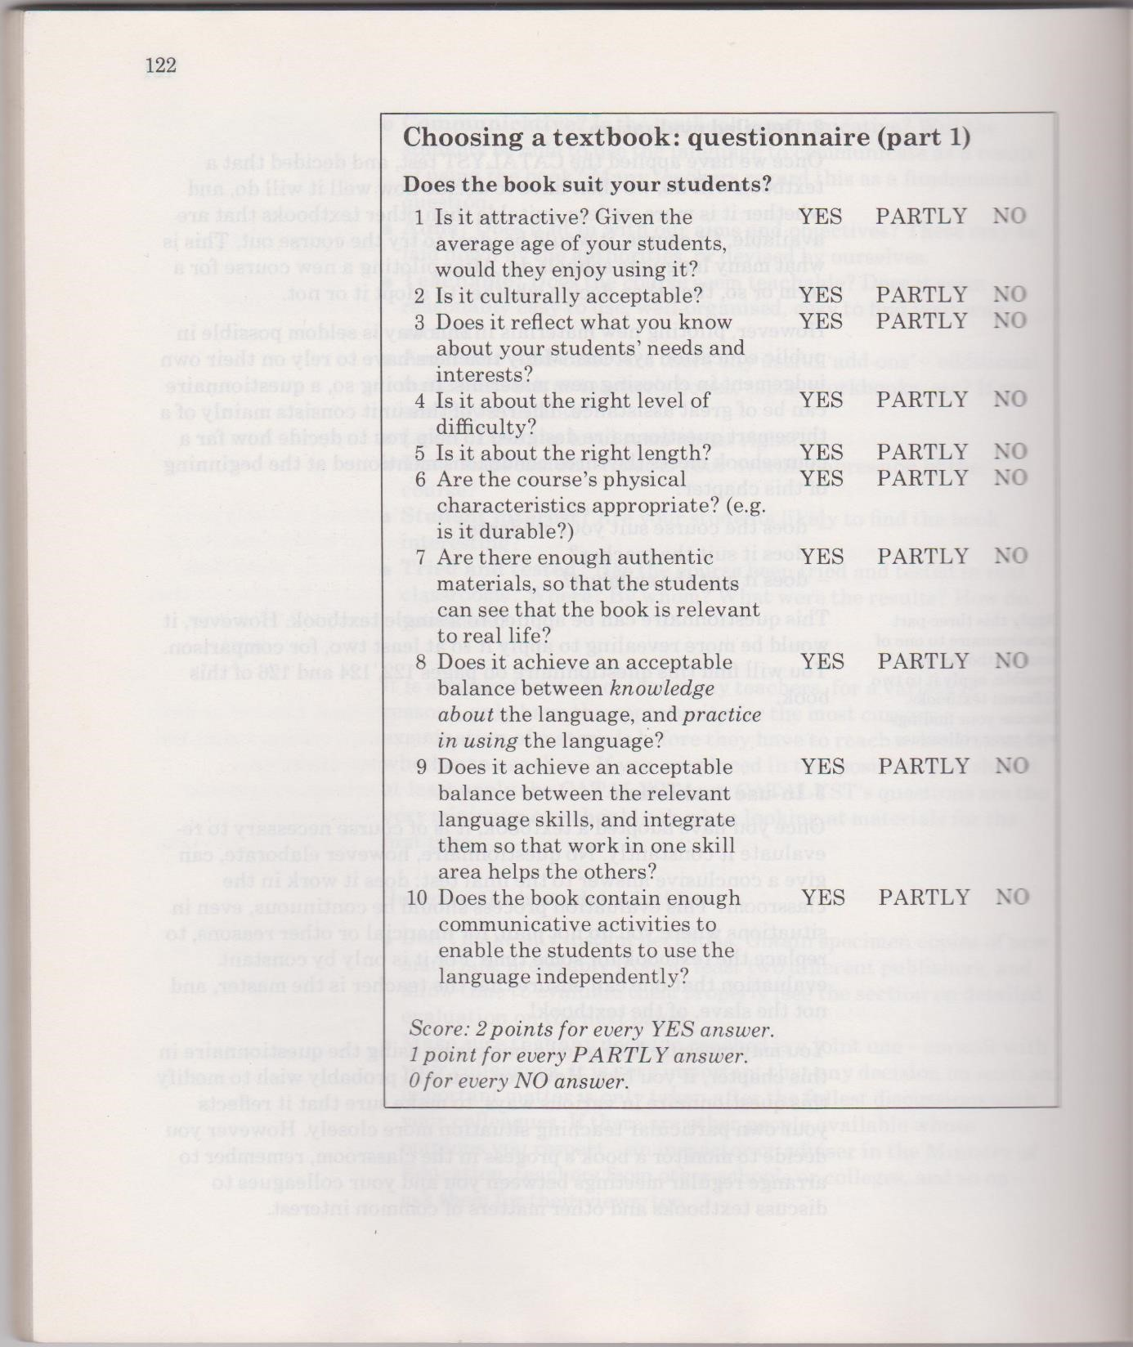
Appendix 1 – Grant's questionnaire for choosing a coursebook

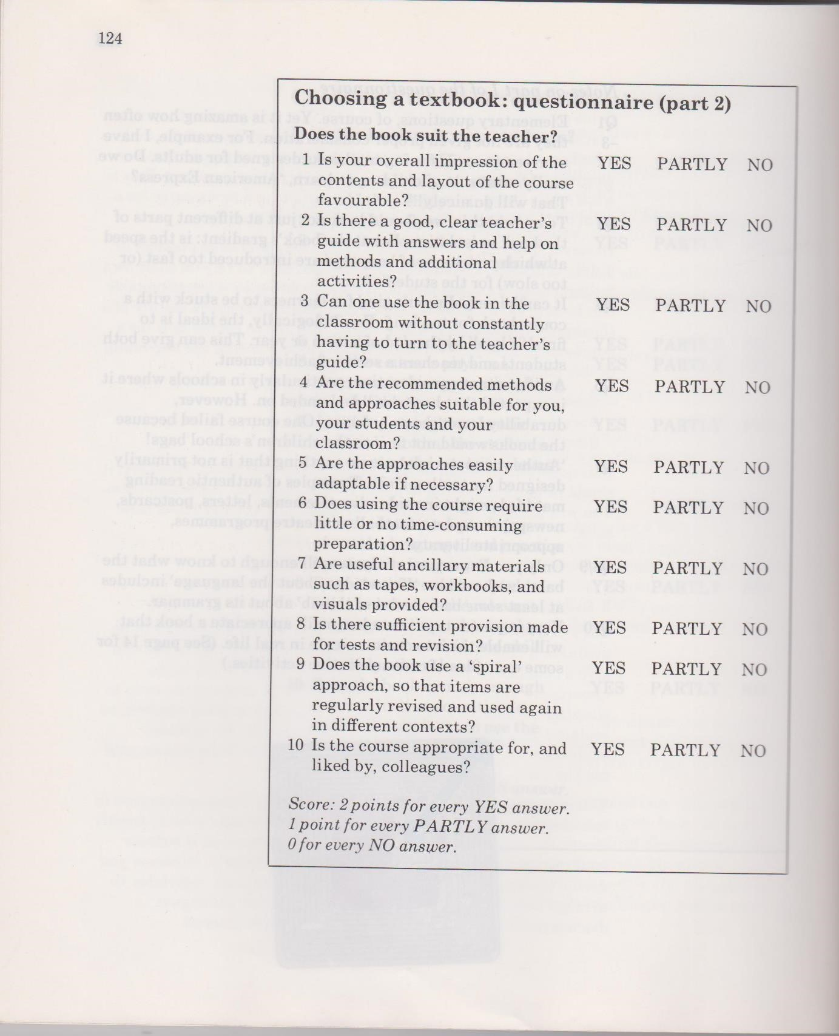
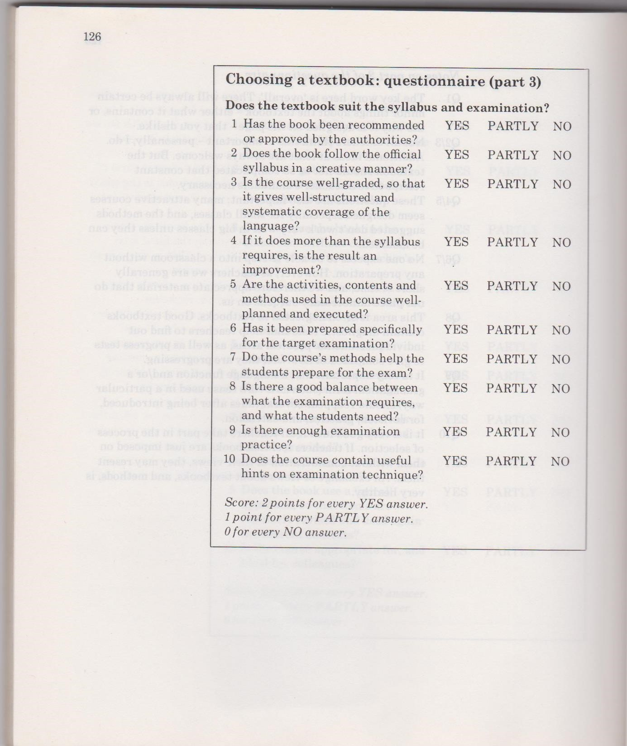

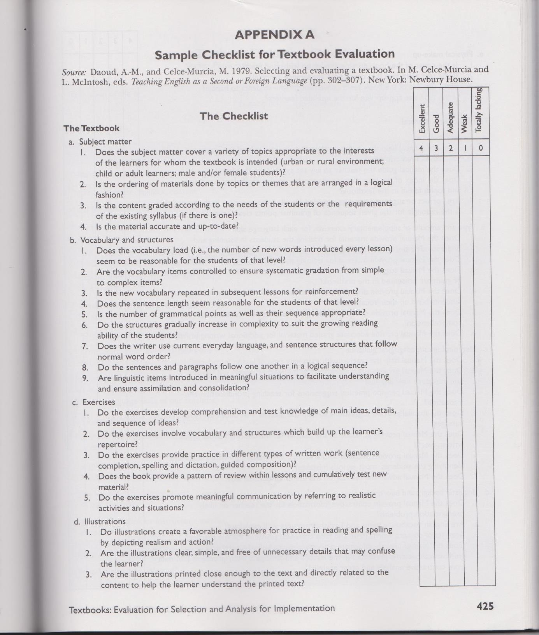
Appendix 2 – Celce-Murcia's checklist for coursebook evaluation
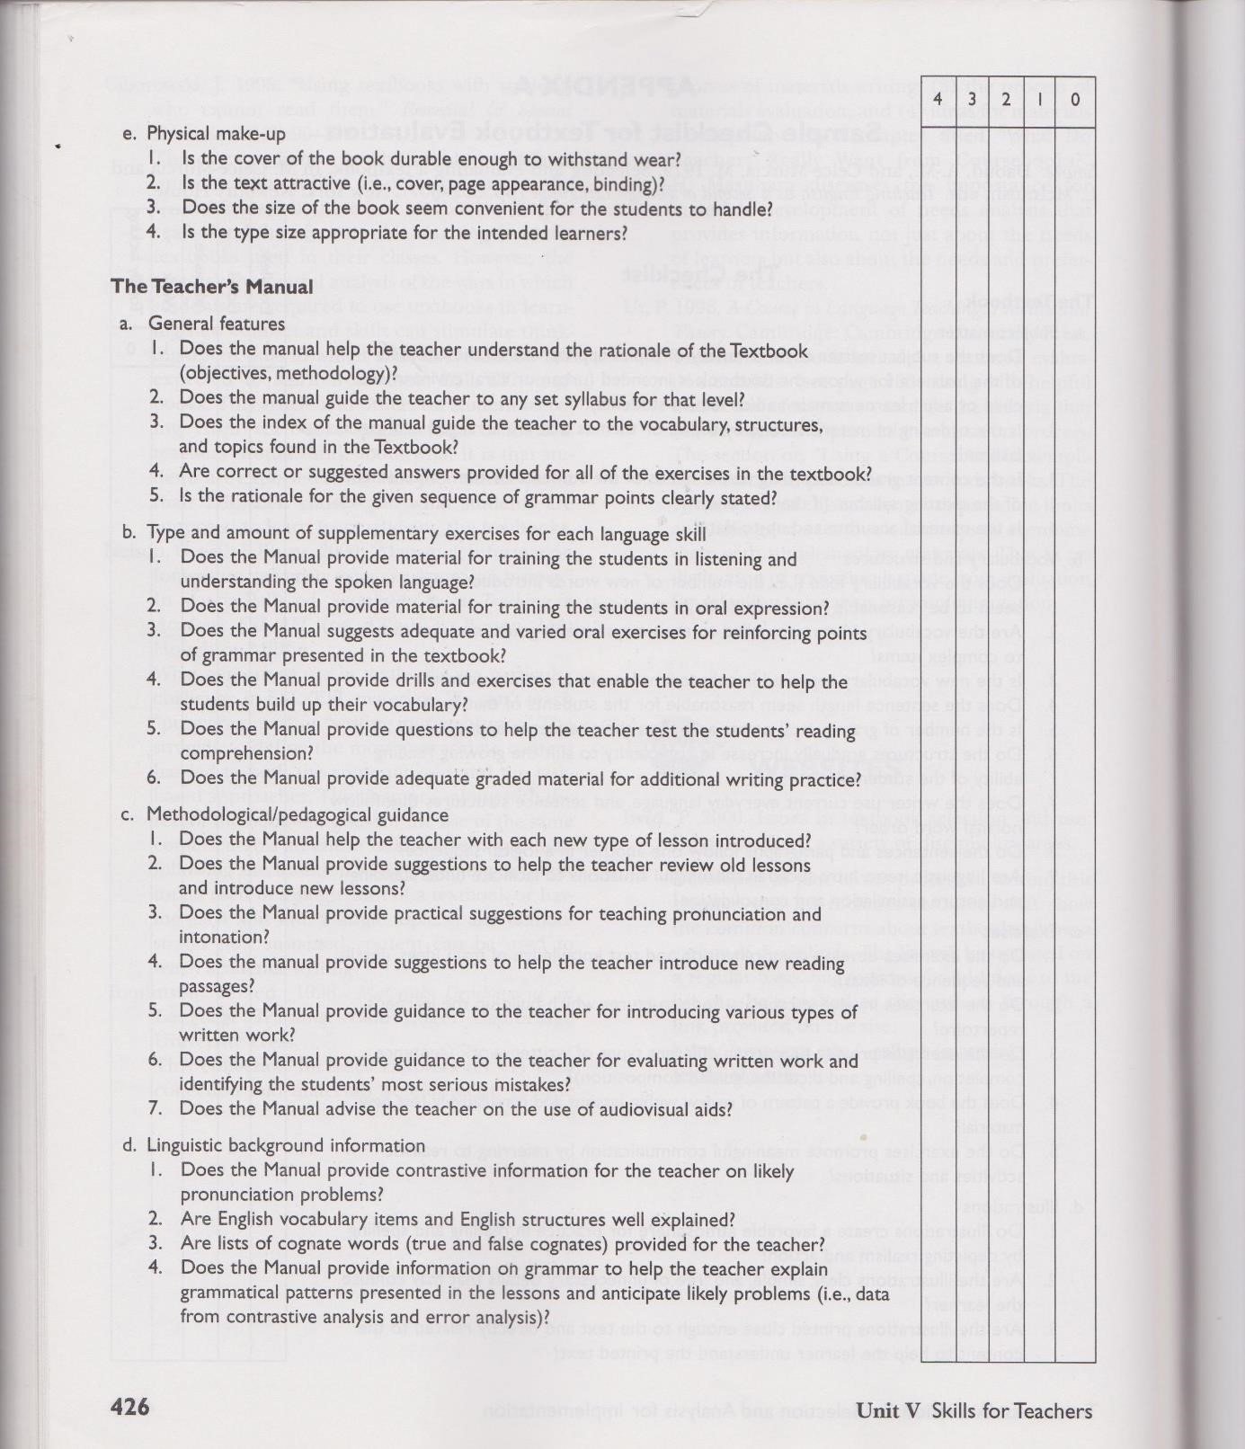

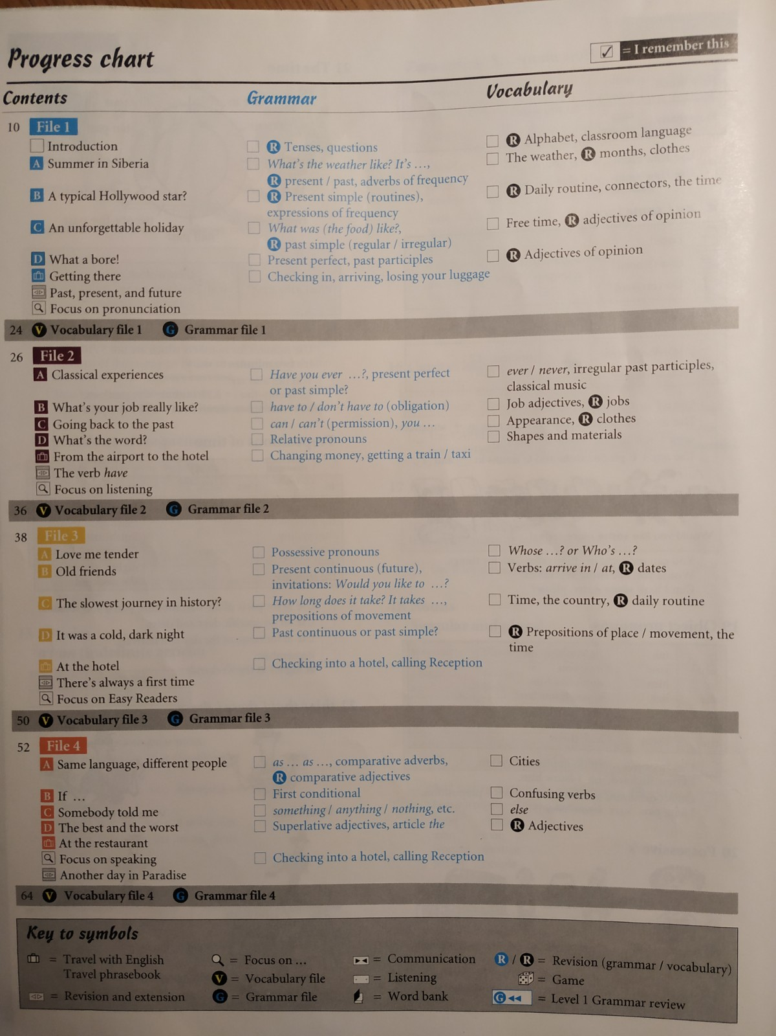
Appendix 3 – Table of contents in English File first edition
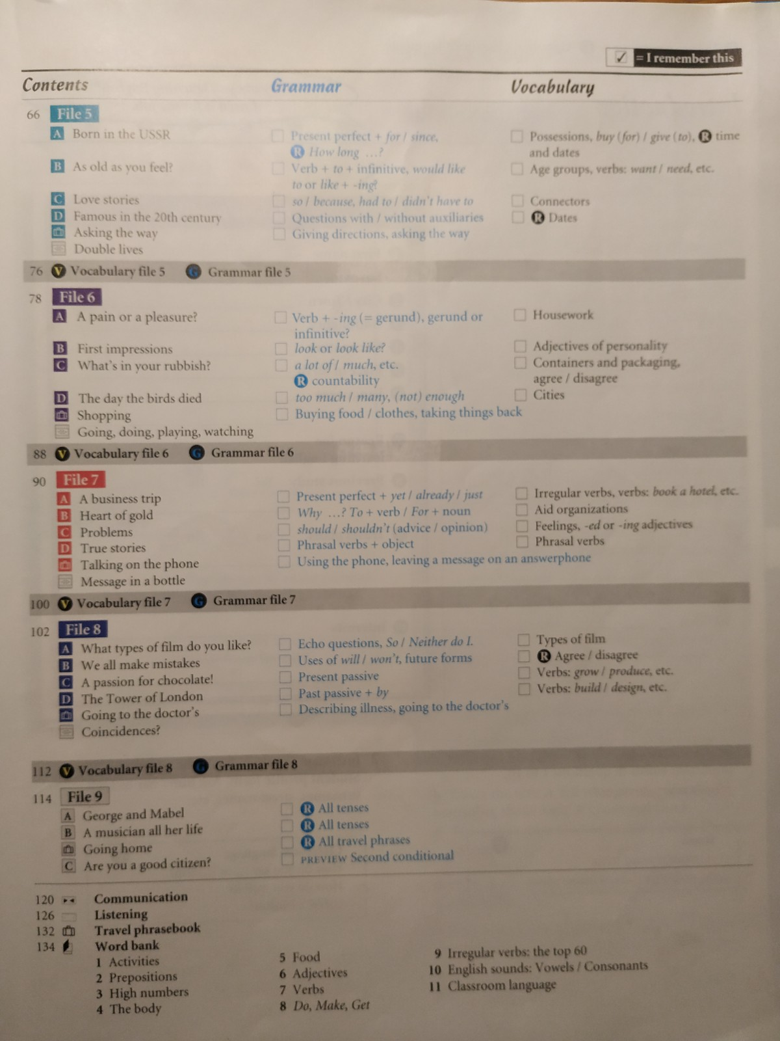

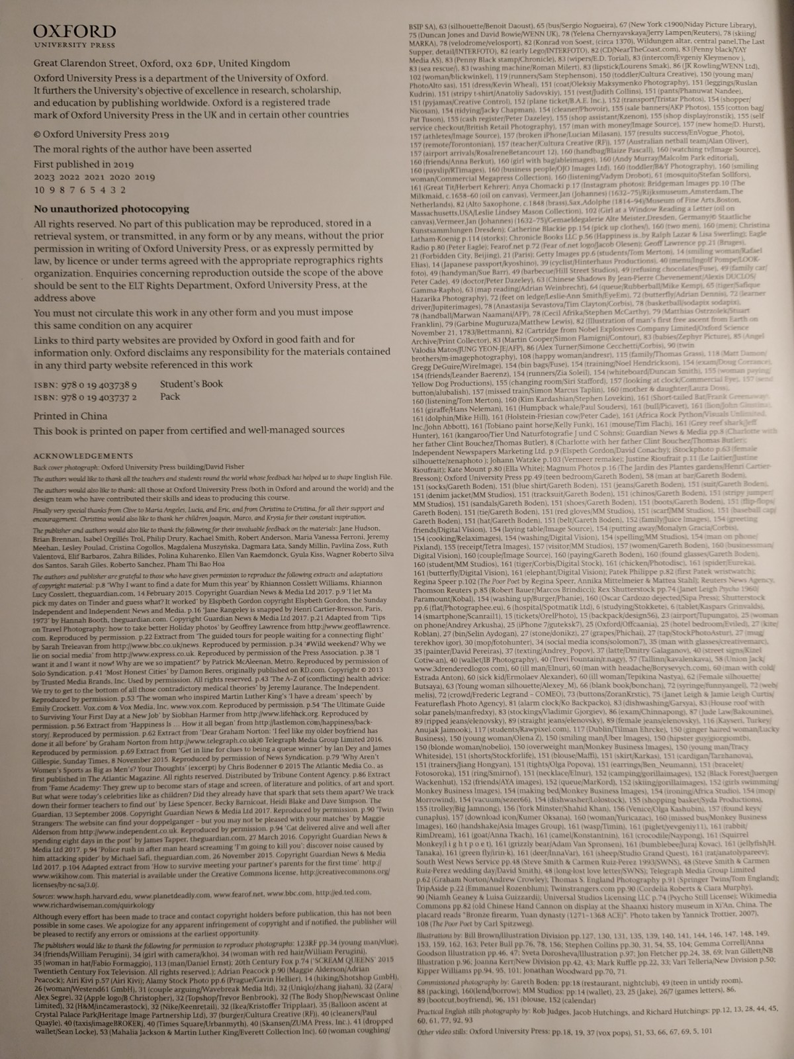
Appendix 4 – Acknowledgements in English File first edition

Appendix 5 – Table of contents in English File fourth edition
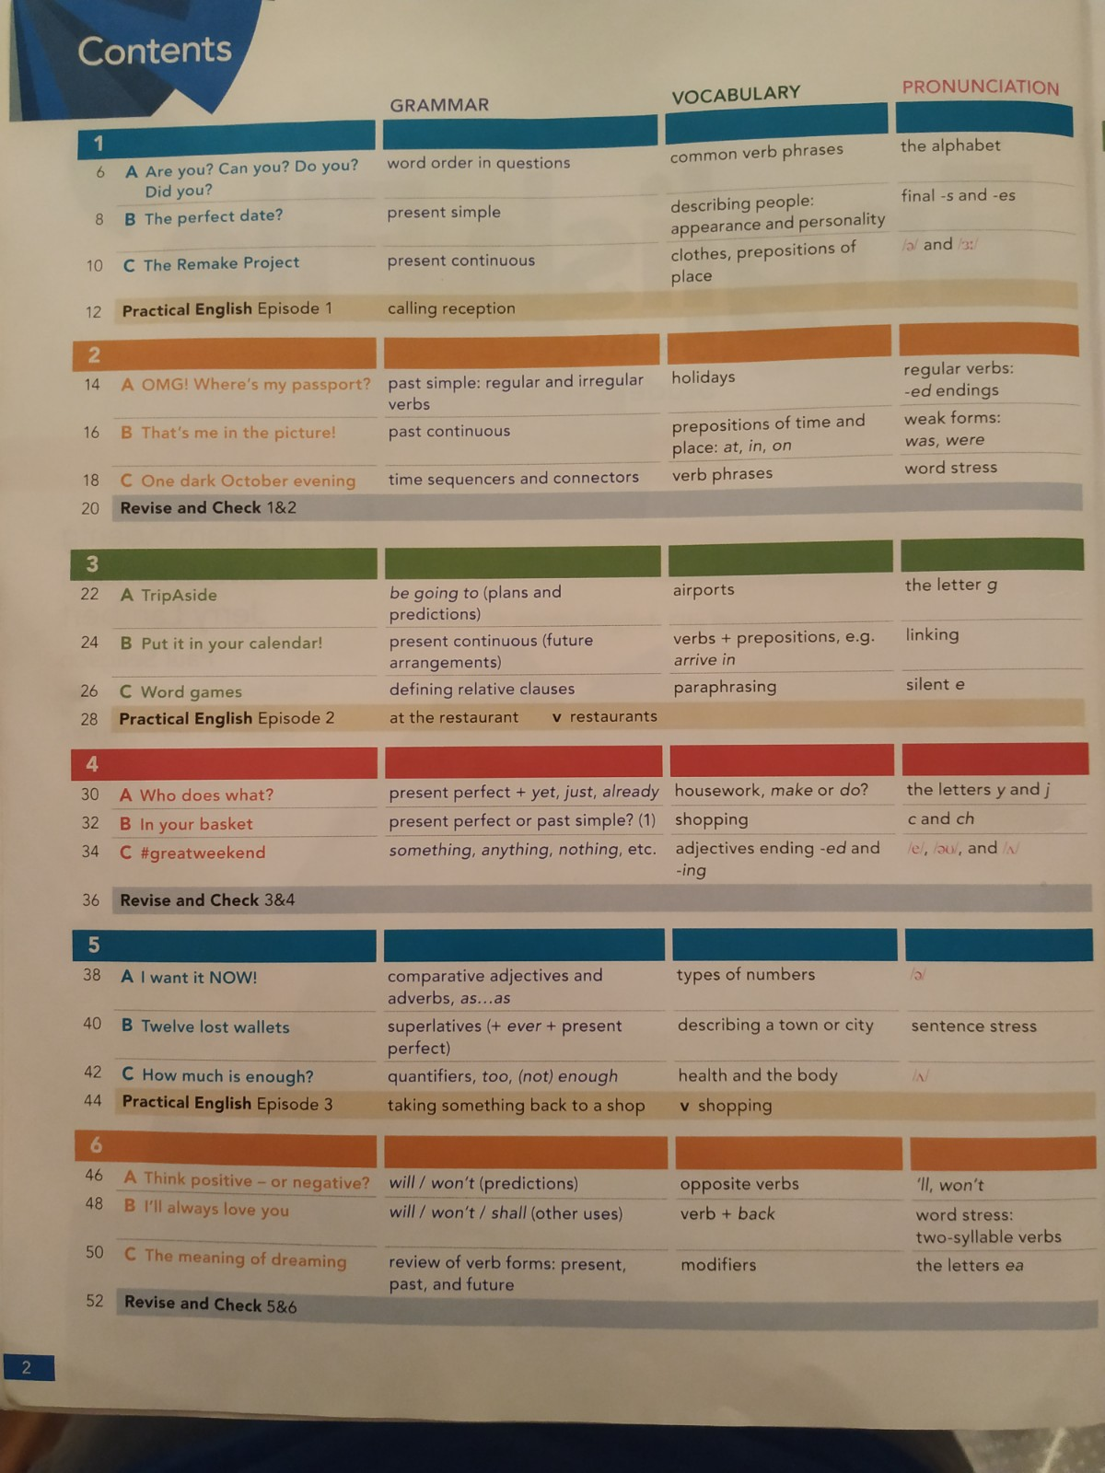

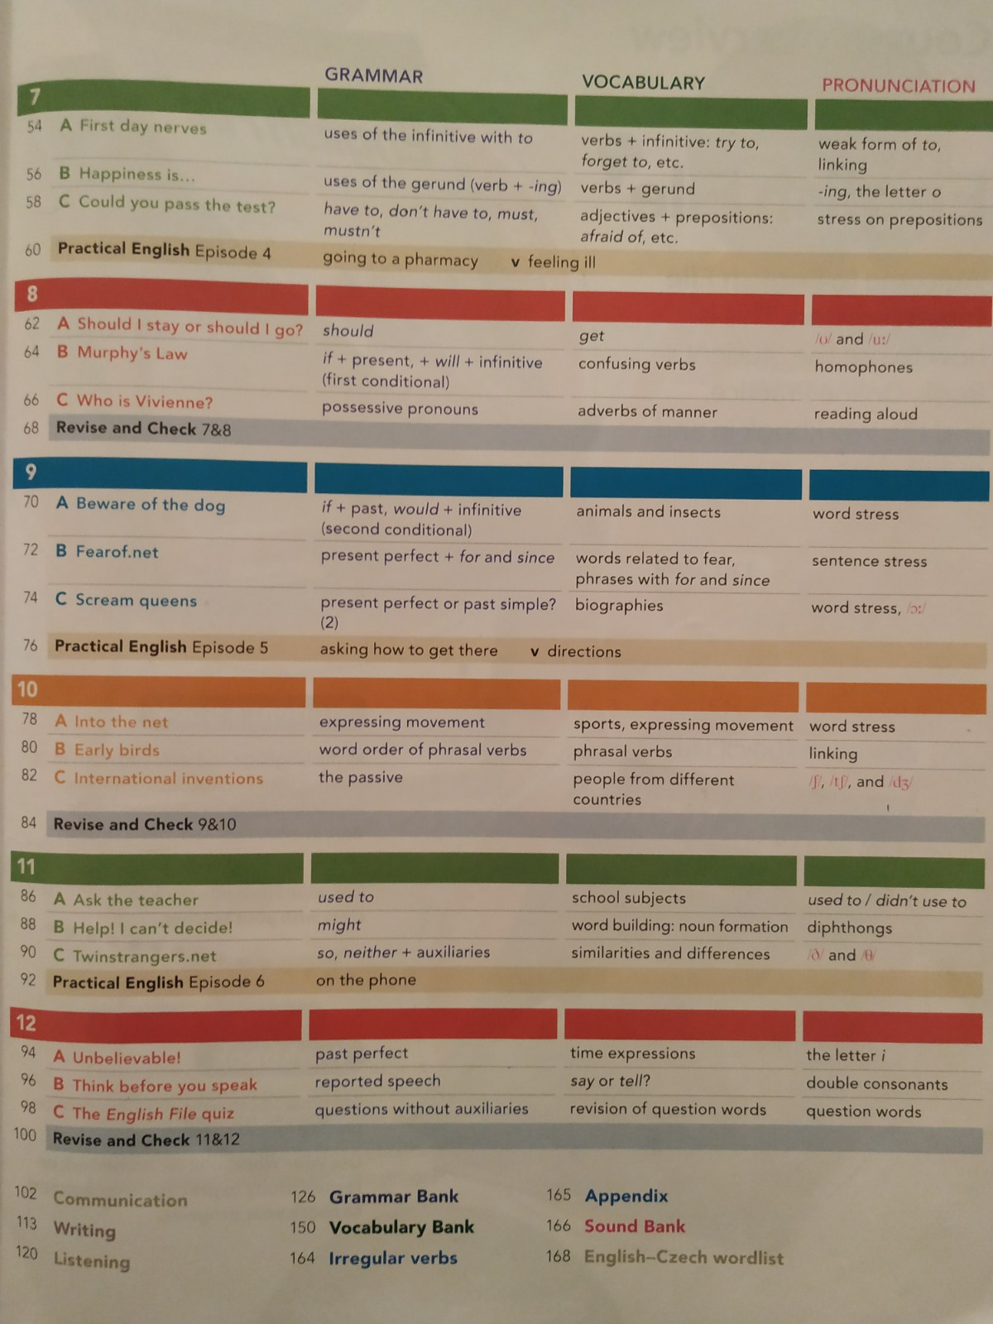

Appendix 6 – Acknowledgements in English File fourth edition
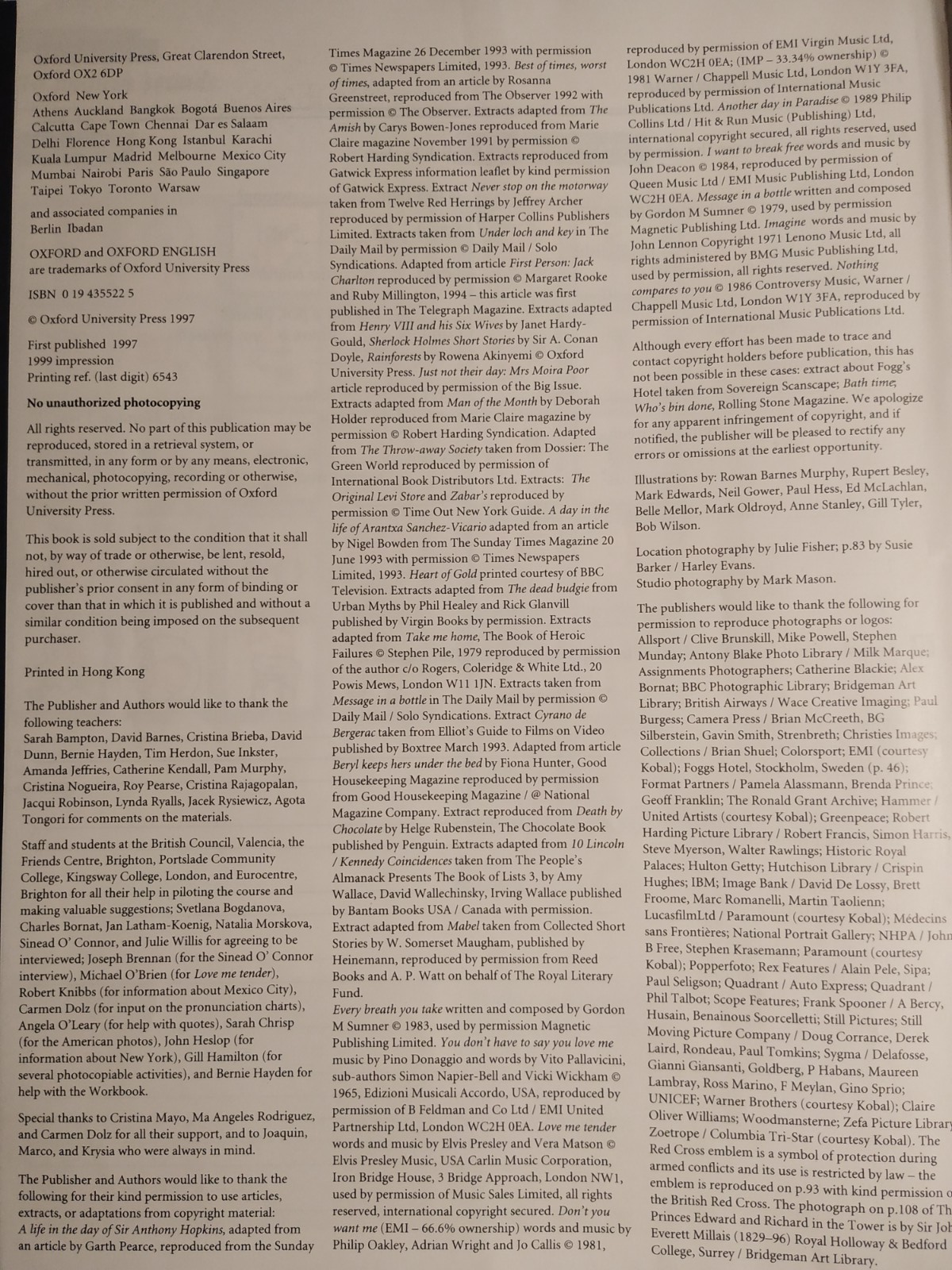

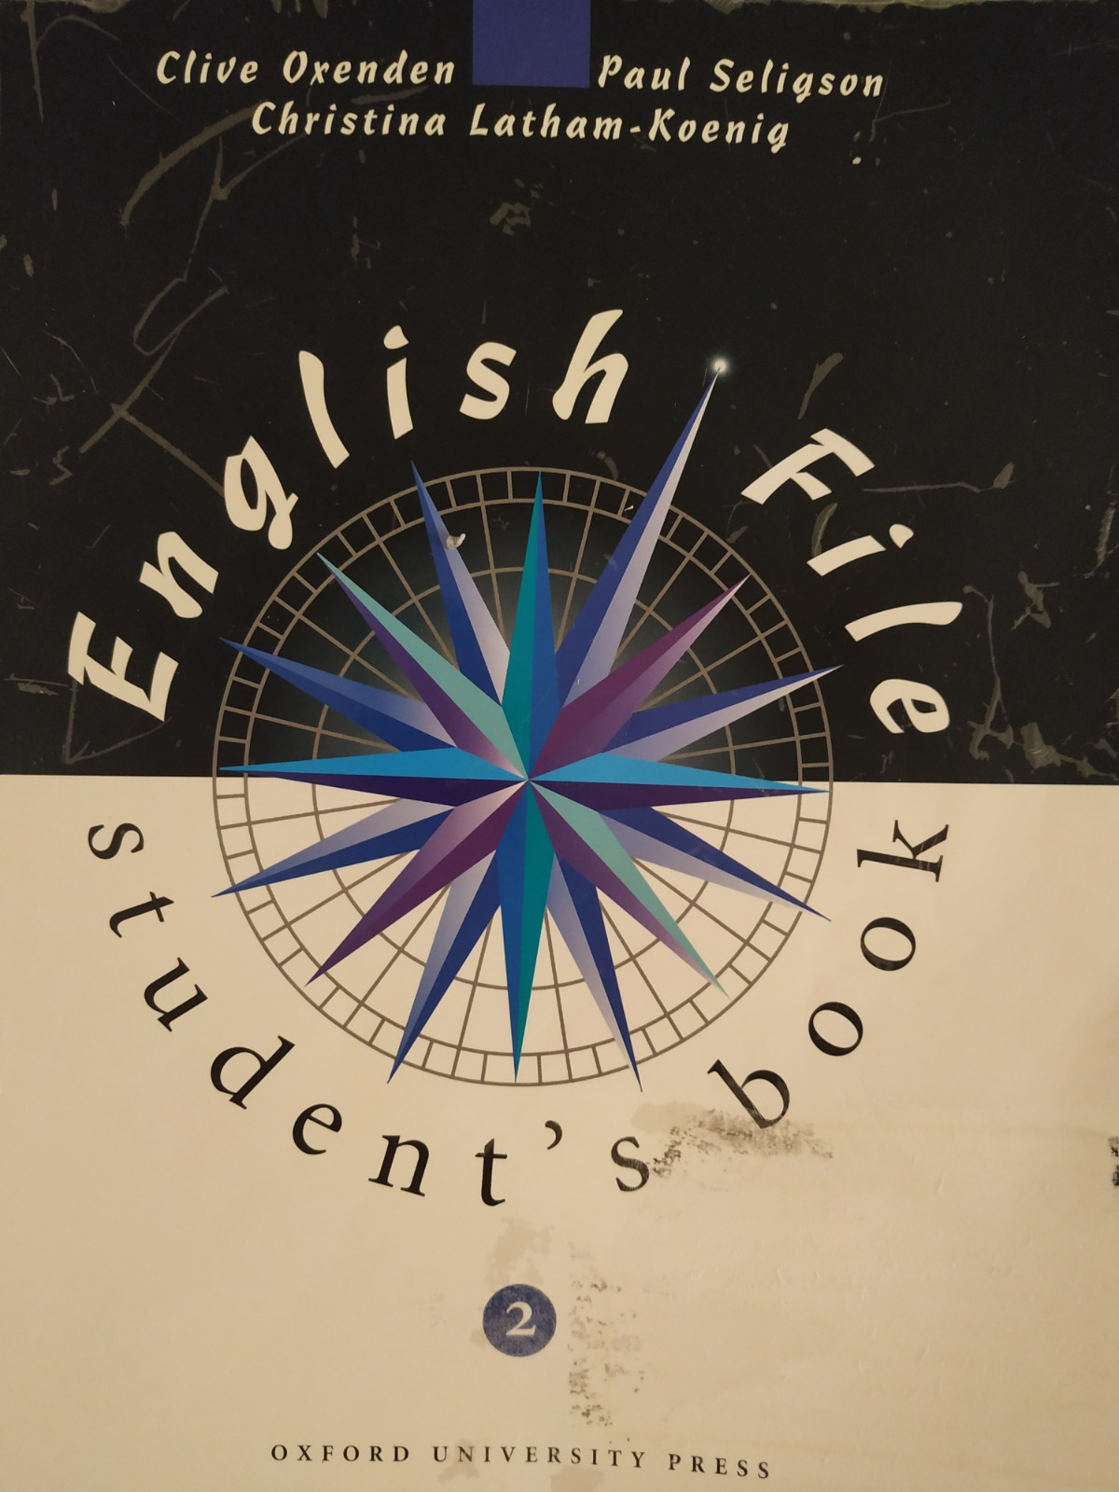
Appendix 7 – The cover pages of both coursebooks
