Přírodovědecká fakulta
NMR spektroskopie supramolekulárních systémů
Diplomová práce
Aliaksandra Kursit

Vedoucí práce: Mgr. Jan Novotný, Ph.D.
Ústav biochemie
Program Biomolekulární chemie
Brno 2024

Bibliografický záznam
Autor: Aliaksandra Kursit
Přírodovědecká fakulta
Masarykova univerzita
Ústav biochemie
Název práce: NMR spektroskopie supramolekulárních systémů
Studijní program: Biomolekulární chemie
Vedoucí práce: Mgr. Jan Novotný, Ph.D.
Rok: 2024
Počet stran: 97
Klíčová slova: Pt(II) komplexy, Pt(IV) komplexy, metaloléčiva, cyklodextriny, kukurbiturily, DNA duplex, G-kvadruplex, NMR titrace, hostitel-host komplexy, interkalace

Bibliographic record
Author: Aliaksandra Kursit
Faculty of Science
Masaryk University
Department of Biochemistry
Title of Thesis: NMR spectroscopy of supramolecular systems
Degree Programme: Biochemistry
Supervisor: Mgr. Jan Novotný, Ph.D.
Year: 2024
Number of Pages: 97
Keywords: Pt(II) complexes, Pt(IV) complexes, metallodrugs, cyclodextrins, cucurbiturils, DNA duplex, G-quadruplex, NMR titration, host-guest complexes, intercalation

Abstrakt
Výzkum metaloléčiv na bázi platiny se neustále rozvíjí s cílem překonat omezení tradičních látek podobných cisplatině a zvýšit jejich terapeutickou účinnost. V této práci bude studována interakce hostitel-host mezi proléčivy na bázi platiny(IV) odvozenými od oxaliplatiny, monofunkčními Pt(II) deriváty cisplatiny a makrocyklickými nosiči, jako jsou cyklodextriny a kukurbiturily. K vyhodnocení vazebných afinit těchto komplexů byly použity ¹H NMR titrační experimenty. Způsob interakce komplexů platiny(II) s kanonickými duplexními a G-kvadruplexními strukturami DNA byl charakterizován pomocí ¹H NMR titrace a ¹H-¹H 2D NOESY experimentů. Výsledkem je zjištění, že monovalentní komplex platiny(IV) vykazuje vyšší afinitu ke kukurbit[7]urilu než β-cyklodextrinu. Jeho derivát, divalentní komplex, při tvorbě dienkapsulovaných komplexů vykazoval nekooperativní vazbu β-cyklodextrinu na monoenkapsulovaný komplex a homotropní negativní kooperativitu vazby dvou kukurbit[7]urilů. Zapouzdření komplexů platiny(II) s kukurbit[7]urilem bylo charakterizováno středně silnou vazebnou afinitou, přičemž u komplexu PtPyrPhe došlo v přítomnosti kukurbit[7]urilu k rychlé hydrolýze. Studium PtPyrPhe se sekvencemi DNA prokázalo specifickou vazbu do žlábku v AT oblastech duplexu DNA a slabou interakci nad horní G-tetrádou G-kvadruplexu.
Abstract
The research of platinum-based metallodrugs is constantly developing to overcome the limitations of traditional cisplatin-like agents, enhancing their therapeutic efficacy. In this work, the host-guest interaction of oxaliplatin-derived platinum(IV) prodrugs and cisplatin-derived monofunctional platinum(II) complexes was studied with macrocyclic carriers such as cyclodextrins and cucurbiturils. The ¹H NMR titration experiments were used to evaluate the binding affinities of these complexes. The interaction mode of platinum(II) complexes with canonical duplex and G-quadruplex DNA structures was characterised using ¹H NMR titration and ¹H-¹H 2D NOESY experiments. As a result, the monovalent platinum(IV) complex exhibited a higher affinity for cucurbit[7]uril over β-cyclodextrin. Its derivative, divalent complex, in the formation of diencapsulated complexes, revealed the non-cooperative binding of β-cyclodextrin to the monoencapsulated complex and homotropic negative cooperativity of the binding of two cucurbit[7]urils. The encapsulation of platinum(II) complexes with cucurbit[7]uril showed moderate affinity bindings, with the phenylpyridine-based Pt complex (PtPyrPhe) complex experiencing rapid hydrolysis in the presence of cucurbit[7]uril. The study of PtPyrPhe with DNA sequences demonstrated specific groove binding at the AT regions of the DNA duplex and weak interaction on top of the top G-tetrad of the G-quadruplex.

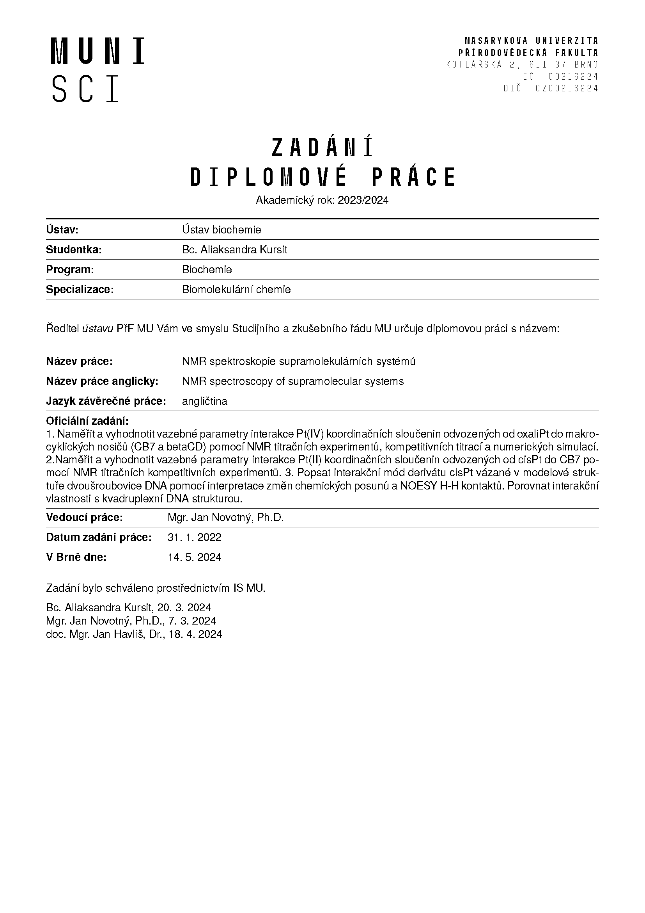
Declaration
I declare that I have prepared my thesis independently under the mentorship of the thesis supervisor and using the information sources provided in the thesis.

Acknowledgements
First of all, I am deeply thankful to my supervisor, Mgr. Jan Novotný, Ph.D., for the guidance, support, and advice provided during my studies and the thesis writing process. I would also like to extend special thanks to Mgr. Jan Chyba, Ph.D., and Shib Shankar Paul, MSc., for providing the compounds used in this work.
Additionally, I want to express my appreciation to Dr. Peter Podbevšek and Prof. Janez Plavec of the National Institute of Chemistry in Ljubljana for their assistance during my Erasmus stay.
I am grateful to my family and friends for their support throughout my studies. Furthermore, I would like to thank my precious cat, Molly, for her constant presence and invaluable mental support.
Table of Contents
Glossary 15
1 Introduction 17
2 Theoretical part 18
2.1 Platinum-based complexes 18
2.1.1 Platinum(II) complexes 18
2.1.2 Platinum(IV) complexes 19
2.1.3 Non-classical platinum(II) complexes 21
2.1.4 Biding to carriers 24
2.1.5 Interaction of platinum complexes with G-quadruplexes 26
2.2 Host-guest supramolecular chemistry 27
2.2.1 Binding constants 28
2.2.2 Measurement of the binding constants 29
2.2.3 NMR methods 30
2.2.4 Cooperativity 35
3 Practical part 38
3.1 Materials 38
3.2 Methods 39
3.2.1 NMR spectroscopy 39
3.2.2 UV/VIS spectroscopy 40
3.3 Results 40
3.3.1 NMR titration experiments with β-CD/CB7 40
3.3.2 NMR titration experiments with Duplex 53
3.3.3 NMR titration experiments with G-quadruplex 60
3.3.4 2D experiments 66
3.3.5 UV/VIS measurement of melting temperatures 71
4 Discussion 72
4.1 Host-guest interactions of platinum(IV) complexes with carriers 72
4.2 Host-guest interactions of platinum(II) complexes with CB7 73
4.3 Interactions of platinum(II) complexes with DNA duplex 74
4.4 Interactions of platinum(II) complexes with DNA G-quadruplex 76
5 Conclusion 78
Bibliography 81
Appendix A 88

Glossary
Ad – adamantane
CB – cucurbituril
CD – cyclodextrin
COSY – COrrelation SpectroscopY
DABCl – 1,4-Diaminobutane dihydrochloride
DMS – Dimethyl sulfone
dx – duplex
G – guest
H – host
HG – host-guest complex
hTel – 24-nt human telomeric sequence
ITC – Isothermal Titration Calorimetry
K_{a} – association/binding constant
K_{d} – dissociation constant
NOESY – Nuclear Overhauser Effect SpectroscopY
Phe – phenyl
phen – phenanthridine
Pyr – pyridine
T_{m} – melting Temperature
UV/VIS – UltraViolet-Visible spectrophotometry

Introduction
In the field of bioinorganic chemistry and medicine, the development of metallodrugs holds significant potential as anticancer agents due to their unique properties. Platinum-based drugs, although widely used and recognised for their efficacy in cancer therapy, come with limitations, such as side effects, drug resistance and off-target toxicity. These problems have encouraged the exploration of novel strategies for developing platinum-based anticancer drugs with improved efficacy and reduced toxicity.
In the theoretical part of this diploma thesis, the classical platinum(II) complexes will be reviewed first. Then, the new approaches to the development of platinum-based drugs will be discussed. Specifically, non-active platinum(IV) prodrugs that act as dual-threat agents, monofunctional complexes with ligands featuring extended aromatic structures, and non-covalently binding platinum complexes with non-cisplatin-like modes of action, such as intercalation and groove binding. In addition, the G-quadruplexes will be reviewed as new potential biological targets beyond canonical B-DNA. Subsequently, an alternative approach for designing new Pt drugs will be explored, which employs carrier systems based on cyclodextrins and cucurbiturils. Furthermore, these systems can function as solubilisers and stimuli-responsive mechanisms of targeting in the delivery system. In the last part of the theory, the concept of host-guest supramolecular chemistry will be introduced, as well as different approaches for calculating binding constants based on the kinetics of the host-guest interaction, using the NMR method.
The aims of this diploma thesis include conducting a series of NMR titration experiments, competitive titrations, and numerical simulations to measure and evaluate the binding parameters of the interaction of Pt(IV) coordination compounds derived from oxaliplatin to macrocyclic carriers such as CB7 and β-CD. Additionally, it aims to investigate the binding of Pt(II) coordination compounds derived from cisplatin to CB7. Furthermore, the aim is to describe the interaction mode of the cisplatin derivatives within a model DNA double helix structure by interpreting changes in chemical shifts and NOESY H-H contacts derived from NMR experiments. Lastly, it aims to compare the interaction properties of platinum complexes with double-helix and quadruplex DNA structures.

Theoretical part
Metallodrugs represent a class of therapeutic agents that contain metal ions as active components, designed to interact with biological systems for diagnostic or treatment purposes. In the interdisciplinary field of medicinal inorganic chemistry, the development of metal-based compounds holds significant promise in addressing a wide range of medical applications compared to mainly used drugs of organic origin. Their wide range of coordination numbers and geometries, accessible redox states, thermodynamic and kinetic characteristics, and the intrinsic properties of the cationic metal ion and ligand enable a broad range of reactivities applicable across medical fields.¹
Numerous metal ions have been routinely used, such as platinum and ruthenium complexes in cancer therapy², gold complexes as antitumour and anti-arthritis agents³, silver complexes as antibacterial⁴, cobalt complexes as antiviral⁵, and gadolinium and technetium as magnetic resonance imaging (MRI) contrasting agents^{6,7}.

Platinum-based complexes

Platinum(II) complexes
The rise in prominence of platinum-based anticancer agents followed the discovery of cisplatin's antineoplastic activity, marking it the first metal-based anticancer drug used clinically (Figure 1).⁸ Despite its therapeutic success across various tumour types, cisplatin's effectiveness is hindered by significant downsides, including dose-limiting side effects (systemic toxicity), acquired and intrinsic resistance of cancer cells, and limited solubility.⁹
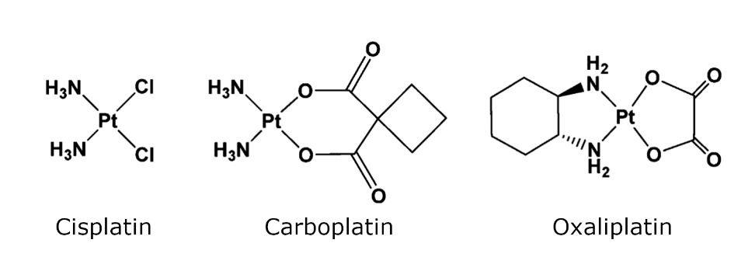
Figure 1: The structures of the Pt(II) drugs cisplatin, carboplatin, and oxaliplatin.¹⁰
After cisplatin's discovery, the development of platinum-based drugs accelerated, driven by the need to overcome the drawbacks of cisplatin, which led to the emergence of second and third-generation platinum drugs. While various platinum derivatives have been synthesised and tested against cancer cells, only a few have progressed to clinical trials. Currently, cisplatin and its derivatives, including carboplatin and oxaliplatin, are extensively used worldwide as effective anticancer treatments (Figure 1). Other derivatives like heptaplatin, nedaplatin, and lobaplatin are employed regionally for their antitumor properties (Figure 2).⁸
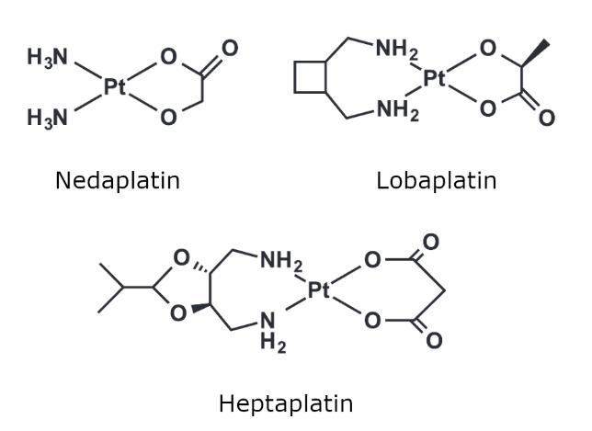
Figure 2: The structures of the Pt(II) drugs nedaplatin, lobaplatin and heptaplatin.¹⁰
These square planar platinum(II) drugs feature 'non-leaving' nitrogen donor ligands and labile chlorido or dicarboxylato ligands. Cisplatin, as a prototypical example, elicits its anticancer effect by first accumulating in tumour cells, where the labile ligands are displaced by water ligands. This results in aquated positively charged platinum(II) species that covalently bind DNA, typically to the nucleophilic N7 atoms of guanine or adenine nucleobases, leading to the distortion in the three-dimensional structure of DNA, which blocks replication and transcription and ultimately triggers apoptosis or programmed tumour cell death.¹¹
Other approved platinum(II) compounds share a similar mechanism of action with cisplatin. However, their chemical structure, reactivity, and spectrum of activity differ, which results in variations in their therapeutic efficacy and toxicity profiles. For instance, cisplatin demonstrates effectiveness against testicular, ovarian, bladder, and lung cancers, whereas carboplatin is mainly used for ovarian cancers. Meanwhile, oxaliplatin, the most recently approved drug, is predominantly employed in the treatment of colorectal cancer.^{12,13}

Platinum(IV) complexes
While cisplatin and its derivatives have made significant progress in oncology, their clinical efficacy is often hindered by adverse side effects like the development of resistance and lack of specificity toward cancer cells.⁸ To address these challenges, novel strategies for platinum-based drug development have been investigated, including the use of platinum(IV) prodrugs.
Platinum(IV) complexes typically exhibit six-coordinate structures and adopt octahedral geometries, which render their coordination spheres saturated and thus more kinetically inert compared to their platinum(II) counterparts. This increased inertness results in greater resistance to ligand substitution reactions, thereby minimising unwanted side reactions with biomolecules before DNA binding.
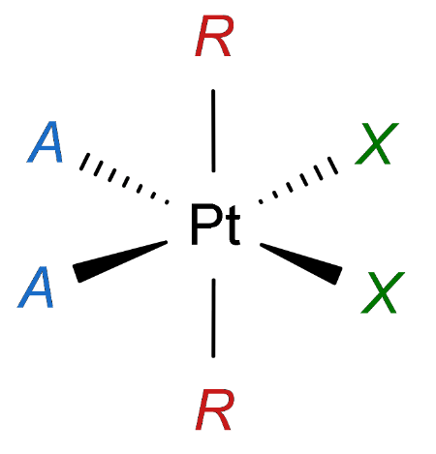
The structure of platinum(IV) complexes closely resembles that of Pt(II), featuring two non-leaving and two labile ligands, along with two additional axial ligands (Figure 3). Although platinum(IV) complexes are capable of interacting with DNA in their oxidised state¹⁴, their anticancer activity relies on reduction to platinum(II). This reduction process involves the loss of the two axial ligands, resulting in the formation of active Pt(II) species, typically cisplatin or related derivatives. These Pt(II) species bind to DNA, disrupting transcription and replication processes, and eventually leading to apoptosis.
Figure 3: Structure of platinum(IV) prodrug. Non-leaving ligands are marked blue, labile ligands are green, axial ligands are red.
Additionally, incorporating biologically active ligands as leaving axial groups in the Pt(IV) scaffold can yield dual-threat agents. These ligands are selected to target on-DNA sites, aiming to minimise cross-resistance with platinum(II) species that target DNA. Moreover, their presence offers opportunities to fine-tune biological properties such as lipophilicity, redox stability, cancer-cell targeting, orthogonal or complementary bioactivity, and improved cellular uptake. Furthermore, these extra ligands facilitate attachment to carrier systems, enhancing drug delivery and efficacy.¹¹
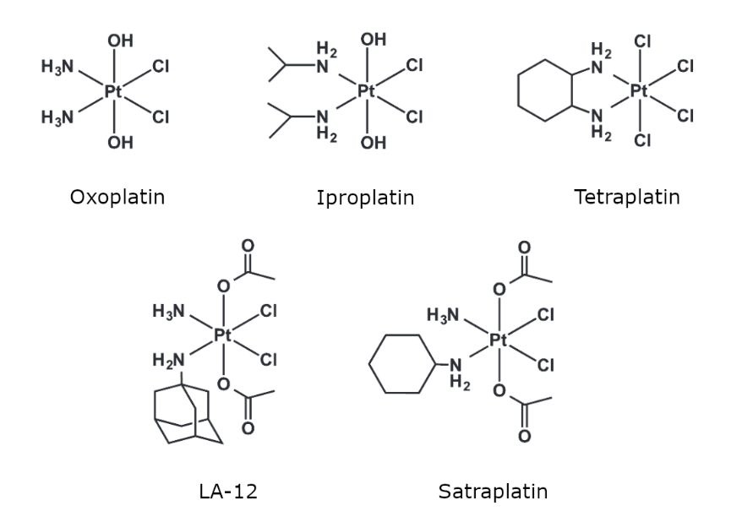
Figure 4: The structures of the Pt(IV) prodrugs.¹⁰
Many Pt(IV) drugs have shown activity across tumour cancer cells, but only a few have reached clinical tests, such as tetraplatin, iproplatin, and oxoplatin.¹⁵ Satraplatin, a mononuclear Pt(IV) complex, is the first example of an orally administered platinum-based drug candidate to enter active clinical investigation. This drug candidate is being tested as a treatment for advanced prostate cancer.¹⁶ Another orally administrated Pt(IV) drug, LA-12, which shares a similar structure with satraplatin, has shown positive outcomes in preclinical studies (Figure 4).¹⁷

Non-classical platinum(II) complexes
In efforts to overcome limitations associated with approved platinum drugs, researchers have been investigating various nonclassical platinum compounds. These include trans-platinum drugs¹⁸, polynuclear platinum(II) complexes such as diplatinum(II) and trinuclear platinum(II) compounds¹⁹, and photosensitive Pt(IV) drugs²⁰. These compounds operate through unique mechanisms of action and offer promising ways to address resistance issues commonly encountered in cancer treatment with traditional cisplatin-like agents.
Monofunctional platinum complexes
Cationic, monofunctional platinum(II) complexes represent another promising class of anticancer agents. Unlike the bifunctional Pt(II) and Pt(IV) complexes discussed above, which form intrastrand or interstrand DNA cross-links, these complexes contain only one labile chloride ligand. They are expected to form only one covalent bond with the N7-guanine on the DNA strands, creating monofunctional adducts. Recent focus has been drawn to these agents due to their unique mode of action, distinctive anticancer spectrum, and promising antitumor activity.¹¹
The field of monofunctional platinum compounds garnered significant attention with the discovery of cis-[Pt(NH₃)₂(Am)Cl]⁺ (where Am represents an aromatic N-heterocyclic amine), which demonstrated notable inhibition of tumour cells, where Pt(II) forms stable Pt-DNA adducts, and the complex intercalated into DNA.²¹
Subsequently, it was found that pyriplatin (Figure 5), the Pt(II) complex structurally similar to cisplatin but with a pyridine substituting one chloride ligand, only formed a monofunctional adduct with DNA and induced little distortion in the DNA double helix upon binding. Despite their limited effect on DNA bending, monofunctional lesions proficiently destabilise the double helix, hindering DNA replication and transcription, ultimately leading to apoptotic cell death. Contrary to the traditional view that a neutral charge is required for platinum drug uptake, the positive charge of monofunctional platinum complexes appears to enhance their uptake via organic cation transporters (OCTs).²²
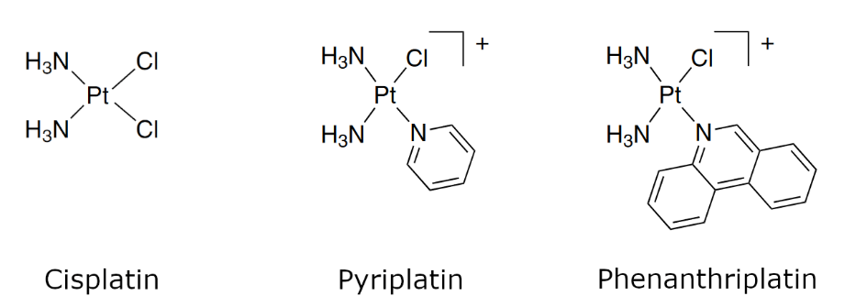
Figure 5: The structures of monofunctional Pt(II) drugs compared to cisplatin (bifunctional drug).²³
Pyriplatin has a unique activity spectrum compared to other platinum agents, as revealed by cytotoxicity screening studies. Despite its low potency relative to conventional platinum-based drugs, this discovery motivated the search for more active analogues.²⁴
Efforts to enhance the cytotoxic effect of monofunctional platinum(II) complexes have involved progressively substituting pyridine with more sterically hindered N-heterocycle ligands. Phenanthriplatin (cis-[Pt(NH₃)₂-(phenanthridine)Cl]⁺NO₃⁻), for instance, features a sizable phenanthridine ring (Figure 5), resulting in a complex exhibiting higher efficacy than cisplatin against most established human cancer cells. Studies have suggested that the binding mechanism of phenanthriplatin involves rapid, partial intercalation of the phenanthridine ring, followed by slower substitution of the adjacent chloride ligand by the N7 atom of a purine base.²⁵ Phenanthriplatin-DNA monofunctional adducts sterically hinder the DNA major groove, blocking the transcription process more effectively than pyriplatin.²⁶
Non-covalently binding platinum complexes
The interaction between anticancer drugs and DNA can be reversible or irreversible, with the latter case usually involving covalent bond formation.²⁷ Examples of covalent binding agents include all previously discussed Pt(II) and Pt(IV) complexes. Non-covalent recognition of DNA usually can be divided into electrostatic, hydrophobic interaction, major or minor groove binding and intercalation.²⁸ These interactions rely on molecular recognition based on shape and size, and hydrogen bonding.²⁹ Positively charged ligands are essential for non-covalent interactions to occur, facilitating electrostatic interactions with the negatively charged DNA molecule.³⁰
Mononuclear platinum(II) complexes, which form non-covalent bonds with DNA, show promising potential as antineoplastic agents. They are gaining growing interest as viable alternatives to traditional platinum-based drugs.¹¹
Platinum(II) complexes featuring π-conjugated heterocyclic ligands like bipyridine, terpyridine, and phenanthroline, use π−π stacking and dipole−dipole interactions to intercalate between base pairs in double-stranded DNA. This intercalation can occur via either the major or minor groove. Moreover, it was observed that most intercalators prefer G-C base pairs in DNA binding due to higher overall dipole moment and the number of hydrogen bonds in the G-C pair compared to A-T.³¹ Intercalation distorts the topology of DNA, causing unwinding, bending, and distortion, which inhibits DNA replication and RNA transcription. This structural effect on DNA is thought to be the mechanism behind their antiproliferative properties.¹¹
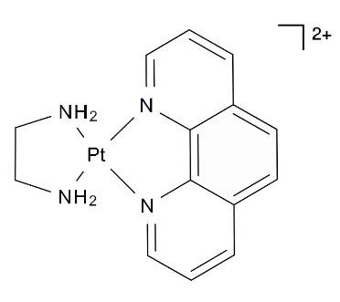
As an example, [(o-phen)Pt(en)]²⁺ (1,10-phenanthroline ethylenediamine platinum(II) intercalates through the minor groove of DNA predominantly between base pairs C-G and T-A, which results in a lengthened and rigidified double helix.³¹
The association constants of most platinum(II) intercalators typically range from 10⁴ to 10⁷ M⁻¹. The strength of intercalative binding depends on the differences in charge and extent of the aromatic system of individual molecules.²⁸ Additionally, the intercalative binding is significantly affected by the ionic strength, where a decrease in ionic strength increases the binding affinity.³¹
Certain metallodrugs can display a dual mode of DNA binding, where they not only bind covalently to DNA but also intercalate within it. Examples of such behaviour were discussed in the earlier section on phenanthriplatin and platinum(II)-acridine complexes This two-mode association approach offers several benefits, including an increased affinity for DNA and, in some cases, base sequence specificity.³²
Another type of non-covalent interaction is groove binding, which is typically based on size and shape recognition between ligands and specific DNA base sequences, determining the interaction's specificity. Groove binding relies on intermolecular forces like electrostatic and van der Waals attractions. However, it does not involve explicit stacking between base pairs, resulting in relatively minor structural changes in the double helix upon binding.³³
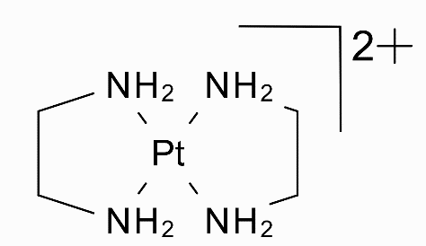
Metal complexes with non-intercalating ligands can also selectively recognise specific DNA sequences and conformations. For instance, the study of the binding of [Pt(en)₂]²⁺ (Bis(ethylenediamine)platinum(II)) to duplexes showed its preference for AT sequences in the DNA minor groove. This preference may be similar in origin to the considerable number of cationic organic groove-binding drugs. The narrower minor groove in AT-rich regions allows for close van der Waals interactions and hydrogen bonds to N3 atoms of adenines or O2 atoms of thymines, which provides more favourable electrostatic interactions due to its higher negative electrostatic potential compared to GC sequences.³⁴

Biding to carriers
A different approach to improve Pt-based drug delivery and targeting involves utilising carrier systems like n-cyclodextrins (n-CD), cucurbit[n]urils (CB[n]), calix[n]arenes (CA), and pillar[n]arenes (PA[n]). These carriers can form host-guest complexes with drug molecules, where the binding process is stabilised by hydrophobic effects within the cavity, through hydrogen or ion-dipole bonds, and electrostatic interactions at the macrocycles’ portals. Encapsulation of the drugs within the macromolecule offers various advantages, including better drug solubility and bioavailability; controlled release by specific stimuli; and targeted delivery, which reduces toxicity. This approach can increase drug specificity for cancerous cells and facilitate the intracellular uptake of the guest.
Cucurbit[n]urils are synthetic, highly symmetric, rigid cyclic oligomers composed of glycoluril units linked by methylene bridges, forming a toroid (pumpkin-shaped) structure (Figure 6). These macrocycles possess an inner hydrophobic cavity and two negatively charged carbonyl portals. The most common types of CB include CB6, CB7, and CB8, with different numbers of glycoluril units.
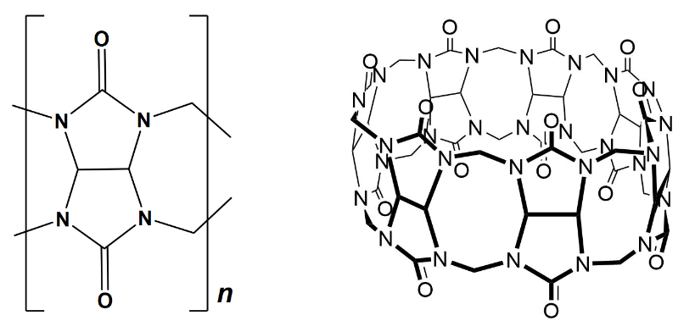
Figure 6: The general chemical structure of a native cucurbit[n]uril on the left. Structure of CB7 on the right.³⁵
The n-cyclodextrin are cyclic oligosaccharides composed of glucose units linked by α-1,4 glycosidic bonds, forming a truncated cone-like structure with a hydrophilic exterior and a relatively hydrophobic inner cavity (Figure 7). The most common cyclodextrins include α-cyclodextrin, β-cyclodextrin, and γ-cyclodextrin, consisting of six, seven, and eight glucose units, respectively.
The cavity of CB has high electrostatic potential, which prefers the interaction with cationic species, whereas CD tends to encapsulate neutral or anionic guests.³⁶
Both n-CD and CB[n]³⁷ families of macrocycles are non-toxic, which makes them suitable for pharmaceutical formulations. Cucurbiturils have not yet been tested in humans. The CD is the only family of macrocycles already approved in the food, pharmaceutical, and drug delivery fields. Its derivatives are used to improve the drugs' solubility, bioavailability, and pharmacokinetics.^{38,39}
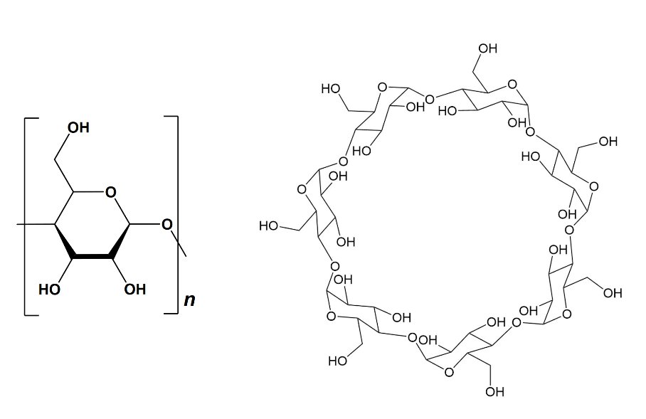
Figure 7: The general chemical structure of a native n-cyclodextrin on the left. Structure of β-CD on the right.³⁵
Solubility varies among macrocycle families and homologues within each family. Cucurbit[n]urils have relatively poor water solubility, with odd-numbered homologues more soluble than even-numbered ones. In contrast, the CD family have better water solubility, though native β-cyclodextrin's lower solubility limits its pharmaceutical use compared to α- and γ-CD.³⁹ Hence, various cyclodextrin derivatives have been developed to enhance water solubility, and there are currently 35 different cyclodextrin-based drug formulations available for human use. For instance, hydroxypropyl-β-cyclodextrin (HP-β-CD) serves as a carrier for intravenous Mitomycin in cancer chemotherapy and rectal Cisapride for heartburn. Native β-cyclodextrin remains approved for orally administered drugs like Omeprazole for gastro reflux and Cetirizine for allergies.^{39,40}
Moreover, due to their easy functionalisation, cyclodextrins (CDs) can be designed to target specific tumour tissues, enhancing the safety and efficacy of delivery systems. Once these drug delivery systems reach tumour cell surfaces, carriers will be biodegraded, releasing drugs to play their pharmacodynamic role. Various pH-sensitive drug carriers based on cyclodextrins have been designed, alongside other stimuli-responsive systems, such as temperature-sensitive, redox-sensitive, and enzyme-sensitive systems. These systems selectively deliver chemotherapeutic agents to lesion locations based on changes in cancerous site physicochemical properties. Targeting ligands like folic acid, biotin, and glucose are commonly attached to drug delivery systems to facilitate tumour targeting because their receptors are overexpressed on the surface of many cancer cells.⁴¹
A recent study investigated the encapsulation of oxaliplatin within a β-CD/phillipsite composite. The system represents an advanced, low-cost, effective option for delivering the drug to cancer cells. The nanocarrier demonstrated significant activity on its own and enhanced the effectiveness of the loaded drug against colorectal cancer cells (HCT-116). Moreover, the composite was found to be safe and biocompatible when tested on normal colorectal cells (CCD-18Co).⁴²
The CB family has also got attention as a potential vehicle for drug delivery, with a focus on encapsulating anticancer drugs, particularly platinum(II) compounds. Complexation with CB has been shown to enhance the antitumor effect of the drug while reducing toxic side effects.⁴³ The most studied system involves CB7 with cisplatin⁴⁴, where in vivo studies have demonstrated a reduction in cisplatin's toxic side effects through complexation with CB[n].⁴⁵ Additionally, complexation with CB7 has shown promise in overcoming specific cisplatin resistance in the A2780/cp70 cell line, likely due to pharmacokinetic effects.⁴⁶
Another explored system involves the encapsulation of oxaliplatin with CB7, which significantly increases complex stability and reduces some side effects. However, this encapsulation also leads to a reduction in the drug's antitumor activity.⁴⁷

Interaction of platinum complexes with G-quadruplexes
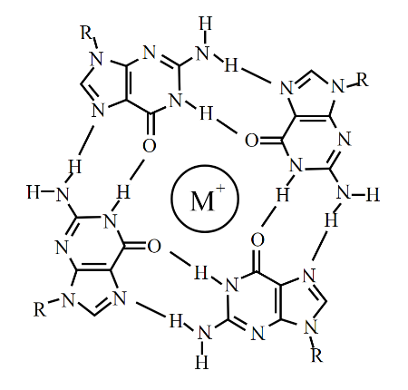
Another promising strategy for developing metallodrugs involves exploring new potential biological targets beyond canonical B-DNA. G-quadruplex nucleic acids, formed by the self-assembly of guanine-rich sequences, are considered attractive targets for anticancer drug development.⁴⁸ Compounds capable of binding and stabilising this type of DNA structure can selectively downregulate gene expression, inhibit telomerase, and activate DNA damage responses. This approach can potentially overcome the non-selectivity and off-target toxicity of traditional cytotoxic agents for B-DNA; and also has possible efficacy in a wide range of genetically complex solid tumour types.⁴⁹
G-quadruplexes are secondary DNA or RNA structures formed by guanine-rich sequences. These structures are characterised by the stacking of four guanine bases (G-tetrads) in a planar arrangement, which are stabilised by Hoogsteen hydrogen bonding and coordination with cations such as potassium (Figure 8⁵⁰). G-quadruplexes can be found in various regions of the genome or transcriptome, including telomeres, promoter regions, and untranslated regions of mRNA.
Figure 8: A guanin-quartet (G-quartet). The central metal ion is coordinated with O6 atoms.
In telomeres, G-quadruplexes play a crucial role in maintaining chromosomal stability and regulating telomere length.⁵¹ In promoter regions, they can regulate gene expression by modulating transcription initiation and elongation.⁵² Additionally, G-quadruplexes have been implicated in other cellular processes such as DNA replication⁵³, recombination⁵⁴, and repair⁵⁵.
A study of a group of Pt(II) intercalators interacting with both duplex and quadruplex DNA, revealed that more π-extended derivatives of Pt(II) phenanthroimidazole complexes exhibit significantly greater binding affinity (by two orders of magnitude) and selectivity for G-quadruplex over duplex DNA structures. Additionally, the CD (Circular Dichroism spectroscopy) data demonstrated an increase in the stability of quadruplex towards thermal denaturation upon binding of the complexes. This selective binding can be attributed to better compatibility between square planar Pt(II) complexes with extended aromatic ligands, resulting in an increased π-surface that better complements the larger G-quartet motif presented in G-quadruplexes compared to canonical DNA structures.⁵⁶

Host-guest supramolecular chemistry
Supramolecular chemistry involving macrocyclic carriers is an interdisciplinary and rapidly growing area of research in chemistry, biochemistry, and materials science. In host-guest-based supramolecular chemistry, non-covalent interactions occur between two molecules (host and guest), which produce supramolecular entities by molecular recognition. Commonly, the host is a large molecule or an aggregate such as an enzyme or synthetic cyclic compound with a central hole or cavity of the correct size, geometry, and chemical nature to interact with the guest. The guest can be a monatomic cation, a simple inorganic anion, an ion pair, or a more sophisticated molecule such as a hormone, pheromone, or neurotransmitter.⁵⁷ The non-covalent interactions include weak ones such as hydrophobicity, van der Waals, dipole-dipole, cation–π interactions, or π–π stacking, and quite strong ones such as electrostatic, coordinative interactions.⁵⁸
The non-covalent nature of the interaction in host-guest chemistry presents several advantages. It allows for the simple and efficient construction of supramolecular structures, avoiding the need for complex synthesis steps. Supramolecular structures are typically reversible, allowing for easy dissociation and reconstruction at a low energy cost. This reversibility enables dynamic control over the structure and properties of the materials. Additionally, supramolecular materials can be recycled and self-repaired from external mechanical damage due to their reversible nature, making them more environmentally friendly than traditional chemical synthesis.
These materials can respond to external stimuli, triggering changes in their structure and properties. For instance, several nanoparticles are capable of drug delivery via pH-responsive cucurbituril host-guest interactions, where mesoporous silica nanoparticles are functionalised with bis-ammonium units, allowing for pH-dependent binding with cucurbit[6]uril, resulting in drug release from the nanoparticle under basic conditions.⁵⁹ This adaptability is useful for designing stimuli-responsive materials for various applications in nanotechnology, materials science, biosensors, drug delivery, analytical chemistry, and biomedical sciences.⁶⁰
Diverse classes of the host molecules discovered so far include n-cyclodextrins (n-CD), cucurbit[n]urils (CB[n]), calix[n]arenes (CA), pillar[n]arenes (PA[n]), crown ethers, cyclophanes, cryptands, and many others. These macrocyclic hosts have reasonably rigid hydrophobic cavities of varying sizes and molecular recognition characteristics. Among these hosts, CAs, CDs, and CBs are increasingly popular in the biomedical field due to their biocompatibility and facile and reversible process formation, which facilitates the design of stimuli-responsive supramolecular systems.⁶¹

Binding constants
The binding of a guest by a host species is an equilibrium process. The thermodynamic stability of it is described in a given solvent at a given temperature by association/binding (K_{a}) or dissociation (K_{d}) constants. The binding constant is defined by Eq.(2), using the concentrations of the species present at equilibrium: host (H), guest (G), and the resulting host-guest complex (HG) Eq.(1). Explicit solvent is not used because ΔG° for the association constant reflects the stability of solvated H and G relative to solvated HG and released solvent. The final value, K_{a}, has units of concentration mol dm⁻³ or M⁻¹.
$$H + G ⇄ HG$$ | (1)
$$K_{a}=\frac{\left[HG\right]}{\left[H\right]\left[G\right]}$$ | (2)
$$K_{d}=\frac{[H]\left[G\right]}{[HG]}$$ | (3)
$$∆G°=-RT\ln{K_{a}}$$ | (4)
The dissociation constant, K_{d}, is a commonly used quantity in biological systems. It is the reciprocal of the binding constant and is expressed in concentration units (M). The K_{d} value is helpful because it directly measures the concentration at which an HG complex will dissociate.
In the case of host-guest complexes that form a 1:2 ratio, then two K values may be measured for the 1:1 and 1:2 complexes, respectively: K₁₁ and K₁₂. An overall binding constant β₁₂ can be defined for the process with the individual K values as stepwise binding constants:
$$β_{12}=K_{11}∙K_{12}$$ | (5)
where:
$$H + G ⇄ HG$$ | $$K_{11}=\frac{[HG]}{\left[H\right]\left[G\right]}$$ | (6)
$$HG + G ⇄ {HG}_{2}$$ | $$K_{12}=\frac{[{HG}_{2}]}{\left[H\right]\left[HG\right]}$$ | (7)

Measurement of the binding constants
In supramolecular chemistry, the most common approach for quantifying host-guest interactions is the supramolecular titration experiments. These are usually carried out by fixing the concentration of one component, for example, the host (H), while the concentration of another component, the guest (G), is varied. Because it is usually not possible to measure [HG] (or [H] and [G]) that are required to determine K_{a}, the method relies on indirect determination of the concentration of the complex [HG] from experiments. Thus, during this titration, the physical changes in the system are monitored. It can be a specific nuclear resonance (NMR), absorption band (UV), or binding enthalpy (ITC) that is sensitive to certain supramolecular interactions. Then this change is plotted as a function of guest added to host. The resulting titration curve known as a binding isotherm is then fitted to a mathematical model that is derived from the assumed equilibria to obtain the association or dissociation constant.⁶²
The mathematical model is derived from the assumption that the observed physical change (Y) is correlated to the concentration of the complex as ΔY ∝ [HG]. The physical change (Y) being monitored can be described as the aggregate of the individual components according to Eq.(8) as a function of mole fractions χ_{X} (χ_{X} defined as χ_{X} = [X]/[X]₀ ) in the case of NMR.
$$Y = Y_{H}χ_{H}+Y_{G}χ_{G}+Y_{HG}χ_{HG}$$ | (8)
Then by combining the mole fraction (f) notion with Eq.(2) and mass balance equations (Eq. (9), (10)), we can describe the general binding isotherm for a simple 1:1 binding system as a hyperbolic relationship between $f$_{G} and the free guest ([G]) concentration (Eq.(11)).
$${[H]}_{0}=\left[H\right]+\left[HG\right]$$ | (9)
$${[G]}_{0}=\left[G\right]+\left[HG\right]$$ | (10)
$$χ_{G}=\frac{K_{a}[G]}{1+K_{a}[G]}$$ | (11)
Because we cannot usually measure the free form of [G] directly, another approach is required, where after rearranging Eq. (9) and (10) to isolate for [H] and [G], respectively, and inserting these into Eq.(2), we will get the corresponding solution for [HG]:
$$\left[HG\right]=\frac{1}{2}\left(\frac{1}{K_{a}}+{\left[G\right]}_{0}+{\left[H\right]}_{0}\right)-\sqrt{{\left(\frac{1}{K_{a}}+{\left[G\right]}_{0}+{\left[H\right]}_{0}\right)}^{2}-4{[H]}_{0}{[G]}_{0}}$$ | (12)
Now developing a solution for Eq.(8) it requires only the knowledge of the total (or initial) concentrations of the host and guest ([H]₀ and [G]₀) in addition to the association constant (K_{a}) and the physical properties (Y) that are changing (ΔY) during the course of the titration. Then the physical change is calculated using the given equation (where Y_{ΔHG}=Y_{HG} -Y_{H}):
$$∆Y = Y_{∆HG}\frac{[HG]}{{[H]}_{0}}$$ | (13)
In the special case of NMR, physical change is a change of chemical shift (Δδ):
$$∆δ = δ_{∆HG}\frac{[HG]}{{[H]}_{0}}$$ | (14)
By using this equation for [HG], it is possible to describe the expected changes from a supramolecular titration experiment from two known ([H]₀ and [G]₀), where the unknown K_{a} and Y_{ΔHG} parameters are obtained by non-linear regression of the data obtained. It is achieved by making some initial guesses for K_{a} and Y_{ΔHG} that are used for the calculation of [G] for varying values of [G]₀. The process is repeated by varying K_{a} and Y_{ΔHG} until the created theoretical isotherm will fit the real experimental data.⁶²

NMR methods
One of the most informative techniques is the ¹H NMR titration experiment. Apart from the quantitative information, qualitative analysis of the spectra can provide insights into the location of guest binding, the binding affinity, and stoichiometry.
Exchange Regime/Dynamics
The chemical exchange is a dynamic process of interconversion between guest-free ↔ guest-bound states in case of host-quest interactions. In NMR, in order to estimate the K_{a} of the complexation, we have to consider the relationship between the equilibrium association constant and the kinetics on/off rates (K_{a} = k_{on}/k_{off}) and the timescale of the NMR experiment.
 | (15)
The parameters that characterise the chemical exchange regime of a HG interaction are the exchange rate, k_{ex} (in units of s⁻¹):
$$k_{ex}=[H]k_{on}+k_{off}$$ | (16)
and the chemical-shift difference between the free and bound states, Δω (in units of rad·s⁻¹), that is calculated from the chemical-shift difference in units of ppm (Δδ) as:
$$∆ω=2π∆δB_{0}$$ | (17)
where B₀ denotes the magnetic field in units of Hz. Then, by comparing kex and Δω, we can predict if the interaction is in the fast or slow exchange regime. In the fast exchange regime (k_{ex} >> |Δω|), only one NMR signal appears at the population-averaged chemical shift of the free and bound states. In the slow exchange regime (k_{ex} << |Δω|), NMR signals from both states are observed reflecting their distinct chemical shifts. In the intermediate exchange regime (k_{ex} ≈ |Δω|), only one signal is observed with an intermediate chemical shift (Figure 9). The knowledge of the exchange regime of the interaction is necessary for the choice of NMR titration experiment design and strategy for analysing NMR data.⁶²
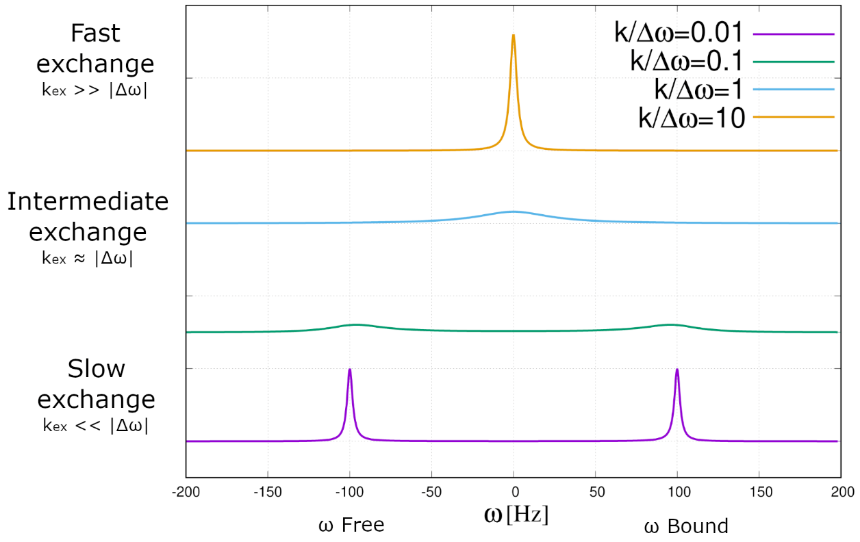
Figure 9: Chemical exchange process between free and bound fractions of guest resonance. The resonance frequencies of free and bound guest protons are -100 Hz and 100 Hz, respectively. The population fraction of each state is 50%.
Fast exchange regime
Most host-guest complexes show a fast exchange regime on the NMR timescale. In this case in the NMR spectrum, we see only one chemical shift (δ) which is the average of chemical shifts of free and bound form weighted by their molar fractions (χ) (Eq. 18). Then for the signal of the host, we can derive equations:
$$δ_{obs}=δ_{H}χ_{H}+δ_{HG}χ_{HG}$$ | (18)
$$χ_{HG}=\frac{K_{a}[G]}{1+K_{a}[G]}$$ | (19)
$$∆δ=δ_{obs}-δ_{H}=χ_{HG}\left(δ_{HG}-δ_{H}\right)=\frac{Δδ_{tot}K_{a}[G]}{1+K_{a}[G]}$$ | (20)
Eq. 20 describes the chemical shift change of the host-guest complex, where δ_{obs} is the observed shift and δ_{H} is the chemical shift of the free host.
In a typical NMR titration experiment, small aliquots of guest are added to a solution of a host with known concentrations (In case of poor solubility of guest, reverse mode of titration can be used, where a host is added to the solution of guest). Usually, changes in chemical shift (∆δ) are noted for various atomic nuclei present (for protons in ¹H NMR) as a function of the influence the guest binding has on their magnetic environment. This way it is possible to qualitatively analyse the location of the binding of guest to host by observation of the most affected nuclei.
The chemical shift change is monitored as a function of the total concentrations of the host ([H]₀) and the guest ([G]₀) (or host: guest ratio), and the data are fitted with the equation:
$$Δ{δ(H)}_{obs}=\frac{{Δδ}_{max}}{{2[H]}_{0}}\left\{K_{d}+{[H]}_{0}+{[G]}_{0}-\sqrt{({K_{d}+{[H]}_{0}+{[G]}_{0})}^{2}-4{[H]}_{0}{[G]}_{0}}\right\}$$ | (21)
The value of the binding constant (or dissociation constant K_{d}=1/K_{a}) and ∆δ_{max} can be derived by plotting Δδ_{obs} versus different guest concentrations [G₀] and using Eq.(21) for the data fitting. Both [H]₀ and [G]₀ are treated as independent variables in the data fitting to increase in the accuracy of the fitted K_{d} and ∆δ_{max} values.⁶³
Slow exchange regime
If the dissociation rate is slow on the NMR time scale, two separate signals of free and bound state are visible in the NMR spectrum. Then the intensity of each peak directly reports on the population of that species, conceding that sufficient inter-scan recovery time was provided. The integral of the signal of the bound guest provides the concentration of the HG complex. Then by plotting the [HG]/[H]₀ measured values versus the concentration of the guest (or [H]₀/[G]₀) the dissociation constant can be derived using modified Eq. (21):
$$\frac{[HG]}{{[H]}_{0}}=\frac{K_{d}+{[H]}_{0}+{[G]}_{0}-\sqrt{({K_{d}+{[H]}_{0}+{[G]}_{0})}^{2}-4{[H]}_{0}{[G]}_{0}}}{2{[H]}_{0}}$$ | (22)
With NMR it is possible to obtain good quality spectra with sub-millimolar concentrations (routinely as low as 10⁻⁴ M), suggesting that K_{d} up to 10⁻⁵ M is the limit for direct NMR titration experiments. Then differentiation among the stronger binding constants becomes difficult. Therefore, it is necessary to resort to an indirect method - competitive titration mode. In this type of experiment, a tight binding guest that exhibits slow exchange kinetics and an excess of a more weakly binding guest are competing for a limiting quantity of a host. The integration of signals of bound forms of both guests is used to create a binding isotherm. That allows for an estimation of a binding constant, which requires a knowledge of the K_{a} of one of the guests.⁶²
To estimate the value of K_{a}, measured data can be qualitatively compared to simulated binding isotherms for different binding constants. The isotherms are generated using experimental concentration values of all components in the system by varying guessed values of K_{a}. Hence, the binding constant is iteratively changed until the created theoretical isotherm fits the experimental one.
Designing of NMR titration experiments/Methodology
Before conducting an experiment, a few things should be taken into consideration. The first is the accurate preparation of solutions of H and G (and competitor) since the resulting concentrations directly influence the calculation of binding constants. An internal calibrant can be used for the determination of the concentration and purity of all components. In the case of experiments, where a fast exchange regime is expected, this calibrant can be used as a chemical shift reference, on the condition that it is chemically inert and does not influence the host-guest interaction.
The second is that in experiments, where the HG system exhibits slow kinetics, accurate integration of signals in the NMR spectrum is required to estimate binding constants. To overcome integration errors, the relaxation delay (d1) used must be long enough to ensure that all signals have relaxed fully between pulses. However, in the case of an intermediate exchange regime, it can be difficult to obtain accurate integrals, due to significant broadening or even disappearance of the signals.⁶⁴
The third – the expected association constant determines what concentration should be chosen for the host system. For this reason, the shape of the binding isotherm for different simulated scenarios can be analysed. Binding isotherms were created for different K_{d} with constant [H]₀ and plotted for comparison (Figure 10):
If K_{d} > [H]₀ (thus weak interaction, K_{d} relatively high) then a relatively large excess of [G]₀ is required to saturate the host. Then the data points should be collected within the large range of [G]₀/[H]₀ ratio (up to 10 equivalents of G added) to obtain accurate results.
If K_{d} ≈ [H]₀, data can be collected anywhere within the range of 0 to >10 equivalents of G added.
If K_{d} < [H]₀ (thus strong interaction, K_{d} relatively low) it is essential to obtain as many points as possible between 0–1 equivalents of G added because saturation of the host is quick.⁶²
In the case of K_{d} much lower than [H]₀ (K_{d} 10⁻⁶ and 10⁻⁷), the analysis of binding isotherm is not representative enough, because the differences between stronger binding constants are too small. This is the exact situation where a competitive mode of titration experiment is needed.
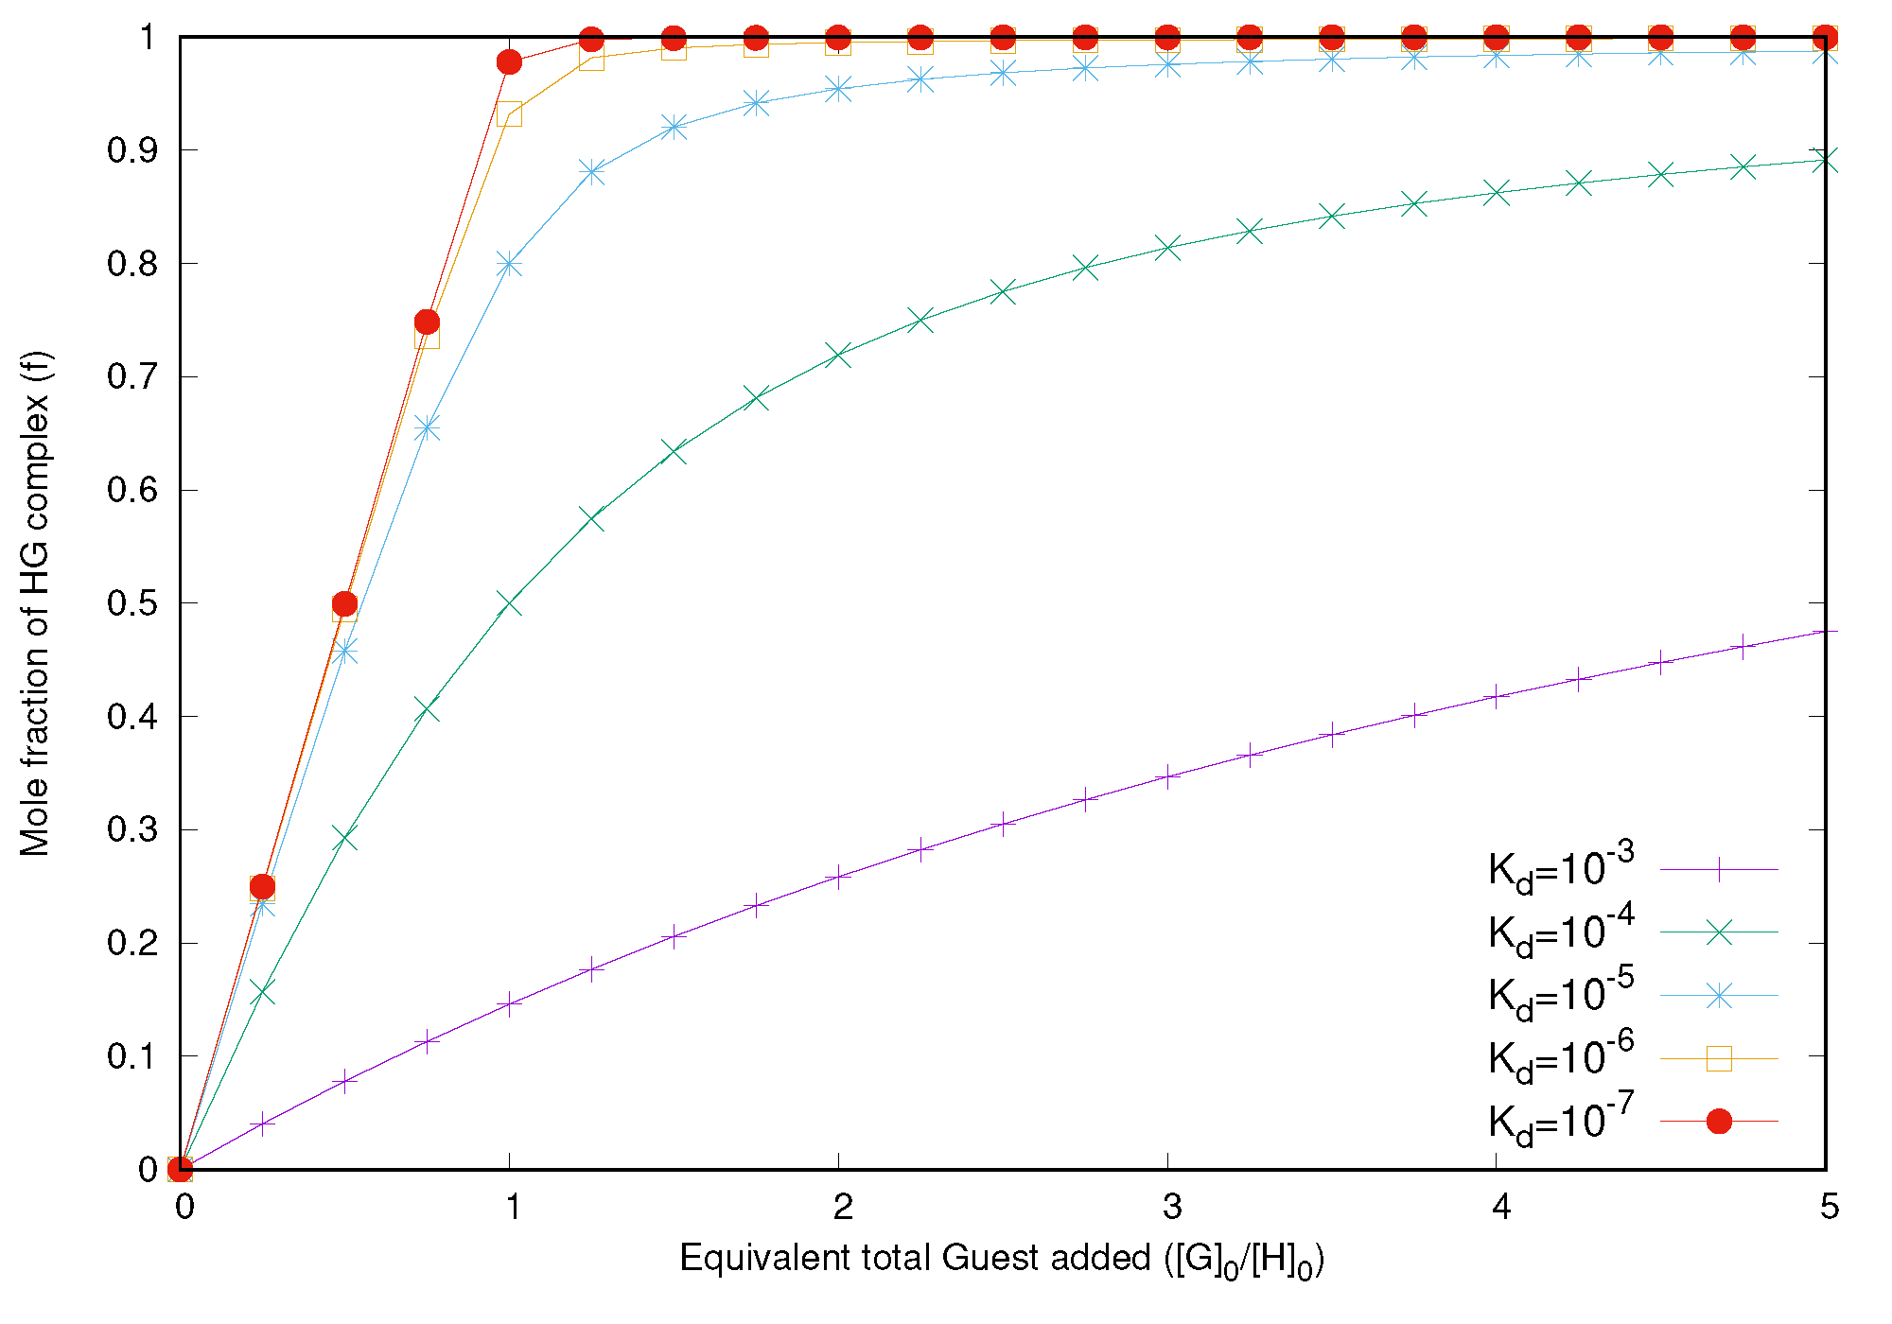
Figure 10: The simulated binding isotherms for 1:1 complexation for varying dissociation constants with constant [H]₀. The increasing concentration of G (on the x-axis) was fitted to the mole fraction of the formed HG complex (on the y-axis).

Cooperativity
In host-guest complexation, the concept of cooperativity can be applied when a host molecule has more than one binding site. For a 1:2 system, if the binding of the first guest changes the binding properties of the second site or there is some interaction between the two guests bound in HG₂, cooperative binding is observed. Cooperativity can be positive or negative depending on whether the binding of a first G increases or decreases the host's apparent affinity for the second G. If the interaction of the host with the first guest does not change the affinity for the second guest, we refer to it as non-cooperative binding. Cooperativity can be homotropic if a guest influences the binding of guests of the same kind, or heterotropic if it influences the binding of other types of guests.⁶⁵
As mentioned in Section 2.2.1, the 1:2 HG system is characterised by the association constants K₁₁ and K₁₂. Then the cooperativity effect can be described by the interaction parameter α, which is defined by: α=K₁₂/K₁₁. In the absence of cooperativity, the association constants are identical to the value for the corresponding host molecule with one binding site, that is, K₁₁ = K₁₂ = K and α = 1. In the system with negative cooperativity, where K₁₁ > K₁₂ and α < 1, the formation of the intermediate state (HG) is preferred over the formation of a fully bound complex (HG₂). In the system with positive cooperativity, where K₁₁ < K₁₂ and α > 1, the interactions in the fully bound state are more favourable than in the intermediate (Figure 11).⁶⁶
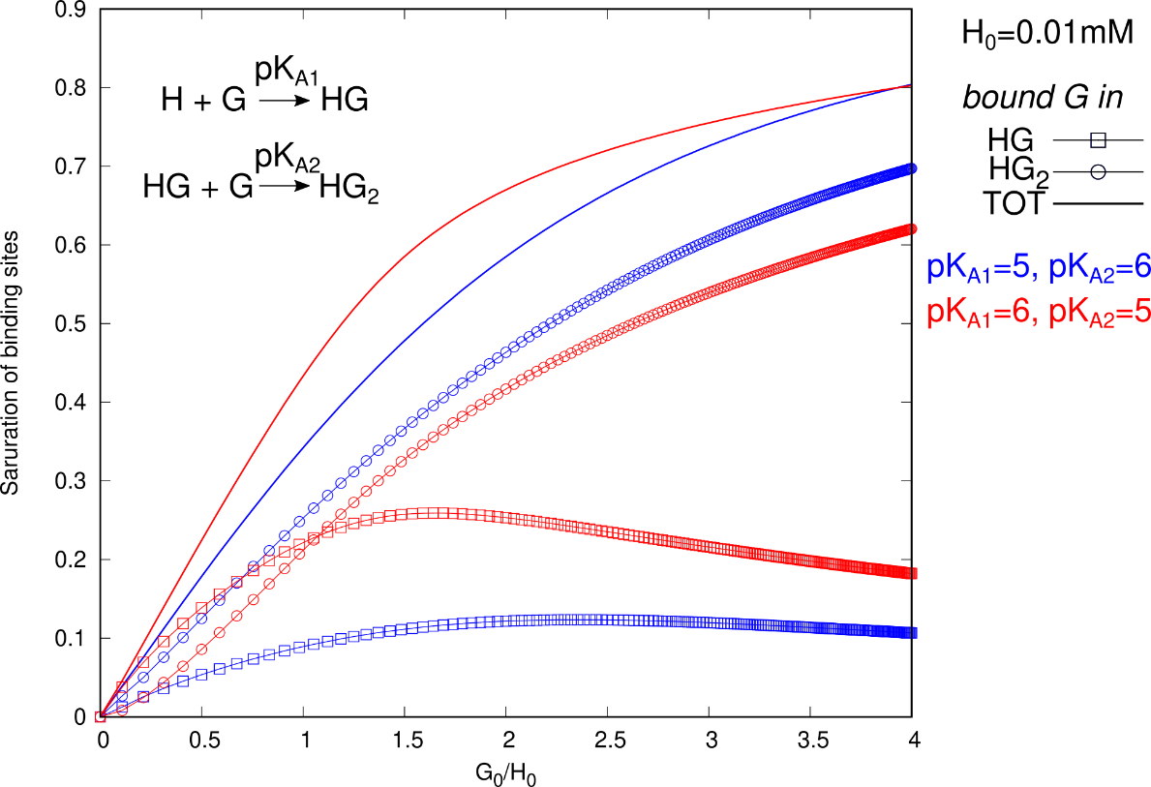
Figure 11: Simulated binding isotherms for the formation of a 1:2 system under cooperative conditions with [H]₀=10⁻⁵ M. Colour coding: blue–positive cooperativity (where K₁₁ < K₁₂ and α = 10) and red–negative cooperativity (where K₁₁ > K₁₂ and α =0, 1).
Different types of cooperativities determine speciation in supramolecular and biological systems, for example, intermolecular (allosteric) and intramolecular (chelate) cooperativity. The first type can occur in complexes assembled from, for instance, two monovalent guests and a divalent host, that will form a 1:2 complex. Usually, the allostery requires some structural communication between the binding sites in the host. Several mechanisms can result in positive or negative allosteric cooperativity, including conformational changes, electronic polarisation of the host, or long-range electrostatic interactions between the guests. Steric repulsion between two bound guests is the most common cause of negative cooperativity. Intramolecular or chelate cooperativity is the second type, which only occurs in complexes of a multivalent guest and a multivalent host. Chelate cooperativity is caused by connecting binding sites in both binding partners through suitable spacers and can overlap with additional effects from intermolecular cooperativity.⁶⁷ It was found that in allosteric systems cooperativity can be either positive or negative, depending on the value of α, whereas chelate cooperativity can only be positive.⁶⁶
Allosteric cooperativity has been extensively studied in biological systems, such as oxygen binding to haemoglobin, where the binding of oxygen facilitates the binding of more oxygen (homotropic positive cooperativity), while binding of CO₂ reduces haemoglobin’s ability to bind O₂ (heterotropic negative cooperativity).⁶⁸ The chelate type of cooperativity is observed in protein folding or DNA duplex formation and supramolecular self-assembly. In the case of haemoglobin, chelate cooperativity is also observed, where it leads to the formation of a self-assembled tetrameric protein.⁶⁶
The cooperativity effect in supramolecular chemistry, observed in host-guest complexes with monovalent guests is commonly termed allosteric cooperativity. The effect has been explored within the cucurbituril and cyclodextrin families, as homodimers of CDs can show homotropic cooperativity toward the p-nitrophenyl ester⁶⁹; or by adjusting the hydrophobic effect and gradually tuning the side groups of guest molecules from hydrophilic to hydrophobic, it becomes feasible to control the binding cooperativity of CB8 from positive to negative.⁷⁰ The cooperative effect is likewise evident in systems involving a divalent guest and monovalent hosts. For example, a guest molecule possessing two binding sites enables cooperative binding with cucurbiturils, cyclodextrins, or both within a single supramolecular system.⁷¹
Previous studies have also discovered cooperative binding between guests and DNA. For example, strong positive cooperativity was observed between two small molecules binding to adjacent A/T-rich regions on complementary strands of a duplex.⁷²

Practical part

Materials
Platinum(IV) complexes were synthesised by Mgr. Jan Chyba, Ph.D., from the group of Prof. RNDr. Radek Marek, Ph.D., in laboratories of CEITEC MU. Both complexes are oxidised derivatives of oxaliplatin that bear ester ligands in the axial position, with one adamantane ligand in the case of the Pt1 complex and two in the Pt2 complex. Host-guest interactions of Pt(IV) complexes were studied with β-cyclodextrin (β-CD) and cucurbit[7]uril (CB7) purchased from Merck Inc. and Strem Chemicals, Inc.
Pt1 | Pt2
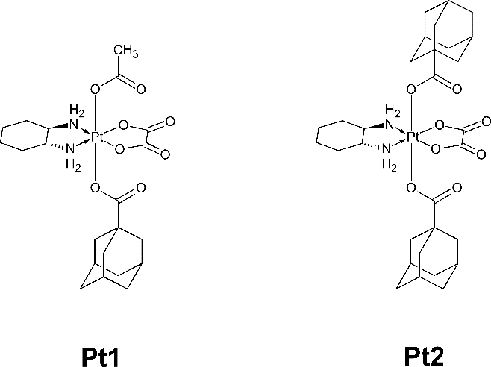
Platinum(II) complexes were synthesised by Shib Shankar Paul, MSc. from the group of Prof. RNDr. Radek Marek, Ph.D. Complexes are cisplatin derivatives with modified ligands such as pyridine, phenyl-pyridine, adamantane-pyridine and phenanthridine. Host-guest interactions of Pt(II) complexes were studied only with cucurbit[7]uril (CB7).
PtPyr | [cis-Pt -(NH₃)₂(Pyr)-Cl]⁺ NO₃⁻
PtPyrPhe | [cis-Pt-(NH₃)₂(Phe-Pyr)-Cl]⁺ NO₃⁻
PtPyrAd | [cis-Pt-(NH₃)₂(Ad-Pyr)-Cl]⁺ NO₃⁻
phenPt | [cis-Pt-(NH₃)₂(Phenanthridine)-Cl]⁺ NO₃⁻
Chosen DNA sequences were synthesised by Dr. Peter Podbevšek from the group of Prof. Janez Plavec in laboratories of the National Institute of Chemistry in Ljubljana. The purified sample of hTel was dissolved in 550 μl of buffer containing 5% D₂O, 70 mM KCl, and 20 mM K₂HPO₄/KH₂PO₄. The first sample of the purified duplex was dissolved in 550 μl of buffer containing 5% D₂O, 20 mM Na₂HPO₄/NaH₂PO_{4.} The second sample of the purified duplex - 5% D₂O, 70 mM KCl, and 20 mM K₂HPO₄/KH₂PO₄. All DNA samples were prepared to have a pH value of 7.
Duplex | d(CAATCCGGATTG)₂
hTel | d[TTGGG(TTAGGG)₃A]

Methods

NMR spectroscopy
NMR experiments were used as a main tool to study the interaction between platinum complexes and CB7/β-CD or DNAs. ¹H 1D NMR titration experiments were performed to determine the mode of interaction and K_{d}. Also, NMR experiments were used to estimate the melting temperature of DNA samples. ¹H-¹H 2D NOESY measurements were performed to define the binding site and orientation of Pt-complexes to DNAs.
NMR experiments with CB7/β-CD were measured in D₂O at 298.2 K; experiments with DNAs were measured in 95% H₂O/5% D₂O at 298.2 K (or at 278.2 K). Measurements were acquired on Bruker Avance NEO 600MHz equipped with 5 mm quadruple-resonance (¹H-³¹P-¹³C-¹⁵N) inversed cryoprobe and Bruker Avance NEO 700MHz spectrometers equipped with 5 mm triple-resonance (¹H-¹³C-¹⁵N) cryoprobe or 5 mm triple-resonance (¹H/¹⁹F-¹³C-¹⁵N) inversion cryoprobe. In the case of measurements with DNAs in H₂O, the WATERGATE⁷³ pulse sequence was used to suppress the signal of water. In measurements with CB7/β-CD in D₂O, water presaturation was used. Spectra were referenced to a water signal in the case of measurements with CB7; and to an impurity signal at the position 3.1 ppm - with DNAs. NOESY spectra were measured with 200 ms mixing time. NMR spectra were processed in MestReNova (Mestrelab)⁷⁴ or TopSpin (Bruker), and 2D spectra were assigned using Sparky⁷⁵. Figures were made in MestReNova (Mestrelab) or TopSpin (Bruker). The 3D models were visualised in PyMOL⁷⁶.
Maleic acid was used as an internal standard to estimate the purity of CB7 by integrating their signal area in ¹H 1D NMR spectra of their solutions. The purity of the CB7 solutions was estimated separately before each experiment. Similarly, DMS was used as an internal standard and chemical shift reference in experiments with β-CD.

UV/VIS spectroscopy
UV/VIS experiments were used to estimate the melting temperatures of DNAs with and without platinum complexes. Melting experiments were performed on a Varian CARY-100 BIO UV−Vis spectrophotometer using 1 cm path length cells. Samples were heated/cooled at a 1 °C/min rate in the 10−90 °C range. The change in absorbance was measured at 260 nm in the case of duplex and at 295 nm for G-quadruplex.
Additionally, the concentrations of prepared oligonucleotides were measured using a Nanodrop UV/VIS spectrometer. Extinction coefficients were estimated using online software.⁷⁷

Results
In the following sections, the host-guest interactions of Pt compounds with β-cyclodextrin and cucurbit[7]uril will be examined, by conducting ¹H NMR titration experiments to estimate the binding affinities of the interactions, first, with platinum(IV) compounds and then with platinum(II). Next, the interaction of platinum(II) complexes will be studied with the model of DNA duplex and G-quadruplex by conducting ¹H NMR titrations and 2D NOESY experiments. If possible, a representative 3D model will be constructed based on the NMR data of these interactions to represent the binding sites and orientation of the complexes.

NMR titration experiments with β-CD/CB7

Platinum(IV) complexes
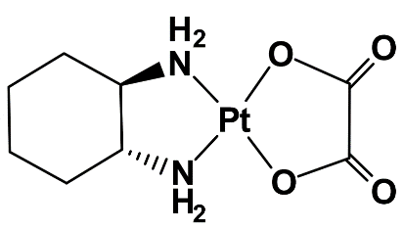
The platinum(IV) complexes studied in this work are oxidised derivatives of oxaliplatin with modified axial positions. The complex bearing one acetate residue and one carboxy-adamantane ligand is labelled Pt1, and the complex with two carboxy-adamantane ligands is labelled Pt2. Both complexes have a neutral charge, contributing to their limited solubility in aqueous solutions. Furthermore, the presence of adamantane residues further reduces their solubility, especially in the case of Pt2 complex.
The encapsulation of these complexes within molecular carriers was studied on β-cyclodextrin (β-CD) and cucurbit[7]uril (CB7) in D₂O with 50 mM NaCl. While preparing a solution of the Pt1 complex with a concentration of up to 0.2 mM was feasible, the Pt2 complex remained practically insoluble. Therefore, the Pt2 complex was studied in a monoencapsulated form with CB7 (Pt2@CB7), which increased the complex solubility.
Pt1@β-CD
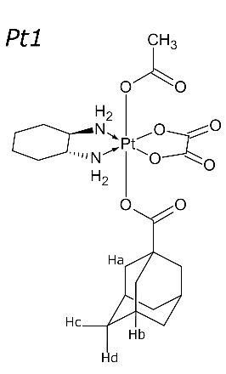
Due to poor solubility, the reverse titration experiment was conducted to estimate the binding affinity of Pt1 with β-CD. The solution of β-CD (1.58 mM) was titrated into the NMR tube with 0.115 mM Pt1 solution until the ratio of β-CD:Pt1 was 4:1. Both samples were prepared in D₂O with 50 mM NaCl. The system exhibited fast exchange kinetics on the NMR time scale, as indicated by observing the population-averaged NMR signal of free and bound forms of adamantane signals (Figure 12). The hydrogen resonances of adamantane were significantly deshielded in the presence of β-CD, particularly with Hb shifting 0.19 ppm. The chemical shift changes for Ha, Hb, and T (from cyclohexane ring) signals of the Pt1 complex were plotted using Gnuplot (Figure 13). The dissociation constant was estimated separately for each resonance as 10^{-4.4} in the case of Ha and T and 10^{-4.6} for Hb. The average of values of K_{d} is 10^{-4.5}.
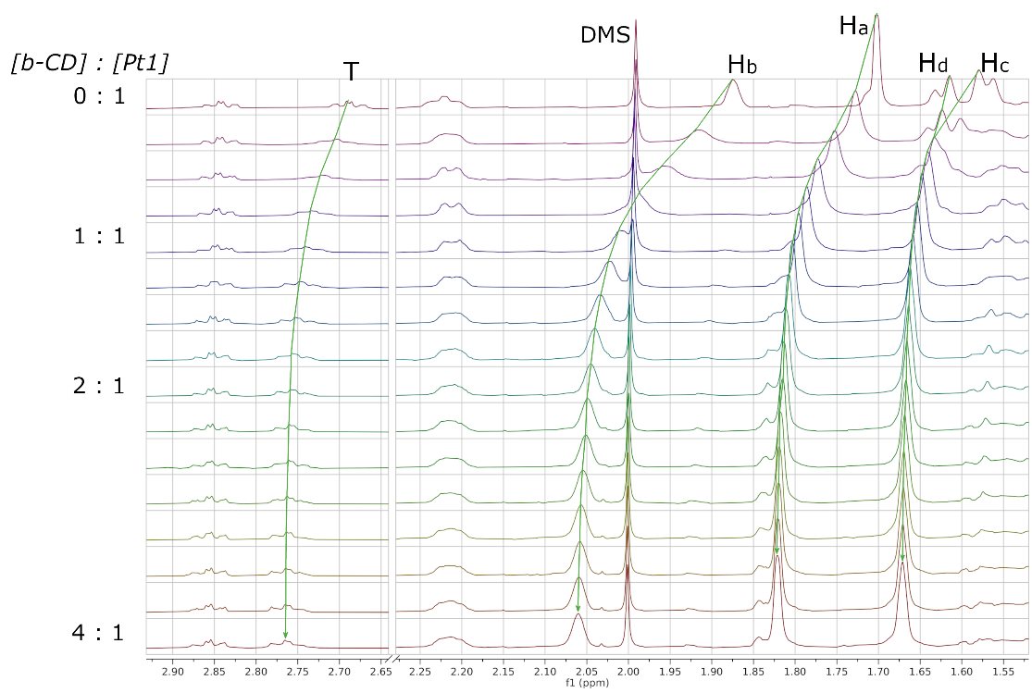
Figure 12: ¹H 1D NMR titration of β-CD (1.58 mM) into the solution of Pt1 (0.115 mM) in D₂O with 50 mM NaCl at 298.2 K. The concentration of Pt1 was constant during the titration. The spectra were referenced to DMS.
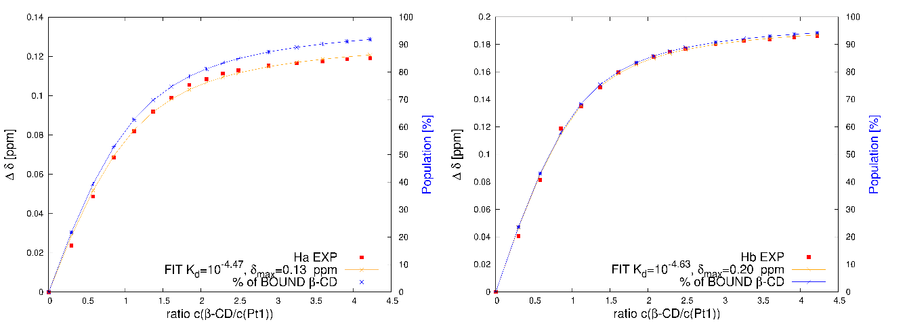
Figure 13: The plot of chemical shift changes of Ha and Hb signals of Pt1 complex upon complexation with β-CD. The ratio of concentrations of β-CD and Pt1 (on the x-axis) was fitted to the chemical shift change of the resonance (on the y-axis). The red dots correspond to experimental data, the red line is fitted binding isotherm. The blue line corresponds to the fitted percentage of the bound form of β-CD.
Pt1@CB7
To determine the dissociation constant of the interaction of Pt1 with CB7, a competitive titration mode was chosen due to the expected high binding affinity of the adamantane core towards CB7. For this purpose, β-CD was used as a competitor since its K_{d} was already estimated. The stock solution of Pt1@β-CD with a concentration ratio of 1:5 (c(Pt1)=0.11 mM, c(β-CD)=0.54 mM) was prepared and added into the NMR tube, where 0.58 mM solution of CB7 was directly titrated. All samples were prepared in D₂O with 50 mM NaCl. By the end of the titration, the concentration ratio of CB7:β-CD was 1:4.6 (and for CB7:Pt1 - 1:1). Upon titration of CB7, the signals corresponding to the bound form of adamantane in β-CD disappeared, while the signals of the bound form of Ad in CB7 reappeared, significantly shielded (Figure 14). These observations indicate that the interaction of Pt1@CB7 exhibited a slow exchange regime on the NMR timescale. The signals of adamantane bound in β-CD and CB7 were integrated and used in the simulation of binding isotherms to derive the K_{d}, which ended up being around 10^{-6.5} (Figure 15).
The same titration was repeated without salt. Into the NMR tube with a stock solution of Pt1@β-CD with a concentration ratio of 1:5.2 was directly titrated CB7 (c=1.076 mM) until the CB7:β-CD was 1:3.6 (and for CB7/Pt1 - 1.5:1). The value of K_{d} was estimated as 10^{-5.5}.
The presence of salt in the experiment usually slows down the host-guest binding as cation play the role of a weak competitor that can bind to CB7. This effect was not observed in these two measurements, as the dissociation constants of Pt1 to CB7 in the experiment with salt were estimated as 10^{-6.5}, but without salt, the K_{d} was - 10^{-5.5}.
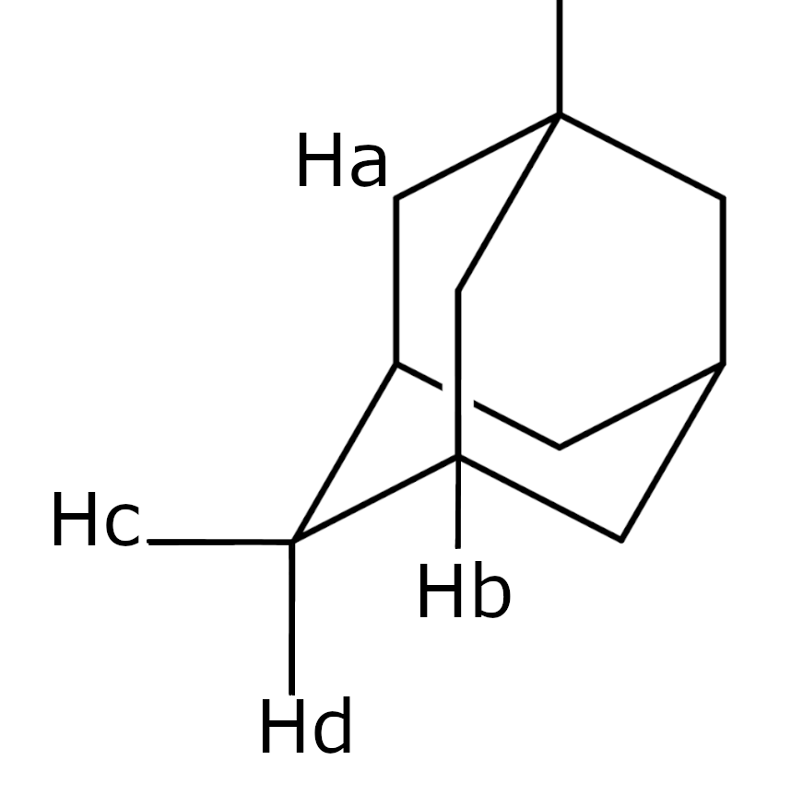
Figure 14: ¹H 1D competitive NMR titration of CB7 into the solution of Pt1@β-CD in D₂O with 50 mM NaCl at 298.2 K. The concentration of Pt1@β-CD was constant during the titration. The signals of Ad bound in β-CD and CB7 are shown in green and red rectangles, respectively. The spectra were referenced to a signal of water.
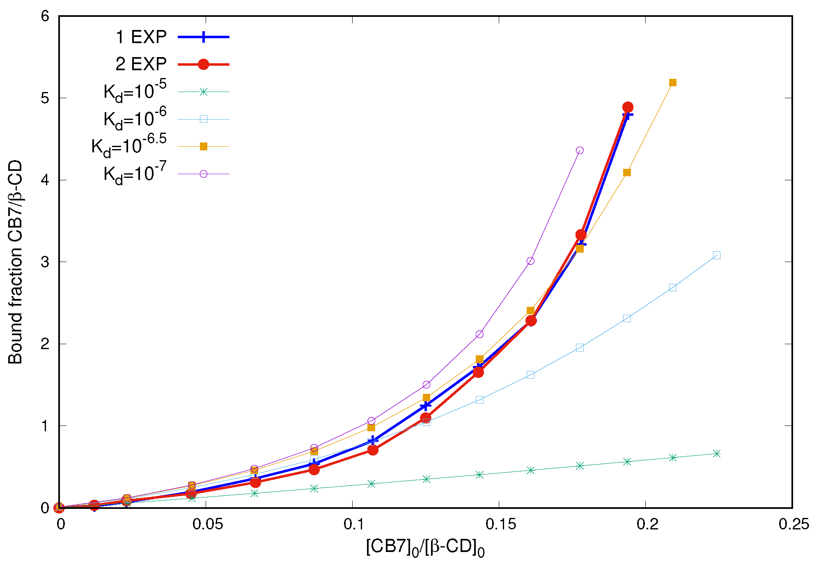
Figure 15: The plot of binding isotherm of experimental data and simulated dissociation constants for CB7 binding to Pt1. The concentration ratio of CB7 and β-CD (on the x-axis) was fitted to the ratio of the bound fractions of CB7 and β-CD (on the y-axis). The experimental data are shown in bold.
Pt2@β-CD
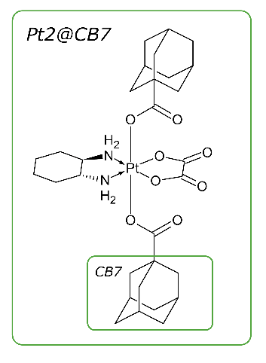
As mentioned previously, the Pt2 complex was studied as a monoencapsulated Pt2@CB7 complex due to its insolubility in water. The monoencapsulated complex was formed by mixing one equivalent of Pt2 with one equivalent of CB7. Then, to determine the dissociation constant of the binding of the second cavitand to Pt2’s second adamantane, β-CD or CB7 was titrated into a monoencapsulated complex. The K_{d} of formation of Pt2@CB7 monoencapsulated complex was taken from the ITC experiment of Pt1 with CB7, which was equal to 10^{-6.5}. This dissociation constant was used in calculations of K_{d} of the diencapsulated complex either with β-CD or second CB7.
The β-CD (c=2.4 mM) was titrated into the NMR tube with Pt2@CB7 (0.067 mM) until the free form of Ad signals was converted into the bound form. All samples were prepared in D₂O with 50 mM NaCl. By the end of the titration 12 molar equivalents of β-CD were added (Figure 16).
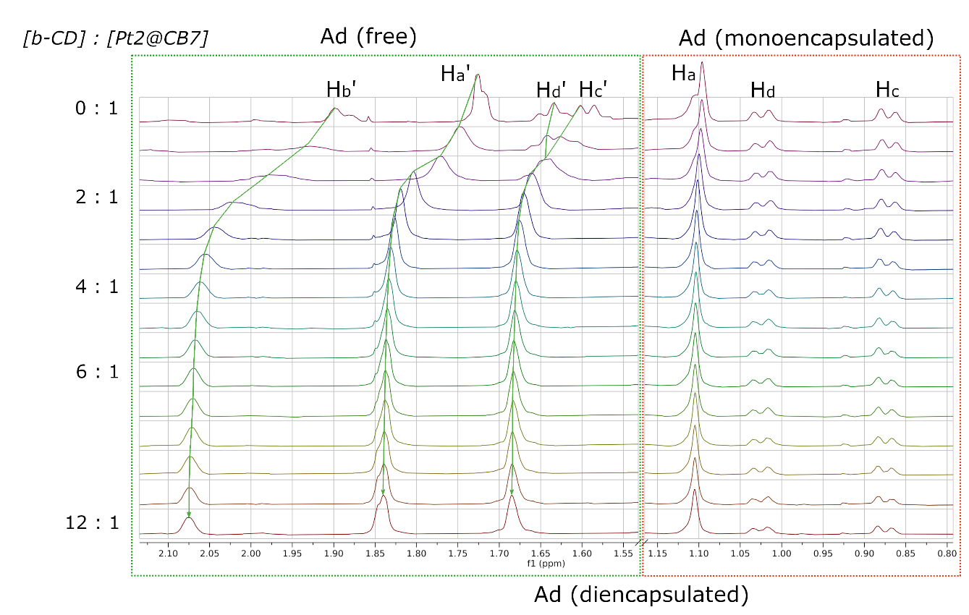
Figure 16: ¹H 1D NMR titration of β-CD into the solution of Pt2@CB7 in D₂O with 50 mM NaCl at 298.2 K. The concentration of Pt2@CB7 was not constant during the titration. The signals of Ad bound in β-CD and CB7 are shown in green and red rectangles, respectively. The spectra were referenced to a signal of water.
The binding of β-CD to the Pt2 exhibited the fast exchange regime on the NMR timescale. The hydrogen resonances of free adamantane were deshielded in the presence of β-CD, especially with Hb’ shifting 0.19 ppm. Besides, it was observed that the position of signals of adamantane encapsulated in CB7 was not changing during the titration, therefore they were not influenced by the addition of an excess of β-CD, which indicates that the binding of CB7 is much stronger than of β-CD. The dissociation constant was determined by fitting the change in chemical shift of Ha and Hb signals of adamantane to the ratio c(β-CD)/c(Pt@CB7) (Figure 17). The K_{d} in the case of both signals was estimated as 10^{-4.4}.
The binding affinity of β-CD with the Pt2 in the diencapsulated complex and the Pt1 complex was found to be similar. This suggests that the binding between Pt2@CB7 and β-CD is non-cooperative; therefore, the binding sites can be considered independent.
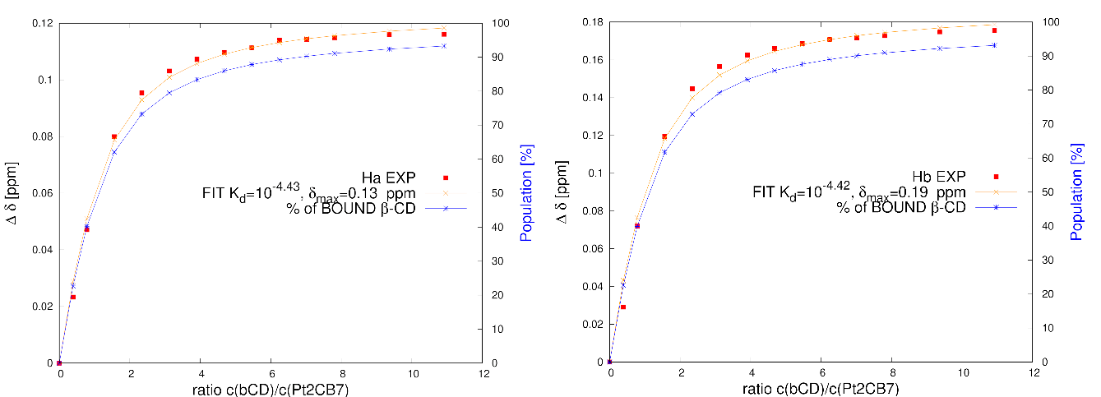
Figure 17: The plot of chemical shift changes of signals of Pt2 complex upon complexation with β-CD. The ratio of concentrations of β-CD and Pt2@CB7 (on the x-axis) was fitted to the chemical shift change of the resonance (on the y-axis). The red dots correspond to experimental data, the red line is fitted binding isotherm. The blue line corresponds to the fitted percentage of the bound form of β-CD.
Pt2@CB7
Similarly, the titration experiment was performed with CB7. In the NMR tube with Pt2@CB7 (0.074 mM), the CB7 (1.78 mM) solution was titrated. All samples were prepared in D₂O with 50 mM NaCl. By the end of the experiment, 5.8 equivalents of CB7 were added to the monoencapsulated Pt2@CB7 complex.
At the beginning of the experiment, two forms of Ad were present - free and bound with one CB7, and then during the addition of CB7 both forms of Ad signals began to disappear and then reappeared as one diencapsulated form. This indicates that the binding of the second CB7 to Pt2@CB7 restored the symmetry of the Pt2 complex (Figure 18). The binding of the second CB7 to Pt2 also exhibited a slow exchange regime on the NMR time scale. To estimate the dissociation constant the signals of free and bound adamantane were integrated. Their ratio was plotted and compared with the simulated data for different K_{d} values (Figure 19). The K_{d} ended up being around 10^{-4.8}.
The binding affinity of CB7 to Pt2 in monoencapsulated and diencapsulated forms differ by almost two orders, indicating the negative cooperativity effect since the binding of a first CB7 decreases Pt2’s apparent affinity for the second CB7.
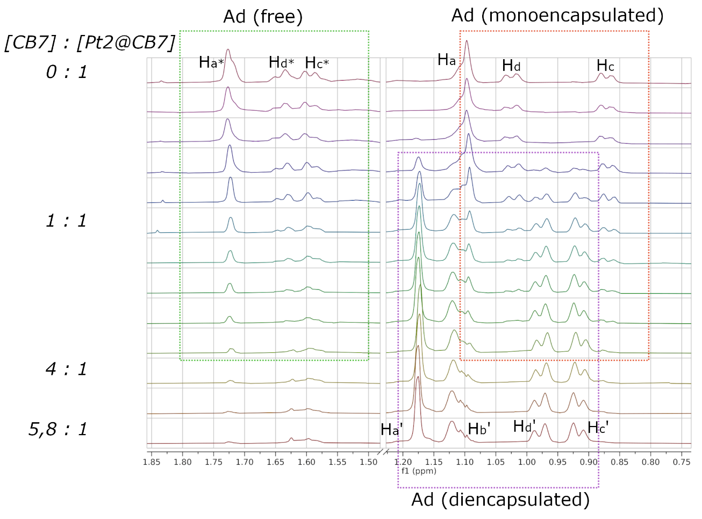
Figure 18: ¹H 1D NMR titration of CB7 into the solution of Pt2@CB7 in D₂O with 50 mM NaCl at 298.2 K. The concentration of Pt2@CB7 was not constant during the titration. The signals of free Ad (*) and bound in CB7 are shown in green and red rectangles, respectively. The signals of a diencapsulated Ad are shown in purple. The spectra were referenced to a signal of water.
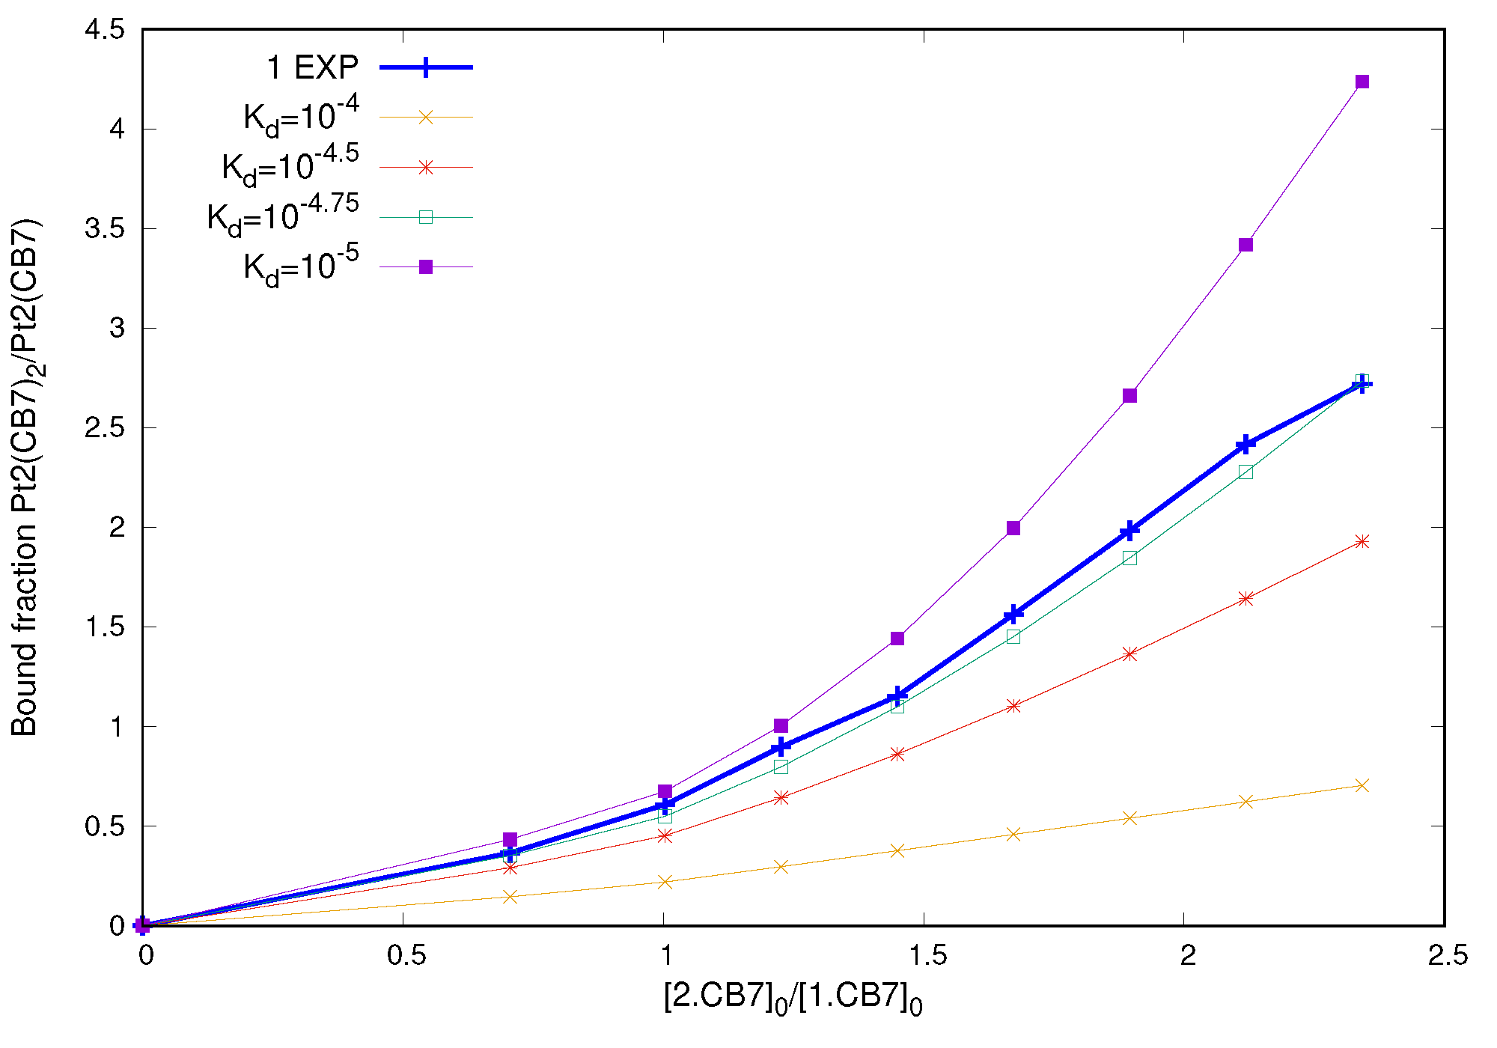
Figure 19: The plot of binding isotherm of experimental data and simulated dissociation constants for the formation of diencapsulated complex (CB7 binding to Pt2@CB7). The concentration ratio of di- and monoencapsulated complexes (on the x-axis) was fitted to the ratio of the bound fractions of di- and monoencapsulated complexes (on the y-axis). The binding constant for the first binding site was set to pK_{d} = -6,5. The experimental data is shown in bold.
Before conducting the NMR titration experiments, the binding constants and thermodynamic parameters of the host−guest interaction were investigated using ITC by Mgr. Jan Chyba, Ph.D.⁷⁸ The ITC experiments of the Pt1 complex with both cavitands were conducted in pure water; the ITC experiments of Pt2@CB7 with both cavitands were conducted with 50 mM NaCl. The experimental K_{d} values for both complexes are shown in Table 1. All NMR titration experiments were performed in D₂O with 50 mM NaCl, the K_{d} values are also shown in Table 1. In the case of the Pt1 complex, the results from both methods showed the same binding affinities for both hosts, even though one would expect lower binding affinity in the NMR experiment with salt. In the case of the Pt2@CB7 complex, the binding affinities were consistent between both methods. Typically, the binding of adamantane moieties is weaker with β-CD than with the CB7 cavity.⁷⁹ This trend was observed in the experiments with the Pt1 complex However, the dissociation constants for diencapsulated complexes of Pt2 with both cavitands were similar. The lower K_{d} of the second CB7 binding to Pt2@CB7 can be reasoned by steric repulsion between two adjacent CB7 bound to Pt2, which caused the negative cooperative effect.
Table 1: Comparison of experimental binding affinities of host-guest complexes of Pt(IV) with β-CD and CB7 obtained from ITC and NMR titration experiments.
Guest | Host | Dissociation constants logK_{d}, M
Guest | Host | ITC | NMR
Pt1  (in H₂O by ITC) | β-CD | 10^{-4.6} | 10^{-4.5}
Pt1  (in H₂O by ITC) | CB7 | 10^{-6.5} | 10^{-6.5}
Pt2@CB7  (in 50 mM NaCl) | β-CD | 10^{-4.4} | 10^{-4.4}
Pt2@CB7  (in 50 mM NaCl) | CB7 | 10^{-4.4} | 10^{-4.8}

Pt(II) complexes
In this section, Pt (II) complexes, derivatives of cisplatin, were investigated. The first complex, featuring a phenyl-pyridine ligand, is referred to as PtPyrPhe; the second complex, with a pyridine-adamantane ligand, is labelled PtPyrAd. Both complexes carry a positive charge and NO₃⁻ as an anion. The complexation of these guests was studied with cucurbit[7]uril (CB7) in D₂O. Previously, the adamantyl anchor was found to form a high-affinity complex with CB7 due to Ad's favourable size fit into the internal cavity of CB7 and the hydrophobic nature of this interaction.⁸⁰ Similarly, the aromatic ligands can form high-affinity complexes with CB7.⁸¹ Furthermore, the positive charge of both complexes enhances their affinity to CB7, as CB7 prefers interaction with cationic species due to its negatively charged carbonyl portals.
PtPyrPhe | PtPyrAd
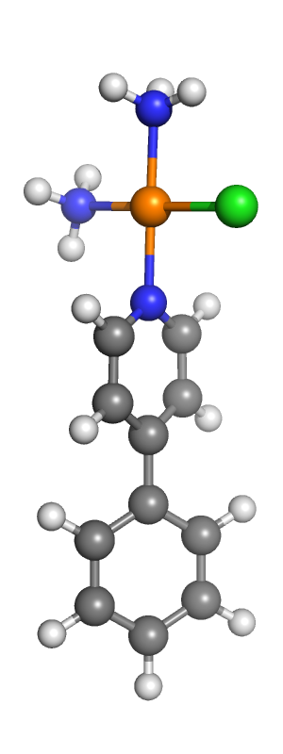 | 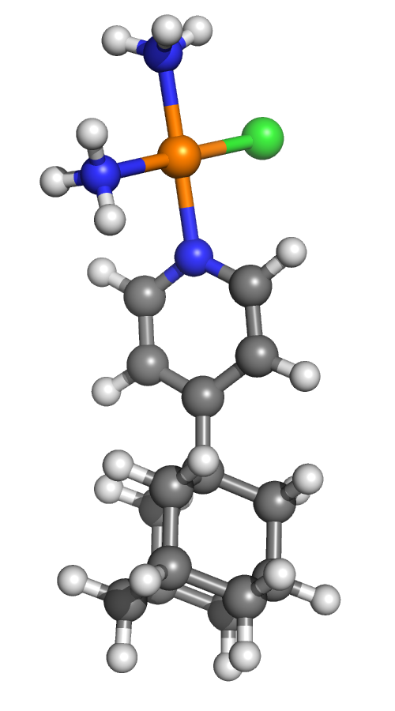
PtPyrPhe@CB7
To estimate the dissociation constant of PtPyrPhe binding to the CB7 the titration experiment was carried out at first in the standard way, where a solution of Pt complex with 3.38 mM concentration was added to an NMR tube with a solution of CB7 with 0.92 mM until concentration ratio was 1:1. The system was in a slow exchange regime on the NMR timescale, in which case the signals of free and bound form of CB7 are visible in the spectrum separately. Both forms of doublet and singlet signals of CB7 were integrated and plotted in Gnuplot, where on the x-axis is the total concentration ratio of Pt to CB7 and on the y-axis is the bound fraction of CB7. The plot estimated the dissociation constant to be 10^{-5.1} which is on the edge of what can be precisely measured by NMR spectroscopy. In the solution of PtPyrPhe, the presence of CB7 led to the formation of the hydrolysed form of the Pt complex (Figure S42). The derived K_{d} is an average value for hydrolysed and non-hydrolysed forms as both forms were integrated as one bound form of PtPyrPhe.
Since the affinity of this interaction is high due to the cationic character of the PtPyrPhe complex, it is necessary to perform the titration in competitive mode to enhance the accuracy of the results. 1,4-diaminobutane dihydrochloride (DABCl·2HCl) was used as a competitor for this system. The dissociation constant for DABCl and CB7 interaction was determined to be 10^{-5.9}.⁸² This value will be used in the simulation for deriving the K_{d} of PtPyrPhe@CB7 interaction. The binding of DABCl to CB7 also exhibited a slow exchange regime on the NMR time scale.
To perform a competitive titration a stock solution of PtPyrPhe@CB7 was prepared with a concentration ratio of 2:1. The stock solution was left for a day to convert the PtPyrPhe complex into the hydrolysed form. Then, a solution of DABCl (30 mM) was titrated into PtPyrPhe@CB7 in the NMR tube until the concentration ratio of DABCl/PtPyrPhe was 5:1 (and for DABCl/CB7 - 10:1).
At the beginning of the experiment, only the hydrolysed PtPyrPhe complex was present in the spectrum. All CB7 was bound with the Pt complex. During the titration, the signals of CB7 bound with Pt complex were decreasing, while signals of CB7 bound with DABCl began to emerge slightly deshielded. Notably, no splitting of the doublets of CB7 into two sets of signals was observed since the encapsulation of the symmetric guest did not disrupt the symmetry of the CB7 host (Figure 20).
The integrated doublet and singlet signals of CB7 of both bound forms, with Pt and DABCl, were used in simulations to derive the K_{d}, which ended up being around 10^{-6.4} (Figure 21).
Figure 20: ¹H 1D NMR titration of DABCl into the solution of PtPyrPhe@CB7 in D₂O at 298.2 K. The concentration of PtPyrPhe@CB7 was constant during the titration. The signals of CB7 bound to DABCl are marked with a prime (‘). The spectra were referenced to a signal of water.
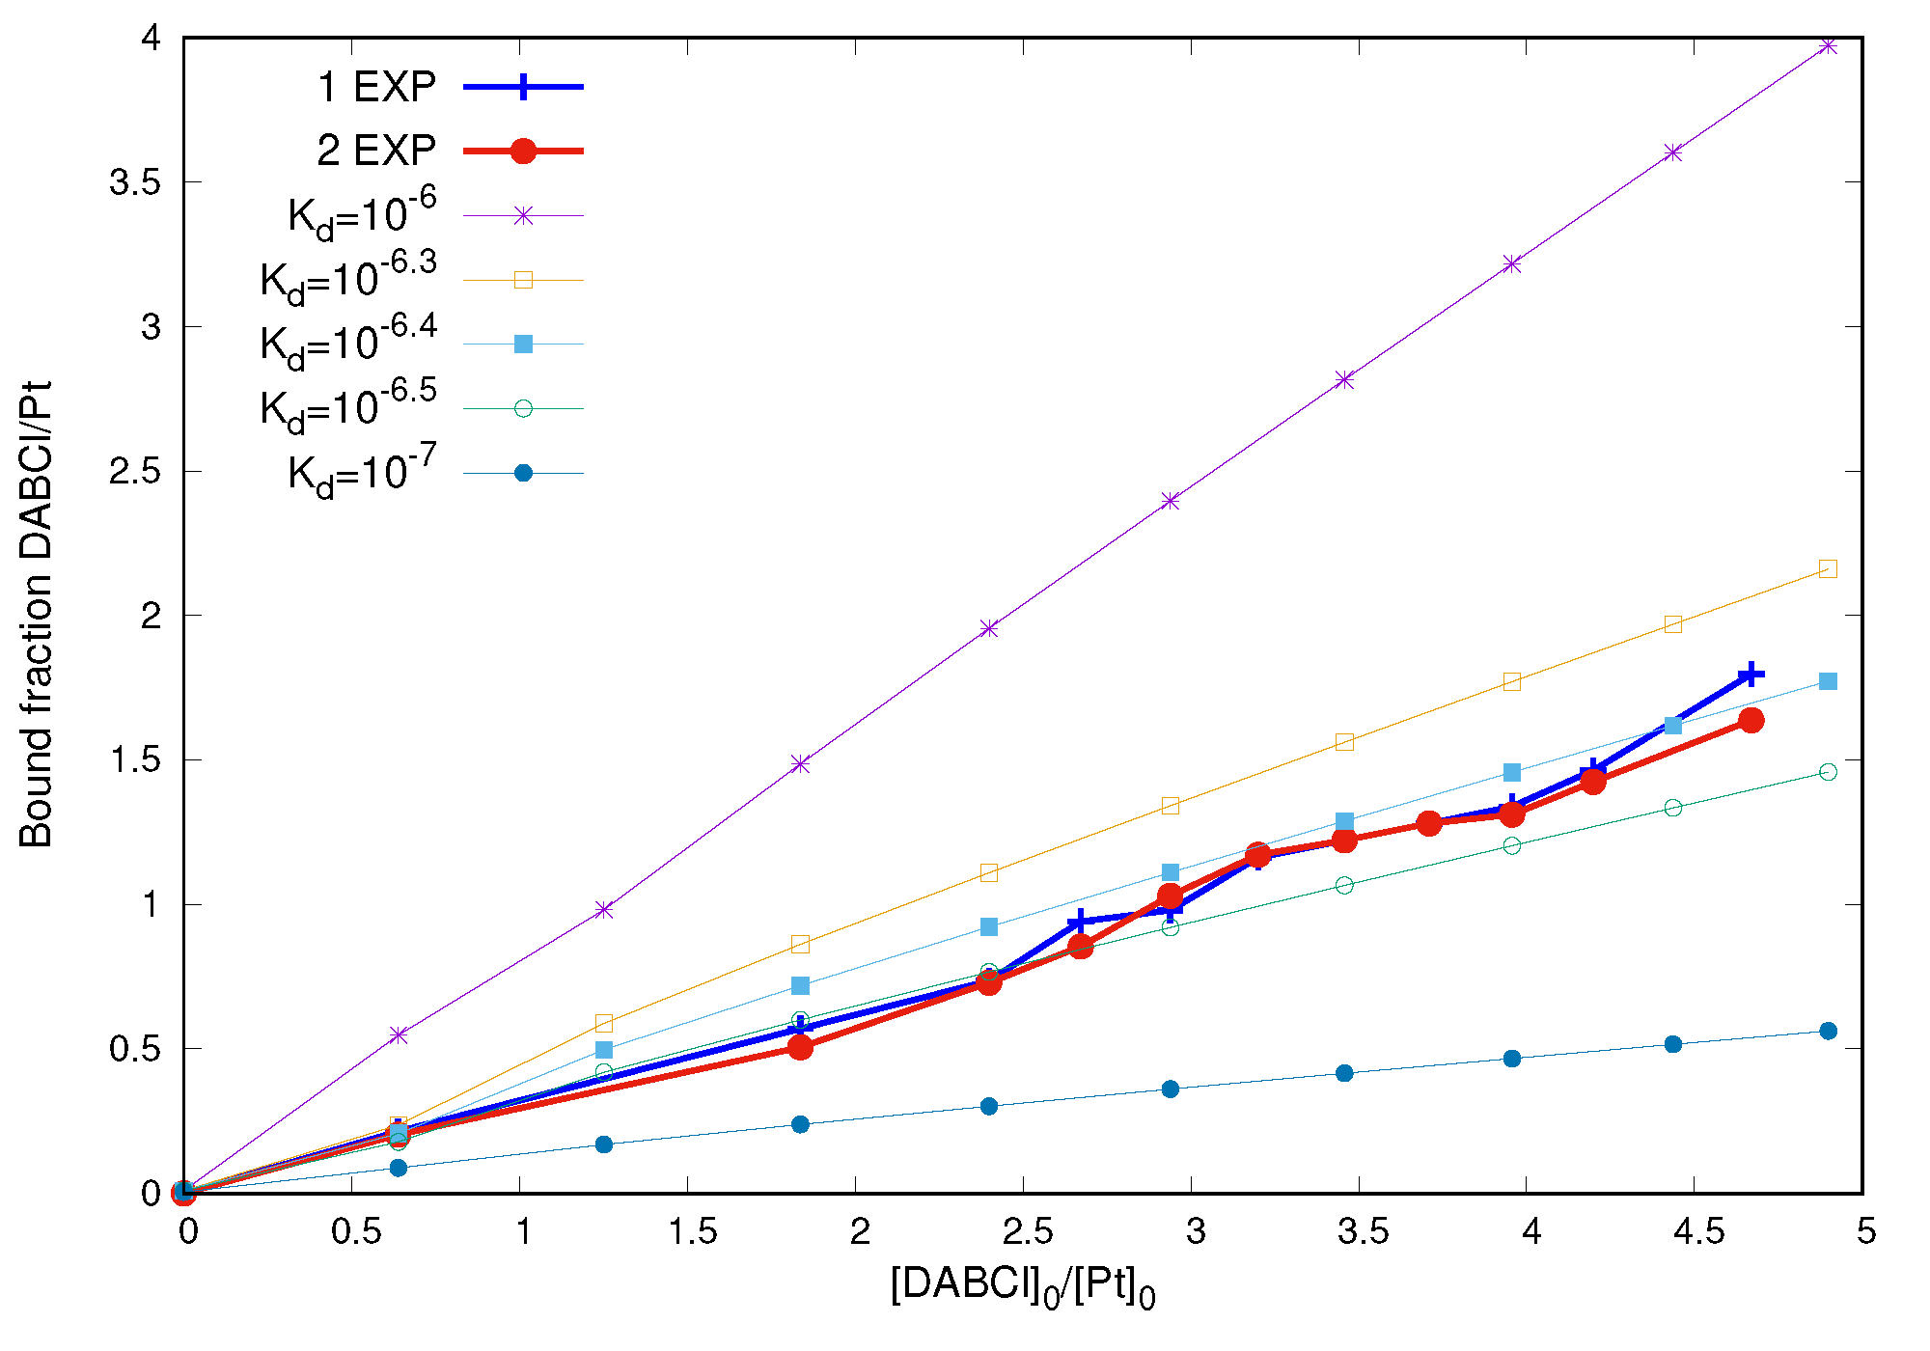
Figure 21: The plot of binding isotherm of experimental data and simulated dissociation constants for CB7 binding to PtPyrPhe. The concentration ratio of DABCl and PtPyrPhe (on the x-axis) was fitted to the ratio of the bound fractions of DABCl and PtPyrPhe (on the y-axis). The binding constant for the DABCl@CB7 binding was set to pK_{d} = -5,9. The experimental data is shown in bold.
PtPyrAd@CB7
Since adamantyl core has a high binding affinity to CB7, the competitive mode of titration experiment was conducted. Likewise, DABCl was used as a competitor. A stock solution of DABCl@CB7 was prepared with a concentration ratio of 4:1. Subsequently, the 2 mM PtPyrAd solution was titrated directly into the NMR tube containing the stock solution until the concentration ratio of Pt/CB7 reached 1.1:1 (and for Pt/DABCl - 1:3.4). The system exhibited a slow exchange regime on the NMR time scale. The hydrolysation of the PtPyrAd complex was not observed during the titration. This time, the observation of the splitting of doublets of CB7 into two sets of signals confirms the loss of symmetry of the CB7 host upon PtPyrAd encapsulation (Figure 22). To determine the dissociation constant of PtPyrAd@CB7 interaction, the integrals of CB7 were processed similarly to the previous titrations. The value of K_{d} was estimated as 10^{-7.5} (Figure 23).
Figure 22: ¹H 1D NMR titration of PtPyrAd into the solution of DABCl@CB7 in D₂O at 298.2 K. The concentration of DABCl@CB7 was constant during the titration. The signals of CB7 bound with PtPyrAd are marked with a prime (‘). The spectra were referenced to a signal of water.
When estimating the dissociation constant based on the comparison with simulated binding isotherms, the region where integrals are similar (1:1 ratio on the y-axis) produces less of integration errors. It can be seen at the higher than 2:1 ratio of integrals, where the mismatch in experimental and simulated isotherms is growing (Figure 23). The effect is caused by differences in the intensities of integrated signals.
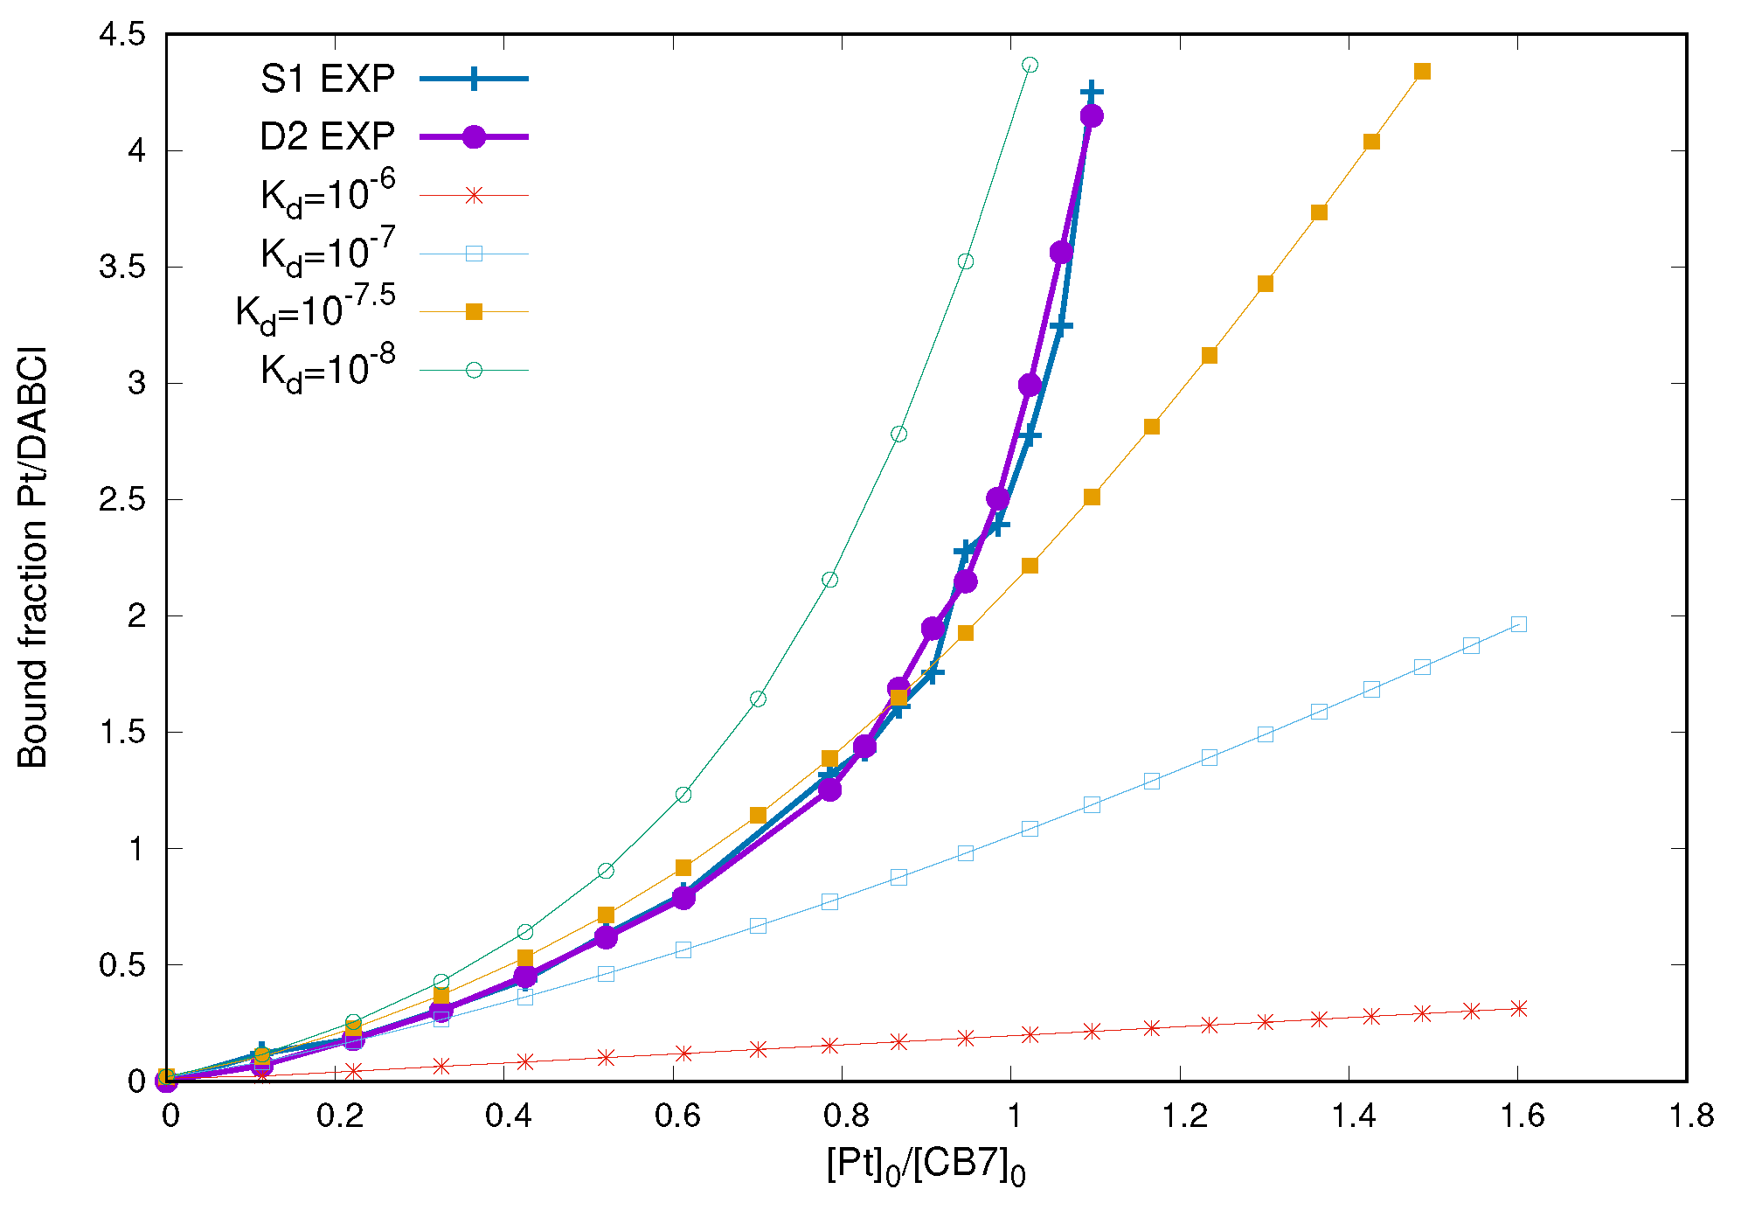
Figure 23: The plot of binding isotherm of experimental data and simulated dissociation constants for CB7 binding to PtPyrAd. The concentration ratio of PtPyrAd and CB7 (on the x-axis) was fitted to the ratio of the bound fractions of PtPyrAd and DABCl (on the y-axis). The binding constant for the DABCl@CB7 binding was set to pK_{d} = -5,9. The experimental data is shown in bold.
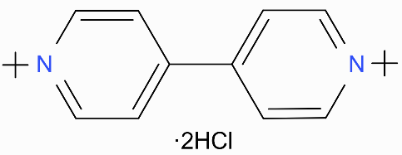
Both PtPyrPhe and PtPyrAd complexes formed high-affinity complexes with CB7 moiety. The dissociation constant value derived for the PtPyrPhe@CB7 host-guest complex corresponds to the hydrolysed form of the Pt complex since only this form was present in the spectrum before conducting the NMR titration experiment. The hydrolysis process changed the charge of the Pt core from 1+ to 2+, which increased the affinity of the complexation with CB7. The estimated K_{d} falls within the range of strong binding typically observed for heterocyclic aromatic compounds with more than one ring. For example, the affinity of 4,4'-bipyridine dihydrochloride to CB7 is 10^{-6,5}.⁸²
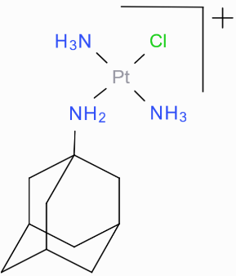
The estimated dissociation constant value for PtPyrAd@CB7 is ~10⁻⁷, and it demonstrates weaker affinity when compared to a similar complex, trans-Pt-NH₂-Ad ([trans-Pt(NH₃)₂Cl(NH₂-Ad)]⁺) with CB7, which showed strong binding constant of 10⁻⁹.⁸³ Both complexes have the same 1+ charge, thus this difference in affinity comes from the anchor that connects the adamantane ligand to the Pt core. In the case of trans-Pt-NH₂-Ad, the higher affinity can be rationalised by favourable electrostatic interaction between the NH₃ groups and -NH₂ anchor and carbonyl portal of CB7. Whereas the pyridine ligand in PtPyrAd does not provide this additional stabilisation, thus the complex is only stabilised by hydrophobic forces.

NMR titration experiments with Duplex
To investigate the interaction mode of derivatives of cisplatin with biologically relevant structures, the canonical DNA duplex was selected, specifically the self-complementary dodecanucleotide d(CAATCCGGATTG)₂. This structure was designed to have one central GG sequence and two potential A/T-rich binding regions. As previously observed, this duplex adopts a B-type conformation in solution.³⁴ Given the diverse binding sites offered by DNA structure, ligands can engage in two primary interaction modes: covalent and non-covalent (intermolecular association). Our primary focus in this study was to investigate the latter binding mode, which can be divided into electrostatic interactions, grove binding, and intercalation.
The square planar Pt(II) complexes studied in this section are derivates of cisplatin that bear aromatic ligands such as pyridine, phenyl-pyridine, and phenanthridine. The naming and structure of the complexes are:
PtPyr | PtPyrPhe | phenPt
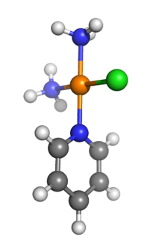 |  | 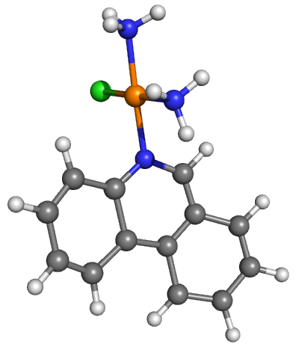
As previously investigated pyriplatin binds to DNA duplex at the N7 position of guanine residues.²² However, the binding mode of the Pt complex substituted with phenyl-pyridine has not been studied. Since PtPyrPhe is similar to pyriplatin, the last one was used in experiments as a reference compound. The phenPt complex tends to bind covalently to N7-guanosine in the same manner as pyriplatin.²⁶ However, a recent study showed that phenPt binds DNA in a two-step process in which rapid, partial intercalation of the phenanthridine ring is followed by slower substitution of the adjacent chloride ligand by, most likely, the N7 atom of a purine base.²⁵
Structure of duplex and assignments of the proton resonances
Oligonucleotide was synthesised and purified, then its concentration was measured using a Nanodrop UV/VIS spectrometer. Subsequently, the initial task involved assigning the regions of imino and aromatic protons in the ¹H 1D spectra of the duplex. The NMR resonances of the free dodecanucleotides were then determined using a combination of NOESY and COSY techniques (Figure 25). Furthermore, these assignments were cross-checked with published data for verification.³⁴ Dodecanucleotide adopts a B-type conformation in solution, as each base H8/H6 proton NOE cross-peak to its own H2′ proton is larger than the cross-peak to H2′ proton on the 5′ sugar. By examining the imino protons region of the duplex, only 5 resonances were observed, which indicates that the terminal residue does not form a stable base pair at 298.2 K. The 5th resonance appeared in the spectrum at 278.2 K (Figure 24).
Figure 24: ¹H 1D spectra of the duplex, imino protons region. 5% D₂O, 20 mM Na⁺ buffer, c(duplex)=0.375 mM. The top spectrum measured at 298.2 K, and the bottom one at 278.2 K.
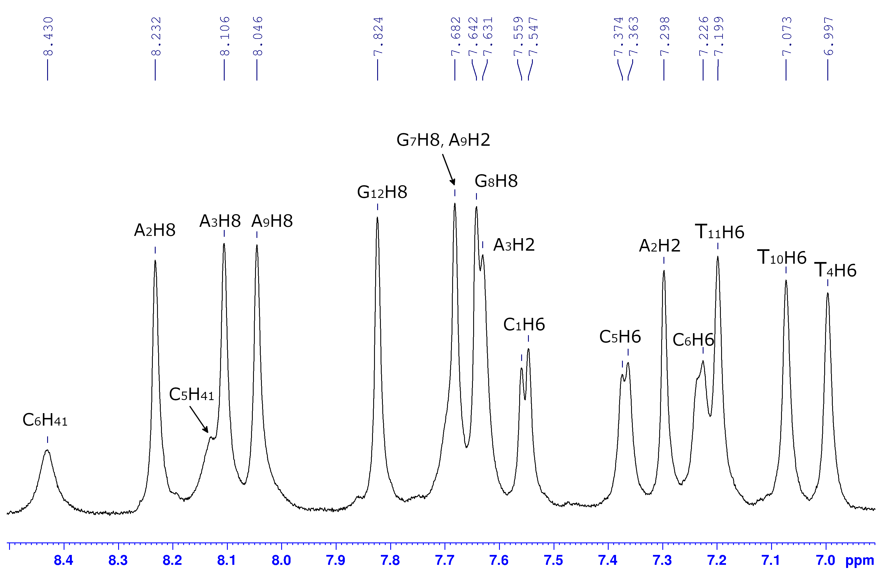
Figure 25: ¹H 1D spectrum of the duplex, aromatic protons region. 5% D₂O, 20 mM Na⁺ buffer, 298.2 K, c(duplex)=0.375 mM.
PtPyr complex
Upon adding PtPyr (8.33 mM) to the duplex solution (0.375 mM, 550 μl), only one set of duplex signals was detected, indicating fast exchange between the free dodecanucleotide and PtPyr-bound forms on the NMR timescale. Titration proceeded until the dx to PtPyr ratio reached 1:4. Towards the end of the titration, changes in the duplex's chemical shifts were insignificant ( < 0.03 ppm), and PtPyr signals remained stable (Figure S43, Figure S44), suggesting no direct interaction with the duplex. However, new duplex species signals emerged, indicating PtPyr likely began covalently binding to the DNA at multiple sites.
The titration was repeated, this time preparing the duplex sample with 70 mM KCl to slow down the covalent binding of the Pt complex. Results indicated that PtPyr did not interact with the duplex; the presence of salt slowed down the covalent binding process, which did not occur within a week. Notably, changes in chemical shifts were even smaller in the presence of salt.
PtPyrPhe complex
PtPyrPhe (8.51 mM) was titrated into a tube containing duplex (0.375 mM, 550 μl) until reaching a dx:PtPyrPhe ratio of 1:2. The system exhibited a fast exchange regime on the NMR timescale. The addition of PtPyrPhe caused significant shifts in the chemical resonances of the duplex ( > 0.05 ppm), accompanied by changes in the position of PtPyrPhe signals, indicating the interaction between the Pt complex and the duplex.
Figure 26: ¹H 1D spectrum from titration of PtPyrPhe to duplex, imino protons region. 5% D₂O, 20 mM Na⁺ buffer, 298.2 K, c(duplex)=0.375 mM. The spectra were referenced to an impurity signal at 3.1 ppm.
In the imino region, the most notable chemical shift changes were observed for the resonances of T₁₀ and G₈ (Figure 26). In the aromatic region, most purine H8 and pyrimidine H6 resonances in the major groove experienced minor shifts ( < 0.05 ppm). However, T₄H6, T₁₀H6, and G₁₂H6 showed slightly larger shifts ( > 0.05 ppm) compared to other major groove protons, while C₆H6 and amino protons of C₆ displayed significant shifts. Adenines' minor groove H2 resonances also exhibited substantial changes, particularly with A₉H2 shifting 0.11 ppm downfield (Figure 27). This substantial and specific shift of the A₉H2 resonance suggests Pt complex binding near the A₉ residue in the minor groove. Additionally, the region of sugar H1’ protons was analysed, which showed even larger chemical shift changes, especially for C₆ (-0.209 ppm upfield) and T₁₀ (-0.306 ppm upfield). All chemical shift changes of duplex resonances induced by the addition of PtPyrPhe are shown in Table 2.
The most significant chemical shift changes come from AH2 and H1’ protons, which are in the minor groove of the DNA. However, these findings from the 1D experiment alone are insufficient to determine the exact binding site of the metal complex. Nonetheless, it's possible to suggest a 2:1 stoichiometry for PtPyrPhe binding to the duplex.
Figure 27: ¹H 1D spectrum from titration of PtPyrPhe to duplex, aromatic protons region. 5% D₂O, 20 mM Na⁺ buffer, 298.2 K, c(duplex)=0.375 mM. The spectra were referenced to an impurity signal at 3.1 ppm.
Table 2: ¹H NMR chemical shift changes of duplex induced by the addition of PtPyrPhe at the ratio of 1:4. Negative numbers indicate an upfield shift. Significant chemical shift changes ( > 0.05 ppm) are shown in bold.
 | Chemical shifts change Δδ, ppm
 | Dodecanucleotide protons
Base | H8/H6 | AH2 | NH | NH₂ | H1’
C₁ | 0.008 |  |  |  | 0.022
A₂ | 0.003 | -0.059 |  |  | -0.02
A₃ | 0.012 | 0.055 |  |  | 0.02
T₄ | -0.057 |  | 0.008 |  | -0.138
C₅ | -0.037 |  |  |  | -0.125
C₆ | -0.104 |  |  | -0.065, -0.073 | -0.209
G₇ | -0.017 |  | -0.025 |  | 0.095
G₈ | -0.029 |  | 0.114 |  | -0.038
A₉ | 0.043 | 0.11 |  |  | 0.012
T₁₀ | -0.063 |  | -0.081 |  | -0.306
T₁₁ | -0.021 |  | -0.042 |  | -0.135
G₁₂ | -0.062 |  |  |  | -0.1
Similarly to the dx:PtPyr system, signals of new duplex species appeared towards the end of this titration due to Pt complex covalent binding to DNA. Five days later, analysis revealed the presence of at least two additional duplex species in the sample. (Figure S45) A buffer modification with 70 mM KCl was employed to slow down this binding. The results of the second titration showed a decrease in the overall chemical shift changes. However, the pattern of these changes remained consistent with that observed in the titration conducted without salt.
phenPt complex
PhenPt (5.1 mM) was titrated into a tube containing duplex (0.46 mM, 550 µL, 70 mM KCl) until the dx:phenPt ratio reached 1:2.5. The addition of phenPt resulted in the overall broadening of signals in the spectrum, including site-specific signal broadening, leading to the disappearance of some duplex resonances. This indicates an intermediate exchange regime between the duplex and the bound form of the Pt complex on the NMR timescale. The signals of phenPt were also not visible in the spectrum due to broadening. Notably, the imino resonances, particularly those of G₇ and G₈, experienced the most significant influence from the titration of the Pt complex ( > 0.07 ppm) (Figure 28), while aromatic protons showed only slight chemical shift changes ( ≤ 0.05). Additionally, the amino protons of C₆ and C₅ underwent minor shift changes, but their broadening effect was significant and similar to that of the imino protons (Figure 29). The significant chemical shift changes are presented in Table 3.
Table 3: ¹H NMR chemical shift changes of some of the duplex resonances induced by the addition of phenPt at the ratio of 1:2.5. Negative numbers indicate an upfield shift.
 | Chemical shifts change Δδ, ppm
 | Dodecanucleotide protons
Base | AH2 | NH
A₂ | -0.057
A₃ | -0.043
T₄ |  | -0.084
G₇ |  | -0.096
G₈ |  | -0.099
A₉ | -0.041
T₁₀ |  | -0.084
T₁₁ |  | -0.075

Figure 28: ¹H 1D spectrum from titration of phenPt to duplex, imino protons region. 5% D₂O, 70 mM KCl salt, 20 mM K⁺ buffer, 298.2 K, c(duplex)= 0.461 mM. The spectra were referenced to an impurity signal at 3.1 ppm.
Figure 29: ¹H 1D spectrum from titration of phenPt to duplex, aromatic protons region. 5% D₂O, 70 mM KCl salt, 20 mM K⁺ buffer, 298.2 K, c(duplex)= 0.461 mM. The spectra were referenced to an impurity signal at 3.1 ppm.
These observations suggest nonspecific binding of the phenPt complex with the duplex at multiple sites.²⁵ The negative values of chemical shift changes might come from the intercalation mode of interaction when the nucleobases’ imino protons are placed above or below the plane of the phenPt aromatic system. Yet the absence of signals from the Pt complex, along with unfavourable binding dynamics, precludes further investigation of the binding site of phenPt to the duplex using 2D experiments.

NMR titration experiments with G-quadruplex
To compare the interaction abilities of platinum complexes with duplex, the G-quadruplex DNA structure was chosen, specifically the 24-nt d[TTGGG(TTAGGG)₃A] sequence. The structure was derived from the natural 23-nt human telomeric d[TAGGG(TTAGGG)₃] sequence with two modifications at terminal residues. The biggest advantage of the following sequence is its propensity to predominantly adopt a major G-quadruplex (3+1) conformation (approximately 95%) in K⁺ solution. This characteristic enables the obtaining of high-quality NMR spectra, facilitating detailed structural studies.⁸⁴
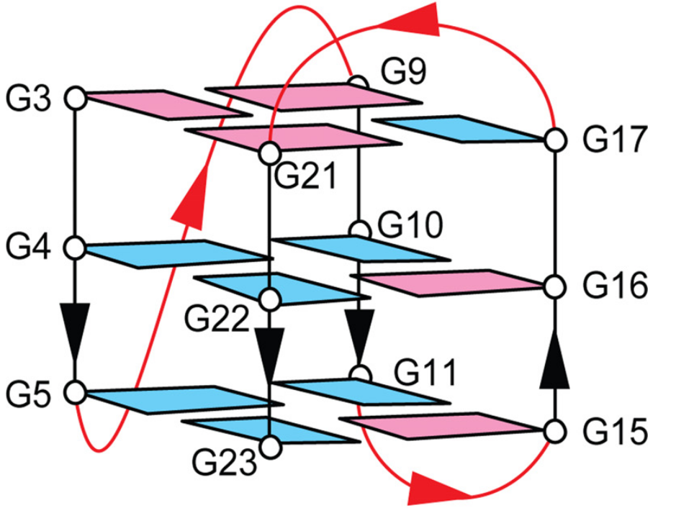
The fold of the hTel has three G-tetrads: G₉-G₃-G₂₁-G₁₇, G₁₀-G₁₆-G₂₂-G₄, and G₁₁-G₁₅-G₂₃-G₅, top, middle, and bottom, respectively (Figure 30⁸⁵). The first G-tetrad has anti-syn-syn-syn glycosidic conformation and the second and third – syn-anti-anti-anti. Such glycosidic conformations are called (3+1) G-tetrad core, where three G-tracts (G₉-G₁₁, G₃-G₅, and G₂₁-G₂₃) oriented in one direction and the fourth (G₁₅-G₁₇) tract in the opposite direction. The structure of hTel has three linkers. The first linker (T₆-T₇-A₈) forms a double-chain-reversal loop. The two other linkers (T₁₂-T₁₃-A₁₄ and T₁₈-T₁₉-A₂₀) form edgewise loops, that are placed on the top and bottom of the G-tetrad core, respectively. Also, it was observed that the structure of hTel has Watson-Crick T₁-A₂₀ and reversed Watson-Crick T₁₃-A₂₄ pairs, stacked on the top and bottom sides of the G-tetrad core, respectively.
Figure 30: Folding schematic of the 24-nt hTel (3+1) G-quadruplex. Guanin bases are coloured based on their syn (magenta) or anti (cyan) glycosidic conformation.
The chosen (3+1) core G-quadruplex scaffold is identified by one narrow, one wide, and two medium grooves, thus providing binding places for ligands. Although one of the grooves is occupied by the double-chain-reversal loop, the three other grooves are accessible for binding of either planar or nonplanar ligands. Additionally, planar ligands can potentially stack over the ends of the quadruplex.⁸⁶
Structure of hTel and assignments of the proton resonances
The preparation of the structure of hTel was replicated from the article.⁸⁴ Oligonucleotide was synthesised and purified, and then its concentration was measured using a Nanodrop UV/VIS spectrometer. Subsequently, ¹H 1D and 2D ¹H-¹H NOESY and COSY experiments were performed. The imino and aromatic resonances of measured spectra were assigned with the help of previously published data (Figure 31, Figure 32). Analysis of the NOESY spectra facilitated the assignment of all imino and aromatic protons. A comparison between the measured spectra with the published showed complete similarity, thus confirming the structural identity of hTel (Figure S46).
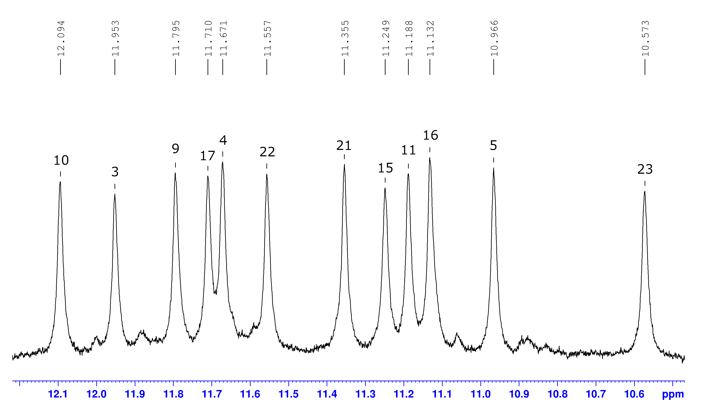
Figure 31: ¹H 1D spectrum of the G-Quadruplex, imino protons region. 5% D₂O, 70 mM KCl, 20 mM K⁺ buffer, 298.2 K, c(hTel)=0.362 mM.
To further investigate the folding topology and confirm the structural resemblance of hTel to that presented in the publication, characteristic NOEs between imino- and H8-protons were examined. This analysis revealed a region consistent with the published results, indicating the consistency of the G-quadruplex fold. Furthermore, the glycosidic conformations of the G-tetrads were verified by the detection of five strong intraresidual H8-H1′ cross-peaks that correspond to syn-glycosidic bonds, in contrast to weak cross-peaks of anti-glycosidic bonds (Figure 33).

Figure 32: ¹H 1D spectrum of the G-Quadruplex, aromatic protons region. 5% D₂O, 70 mM KCl, 20 mM K⁺ buffer, 298.2 K, c(hTel)=0.362 mM. Green numbers represent H8 of guanines.
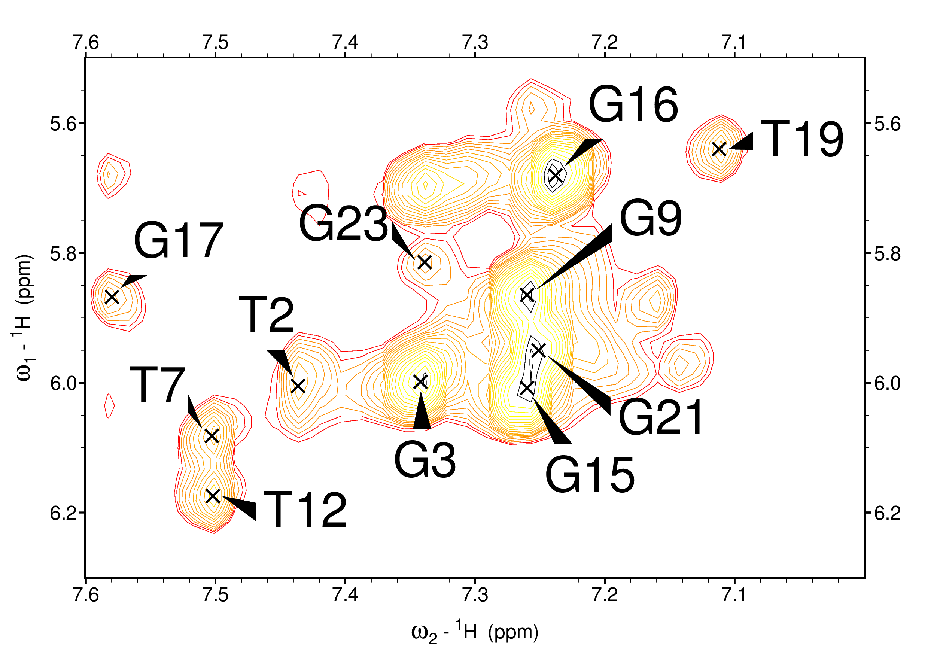
Figure 33: ¹H-¹H NOESY spectrum of hTel (mixing time, 200 ms) that distinguishes five strong intraresidual H8-H1′ cross-peaks for G₃, G₉, G₁₅, G₁₆, and G₂₁ with syn-glycosidic bonds from weak cross-peaks with anti-glycosidic bonds.
PtPyr complex
PtPyr (8.33 mM) was titrated into the NMR tube with hTel (0.362 mM, 550ul) until the ratio hTel:PtPyr was 1:1. Since the addition of PtPyr led to insignificant changes in the chemical shifts of all imino and aromatic protons, with the most significant change observed in G₂₂(H8) (Δδ=0.007 ppm), further investigation of the system was not pursued (Figure S47, Figure S48).
PtPyrPhe complex
The NMR tube containing hTel (0.362 mM, 550 µL) was titrated with a solution of PtPyrPhe (8.51 mM) until the hTel:PtPyrPhe ratio reached 1:2. Throughout the titration, only one set of signals was observed, indicating a fast exchange regime between hTel and the bound form of PtPyrPhe on the NMR timescale. Notably, the imino protons of the top G-tetrad – G₉, G₃, and G₁₇ – experienced the most significant chemical shift changes, with a similar shifting observed for the imino proton of G₁₀ from the middle G-tetrad (Figure 34). Also, substantial shifting was observed for the PtPyrPhe, particularly the H6 signal from the pyridine ring shifting 0.088 ppm downfield. The signals of the Pt complex appeared broadened, likely attributed to multiple binding arrangements of the Pt compound (Figure 35).
Figure 34: ¹H 1D spectrum from titration of PtPyrPhe to hTel, imino protons region. 5% D₂O, 70 mM KCl salt, 20 mM K⁺ buffer, 298.2 K, c(hTel)=0.362 mM. The spectra were referenced to an impurity signal at 3.1 ppm.
In the aromatic proton region, the largest shifts correspond to T₁₉(H6) and A₂₀(H8), with A₂₀(H2) showing particularly significant changes (Figure 35). The table of chemical shift changes of hTel is provided in Appendix (Table S7). These residues are located on the top of the top G-tetrad, which suggests that it is the binding site of PtPyrPhe. As described previously, the structure of hTel features a Watson-Crick T₁-A₂₀ pair stacked on the top side of the G-tetrad core. This base pair is probably disrupted upon PtPyrPhe binding. However, the absence of T₁ imino resonance in the NMR spectra of free hTel hinders experimental confirmation of this hypothesis.
Figure 35: ¹H 1D spectrum from titration of PtPyrPhe to hTel, aromatic protons region. 5% D₂O, 70 mM KCl salt, 20 mM K⁺ buffer, 298.2 K, c(hTel)=0.362 mM. The H2 protons of adenines are labelled with an asterisk(*). Resonances with large chemical shift changes are shown in bold. The spectra were referenced to an impurity signal at 3.1 ppm.
phenPt complex
PhenPt (5.1 mM) was titrated into the NMR tube with hTel (0.587 mM, 550ul) until the hTel:phenPt ratio reached 1:2. In the imino proton region, only minor chemical shift changes of around 0.035 ppm were observed, specifically for G₂₁ and G₁₇ from the top G-tetrad, and G₂₃ and G₅ from the bottom G-tetrad (Figure 36). The most significant shifts in the aromatic region were observed for A₂₀(H2), located on top of the top G-tetrad; and for A₁₄(H8) and A₂₄(H2) protons, located beneath the bottom G-tetrad (Figure 37). The largest chemical shift changes are presented in Table 4.
Figure 36: ¹H 1D spectrum from titration of phenPt to hTel, imino protons region. 5% D₂O, 70 mM KCl salt, 20 mM K⁺ buffer, 298.2 K, c(hTel)=0. 587 mM. The spectra were referenced to an impurity signal at 3.1 ppm.

Figure 37: ¹H 1D spectrum from titration of phenPt to hTel, aromatic protons region. 5% D₂O, 70 mM KCl salt, 20 mM K⁺ buffer, 298.2 K, c(hTel)=0. 587 mM. The H2 protons of adenines are labelled with an asterisk(*). The spectra were referenced to an impurity signal at 3.1 ppm.
The detection of phenPt signals was hindered by rapid relaxation-induced line broadening. However, upon phenPt the addition, only a slight broadening of hTel signals was observed, in contrast to the titration of PtPyrPhe into the duplex. The titration of phenPt resulted in the specific migration of hTel imino and aromatic resonances, which indicates a fast exchange regime between hTel and bound phenPt. It is conceivable that phenPt weakly binds to both the top and bottom sides of the G-quadruplex, with some conformational freedom in binding contributing to signal broadening.
Table 4: ¹H NMR chemical shift changes of some of the hTel resonances induced by the addition of phenPt at the ratio of 1:2. Negative numbers indicate an upfield shift.
 | Chemical shifts change Δδ, ppm |  | Chemical shifts change Δδ, ppm
 | G-tetrad residues |  | The rest residues
Base | NH | Base | H8 | AH2
G₂₁ | -0.031 | A₁₄ | 0.043
G₁₇ | -0.035 | A₂₀ |  | -0.057
G₂₃ | -0.036 | A₂₄ |  | -0.071
G₅ | -0.036

2D experiments
¹H-¹H 2D NOESY and COSY experiments of the oligonucleotides, both with and without platinum complexes, were conducted at 5°С and 25°С. The parallel assignment of 2D spectra facilitated the assignment of the resonances in 1D spectra before and after the binding event. Subsequently, the 2D spectra were analysed to identify intermolecular cross-peaks between the Pt complexes and DNAs, enabling further investigation into the binding arrangements of platinum complexes with either duplex or hTel.
As the 2D experiments revealed no interaction between the PtPyr complex and DNAs, and the absence of signals from the phenPt complex in 2D spectra hindered further investigation into its binding site, the PtPyrPhe system was solely selected for further exploration of the complex's binding sites with the duplex.
Binding of PtPyrPhe to DNA duplex
¹H-¹H 2D NOESY experiment was conducted on the sample with a concentration ratio of duplex to PtPyrPhe of 1:2. The intermolecular NOE cross-peaks were observed from the A₃H2 and A₉H2 to the metal complex PrH6 protons. Additionally, cross-peaks from the metal PrH6 protons to the T₄H1′, T₁₁H1′, and C₅H1′ were detected. However, due to the overlap of the PrH7 and PhH10 resonances of PtPyrPhe, the assignment of NOE cross-peaks from the A₉H1′ to the metal complex was ambiguous. Nonetheless, the cross-peak was assigned as A₉H1′-PrH7. Furthermore, NOE cross-peaks from PhH10 of Pt complex to C₅H1′ as well as from PhH11 (or PhH12) to C₆H1′ and A₉H1′ were identified (Figure 38). These results strongly suggest that the Pt complex binds in the minor groove at the A₉T₁₀ region (and equivalent A₃T₄ sequence) as the sugar H1′ and adenine H2 protons lie in the DNA minor groove.
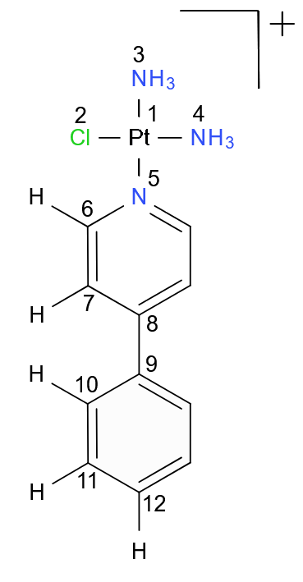
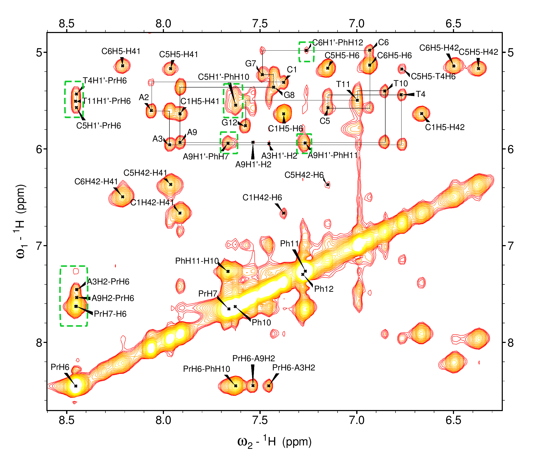
Figure 38: ¹H-¹H 2D NOESY spectrum of the sample of duplex:PtPyrPhe with 1:2 ratio. 5% D₂O, 70 mM KCl salt, 20 mM K⁺ buffer, 278.2 K, 200ms mixing time. Green rectangles show cross-peaks between the Pt complex and protons of DNA.
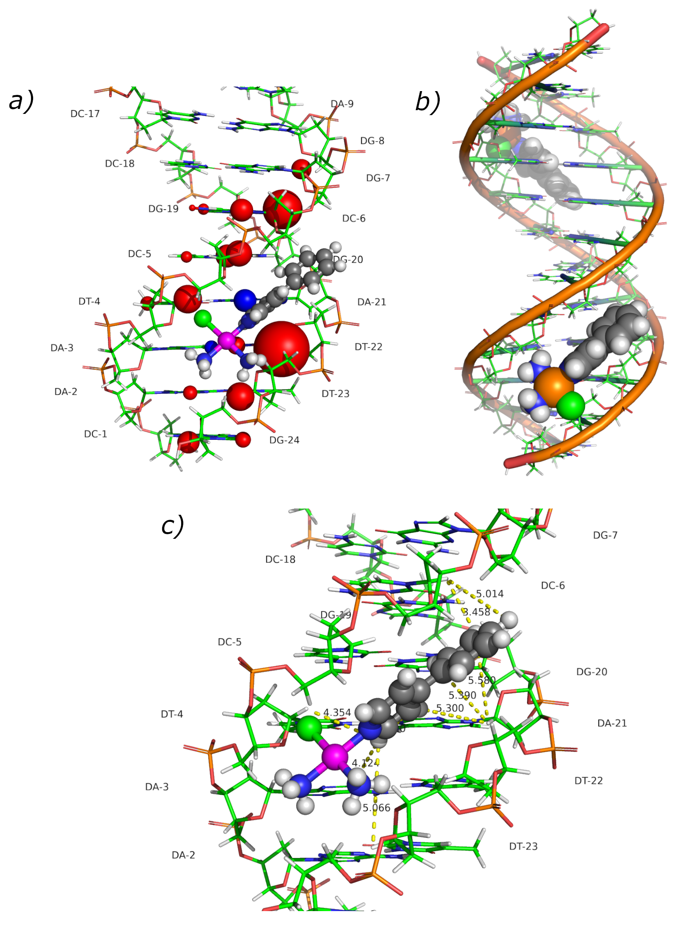
Figure 39: A simple 3D model showing PtPyrPhe binding in the minor groove of the duplex at an AT region. a) Protons that experienced significant ( > 0.05 ppm) chemical shift changes are enlarged on the model with the size of the spheres indicating the magnitude of the changes. Shielded protons are depicted as red spheres and deshielded protons are represented as blue spheres. b) Representation of positioning of PtPyrPhe within duplex during the formation of dx:PtPyrPhe complex with 1:2 stoichiometry, where the Pt centre is oriented towards the end of the duplex and the phenyl-pyridine moiety is directed towards the centre of the duplex. c) Representation of NOE cross-peaks between the protons of the PtPyrPhe and the duplex and the distances derived from the 3D model.
For a visual representation of the binding arrangement of the duplex with the Pt complex, the observed 1D chemical shifts and the intermolecular NOE cross-peaks were transformed into the 3D model of the duplex. The model was built using PyMol software. Protons that experienced chemical shift changes during the titration experiment were enlarged on the model, with the size of the sphere indicating the magnitude of the chemical shift changes. Protons experiencing a shielding effect are depicted as red spheres, while those undergoing deshielding are represented as blue spheres (Figure 39a).
As the 1D chemical shift data aided in approximating the binding site of PtPyrPhe, the 2D intermolecular NOE cross-peaks provided insights into the orientation of the Pt complex along the minor groove of the duplex. The NOE contacts between PrH6 - T₄H1’ and PhH11-C₆H1’ suggest that the platinum centre is oriented towards the end of the duplex, while the phenyl-pyridine moiety is directed towards the centre of the duplex (Figure 39b). The distances between the protons of the Pt complex and the duplex, which had NOE cross-peaks, were derived from the 3D model, depicted in Figure 39c and summarised in Table S8.
Table 5: NOE cross-peaks observed between the duplex and bound PtPyrPhe complex at the ratio of 1:2.
Platinum complex protons | Dodecanucleotide protons
PrH6 | A₉H2, A₃H2, C₅H1’, T₁₁H1’, T₄H1’
PrH7 | A₉H1’
PhH10 | A₉H1’, C₅H1’
PhH11 | A₉H1’, C₆H1’
PhH12 | A₉H1’, C₆H1’

Binding of the PtPyrPhe to G-quadruplex
The NOESY spectrum was recorded using a sample of hTel:PtPyrPhe with a concentration ratio of 1:2. Despite completing the full assignment of hTel peaks, no cross-peaks to the metal complex were identified (Figure 40). Although signals from PtPyrPhe were observed in the 1D spectra, they appeared broadened. This broadening can be attributed to the dynamics of the interaction, indicating that the Pt ligand possesses conformational freedom within the binding site. Given the absence of cross-peaks in the 2D NOESY experiment, only data from the 1D experiment can be utilised to roughly determine the binding site of the Pt complex.
The observed 1D chemical shift changes were transformed into the 3D model of hTel (PDB code: 2GKU), sourced from ⁸⁷. The model was built using PyMol software. The visualisation was performed similarly to the duplex model, with shielded and deshielded protons shown in red and blue, respectively. The size of the spheres corresponds to the magnitude of the chemical shift changes (Figure 41). As discussed earlier, this pattern of chemical shift may be indicative of disruption to the Watson-Crick T₁-A₂₀ pair upon binding of PtPyrPhe above the top G-tetrad.
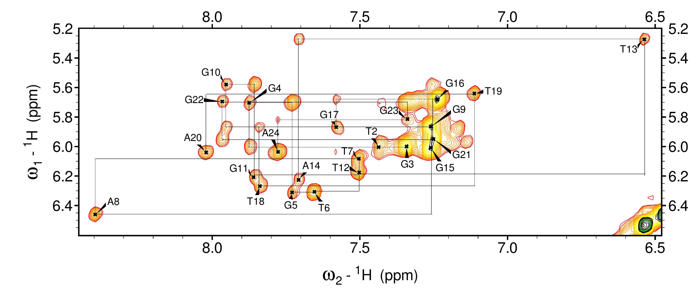
Figure 40: ¹H-¹H 2D NOESY spectrum of H8/H6-H1’ region of the sample of hTel:PtPyrPhe with a 1:2 ratio. 5% D₂O, 70 mM KCl salt, 20 mM K⁺ buffer, 278.2 K, 200ms mixing time.
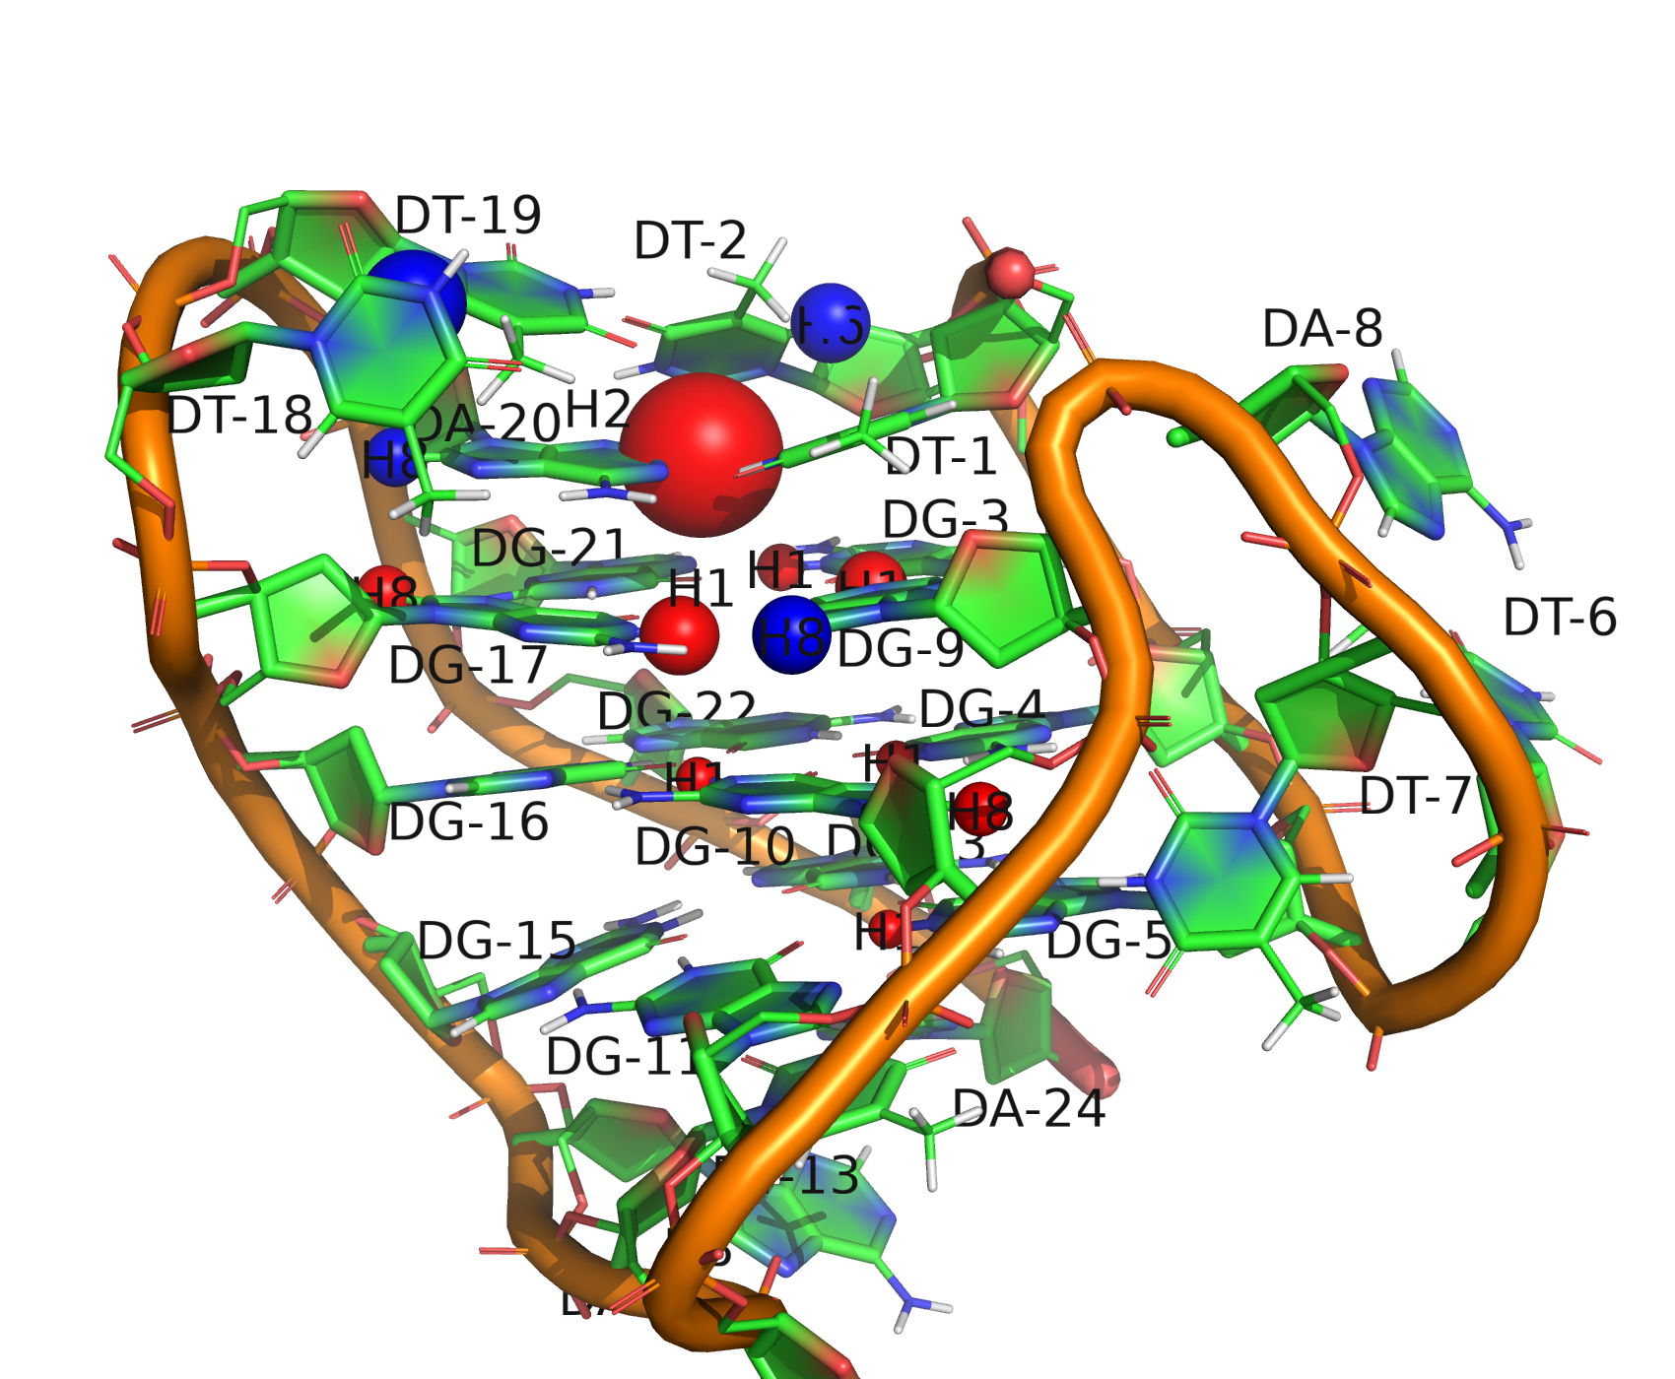
Figure 41: A 3D model of the 24-nt hTel (3+1) G-quadruplex. Protons that experienced significant ( > 0.05 ppm) chemical shift changes are enlarged on the model with the size of the spheres indicating the magnitude of the changes. Shielded protons are depicted as red spheres and deshielded protons are represented as blue spheres.

UV/VIS measurement of melting temperatures
UV/VIS experiments were conducted on samples of free oligonucleotides and those bound with various platinum complexes at ratios of 1:1 and 1:2. All samples were prepared in a solution containing 5% D₂O, 70 mM KCl, and 20 mM K⁺ buffer at pH 7. The concentrations of duplex and hTel were 0.0025 mM and 0.0075 mM, respectively. The buffer served as the reference (blank) solution. Changes in absorbance were measured at 260 nm for the duplex and 295 nm for the G-quadruplex. The plots representing the dependence of absorbance on temperature for experiments with the duplex (Figure S49-S51) and hTel (Figure S53-S55) are provided in the Appendix. The first derivative of each scan was calculated. The maximum peak of each first derivative plot identifies the midpoint of the melting curve and, therefore, the T_{m} value. The results of the UV/VIS experiment are summarised in Table 6.
Table 6: The measured T_{m} values of free DNA and bound with different platinum complexes at 1:1 and 1:2 concentration ratios, measured in the solution containing 5% D₂O, 70 mM KCl, and 20 mM K⁺ buffer at pH 7.
Sample | T_{m} (°C) | Sample | T_{m} (°C)
Free dx | 48 | Free hTel | 66.5
dx:PtPyr (1:1) | 46.5 | hTel:PtPyr (1:1) | 65.5
dx:PtPyr (1:2) | 50 | hTel:PtPyr (1:2) | 66.5
dx:PtPyrPhe (1:1) | 47 | hTel:PtPyrPhe (1:1) | 67
dx:PtPyrPhe (1:2) | 49.5 | hTel:PtPyrPhe (1:2) | 67
dx:phenPt (1:1) | 46.5 | hTel:phenPt (1:1) | 66
dx:phenPt (1:2) | 50 | hTel:phenPt (1:2) | 66.5

The results indicate that the addition of these platinum complexes had minimal impact on the melting temperature of the oligonucleotides, thus suggesting limited influence on the stability of the formed complexes. Notably, the dx:PtPyrPhe (1:2) system exhibited no evident enhancement of duplex stability after binding two equivalents of PtPyrPhe, indicating a weak binding interaction. Similarly, no evident stabilisation was observed in the hTel:PtPyrPhe (1:1) system, suggesting that the binding of PtPyrPhe may have a stabilisation effect similar to that of the Watson-Crick T₁-A₂₀ pair.

Discussion

Host-guest interactions of platinum(IV) complexes with carriers
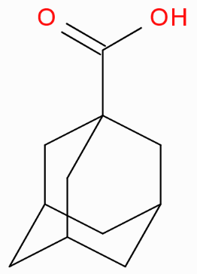
The NMR titration experiments conducted on host-guest complexation of platinum(IV) complex Pt1 revealed that it had a higher binding affinity to CB7 (~10⁻⁶) as compared to β-CD (~10⁻⁴). These findings are consistent with the usual trend of higher binding affinities of adamantane core to CB7 than β-CD. For instance, if we compare host-guest interactions of Pt1 with a similar non-charged molecule of 1-adamantanecarboxylic acid with CB7⁸¹ versus β-CD⁸⁸, where the dissociation constants are 10^{-8.5} and 10^{-4.5} respectively, the trend is the same. However, the K_{d} of Pt1@CB7 is significantly lower than that of Ad-COOH@CB7, which can be explained by the larger repulsion between the ester group in Pt1 with the CB7 carbonyl portal, while in Ad-COOH, the -OH group can stabilise the binding by forming hydrogen bound with the carbonyl portal.
The Pt2 complex was studied as a monoencapsulated complex with CB7 - Pt2@CB7. The binding affinities of β-CD and CB7 to Pt2’s second adamantane ligand were found to be similar (~10⁻⁴) during the formation of diencapsulated complexes. The host-guest interaction of β-CD with Pt2@CB7 revealed the same binding affinity as in the system Pt1@β-CD, indicating that the CB7 bound to the adjacent binding site of Pt2 did not affect the binding of β-CD to the second site. It was also noted that the addition of excess β-CD to Pt2@CB7 did not influence the binding of CB7, demonstrating that CB7 binds more strongly to the adamantane core than β-CD. The system showed non-cooperative binding, and the binding sites of Pt2, in this case, are independent. However, the negative cooperative effect was observed in the formation of a diencapsulated complex of Pt2@CB7 with CB7, where the binding of the first CB7 decreased the affinity of Pt2 for the second CB7 due to steric repulsion between the two adjacent CB7 molecules.
The binding constants of Pt(IV) complexes were investigated by ITC and NMR (Table 1). Results were consistent for the Pt2 complex measured in 50 mM NaCl solution. However, the binding affinities of the Pt1 complex remained similar in both methods, even though the NMR titrations were measured in the presence of 50 mM NaCl, while ITC measurements were conducted in pure water. It was expected that the NMR results would show a decrease in affinity due to the presence of salt. It is known that inorganic cations reduce the apparent binding constant of the guest in host-guest complexes with CB[n], where they function as weak competitors. Potential errors in NMR data may arise from the integration of adamantane signals. The intensities of these signals were low due to the poor solubility of the Pt2 complex. This issue hindered the preparation of the sample at higher concentrations.

Host-guest interactions of platinum(II) complexes with CB7
The host-guest complexation of platinum(II) compounds PtPyrPhe and PtPyrAd revealed moderate affinity complexes with CB7. NMR titration experiments with both complexes were conducted in competitive mode with DABCl as a competitor. Notably, the PtPyrPhe complex exhibited relatively rapid hydrolysis upon CB7 addition to the sample. Therefore, to estimate the dissociation constant, titration was performed on the one-day-old sample of PtPyrPhe@CB7, where the Pt complex had converted into the hydrolysed form. The estimated K_{d} (10^{-6.4}) was comparable to the host-guest interaction of CB7 with a similar organic compound, 4,4'-bipyridine dihydrochloride (10^{-6.5}). Both complexes carry a 2+ charge; however, in the case of bipyridine, the strong binding can be attributed to favourable ion-dipole interaction between the positive charges on nitrogen atoms with both carbonyl portals of CB7, in addition to the hydrophobic effects. While PtPyrPhe exhibited similar ion-dipole interaction with only one carbonyl portal of CB7, the complex may be further stabilised by hydrogen bonds from adjacent -NH₃ and -OH₂ groups on the Pt core to the carbonyl portal of CB7.
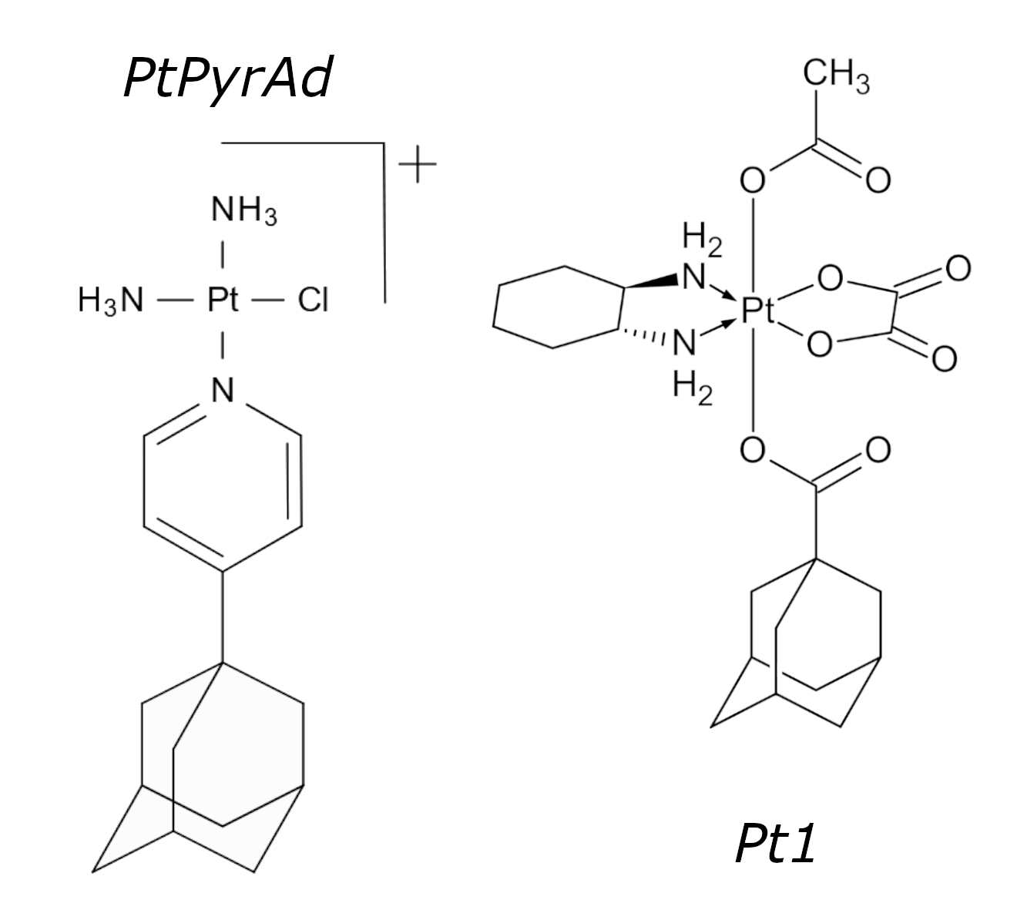
The host-guest complexation of PtPyrAd exhibited the strongest binding affinity to CB7 compared to other complexes in this work. Compared to the PtPyrPhe this stronger binding can be attributed to the greater hydrophobic effect of CB7 with an adamantane core compared to aromatic rings and the optimum volume of Ad that allows effective dispersion forces inside the cavity of CB7. When comparing the complexation constants of PtPyrAd (~10⁻⁷) with Pt1 (~10⁻⁶), PtPyrAd demonstrated an order of magnitude higher binding constant. Firstly, this difference can be explained by the presence of charge in the PtPyrAd complex renders it a more favourable guest for CB7, as CB7 prefers cationic guests over neutral ones. Next, the ester group in Pt1 may cause repulsion with the CB7 carbonyl portal, whereas such an effect is absent in the PtPyrAd complex. Furthermore, the still high-affinity binding of Pt1 to CB7 can also be attributed to the distance between the Pt core and adamantane ligand. In the Pt1 complex, the -NH2 groups on the Pt core can form hydrogen bonds with the CB7 portal, further stabilising the interaction, whereas the larger distance in PtPyrAd may lead to decreased affinity, as the positively charged Pt core is more distanced from the CB7 binding site.

Interactions of platinum(II) complexes with DNA duplex
The DNA binding mode of the platinum(II) complexes PtPyr, PtPyrPhe, and phenPt was investigated on palindromic duplex and G-quadruplex derived from human telomeric sequences.
The interaction mode of PtPyrPhe with self-complementary dodecanucleotide d(CAATCCGGATTG)₂ was investigated by ¹H NMR titration and 2D ¹H-¹H NOESY experiments. During the titration experiment, slow covalent binding of the PtPyrPhe to the duplex was observed. To study the non-covalent interaction, a duplex sample prepared with 70 mM KCl was used in further experiments, resulting in a notable decrease in the covalent association rate.
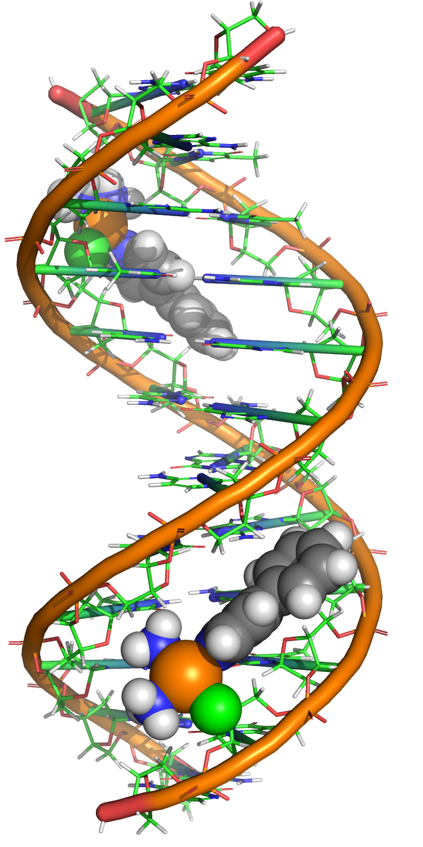
By interpreting changes in chemical shifts and NOESY 1H-1H contacts derived from NMR experiments, it was found that the PtPyrPhe complex binds to the AT region (A₃T₄ and A₉T₁₀) in the DNA minor groove with 1:2 stoichiometry. Based on 1D and 2D data simple model of a duplex with PtPyrPhe bound was built. Even though the Pt complex exhibited fast exchange (on the NMR time scale) in its binding to the duplex, the observation of intermolecular NOE cross-peaks from the Pt complex to various minor groove AH2, AH1’, and TH1’ resonances are strong evidence of selective binding at AT sequences. This preference for the AT minor groove binding may be the cationic nature of the complex and a greater negative electrostatic potential of the AT sequence in the minor groove than that of the GC sequence.³⁴ Additionally, specific NOE contacts (PrH6 - T₄H1’ and PhH11-C₆H1’) allowed us to determine the orientation of the PtPyrPhe within the groove. However, the binding affinity of the Pt complex to duplex was not estimated, as it requires a more sophisticated model, due to the 1:2 binding stoichiometry and the possibility of cooperativity in the binding.
The relatively large aromatic system of the PtPyrPhe complex induced chemical shift changes within six nucleobases upon binding, with the most significant shifts occurring in protons positioned above or below the aromatic rings. For example, the largest observed shift was the -0.306 ppm upfield shift of T₁₀H1’, located under the pyridine ring. Additionally, the proximity of a phenyl ring from both PtPyrPhe near the duplex centre may account for the significant shifts observed in the resonances of the C₆ base, which is relatively distant from the estimated binding site of the Pt complex.
The NMR titration experiment involving PtPyr with the duplex served as a reference. Prior to covalent binding, the addition of PtPyr induced insignificant chemical shift changes ( > 0.03 ppm). Given the well-known covalent binding mechanism of pyriplatin to the N7 of guanine residues in DNA, the PtPyr binding with the duplex was not further investigated in this work. However, a comparison of PtPyr and PtPyrPhe revealed a significant change in interaction mode with DNA, attributed to the additional phenyl ring in PtPyrPhe. This modification shifted its binding from pure covalent interaction to selective binding to the AT region in the DNA minor groove, followed by later covalent binding. Unfortunately, further examination of PtPyrPhe covalent binding was not undertaken in this work.
The UV/VIS measurements of melting temperatures of duplex and PtPyrPhe with 1:1 and 1:2 concentration ratios showed that the addition of Pt complex had minimal impact on the stability of the formed complexes. For instance, dx:PtPyrPhe (1:2) exhibited only a 1.5 °C increase in melting temperature. Even though the interaction between PtPyrPhe and duplex was observed, it did not influence the stability of the duplex, indicating a weak groove binding affinity.
The NMR titration experiments of the phenPt complex with duplex revealed nonspecific binding at multiple sites. The interaction exhibited an intermediated exchange regime, which resulted in the broadening of all signals of DNA in the imino and aromatic regions, with specific resonances disappearing (C₅, C₆, G₇ and G₈). Nonetheless, the observed significant shielding of guanine imino and cytosine amino resonances might indicate the intercalation of the phenanthridine ring between these DNA bases. Unfortunately, the absence of signals from the phenPt complex in the spectrum, coupled with unfavourable binding dynamics, hindered further investigation of its binding site on the duplex using 2D experiments. A recent study suggested a mechanism wherein phenanthriplatin initially undergoes partial intercalation followed by covalent binding to the N7 of purine bases. However, experiments with phenPt in this work were only conducted with 70 mM KCl, which prevented covalent attachment of the Pt complex. As a result, due to the limited amount of data, the interaction mode between phenPt and the duplex was not determined.

Interactions of platinum(II) complexes with DNA G-quadruplex
To compare the interaction properties of platinum(II) complexes between duplex and G-quadruplex, the NMR titration experiments of PtPyr, PtPyrPhe, and phenPt complexes were performed with the 24-nt d[TTGGG(TTAGGG)₃A] hTel sequence. All measurements with hTel were performed in the presence of salt; therefore, this work did not investigate the possible covalent binding mode of Pt complexes.
The previous studies suggest that the strong intercalative interaction between metal complexes and G-quadruplex structures can be achieved with complexes featuring extended aromatic ligands with greater π-surface, which better complement the large G-quartet motifs.⁵⁶ Then, the lack of interaction observed with PtPyr can be attributed to its small aromatic system.
In contrast, PtPyrPhe, with a slightly more extended aromatic system, exhibited external stacking on top of the top G-tetrad, evidenced by significant chemical shift changes (up to 0.2 ppm) in imino and aromatic protons of guanine residues from top G-tetrad and aromatic protons of residues on the loops located above it. Moreover, based on the NMR data, it was proposed that the binding of the PtPyrPhe disrupts the Watson-Crick T₁-A₂₀ pair stacked on the top side of the G-tetrad core. However, this hypothesis was not confirmed due to the absence of T₁ imino resonance in the NMR spectra of free hTel.
The more precise binding site of PtPyrPhe was not determined due to the absence of NOE cross-peaks between the complex and hTel. The observed signal broadening of PtPyrPhe indicates conformational freedom within its binding site, likely because the PyrPhe aromatic system could not form a stable stacking with the G-tetrad. Additionally, the UV/VIS measurements revealed no change in the melting temperature of hTel with PtPyrPhe at 1:1 or 1:2 ratios, suggesting weak intercalative binding with no evident stabilisation effect on hTel.
Contrary to expectations, the titration of the phenPt complex, which possesses a greater aromatic system, with the G-quadruplex induced smaller chemical shift changes compared to the experiment with PtPyrPhe. However, the significant changes ( < 0.07 ppm) of guanine imino resonances from external G-tetrads and adenine aromatic protons from loops placed on both sides of the G-tetrad core indicate interaction of phenPt in these regions. Unfortunately, the absence of phenPt signals in the 2D spectra prevented confirmation of its binding site. Similar to the PtPyrPhe system, UV/VIS melting temperature experiments showed minimal impact on the stability of hTel, indicating weak intercalation of phenPt. It is possible that the size of the phenanthridine ring still does not provide an optimal match with the π-surface of the G-tetrad motif. Employing alternative methods, such as CD or UV/VIS titration, might yield better results by overcoming the unfavourable dynamics of the interaction observed in NMR experiments.

Conclusion
Combining metallodrugs with macrocycles represents a promising strategy for developing advanced anticancer agents. This study investigated the host-guest complexation between neutral platinum(IV) prodrugs and cationic platinum(II) complexes and β-CD and CB7.
The monovalent Pt1 guest, featuring one adamantane ligand as a binding site for macrocycles, exhibited a higher affinity for CB7 over β-CD. However, due to practical insolubility, the divalent Pt2 guest with two adamantane ligands was studied in a monoencapsulated form with CB7, which enhanced its solubility. The formation of diencapsulated complexes with β-CD and CB7 revealed non-cooperative binding of the β-CD and negative cooperativity effect in the binding of two CB7. The comparison of binding constants obtained from ITC and NMR experiments indicated that, despite the consistency of the results for Pt2, the limited solubility of the complexes led to low sensitivity in NMR measurements, which affected the integration of the signals and, therefore, contributed to errors in the estimated dissociation constants.
The investigation into the complexation of platinum(II) PtPyrPhe and PtPyrAd complexes with CB7 showed moderate affinity bindings. Due to the rapid hydrolysis of the PtPyrPhe complex in the presence of CB7, the titration experiment aimed to estimate the dissociation constant of its hydrolysed form, which will have stronger binding with CB7 due to the increased complex charge. Considering the limitations of the NMR technique in affinity studies, a competitive mode of titration experiments was required for these relatively high-affinity complexes. In order to enhance precision in determining the affinity constant, a competitor with a similar binding affinity to the complex of the interest should be selected. Moreover, the use of alternative techniques is needed for cross-validation, especially in the case of PtPyrAd, although they were not employed in this work.
The second part of this work investigated the interaction mode of the cationic monofunctional platinum(II) complexes with varying aromatic system sizes, both with canonical DNA duplex sequence and an alternative target for the platinum agents, the G-quadruplex. The study primarily focused on the intercalative interactions, employing titration experiments in the presence of salt. While the PtPyr complex did not interact with either sequence, the PtPyrPhe complex, featuring a more extended aromatic system, demonstrated specific groove binding at the AT regions of the DNA duplex, supported by intermolecular cross-peaks from the 2D NOESY experiment. Weak interaction of PtPyrPhe on top of the top G-tetrad of the G-quadruplex was observed. However, pinpointing its precise binding site to the quadruplex was hindered by unfavourable dynamics of the binding. In the case of the phenPt complex, possible intercalation into the DNA duplex structure was suggested, evidenced by the significant shielding of the duplex resonances observed. However, the dynamic of the binding prohibited more precise determination of its binding site. The expected intercalative interaction of phenPt possessing a larger aromatic system with the G-quartet of the quadruplex structure was not observed. This may indicate the importance of the phenPt covalent association in forming stable interactions with the DNA duplex and G-quadruplex. Moreover, employing alternative techniques such as UV/VIS and CD could offer more insight into the binding of both phenPt and PtPyrPhe.

Bibliography
(1) Bruijnincx, P. C.; Sadler, P. J. New Trends for Metal Complexes with Anticancer Activity. Curr. Opin. Chem. Biol. 2008, 12 (2), 197–206. https://doi.org/10.1016/j.cbpa.2007.11.013.
(2) Wai-Yin Sun, R.; Ma, D.-L.; Wong, E. L.-M.; Che, C.-M. Some Uses of Transition Metal Complexes as Anti-Cancer and Anti-HIV Agents. Dalton Trans. 2007, No. 43, 4884. https://doi.org/10.1039/b705079h.
(3) Shaw, C. F. Gold-Based Therapeutic Agents. Chem. Rev. 1999, 99 (9), 2589–2600. https://doi.org/10.1021/cr980431o.
(4) Clement, J. L.; Jarrett, P. S. Antibacterial Silver. Met.-Based Drugs 1994, 1 (5–6), 467–482. https://doi.org/10.1155/MBD.1994.467.
(5) Heffern, M. C.; Yamamoto, N.; Holbrook, R. J.; Eckermann, A. L.; Meade, T. J. Cobalt Derivatives as Promising Therapeutic Agents. Curr. Opin. Chem. Biol. 2013, 17 (2), 189–196. https://doi.org/10.1016/j.cbpa.2012.11.019.
(6) Grogna, M.; Cloots, R.; Luxen, A.; Jérôme, C.; Passirani, C.; Lautram, N.; Desreux, J.-F.; Detrembleur, C. Polymer Micelles Decorated by Gadolinium Complexes as MRI Blood Contrast Agents: Design, Synthesis and Properties. Polym. Chem. 2010, 1 (9), 1485. https://doi.org/10.1039/c0py00117a.
(7) De Almeida, A.; Oliveira, B. L.; Correia, J. D. G.; Soveral, G.; Casini, A. Emerging Protein Targets for Metal-Based Pharmaceutical Agents: An Update. Coord. Chem. Rev. 2013, 257 (19–20), 2689–2704. https://doi.org/10.1016/j.ccr.2013.01.031.
(8) Lucaciu, R. L.; Hangan, A. C.; Sevastre, B.; Oprean, L. S. Metallo-Drugs in Cancer Therapy: Past, Present and Future. Molecules 2022, 27 (19), 6485. https://doi.org/10.3390/molecules27196485.
(9) Yousuf, I.; Bashir, M. Metallodrugs in Medicine: Present, Past, and Future Prospects. In Advances in Metallodrugs; Shahid‐ul‐Islam, Hashmi, A. A., Khan, S. A., Eds.; Wiley, 2020; pp 1–39. https://doi.org/10.1002/9781119640868.ch1.
(10) Mcquitty, R. J. Metal-Based Drugs. Sci. Prog. 2014, 97 (1), 1–19. https://doi.org/10.3184/003685014X13898980185076.
(11) Johnstone, T. C.; Suntharalingam, K.; Lippard, S. J. The Next Generation of Platinum Drugs: Targeted Pt(II) Agents, Nanoparticle Delivery, and Pt(IV) Prodrugs. Chem. Rev. 2016, 116 (5), 3436–3486. https://doi.org/10.1021/acs.chemrev.5b00597.
(12) Kelland, L. The Resurgence of Platinum-Based Cancer Chemotherapy. Nat. Rev. Cancer 2007, 7 (8), 573–584. https://doi.org/10.1038/nrc2167.
(13) Pollak, D.; Goddard, R.; Pörschke, K.-R. Synthesis and Structures of 9-Oxabispidine Analogues of Cisplatin, Carboplatin, and Oxaliplatin. Inorg. Chem. 2016, 55 (18), 9424–9435. https://doi.org/10.1021/acs.inorgchem.6b01690.
(14) Dolman, R. C.; Deacon, G. B.; Hambley, T. W. Studies of the Binding of a Series of Platinum(IV) Complexes to Plasma Proteins. J. Inorg. Biochem. 2002, 88 (3–4), 260–267. https://doi.org/10.1016/S0162-0134(01)00360-9.
(15) Sternberg, C. N.; Petrylak, D. P.; Sartor, O.; Witjes, J. A.; Demkow, T.; Ferrero, J.-M.; Eymard, J.-C.; Falcon, S.; Calabrò, F.; James, N.; Bodrogi, I.; Harper, P.; Wirth, M.; Berry, W.; Petrone, M. E.; McKearn, T. J.; Noursalehi, M.; George, M.; Rozencweig, M. Multinational, Double-Blind, Phase III Study of Prednisone and Either Satraplatin or Placebo in Patients With Castrate-Refractory Prostate Cancer Progressing After Prior Chemotherapy: The SPARC Trial. J. Clin. Oncol. 2009, 27 (32), 5431–5438. https://doi.org/10.1200/JCO.2008.20.1228.
(16) Komeda, S.; Casini, A. Next-Generation Anticancer Metallodrugs. Curr. Top. Med. Chem. 2012, 12 (3), 219–235. https://doi.org/10.2174/156802612799078964.
(17) Minirevie, A. MECHANISMS OF EFFECTS OF PLATINUM (II) AND (IV) COMPLExES. COMPARISON OF CISPLATIN AND OxALIPLATIN wITH SATRAPLATIN AND LA-12, NEw PT (IV)-BASED DRUGS. Scr. Medica Brno 2008, 81 (2), 105–116.
(18) Li, W.; Jiang, M.; Cao, Y.; Yan, L.; Qi, R.; Li, Y.; Jing, X. Turning Ineffective Transplatin into a Highly Potent Anticancer Drug via a Prodrug Strategy for Drug Delivery and Inhibiting Cisplatin Drug Resistance. Bioconjug. Chem. 2016, 27 (8), 1802–1806. https://doi.org/10.1021/acs.bioconjchem.6b00302.
(19) Gao, Y.; Jiang, M.; Ma, Y.; Wu, S.; Li, W.; Yang, X.; Li, Y.; Jing, X.; Jiang, H. Nanoparticle-Mediated Delivery of Multinuclear Platinum(IV) Prodrugs with Enhanced Drug Uptake and the Activity of Overcoming Drug Resistance. Anticancer. Drugs 2016, 27 (2), 77–83. https://doi.org/10.1097/CAD.0000000000000302.
(20) Du, R.; Xiao, H.; Guo, G.; Jiang, B.; Yan, X.; Li, W.; Yang, X.; Zhang, Y.; Li, Y.; Jing, X. Nanoparticle Delivery of Photosensitive Pt(IV) Drugs for Circumventing Cisplatin Cellular Pathway and on-Demand Drug Release. Colloids Surf. B Biointerfaces 2014, 123, 734–741. https://doi.org/10.1016/j.colsurfb.2014.10.015.
(21) Hollis, L. S.; Sundquist, W. I.; Burstyn, J. N.; Heiger-Bernays, W. J.; Bellon, S. F.; Ahmed, K. J.; Amundsen, A. R.; Stern, E. W.; Lippard, S. J. Mechanistic Studies of a Novel Class of Trisubstituted Platinum (II) Antitumor Agents. Cancer Res. 1991, 51 (7), 1866–1875.
(22) Lovejoy, K. S.; Todd, R. C.; Zhang, S.; McCormick, M. S.; D’Aquino, J. A.; Reardon, J. T.; Sancar, A.; Giacomini, K. M.; Lippard, S. J. Cis -Diammine(Pyridine)Chloroplatinum(II), a Monofunctional Platinum(II) Antitumor Agent: Uptake, Structure, Function, and Prospects. Proc. Natl. Acad. Sci. 2008, 105 (26), 8902–8907. https://doi.org/10.1073/pnas.0803441105.
(23) Dilruba, S.; Kalayda, G. V. Platinum-Based Drugs: Past, Present and Future. Cancer Chemother. Pharmacol. 2016, 77 (6), 1103–1124. https://doi.org/10.1007/s00280-016-2976-z.
(24) Wang, D.; Zhu, G.; Huang, X.; Lippard, S. J. X-Ray Structure and Mechanism of RNA Polymerase II Stalled at an Antineoplastic Monofunctional Platinum-DNA Adduct. Proc. Natl. Acad. Sci. 2010, 107 (21), 9584–9589. https://doi.org/10.1073/pnas.1002565107.
(25) Almaqwashi, A. A.; Zhou, W.; Naufer, M. N.; Riddell, I. A.; Yilmaz, Ö. H.; Lippard, S. J.; Williams, M. C. DNA Intercalation Facilitates Efficient DNA-Targeted Covalent Binding of Phenanthriplatin. J. Am. Chem. Soc. 2019, 141 (4), 1537–1545. https://doi.org/10.1021/jacs.8b10252.
(26) Park, G. Y.; Wilson, J. J.; Song, Y.; Lippard, S. J. Phenanthriplatin, a Monofunctional DNA-Binding Platinum Anticancer Drug Candidate with Unusual Potency and Cellular Activity Profile. Proc. Natl. Acad. Sci. 2012, 109 (30), 11987–11992. https://doi.org/10.1073/pnas.1207670109.
(27) Metcalfe, C.; Thomas, J. A. Kinetically Inert Transition Metal Complexes That Reversibly Bind to DNA. Chem. Soc. Rev. 2003, 32 (4), 215. https://doi.org/10.1039/b201945k.
(28) García-Ramos, J. C.; Galindo-Murillo, R.; Cortés-Guzmán, F.; Ruiz-Azuara, L. Metal-Based Drug-DNA Interactions. J. Mex. Chem. Soc. 2017, 57 (3). https://doi.org/10.29356/jmcs.v57i3.213.
(29) Pizarro, A. M.; Sadler, P. J. Unusual DNA Binding Modes for Metal Anticancer Complexes. Biochimie 2009, 91 (10), 1198–1211. https://doi.org/10.1016/j.biochi.2009.03.017.
(30) Cusumano, M.; Di Pietro, M. L.; Giannetto, A.; Nicolò, F.; Rotondo, E. Noncovalent Interactions of Platinum(II) Square Planar Complexes Containing Ligands Out-of-Plane with DNA. Inorg. Chem. 1998, 37 (3), 563–568. https://doi.org/10.1021/ic9705406.
(31) Howe-Grant, M.; Lippard, S. J. Binding of Platinum(II) Intercalation Reagents to Deoxyribonucleic Acid. Dependence on Base-Pair Composition, Nature of the Intercalator, and Ionic Strength. Biochemistry 1979, 18 (26), 5762–5769. https://doi.org/10.1021/bi00593a003.
(32) Pages, B. J.; Ang, D. L.; Wright, E. P.; Aldrich-Wright, J. R. Metal Complex Interactions with DNA. Dalton Trans. 2015, 44 (8), 3505–3526. https://doi.org/10.1039/C4DT02700K.
(33) Oguey, C.; Foloppe, N.; Hartmann, B. Understanding the Sequence-Dependence of DNA Groove Dimensions: Implications for DNA Interactions. PLoS ONE 2010, 5 (12), e15931. https://doi.org/10.1371/journal.pone.0015931.
(34) Franklin, C. A.; Fry, J. V.; Collins, J. G. NMR Evidence for Sequence-Specific DNA Minor Groove Binding by Bis(Ethylenediamine)Platinum(II). Inorg. Chem. 1996, 35 (26), 7541–7545. https://doi.org/10.1021/ic9604775.
(35) Https://Suprabank.Org/System/Molecules/Pngs/000/000/002/Original/CB7.Png?1583871434.
(36) Lagona, J.; Mukhopadhyay, P.; Chakrabarti, S.; Isaacs, L. The Cucurbit[ n ]Uril Family. Angew. Chem. Int. Ed. 2005, 44 (31), 4844–4870. https://doi.org/10.1002/anie.200460675.
(37) Uzunova, V. D.; Cullinane, C.; Brix, K.; Nau, W. M.; Day, A. I. Toxicity of Cucurbit[7]Uril and Cucurbit[8]Uril: An Exploratory in Vitro and in Vivo Study. Org. Biomol. Chem. 2010, 8 (9), 2037. https://doi.org/10.1039/b925555a.
(38) Gerloczy, A.; Fonagy, A.; Keresztes, P.; Perlaky, L.; Szejtli, J. Absorption, Distribution, Excretion and Metabolism of Orally Administered 14C-Beta-Cyclodextrin in Rat. Arzneimittelforschung. 1985, 35 (7), 1042–1047.
(39) Gu, A.; Wheate, N. J. Macrocycles as Drug-Enhancing Excipients in Pharmaceutical Formulations. J. Incl. Phenom. Macrocycl. Chem. 2021, 100 (1–2), 55–69. https://doi.org/10.1007/s10847-021-01055-9.
(40) Jambhekar, S. S.; Breen, P. Cyclodextrins in Pharmaceutical Formulations I: Structure and Physicochemical Properties, Formation of Complexes, and Types of Complex. Drug Discov. Today 2016, 21 (2), 356–362. https://doi.org/10.1016/j.drudis.2015.11.017.
(41) Zhang, D.; Lv, P.; Zhou, C.; Zhao, Y.; Liao, X.; Yang, B. Cyclodextrin-Based Delivery Systems for Cancer Treatment. Mater. Sci. Eng. C 2019, 96, 872–886. https://doi.org/10.1016/j.msec.2018.11.031.
(42) Altoom, N.; Ibrahim, S. M.; Othman, S. I.; Allam, A. A.; Alqhtani, H. A.; Al-Otaibi, F. S.; Abukhadra, M. R. Characterization of β-Cyclodextrin/Phillipsite (β-CD/Ph) Composite as a Potential Carrier for Oxaliplatin as Therapy for Colorectal Cancer; Loading, Release, and Cytotoxicity. Colloids Surf. Physicochem. Eng. Asp. 2022, 648, 129144. https://doi.org/10.1016/j.colsurfa.2022.129144.
(43) Pashkina, E. A.; Grishina, L. V.; Aktanova, A. A.; Kozlov, V. A. Antitumor Activity of Supramolecular Complexes of Cucurbituril with Platinum(II) Compounds. Inorganica Chim. Acta 2021, 522, 120370. https://doi.org/10.1016/j.ica.2021.120370.
(44) Wheate, N. J.; Buck, D. P.; Day, A. I.; Collins, J. G. Cucurbit[n]Uril Binding of Platinum Anticancer Complexes. Dalton Trans 2006, No. 3, 451–458. https://doi.org/10.1039/B513197A.
(45) Wheate, N. J. Improving Platinum(II)-Based Anticancer Drug Delivery Using Cucurbit[n]Urils. J. Inorg. Biochem. 2008, 102 (12), 2060–2066. https://doi.org/10.1016/j.jinorgbio.2008.06.005.
(46) Plumb, J. A.; Venugopal, B.; Oun, R.; Gomez-Roman, N.; Kawazoe, Y.; Venkataramanan, N. S.; Wheate, N. J. Cucurbit[7]Uril Encapsulated Cisplatin Overcomes Cisplatin Resistance via a Pharmacokinetic Effect. Metallomics 2012, 4 (6), 561. https://doi.org/10.1039/c2mt20054f.
(47) Jin Jeon, Y.; Kim, S.-Y.; Ho Ko, Y.; Sakamoto, S.; Yamaguchi, K.; Kim, K. Novel Molecular Drug Carrier: Encapsulation of Oxaliplatin in Cucurbit[7]Uril and Its Effects on Stability and Reactivity of the Drug. Org. Biomol. Chem. 2005, 3 (11), 2122. https://doi.org/10.1039/b504487a.
(48) Vigna, V.; Scoditti, S.; Spinello, A.; Mazzone, G.; Sicilia, E. Anticancer Activity, Reduction Mechanism and G-Quadruplex DNA Binding of a Redox-Activated Platinum(IV)–Salphen Complex. Int. J. Mol. Sci. 2022, 23 (24), 15579. https://doi.org/10.3390/ijms232415579.
(49) Neidle, S. Quadruplex Nucleic Acids as Targets for Anticancer Therapeutics. Nat. Rev. Chem. 2017, 1 (5), 0041. https://doi.org/10.1038/s41570-017-0041.
(50) By G-Quadruplex.Jpg: Julian Huppert Jlh29derivative Work: Iridos (Talk) - G-Quadruplex.Jpg, CC BY-SA 2.5, Https://Commons.Wikimedia.Org/w/Index.Php?Curid=15670781.
(51) Kim, N. W.; Piatyszek, M. A.; Prowse, K. R.; Harley, C. B.; West, M. D.; Ho, P. L. C.; Coviello, G. M.; Wright, W. E.; Weinrich, S. L.; Shay, J. W. Specific Association of Human Telomerase Activity with Immortal Cells and Cancer. Science 1994, 266 (5193), 2011–2015. https://doi.org/10.1126/science.7605428.
(52) Huppert, J. L.; Balasubramanian, S. G-Quadruplexes in Promoters throughout the Human Genome. Nucleic Acids Res. 2007, 35 (2), 406–413. https://doi.org/10.1093/nar/gkl1057.
(53) Valton, A.-L.; Prioleau, M.-N. G-Quadruplexes in DNA Replication: A Problem or a Necessity? Trends Genet. 2016, 32 (11), 697–706. https://doi.org/10.1016/j.tig.2016.09.004.
(54) Mani, P.; Yadav, V. K.; Das, S. K.; Chowdhury, S. Genome-Wide Analyses of Recombination Prone Regions Predict Role of DNA Structural Motif in Recombination. PLoS ONE 2009, 4 (2), e4399. https://doi.org/10.1371/journal.pone.0004399.
(55) Linke, R.; Limmer, M.; Juranek, S.; Heine, A.; Paeschke, K. The Relevance of G-Quadruplexes for DNA Repair. Int. J. Mol. Sci. 2021, 22 (22), 12599. https://doi.org/10.3390/ijms222212599.
(56) Kieltyka, R.; Fakhoury, J.; Moitessier, N.; Sleiman, H. F. Platinum Phenanthroimidazole Complexes as G‐Quadruplex DNA Selective Binders. Chem. – Eur. J. 2008, 14 (4), 1145–1154. https://doi.org/10.1002/chem.200700783.
(57) Steed, J. W.; Atwood, J. L. Supramolecular Chemistry; John Wiley & Sons, 2022.
(58) Steed, J. W.; Turner, D. R.; Wallace, K. J. Core Concepts in Supramolecular Chemistry and Nanochemistry; John Wiley & Sons, 2007.
(59) Angelos, S.; Yang, Y.; Patel, K.; Stoddart, J. F.; Zink, J. I. pH‐Responsive Supramolecular Nanovalves Based on Cucurbit[6]Uril Pseudorotaxanes. Angew. Chem. Int. Ed. 2008, 47 (12), 2222–2226. https://doi.org/10.1002/anie.200705211.
(60) Sayed, M.; Pal, H. An Overview from Simple Host–Guest Systems to Progressively Complex Supramolecular Assemblies. Phys. Chem. Chem. Phys. 2021, 23 (46), 26085–26107. https://doi.org/10.1039/D1CP03556H.
(61) Ma, X.; Zhao, Y. Biomedical Applications of Supramolecular Systems Based on Host–Guest Interactions. Chem. Rev. 2015, 115 (15), 7794–7839. https://doi.org/10.1021/cr500392w.
(62) Thordarson, P. Determining Association Constants from Titration Experiments in Supramolecular Chemistry. Chem Soc Rev 2011, 40 (3), 1305–1323. https://doi.org/10.1039/C0CS00062K.
(63) Furukawa, A.; Konuma, T.; Yanaka, S.; Sugase, K. Quantitative Analysis of Protein–Ligand Interactions by NMR. Prog. Nucl. Magn. Reson. Spectrosc. 2016, 96, 47–57. https://doi.org/10.1016/j.pnmrs.2016.02.002.
(64) Dalvit, C.; Gmür, I.; Rößler, P.; Gossert, A. D. Affinity Measurement of Strong Ligands with NMR Spectroscopy: Limitations and Ways to Overcome Them. Prog. Nucl. Magn. Reson. Spectrosc. 2023, 138–139, 52–69. https://doi.org/10.1016/j.pnmrs.2023.07.001.
(65) Stefan, M. I.; Le Novère, N. Cooperative Binding. PLoS Comput. Biol. 2013, 9 (6), e1003106. https://doi.org/10.1371/journal.pcbi.1003106.
(66) Hunter, C. A.; Anderson, H. L. What Is Cooperativity? Angew. Chem. Int. Ed. 2009, 48 (41), 7488–7499. https://doi.org/10.1002/anie.200902490.
(67) Von Krbek, L. K. S.; Schalley, C. A.; Thordarson, P. Assessing Cooperativity in Supramolecular Systems. Chem. Soc. Rev. 2017, 46 (9), 2622–2637. https://doi.org/10.1039/C7CS00063D.
(68) Perutz, M. F. Mechanisms of Cooperativity and Allosteric Regulation in Proteins. Q. Rev. Biophys. 1989, 22 (2), 139–237. https://doi.org/10.1017/S0033583500003826.
(69) Ikeda, H.; Nishikawa, S.; Yamamoto, Y.; Ueno, A. Homotropic Cooperativity of Cyclodextrin Dimer as an Artificial Hydrolase. J. Mol. Catal. Chem. 2010, 328 (1–2), 1–7. https://doi.org/10.1016/j.molcata.2010.06.005.
(70) Huang, Z.; Qin, K.; Deng, G.; Wu, G.; Bai, Y.; Xu, J.-F.; Wang, Z.; Yu, Z.; Scherman, O. A.; Zhang, X. Supramolecular Chemistry of Cucurbiturils: Tuning Cooperativity with Multiple Noncovalent Interactions from Positive to Negative. Langmuir 2016, 32 (47), 12352–12360. https://doi.org/10.1021/acs.langmuir.6b01709.
(71) Chen, Y.; Zhang, Y.; Liu, Y. Molecular Selective Binding and Nanofabrication of Cucurbituril/Cyclodextrin Pairs. Isr. J. Chem. 2011, 51 (5–6), 515–524. https://doi.org/10.1002/ijch.201100010.
(72) Rahimian, M.; Miao, Y.; Wilson, W. D. Influence of DNA Structure on Adjacent Site Cooperative Binding. J. Phys. Chem. B 2008, 112 (29), 8770–8778. https://doi.org/10.1021/jp801997v.
(73) Piotto, M.; Saudek, V.; Sklenář, V. Gradient-Tailored Excitation for Single-Quantum NMR Spectroscopy of Aqueous Solutions. J. Biomol. NMR 1992, 2 (6), 661–665. https://doi.org/10.1007/BF02192855.
(74) Mestrelab Research S.L.; Mestrenova (Version 14.2.2-28739); Mestrelab Research S.L.: Santiago de Compostela, Spain., 2024. https://mestrelab.com/.
(75) Lee, W.; Tonelli, M.; Markley, J. L. NMRFAM-SPARKY: Enhanced Software for Biomolecular NMR Spectroscopy. Bioinforma. Oxf. Engl. 2015, 31 (8), 1325–1327. https://doi.org/10.1093/bioinformatics/btu830.
(76) The PyMOL Molecular Graphics System, Version 3.0.2, Schrödinger, LLC.
(77) Biosearch Technologies. Available at: Https://Www.Biosearchtech.Com/. Accessed October, 2023.
(78) Mgr. Jan Chyba, Ph.D., Unpublished Results.
(79) Zatloukal, F.; Achbergerová, E.; Gergela, D.; Rouchal, M.; Dastychová, L.; Prucková, Z.; Vícha, R. Supramolecular Properties of Amphiphilic Adamantylated Azo Dyes. Dyes Pigments 2021, 192, 109420. https://doi.org/10.1016/j.dyepig.2021.109420.
(80) Moghaddam, S.; Yang, C.; Rekharsky, M.; Ko, Y. H.; Kim, K.; Inoue, Y.; Gilson, M. K. New Ultrahigh Affinity Host−Guest Complexes of Cucurbit[7]Uril with Bicyclo[2.2.2]Octane and Adamantane Guests: Thermodynamic Analysis and Evaluation of M2 Affinity Calculations. J. Am. Chem. Soc. 2011, 133 (10), 3570–3581.
(81) Liu, S.; Ruspic, C.; Mukhopadhyay, P.; Chakrabarti, S.; Zavalij, P. Y.; Isaacs, L. The Cucurbit[n]Uril Family: Prime Components for Self-Sorting Systems. J. Am. Chem. Soc. 2005, 127 (45), 15959–15967. https://doi.org/10.1021/ja055013x.
(82) Dong, N.; He, J.; Li, T.; Peralta, A.; Avei, M. R.; Ma, M.; Kaifer, A. E. Synthesis and Binding Properties of Monohydroxycucurbit[7]Uril: A Key Derivative for the Functionalization of Cucurbituril Hosts. J. Org. Chem. 2018, 83 (10), 5467–5473. https://doi.org/10.1021/acs.joc.8b00382.
(83) Sojka, M.; Chyba, J.; Paul, S. S.; Wawrocka, K.; Hönigová, K.; Cuyacot, B. J. R.; Castro, A. C.; Vaculovič, T.; Marek, J.; Repisky, M.; Masařík, M.; Novotný, J.; Marek, R. Supramolecular Coronation of Platinum(II) Complexes by Macrocycles: Structure, Relativistic DFT Calculations, and Biological Effects. Inorg. Chem. 2021, 60 (23), 17911–17925. https://doi.org/10.1021/acs.inorgchem.1c02467.
(84) Luu, K. N.; Phan, A. T.; Kuryavyi, V.; Lacroix, L.; Patel, D. J. Structure of the Human Telomere in K+ Solution: An Intramolecular (3 + 1) G-Quadruplex Scaffold. J. Am. Chem. Soc. 2006, 128 (30), 9963–9970. https://doi.org/10.1021/ja062791w.
(85) Lech, C. J.; Phan, A. T. Ball with Hair: Modular Functionalization of Highly Stable G-Quadruplex DNA Nano-Scaffolds through N2-Guanine Modification. Nucleic Acids Res. 2017, 45 (11), 6265–6274. https://doi.org/10.1093/nar/gkx243.
(86) Phan, A. T.; Kuryavyi, V.; Gaw, H. Y.; Patel, D. J. Small-Molecule Interaction with a Five-Guanine-Tract G-Quadruplex Structure from the Human MYC Promoter. Nat. Chem. Biol. 2005, 1 (3), 167–173. https://doi.org/10.1038/nchembio723.
(87) Luu, K.N., Phan, A.T., Kuryavyi, V.V., Lacroix, L., Patel, D.J. (2006). https://doi.org/10.2210/pdb2gku/pdb.
(88) Cromwell, W. C.; Bystrom, K.; Eftink, M. R. Cyclodextrin-Adamantanecarboxylate Inclusion Complexes: Studies of the Variation in Cavity Size. J. Phys. Chem. 1985, 89 (2), 326–332.

Figure S42: ¹H 1D NMR titration of PtPyrPhe into the solution of CB7 in D₂O at 298.2 K. The concentration of CB7 was constant during the titration. The signals of CB7 bound to the non-hydrolysed PtPyrPhe are marked with a prime (‘) and to the hydrolysed PtPyrPhe - double prime (‘’). The spectra were referenced to a signal of water.
Figure S43: ¹H 1D spectrum from titration of PtPyr to duplex, imino protons region. 5% D₂O, 20 mM Na⁺ buffer, 298.2 K, c(duplex)=0.375 mM. The spectra were referenced to an impurity signal at 3.1 ppm.
Figure S44: ¹H 1D spectrum from titration of PtPyr to duplex, aromatic protons region. 5% D₂O, 20 mM Na⁺ buffer, 298.2 K, c(duplex)=0.375 mM. The spectra were referenced to an impurity signal at 3.1 ppm.
Figure S45: ¹H 1D spectra of the duplex with PtPyrPhe 1:2 concentration ratio, imino protons region. 5% D₂O, 20 mM Na⁺ buffer, 298.2 K, c(duplex)=0.375 mM. Spectrum on the top - right after the performed titration, on the bottom measured after 5 days. New duplex species in the sample appeared due to the covalent binding of PtPyrPhe.
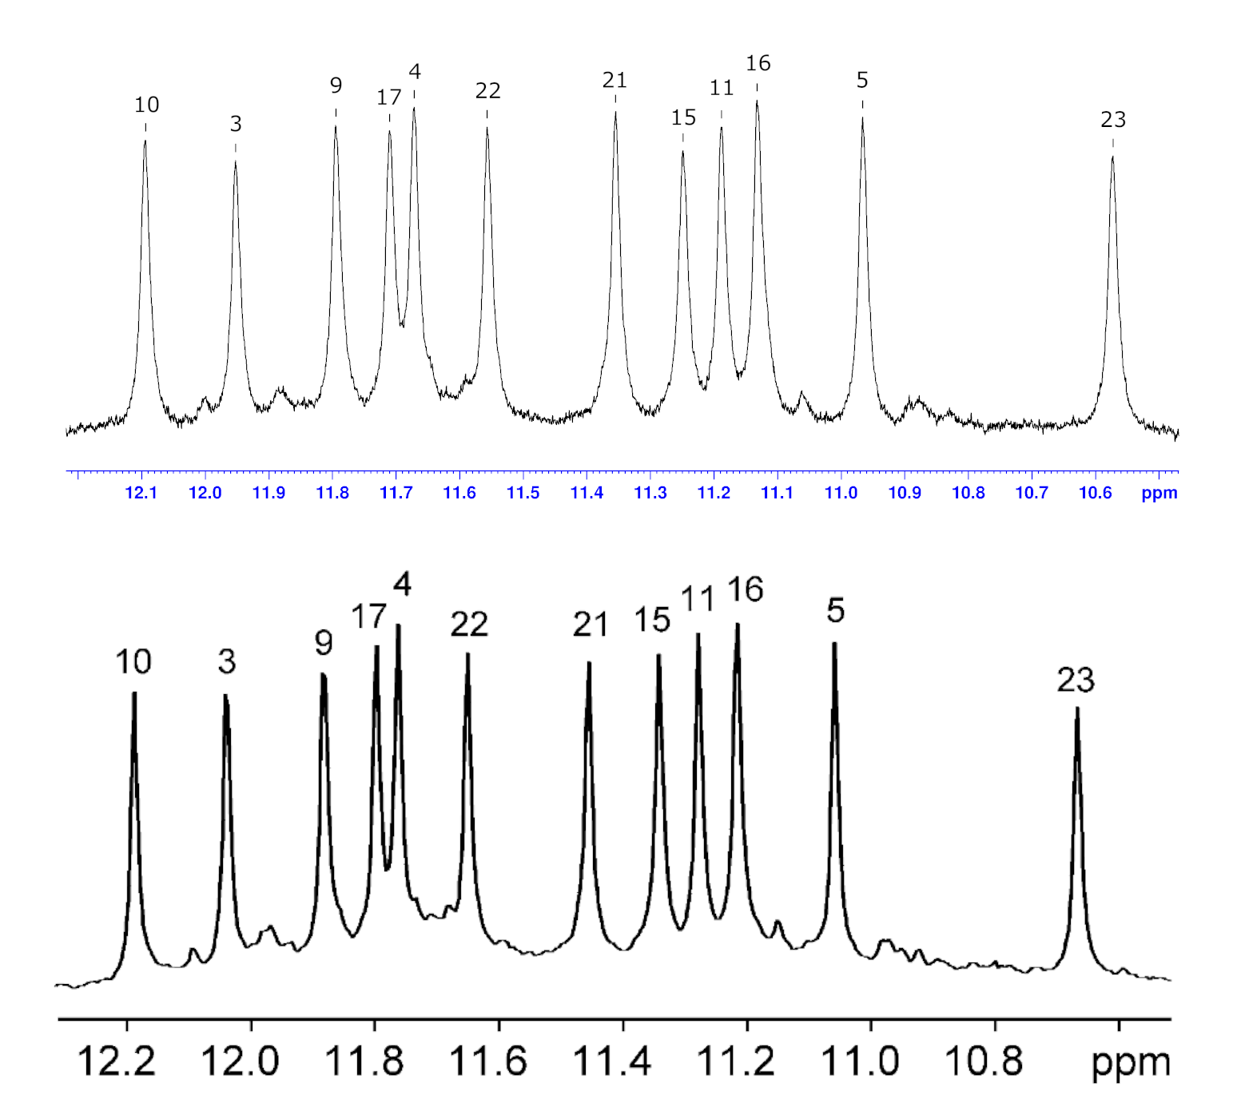
Figure S46: A comparison of ¹H 1D spectrum of the G-Quadruplex, imino protons region. Spectrum on the top - this work, spectrum on the bottom - ⁸⁴.
Figure S47: ¹H 1D spectrum from titration of PtPyr to hTel, imino protons region. 5% D₂O, 70 mM KCl salt, 20 mM K⁺ buffer, 298.2 K, c(hTel)=0. 362 mM. The spectra were referenced to an impurity signal at 3.1 ppm.
Figure S48: ¹H 1D spectrum from titration of PtPyr to hTel, aromatic protons region. 5% D₂O, 70 mM KCl salt, 20 mM K⁺ buffer, 298.2 K, c(hTel)=0.362 mM. The spectra were referenced to an impurity signal at 3.1 ppm.
Table S7: ¹H NMR chemical shift changes of G-quadruplex induced by the addition of PtPyrPhe at the ratio of 1:2. Negative numbers indicate an upfield shift. Significant chemical shift changes ( > 0.05 ppm) are shown in bold. Different colours represent different G-tetrads or linkers of the G-quadruplex.
 | Chemical shifts change Δδ, ppm
 | G-tetrad residues |  |  | The rest residues
Base | H8/H6 | NH | Base | H8/H6 | H2
G₉ | 0.096 | -0.095 | T₁ | 0.007
G₃ | 0.015 | -0.056 | T₂ | 0.113
G₂₁ | -0.036 | 0.013 | T₆ | 0.005
G₁₇ | -0.068 | -0.104 | T₇ | -0.009
G₁₀ | -0.058 | -0.044 | A₈ | -0.019 | -0.015
G₁₆ | -0.007 | 0.005 | T₁₂ | -0.009
G₂₂ | -0.012 | 0.009 | T₁₃ | -0.006
G₄ | -0.012 | -0.039 | A₁₄ | 0.046 | -0.02
G₁₁ | -0.015 | 0.011 | T₁₈ | 0.002
G₁₅ | 0.017 | -0.012 | T₁₉ | 0.147
G₂₃ | 0.015 | -0.007 | A₂₀ | 0.072 | -0.258
G₅ | -0.01 | -0.036 | A₂₄ | 0.016 | -0.036

Table S8: Distances between the duplex and bound PtPyrPhe complex at the ratio of 1:2 extracted from the 3D model.
Distances |  | Å
From Pt | To DNA | Å
H6 | A₉H2 | 4.9
H6 | A₃H2 | 5.4
H6 | C₅H1' | 5.3
H6 | T₁₁H1' | 5.3
H6 | T₄H1' | 5.5
H7 | A₉H1' | 5.3
H10 | A₉H1' | 5.1
H11 | A₉H1' | 4.9
H11 | C₆H1' | 3.8
H12 | A₉H1' | 6.5
H12 | C₆H1' | 5.2

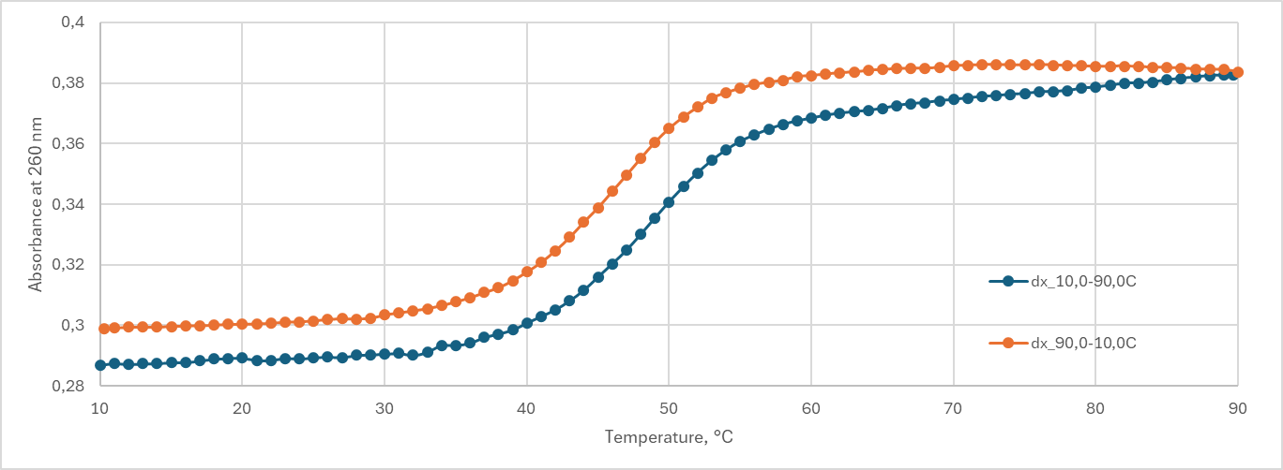
Figure S49: UV/VIS melting curves of free duplex measured at 260 nm in a solution containing 5% D₂O, 70 mM KCl, and 20 mM K⁺ buffer at pH 7. The c(dx)=0.0025 mM.
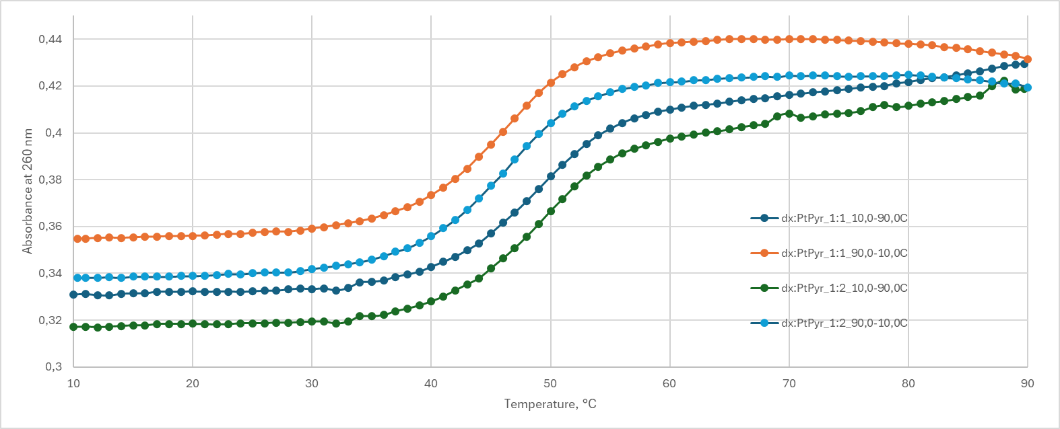
Figure S50: UV/VIS melting curves of duplex with PtPyr at 1:1 and 1:2 concentration ratios measured at 260 nm in a solution containing 5% D₂O, 70 mM KCl, and 20 mM K⁺ buffer at pH 7. The c(dx)=0.0025 mM.
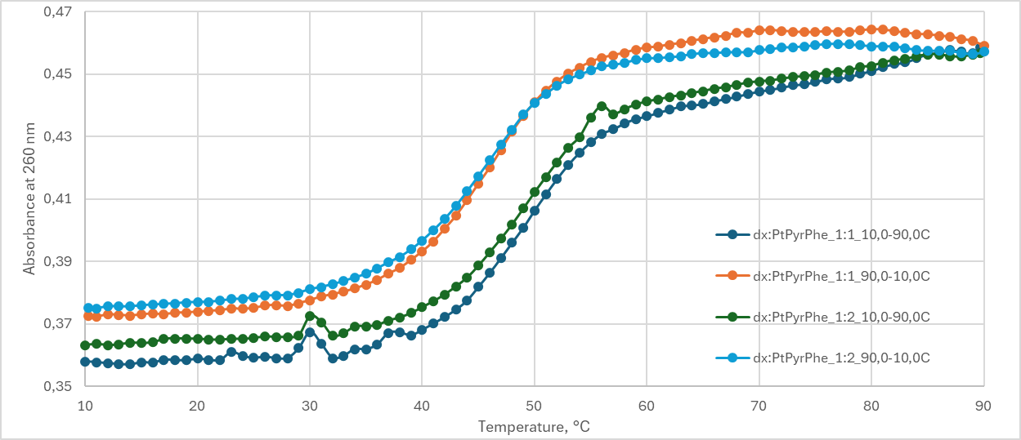
Figure S51: UV/VIS melting curves of duplex with PtPyrPhe at 1:1 and 1:2 concentration ratios measured at 260 nm in a solution containing 5% D₂O, 70 mM KCl, and 20 mM K⁺ buffer at pH 7. The c(dx)=0.0025 mM.
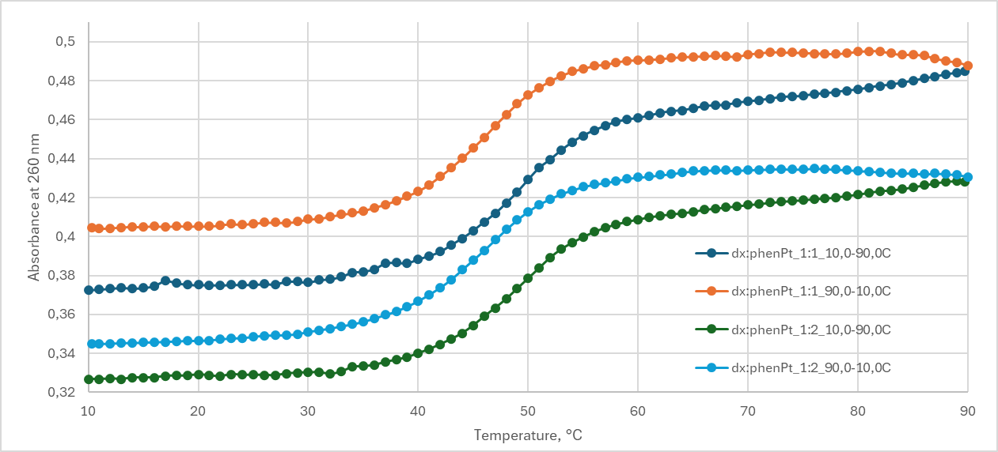
Figure S52: UV/VIS melting curves of duplex with phenPt at 1:1 and 1:2 concentration ratios measured at 260 nm in a solution containing 5% D₂O, 70 mM KCl, and 20 mM K⁺ buffer at pH 7. The c(dx)=0.0025 mM.
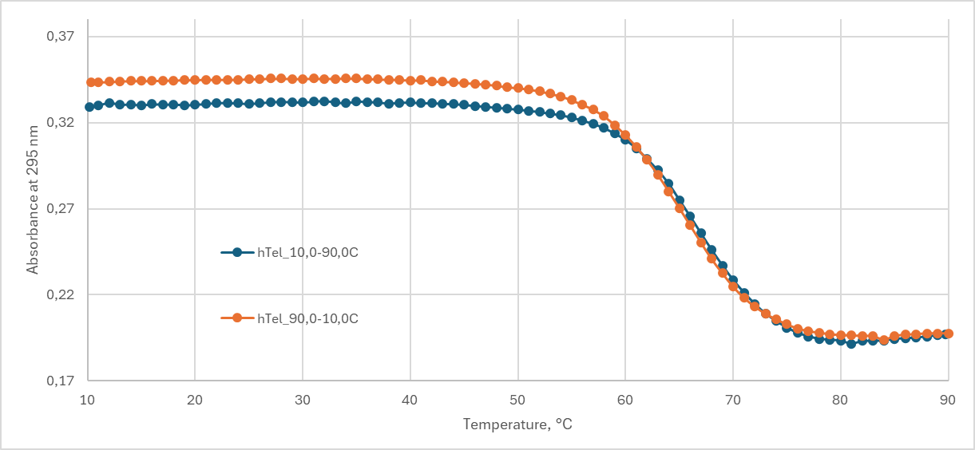
Figure S53: UV/VIS melting curves of free hTel measured at 295 nm in a solution containing 5% D₂O, 70 mM KCl, and 20 mM K⁺ buffer at pH 7. The c(hTel)=0.0075 mM.
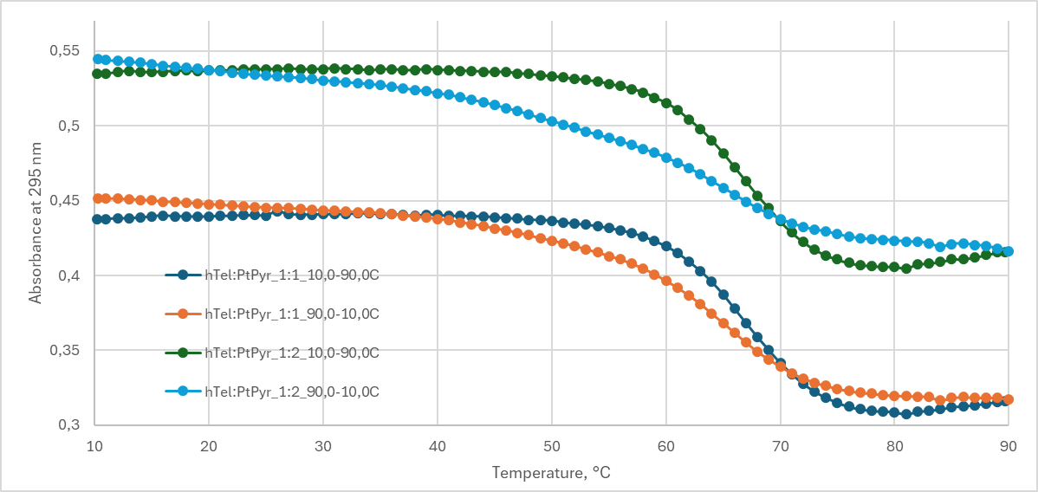
Figure S54: UV/VIS melting curves of hTel with PtPyr at 1:1 and 1:2 concentration ratios measured at 295 nm in a solution containing 5% D₂O, 70 mM KCl, and 20 mM K⁺ buffer at pH 7. The c(hTel)=0.0075 mM.
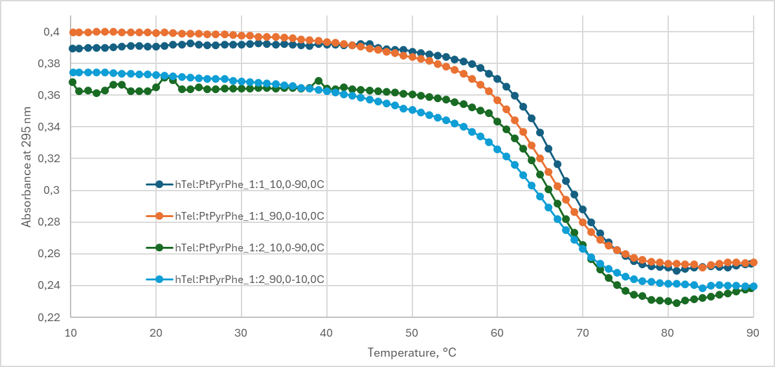
Figure S55: UV/VIS melting curves of hTel with PtPyrPhe at 1:1 and 1:2 concentration ratios measured at 295 nm in a solution containing 5% D₂O, 70 mM KCl, and 20 mM K⁺ buffer at pH 7. The c(hTel)=0.0075 mM.
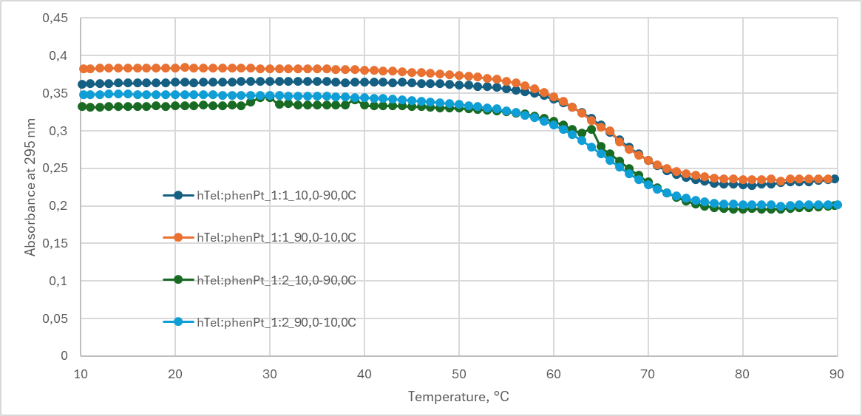
Figure S56: UV/VIS melting curves of hTel with phenPt at 1:1 and 1:2 concentration ratios measured at 295 nm in a solution containing 5% D₂O, 70 mM KCl, and 20 mM K⁺ buffer at pH 7. The c(hTel)=0.0075 mM.

