Masaryková univerzita
Přírodovědecká fakulta
Ústav chemie

Nanočástice v molekulové spektroskopii
Diplomová práce

Patrik Baliak

Vedoucí práce: doc. RNDr. Přemysl Lubal, Ph. D. Brno, 2017
Bibliografický záznam

Autor: Bc. Patrik Baliak
Přírodovědecká fakulta, Masaryková univerzita
Ústav chemie
Název práce: Nanočástice v molekulové spektroskopii
Studijný program: Chemie
Studijný obor: Analytická chemie
Vedoucí práce: doc. RNDr. Přemysl Lubal, Ph. D.
Akademický rok: 2016/2017
Počet stran: 65
Klíčová slova: Nanočástice, kvantové tečky, CdTe, GSH, MPA, fluorescenční spektroskopie, ramanová spektroskopie, SERS, Ag, syntéza,

Bibliographic entry

Author: Bc. Patrik Baliak
Faculty of Science, Masaryk University
Department of chemistry
Title of Thesis: Nanoparticles in molecular spectroscopy
Degree program: Chemistry
Field of study: Analytical chemistry
Supervisor: doc. RNDr. Přemysl Lubal, Ph. D.
Academic year: 2016/2017
Number of pages: 65
Keywords: Nanoparticles, Quantum dots, CdTe, GSH, MPA, fluorescent spectroscopy, Raman spectroscopy, SERS, Ag, synthesis,

Abstrakt
Tato práce je rozdělená do tří částí. První část se zabývá syntézou CdTe a Ag nanočástic. Obsahuje také výzkum procesu jednokrokové “bottom-up“ syntézy. Druhá část se zabývá vybranými metodami analýzy připravených nanočástic pomocí luminiscenční a absorpční spektroskopie. Závěrečná část obsahuje vybrané aplikace těchto nanočástic v analytické spektroskopii.

Abstract
This work is divided into three parts. The first part deals with synthesis of CdTe and Ag based nanoparticles. Process of one-pot bottom-up synthesis is described and results are shown. The second part covers selected methods of analysis of prepared nanoparticles including absorption and fluorescence spectroscopy. The final part shows selected applications of these nanoparticles in analytical spectroscopy.

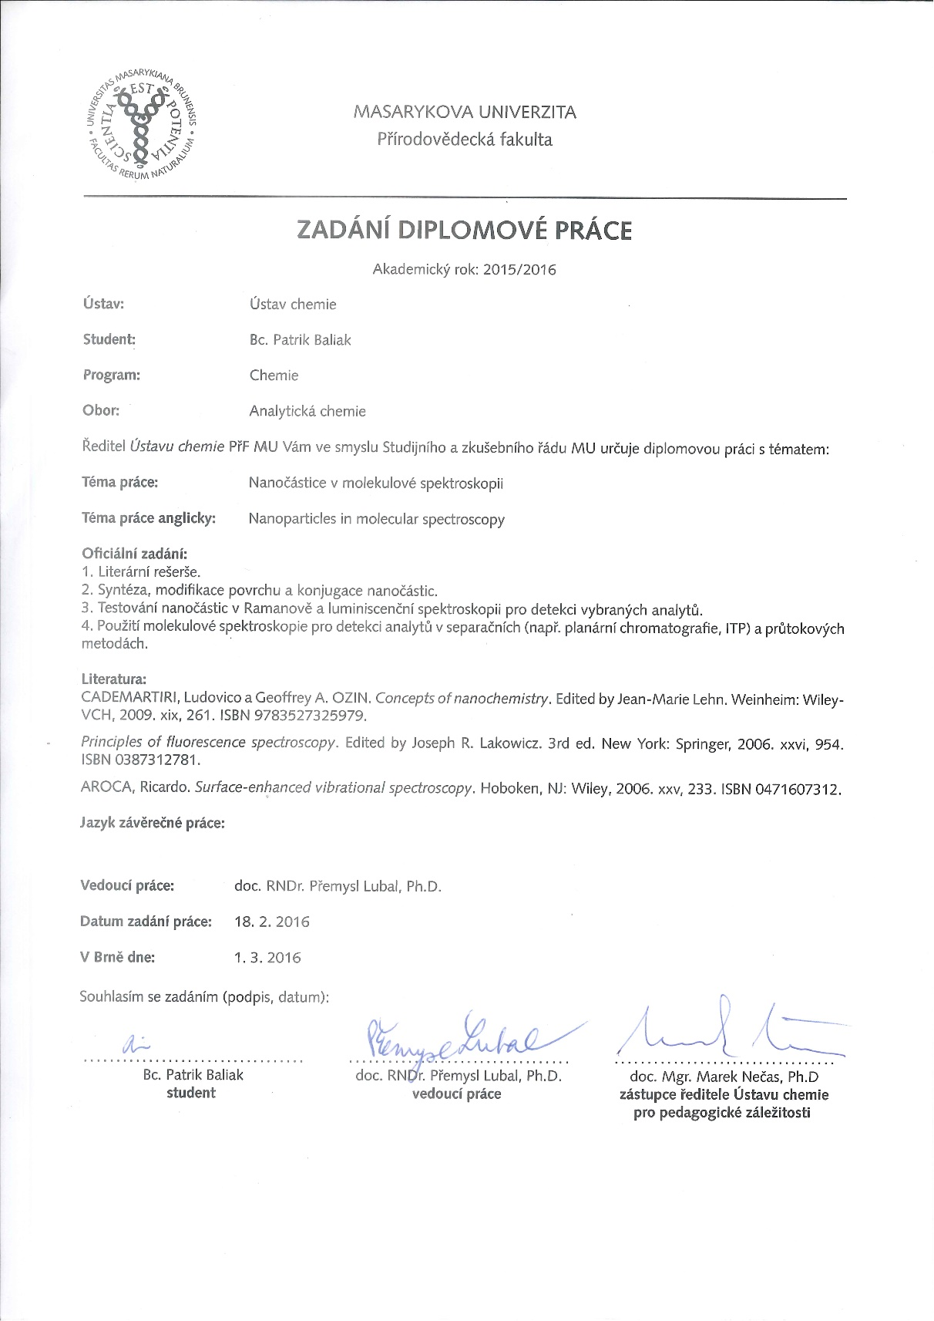

Acknowledgements
“Education: the path from cocky ignorance to miserable uncertainty.”
― Mark Twain

The more I know, the more I’m aware of how much I don’t know. That must undeniably be a sign that I have been educated. This education came from many different directions, and I would like to use this space to thank everybody who helped me on this journey. Especially I would like to thank my supervisor Doc. RNDr. Přemysl Lubal Ph.D, for his guidance, helpfull remarks and for imprinting a vast amount of knowledge which, I hope, was not totaly lost on me. Also I would like to thank everybody from department of Analytical chemistry, whether it be teachers or students. Almost each one of you has taught me something, and I’m thankful for it. Special thank you, comes to Mgr. Filip Smrčka, which comes as an apologi as well, for pestering him with irrelevant stuff about how to operate machines, and where to find stuff.
Another big part of my education comes from my personal life, and here I’d like to say big thank you to my family, close or otherwise. Without the support from my parents this would not have been possible, and I wouldn’t be writing this. They have always been here for me and I am really thankful for it. Big thank you also come to Mgr. Marcela Holkova, for being such an amazing and supportive person. I would have not been able to do this without you, without the conversations we have, laughs we share, advices you have given me and of course, without the endless pestering me about taking a break and coming home once in a while.
Thank you all,
Patrik Baliak

PROHLÁŠENÍ

Prohlašuji, že jsem svoji diplomovou práci vypracoval samostatně s využitím informačních zdrojů, které jsou v práci citovány.

DECLARATION
I hereby declare, that my Master thesis was written independently by me, with use of the cited sources.

Brno 22.5.2017 ……………..
Patrik Baliak
Table of Content

I. Introduction 9
II. Theoretical part 11
II.1 Synthesis of the nanoparticles 11
II.2 Characterization of nanoparticles 12
II.2.1 Absorption spectroscopy 12
II.2.2 Dynamic Light Scattering 13
II.2.3 Time resolved luminescence 13
II.2.4 Voltammetry 13
II.3 Application of nanoparticles 14
II.3.1 Raman spectroscopy 14
II.3.2 Luminescence spectroscopy 20
III. Experimental part 23
III.1 Chemicals 23
III.2 Instrumentation 24
III.2.1 Experimental instrumentation 24
III.2.2 TCSPC 26
III.2.3 PTI Quantamaster 300+ 26
III.2.4 Metrohm 910 PSTAT Mini 26
III.2.5 pH meter: Orion 3 Star 27
III.2.6 Zetasizer nano ZS 27
III.3 Synthesis of silver nanoparticles 27
III.4 Synthesis of quantum dots 28
III.4.1 Investigation of synthesis time 30
III.5 Characterization of silver nanoparticles 31
III.5.1 Absorption spectroscopy 31
III.5.2 Dynamic light scattering 31
III.6 Characterization of quantum dots 31
III.6.1 Excitation and emission spectra measurement 31
III.6.2 pH dependence of intensity 31
III.6.3 Fluorescent lifetime measurement 32
III.6.4 Voltammetric study of quantum dots 32
III.7 Determination of metal ions using SERS 32
III.8 Luminescent quenching of quantum dots 33
III.9 Investigation of luminescent quenching 33
IV. Results and discussion 34
IV.1 Synthesis of nanoparticles 34
IV.1.1 Silver nanoparticles 34
IV.1.2 Quantum dots 36
IV.2 SERS using silver nanoparticles 42
IV.3 Luminescent quenching of quantum dots 48
V. Conclusion 60
VI. List of abbreviations 62
VII. List of figures 63
VIII. List of sources 65

Introduction
According to United States patent and trademark office, nanoparticles are particles that have at least one dimension in scale of 1 – 100 nm in length¹. Because of the size of these objects they have unique properties. Nanoparticles can be used in many areas such as medicine, cosmetics, engineering, material chemistry, biochemistry and analytical chemistry. Nanomaterials are class of particles classified according to their shape. They include basic nanoclusters, nanotubes, nanowires and other shapes.

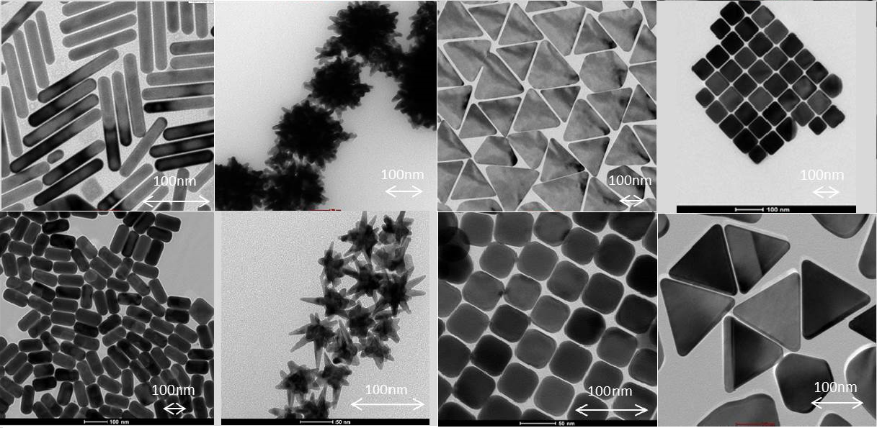
Figure 1: Shapes and sizes of nanoparticles²

Quantum dots are semiconducting nanoparticles that are smaller than 100 nm in all directions. They typically contain 10 to 10⁵ atoms³. These nanomaterials provide unique luminescent properties, which renders them useful in many applications in vitro and also in vivo⁴. These properties are caused by electrons in semiconducting material. Energy required to excite electron to higher energy state can be provided by absorption of VIS/UV light. As electron absorbs the energy, it is moved to a higher energy state. Difference between energy of this excited state increases with the size of the nanoparticle. This means that the emission maximum of the bigger nanoparticles is shifted towards higher wavelengths. Energy gained through absorption of the photon has to be disposed in some way. There are two mechanisms through molecule can proceed. Non-radiative mechanisms include vibrations or rotations while radiative mechanisms include fluorescence and phosphorescence. Electron usually uses non-radiative mechanisms, until it descends to the lowest vibrational level of the excited state. The following gap in energies may be too big to cross using non-radiative options, therefore electron loses energy by emitting photon of wavelength corresponding to the energy lost.
Another phenomenon that adds to usefulness of QD nanoparticles is possibility of modification of their surface by a wide variety of substances⁵. This modifying molecules can be used not only for the stabilization of nanoparticles, but also as a means for other interactions of quantum dots, such as labeling of proteins^{5,6}. Among the most common modifying molecules belong thiol capped ligands such as glutathione (GSH), mercaptopropionic acid (MPA) or cysteine. The fact that color of the emitted light depends on the size of the nanoparticle can also be exploited, as it provides possibility to synthesize the quantum-dot like nanoparticles with tuned emission properties⁵.

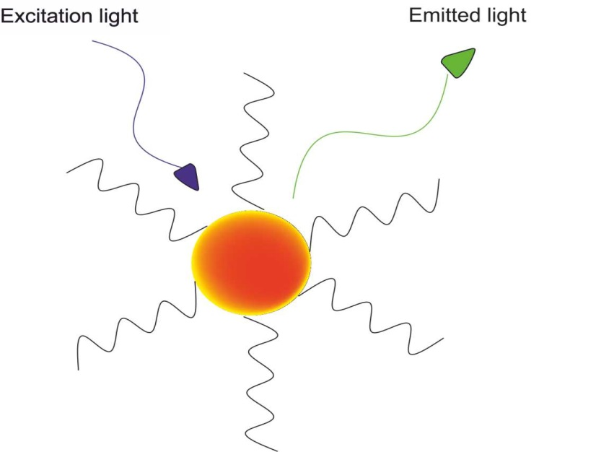
Figure 2: Quantum-dot (QD) nanoparticle

Theoretical part

Synthesis of the nanoparticles
First part of this work consists of synthesis of nanoparticles used throughout the experiments. For nanoparticles there are generally two ways of preparation: bottom-up, and top-down. Bottom-up synthesis is based on building of nanoparticle from smaller parts while top-down is the exact opposite, therefore from bulk material down to the nanosized material.

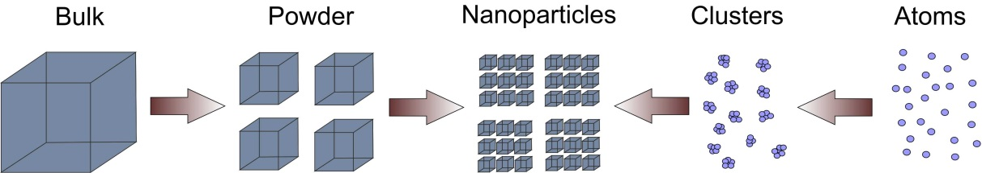
Figure 3: Bottom-up and top-down approach

Bottom-up synthetic approach was used in this work. There are many different variations of this approach, which can be generally described by two terms: one pot or two pots synthesis. As is apparent from the names, one pot synthesis is done by gradually adding reactants to the reaction mixture in one container. On the other hand, two pots synthesis requires preparation of an intermediate in separate container and adding it to the reaction mixture.
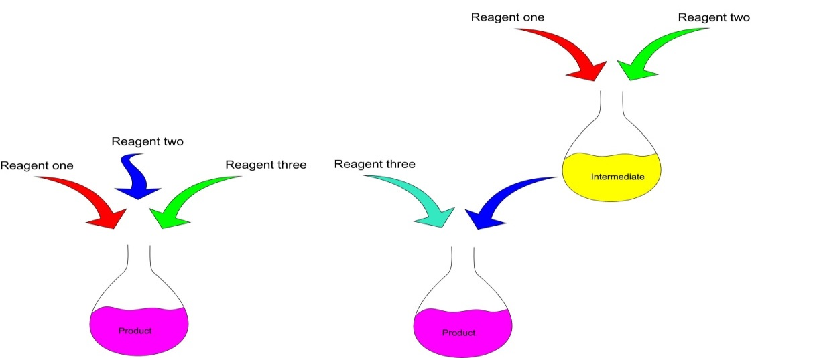
Figure 4: Description of one-pot vs. two-pots synthesis
Two kinds on nanoparticles were prepared for this work, for two different applications. Firstly, silver nanoparticles, stabilized by citrate for application as substrates for SERS, secondly CdTe-quantum dot nanoparticles stabilized by GSH and MPA, to be used in luminescence spectroscopy.
One-pot synthesis of silver nanoparticles was done as described in literature^{7,8}. Analogous procedure is also described in experimental part of this work. As for quantum dots, one-pot procedure was carried out⁹.

Characterization of nanoparticles
The prepared nanoparticles were analyzed by different experimental techniques which are mentioned in following text.

Absorption spectroscopy
The absorption spectra were measured for silver nanoparticles in order to get general idea about dispersion of nanoparticles of different sizes, taking FWHM of the peak as criterion¹⁰.
Absorption spectroscopy is analytical method widely used because of simplicity of its instrumentation, virtually no cost of analysis besides reagents and initial purchase of the instrument as well as ease of use. The method is based on absorption of light by molecules of analyte. This absorption is governed by Bouguer-Lambert-Beer law:
$$A= ε l c$$
where A stands for absorbance, $ε$ is absorption coeficient, $l$ is length of the absorption path and $c$ is concetration of the analyte.
In this work we use the fact that nanoparticles of different sizes are able to absorb different kinds of wavelengths. Therefore if the absorption peak is broad, we can ascertain that the solution of nanoparticles contains particles of many different sizes. On the other hand, if its FWHM is low we can assume that these particles are roughly the same size¹¹.

Dynamic Light Scattering
Dynamic Light Scattering (often referred to as Photon Correlation Spectroscopy) is a method widely used to determine size of macromolecules such as proteins or particles in colloidal solutions. This makes it ideal for determination of size of prepared nanoparticles¹².
The method works by measuring Brown movement of the particles present in solution. Heavier particles move slower than lighter. The size of the particle is determined by measuring fluctuations of the scattered light. Important notes are that constant temperature must be maintained throughout the measurement in order to ensure no convection¹¹.

Time resolved luminescence
Time correlated single photon counting is a technique used to analyze emission properties of luminophores, in particular to monitor luminescence decay and determination of half-life of this decay. It involves use of pulse light source, usually a picosecond laser⁵. After short pulse of light from the source, intensity of emission is measured. Time is measured for single photon to arrive to detector, since excitation pulse. After many pulses, one obtains the correlation between time elapsed and number of photons detected. From the shape of the curve obtained, it is possible to ascertain many useful properties of the analyzed substance, for example presence of another luminophore⁵.

Voltammetry
Voltammetry is a group of electroanalytical methods used for various determinations. Electric current is measured with varied potential applied. The resulting information gained depends on exact technique used, and can be for example peak, square wave, staircase pattern, or special kind of peak associated with cyclic voltammetry. In this work, we test using differential pulse voltammetry in conjunction with adsorptive stripping for purposes of characterization of prepared QD nanoparticles and study of their interactions with metal ions.

Adsorptive stripping
Adsorptive stripping is a preconcentration technique used to improve detection limits of voltammetry¹³. Analyte is adsorbed on the surface of the electrode by convection, which is a main difference between this technique and anodic or cathodic stripping voltammetry. In order to use this technique with our voltammetric setup, pretreatment of the electrode is needed. In this pretreatment step, a thin plating of mercury is deposited on the surface of the electrode¹⁴.

Differential pulse voltammetry
Differential pulse voltammetry is a modification of linear sweep voltammetry. The difference is that the current is measured immediately before each potential change and the difference is plotted against the potential. The aim of this modification is to reduce the effect of the charging current, leading to lower detection limits¹³.

Application of nanoparticles

Raman spectroscopy

Overview
Raman spectroscopy is method of analytical spectroscopy which uses interaction between light and matter. The result of the analysis is spectrum that contains information about vibrational states of the analyte, which can be employed for qualitative analysis. Intensity of peaks in this spectrum is also proportional to concentration of the analyte, which allows for calibration and subsequent determination of the analyte in unknown sample, or use of the standard addition method. As Raman intensities can be theoretically calculated, the option for absolute determination of concentration is also possible¹⁵. In this work, application of SERS using silver nanoparticles in determination of heavy metal ions¹¹ was explored.

Principle
Raman spectroscopy is based on Raman scattering effect. Important factor is that the analyzed molecule must be polarizable^{3,15}. When energy is absorbed by a molecule some of the electrons in outer shell are excited to virtual energy states and after returning from these higher virtual energy states they lose energy. However, this loss of energy is not always equal to the energy gained. Electrons therefore end up with slightly more or less energy than they had before, that means they are in a higher or lower vibrational state than they were before¹⁵. This change of energy is registered in Raman spectra as a shift from the initial wavelength of the light used. If the electron loses more energy than it gained, the shift is called Anti-Stokes shift, if it gains more energy than it lost, the shift is called Stokes shift. Value of this shift can be assigned to independent vibration of bond, therefore it is qualitative characteristic. Anti – Stokes lines are usually less pronounced due to lower population of electrons in higher vibrational states, as compared to Stokes lines¹⁵. Intensity of scattered light is proportional to amount of analyte in unknown sample. Therefore the height or the area of the peak can be used to quantitatively determine concentration of analyte in the sample. It should be noted that Raman scattering has much smaller effective diameter than Rayleigh scattering, therefore it is much more difficult to detect and higher requirements for instrumentation are needed.
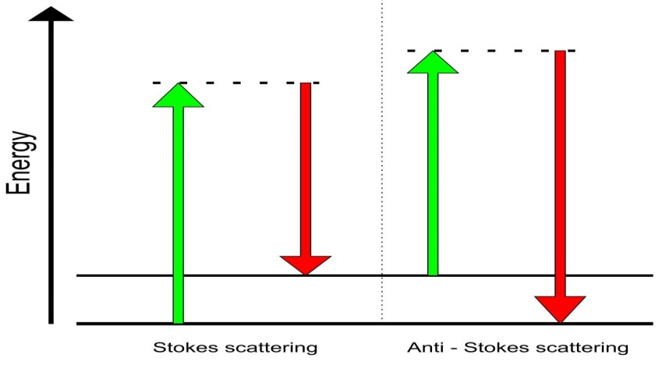
Figure 5: Energy diagram of Raman Scattering

Surface Enhanced Raman Spectroscopy (SERS)

Surface Enhanced Raman Spectroscopy is a modification of Raman spectroscopy, with aim to improve sensitivity of this technique. When Raman spectrum is measured on a rough surface of a precious metal, such as gold or silver, signal for this measurement is intensified by order of 10⁶ - 10¹⁴ ^{16,17}. In extreme cases, single molecule detection can be achieved using this technique with appropriate analyte. The same effect could be achieved by using nanoparticles of the same metals.
This effect is not yet fully understood, but there are two prevalent explanations:
- Chemical explanation
The analytical signal produced is intensified by formation of charge-transfer complex between analyte and precious metal. This interaction is limited to the available nanoparticle surface and therefore accounts for only small part of enhancement (10 - 10²)¹⁶.
- Plasmonic explanation

Signal is amplified by formation of plasmon on precious metal surface. This plasmon is created by collective excitation of electrons in the metallic structures¹⁶ and serves as an antenna. As excitation of electrons is not limited to the metal surface, this effect is much more intense one than observed for chemical amplification¹⁶.

Instrumentation

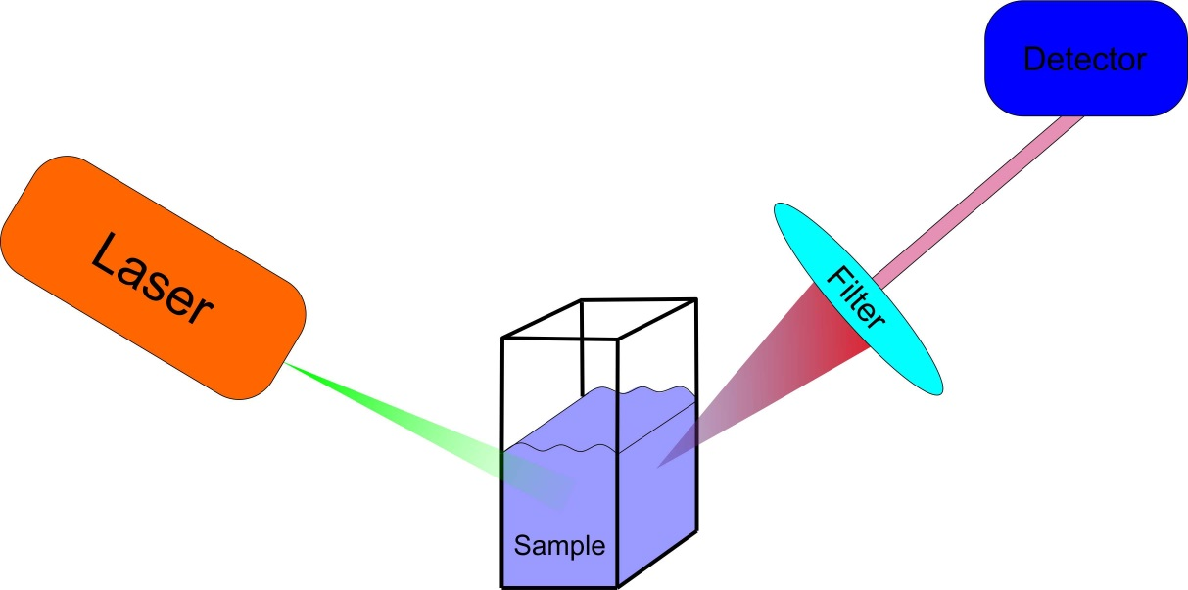
Figure 6: Raman spectroscopy instrumentation

Raman spectrometers usually consist of several parts:
- Light source
Light used in Raman spectroscopy should be monochromatic. This goal can be achieved by different ways. One can use standard light sources, for example xenon or mercury lamp and employ monochromator to select desired wavelength. However, this approach is being replaced by use of lasers, which serves as much more convenient and ultimately cheaper option for Raman spectroscopy. Inherent monochromaticity of the light emitted by lasers is another advantage of their application which eliminates the necessity to use excitation monochromator¹⁸.
- Sample compartment

Raman spectra can be measured in all three states of matter. In selection of a sample compartment one must take into consideration several factors. First one is that the material of the container must be chemically inert. The second one is ability to pass the light from the excitation source and thirdly, the material should not be luminescent, as luminescence phenomenon is not desired in Raman spectra measurement.

- Filters
The interaction of the excitation light with the sample can produce Raman scattering as well as Rayleigh scattering which is much more pronounced than desired Raman scattering and it interferes with measurement of Raman spectra. This effect can be controlled to certain degree by use of absorption filters. These filters are designed to permit only certain wavelengths of light. If anti-Stokes lines are measured, we can use so called short-pass filters which permits only wavelength of lower value through. If the situation is reverse, we can use long-pass filters, which will permit higher wavelength to pass. Sometimes the measurement requires us to measure both kinds of lines. In that case we can use so called notch filter, which will absorb only in certain regions of the spectra, and it is transparent for light in certain region¹⁵.

Figure 7: Transmission spectrum of different kinds of filters

- Emission monochromator

As Raman spectroscopy operates with very small changes in wavelength, high resolution is needed. This is typically achieved by use of emission monochromator. Sometimes it can be used in tandem with the second or even third monochromator. These are usually constructed in Czerny-Turner configuration¹⁹.

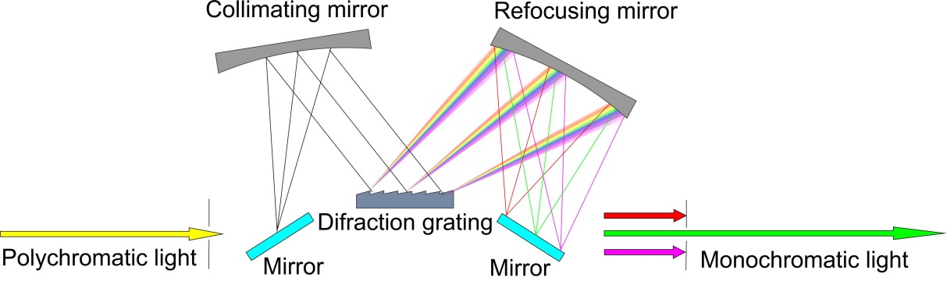
Figure 8: Czerny - Turner monochromator scheme

- Detector

The most commonly used light detector for any spectroscopic method is photomultiplier. This device can also be used in Raman spectroscopy and its main advantage is its sensitivity. However, use of this device requires the monochromator to be adjusted for every single wavelength individually, therefore the measurement is sequential. This approach is very time consuming, and can take about 20 minutes to acquire desired spectrum, based on parameters of the measurement. Another way is to use semiconductor detectors. Among the most commonly used are photodiode-arrays and CCD detectors, which can record the whole Raman spectrum in a short time¹⁹. These detectors therefore eliminate the necessity to use monochromator.

Luminescence spectroscopy

Overview
Luminescence spectroscopy is widely used analytical method, based on an ability of certain compound to emit light at certain experimental conditions. This light can be detected in the form of emission spectrum where the position of peaks can be used for qualitative analysis and their height and area for quantitative analysis by standard addition or calibration curve methods after calibrating the equipment.

Principle
Emission of light by a compound is caused by electrons returning from higher excited states back to the ground state (Figure 8) and this light is detected at wavelength dependent on the difference of the two energy states.
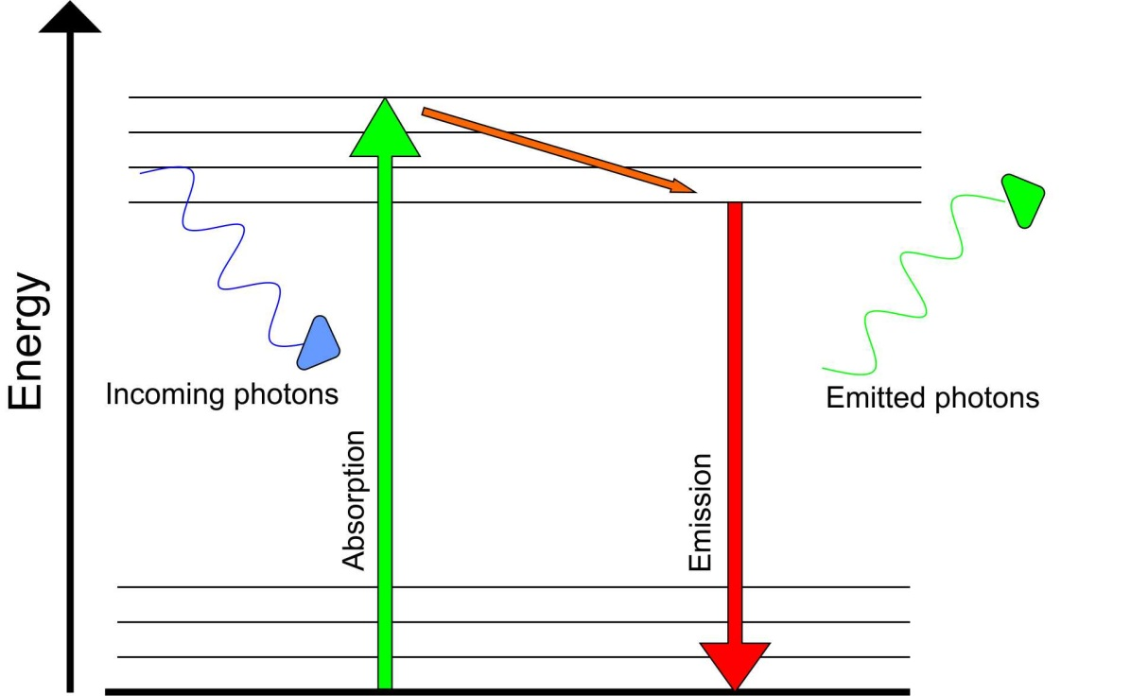
Figure 9: Jablonski diagram

The electron can be excited by different ways. According to process by which the electron is excited, we recognize different kind of luminescence. The most common way to excite electron is by absorption of light. Among other processes we can name excitation by pressure, heat, chemical reaction and sound⁵.
As the electron loses energy through vibration, it descends to the lowest vibrational level of the excited state. The transition back to the ground state is achieved by emission of a photon. That is because the difference of energy between two states is too high, and therefore the electron can’t lose the energy through vibrations. After emission, the electron descends vertically and lands in a higher vibrational level of the ground state. As some of the energy absorbed has been exchanged during vibrational transitions, the emission peak is positioned to the right side of the absorption peak, corresponding to lower energies³.

Instrumentation
Instrumentation for measurement of luminescence spectra is rather similar to instrumentation for Raman spectroscopy. In fact, it is possible to measure Raman spectra on a fluorimeter. The difference is only demand on the sensitivity of the measurement. While in Raman spectroscopy supreme sensitivity of the detector is needed, because of low intensity of the analytical signal, in fluorescent spectroscopy we can dispense with lower sensitivity because the analytical signal is usually sufficiently strong.

Determination of heavy metal ions
Heavy metals are frequent industrial pollutants. Therefore, it is necessary to monitor the concentration levels of these metal ions and their impact on environment. Number of analytical methods can be used to this purpose. Among them, the electrochemical methods such as electrogravimetry, coulometry, voltammetry, etc. are used as well as spectroscopic methods, for example ICP –OES/MS or AAS. In this work, the possibilities of using silver nanoparticles for SERS and QD nanoparticles with unique luminescent properties for metal ion analysis are investigated. It is documented that heavy metals interact with many luminophores, and are able to lower the intensity of their luminescence⁵. This process is referred to as luminescent quenching. There are two kinds of luminescent quenching, depending on the mechanism of interaction between quencher and luminophore. The first mechanism is called static quenching, the second one dynamic quenching⁵. Both of these processes are described by Stern - Volmer equation, which can be used to linearize obtained intensities and therefore permits calibration.
$$\frac{F_{0}}{F}=1+k_{q}τ_{0}\left[Q\right]=1+K_{SV}\left[Q\right]$$
where F₀ is the initial intensity of the emitted light, F is the intensity of the emission after the quencher addition, $k_{q}$is the reaction rate constant, $τ_{0}$ is the lifetime of the emissive excited state, [Q] is the concentration of the quencher and K_{SV} is Stern – Volmer constant. In case of dynamic quenching, K_{D} is used instead of K_{SV}.
In some case however, both static and dynamic quenching take place. The result of such a process would be nonlinear Stern – Volmer plot, most likely with upward curvature, characterized by modified Stern – Volmer equation⁵:
$$\frac{F_{0}}{F}=\left(1+K_{D}\left[Q\right]\right)\left(1+K_{S}\left[Q\right]\right)$$
where the first part accounts for the dynamic quenching and the second part for static. Individual quenching constant for dynamic quenching can in this case be determined by measuring luminescent lifetime or, if lifetime measurements can’t be done, by modifying Stern – Volmer equation to allow for graphical separation of the two constants⁵.

List of abbreviations

QD: Quantum dots
MPA : 3 – mercaptopropionic acid
SERS: Surface Enhanced Raman Spectroscopy
TCSPC: Time Correlated Single Photon Counting
DPV: Differential Pulse Voltammetry
ICP – OES: Inductively Coupled Plasma – Optical Emission Spectroscopy
MS: Mass Spectrometry
AAS: Atomic Absorption Spectroscopy
WHO: World Health Organization
BIPY: bipyridyl ligand

List of figures

Figure 1: Shapes and sizes of nanoparticles² 9
Figure 2: Quantum-dot (QD) nanoparticle 10
Figure 3: Bottom-up and top-down approach 11
Figure 4: Description of one-pot vs. two-pots synthesis 11
Figure 5: Energy diagram of Raman Scattering 15
Figure 6: Raman spectroscopy instrumentation 17
Figure 7: Transmission spectrum of different kinds of filters 18
Figure 8: Czerny - Turner monochromator scheme²¹ 19
Figure 9: Jablonski diagram 20
Figure 10: Experimental instrumentation 24
Figure 11: Experimental setup for silver nanoparticle preparation 28
Figure 12: Experimental setup for quantum dot synthesis 30
Figure 13: The chemical structure of Bipyridyl (bipy) ligand 32
Figure 14: The chemical structure of Picolinic (Pic) acid 33
Figure 15: Silver nanoparticles 34
Figure 16: Absorption spectrum of silver nanoparticles 35
Figure 17: Distribution of prepared silver nanoparticles 35
Figure 18: Wavelength dependence of MPA-QD’s on the synthesis time 36
Figure 19: Intensity dependence on the synthesis time 37
Figure 20: Particle size dependence on the synthesis time 37
Figure 21: Visual changes of the emitted light of MPA-QD’s prepared by heating for different time 38
Figure 22: Dependence of luminescent lifetime on length of the synthesis 38
Figure 23: Excitation and emission spectra of the MPA-QD’s 39
Figure 24: Size distribution of prepared QD’s 40
Figure 25: pH dependence of intensity of MPA-QD’s 41
Figure 26: Visual changes of the emitted light of MPA-QD’s measured a pH values (pH = 4-10) 41
Figure 27: Differential pulse voltammogram of quantum dots 42
Figure 28: SERS spectrum of [Cu(bipy)]²⁺ complex 43
Figure 29: Calibration curve for [Cu(bipy)]²⁺ complex 44
Figure 30: SERS spectrum of [Ni(bipy)]²⁺complex 44
Figure 31: Calibration curve for [Ni(bipy)]²⁺complex 45
Figure 32: SERS spectrum of [Zn(bipy)]²⁺complex 45
Figure 33: Calibration curve for [Zn(bipy)]²⁺complex 46
Figure 34: SERS spectrum of [Hg(bipy)]²⁺complex 46
Figure 35: Calibration curve for [Hg(bipy)]²⁺ complex 47
Figure 36: Quenching of QD nanoparticles by Cu(II) 49
Figure 37: Stern – Volmer plot of QD nanoparticles quenched by Cu(II) ions 49
Figure 38: Quenching of QD nanoparticles by Pb(II) 50
Figure 39: Stern – Volmer plot of QD nanoparticles quenched by Pb(II) ions 51
Figure 40: Quenching of QD nanoparticles by Eu(III) 51
Figure 41: Stern – Volmer plot of QD nanoparticles quenched by Eu(III) ions 52
Figure 42: Quenching of QD nanoparticles by Hg(II) 53
Figure 43: Stern – Volmer plot of QD nanoparticles quenched by Hg(II) ions 53
Figure 44: Stern – Volmer plot of QD nanoparticles quenched by [Cu(pic)_{n}]^{2-n} complexes (n=1-3) 55
Figure 45: Stern – Volmer plot of of QD nanoparticles quenched by [Pb(pic)_{n}]^{2-n} complexes (n=1-3) 55
Figure 46: Stern – Volmer plot of QD nanoparticles quenched by [Eu(pic)_{n}]^{3-n} complexes (n=1-4) 56
Figure 47: Stern – Volmer plot of QD nanoparticles quenched by [Hg(pic)_{n}]^{2-n} complexes (n=1-2) 57
Figure 48: Interaction of QD nanoparticles with copper 58
Figure 49: Fluorescent emission curves measured for different concentrations of Cu(II) ions 58
Figure 50: Stern – Volmer plot with luminescent lifetimes 59

List of sources
1. Hunt, G. & Mehta, M. D. Nanotechnology Risk, Ethics and Law. (Earthscan, 2006).
2. Futurenanoneeds.eu
http://www.futurenanoneeds.eu/wpcontent/uploads/2014/02/CBNI_library_of_nanoparticle_shapes_ZK.png. (Accessed 18.3.2017)
3. Atkins, P. & De Paula, J. Physical Chemistry. (Oxford University Press, 2010).
4. Michalet, X. et al. Quantum dots for live cells, in vivo imaging, and diagnostics. Science 307, 538–544 (2005).
5. Lakowicz, J. R. Principles of Fluorescence Spectroscopy. (Springer, 2006).
6. Medintz, I. L., Uyeda, H. T., Goldman, E. R. & Mattoussi, H. Quantum dot bioconjugates for imaging, labelling and sensing. Nat. Mater. 4, 435–446 (2005).
7. Kleinman, S. L. et al. Single-Molecule Surface-Enhanced Raman Spectroscopy of Crystal Violet Isotopologues: Theory and Experiment. J. Am. Chem. Soc. 133, 4115–4122 (2011).
8. Prucek, R., Kvitek, L. & Hrbac, J. SILVER COLLOIDS -METHODS OF PREPARATION AND UTILIZATION. Chemica 43, (2004).
9. Hlaváček, A. & Skládal, P. Kvantové tečky: Příprava, konjugace a využití v bioanalytické chemii a biologii. Chem. Listy 105, 611–615 (2011).
10. Leopold, N. & Lendl, B. A New Method for Fast Preparation of Highly Surface-Enhanced Raman Scattering (SERS) Active Silver Colloids at Room Temperature by Reduction of Silver Nitrate with Hydroxylamine Hydrochloride. J. Phys. Chem. B 107, 5723–5727 (2003).
11. Docherty, J. et al. Determination of metal ion concentrations by SERS using 2,2 ’-bipyridyl complexes. Analyst 140, 6538–6543 (2015).
12. Panacek, A. et al. Silver colloid nanoparticles: Synthesis, characterization, and their antibacterial activity. J. Phys. Chem. B 110, 16248–16253 (2006).
13. Wang, J. Analytical electrochemistry. (Wiley, 2006).
14. Zumbrägel, B. Electrochemistry - A workbook for 910 PSTAT mini. (2013).
15. Telle, H. H., Gonzales Urena, A. & Donovan, R. J. Laser Chemistry: Spectroscopy, Dynamics and Application. (Wiley, 2007).
16. Kellner, R., Mermet, J. M., Otto, M., Valcarcel, M. & Widmer, H. M. Analytical Chemistry : A Modern Approach to Analytical Science. (Wiley, 2004).
17. Demtroder, W. Laser Spectroscopy, Volume 2: Experimental Techniques. (Springer, 2008).
18. Demtroder, W. Laser Spectroscopy, Volume 1: Basic Principles. (Springer, 2008).
19. Skoog, D. A., Holler, F. J. & Crouch, S. R. Principles of Instrumental Analysis. (David Harris, 2007).
20. Mohan, S., Oluwafemi, O. S., Kalarikkal, N. & Thomas, S. Antibacterial and sensing properties of dextrose reduced starch capped silver nanoparticles synthesised via a completely green method. Mater. Today-Proc. 2, 3943–3949 (2015).
21. Jiying Pei, Hui Zhu, Xiaolei Wang, Hanchang Zhang & Xiurong Yang. Synthesis of cysteamine-coated CdTe quantum dots and its application in mercury (II) detection. Analytica Chimica Acta 63–68
22. Zhang, H. et al. Hydrothermal synthesis for high-quality CdTe nanocrystals. Adv. Mater. 15, 1712–+ (2003).
23. Wang, Y., Chen, H., Ye, C. & Hu, Y. Synthesis and characterization of CdTe quantum dots embedded gelatin nanoparticles via a two-step desolvation method. Mater. Lett. 62, 3382–3384 (2008).
24. Perkin - Elmer atomic spectroscopy brochure.
https://www.perkinelmer.com/Content/relatedmaterials/brochures/bro_worldleaderaaicpmsicpms.pdf (Accessed 16.5.2017)
25. World Health Organization.
http://www.who.int/water_sanitation_health/dwq/gdwq0506.pdf (Accessed 16.5.2017)

